Part 1

Final results:

MySQL table:

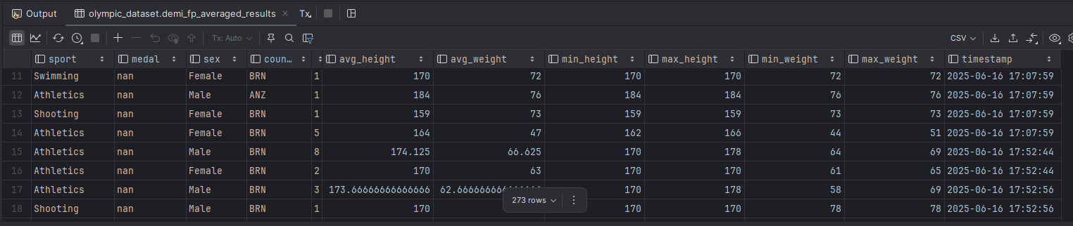

Output results from Kafka topic:

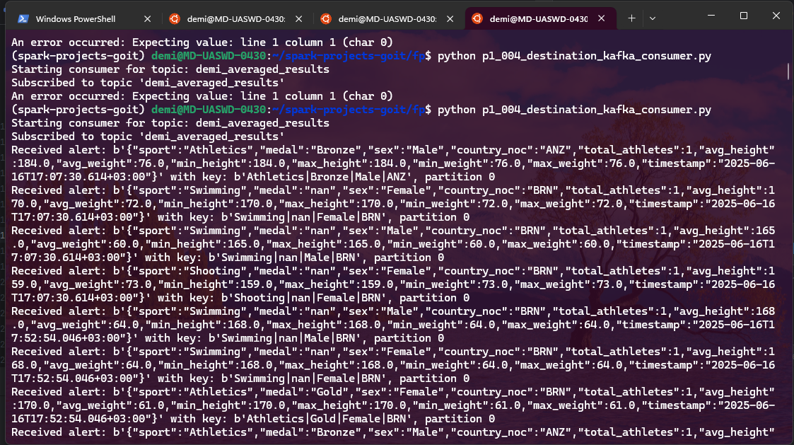

Part 2

Here is how the task run was logged after aggregation.

An extra step (PythonOperator) is used to handle passing table names across executions through temp file.