Project 1B

Team members: Enmao Diao, Haoli Du

**Segregation measurements**

Our team decided to use Enmao’s proposal of using the sum of happiness of all occupants in the graph. As we defined in class, the raw color c(i,j) of a cell (i,j) at time t is the sum of the population values in its neighborhood and the happiness of an individual is the cell’s own value multiplied by the cell’s raw color. This means, the higher the happiness of a give cell the more similar this cell is to the surrounding cells. The cell, thus is in a more segregated environment. This proposed measure was not modified during the development of part B since the measure worked well as an objective and quantitative way to calculate segregation and was easy to compute.

**Segregation measurements under various conditions**

1. **occupancy probability**

Fix M*N and Tribe A population bias, we vary the occupancy probability within [0.3, 0.5, 0.7, 0.9]. Other fixed parameters are shown in Figure 1.

As you can see from the following four plots, as occupancy probability grows, the graph becomes more densely populated. The *segregation measurement after* at occupancy probability = 0.9 is smaller than it is at occupancy probability = 0.7. As the graph becomes denser, each cell has a lower color value because of the higher probability of being influenced by its neighbor who are from a different tribe.

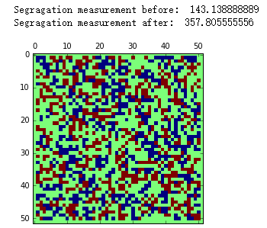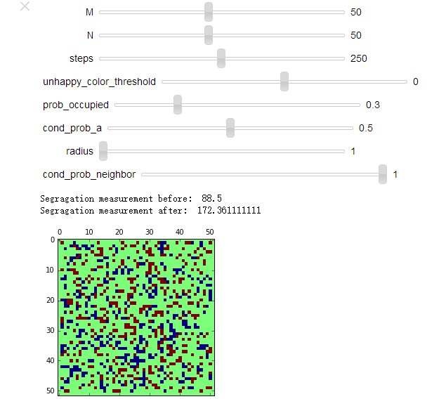

Figure 2. 0.5 occupancy probability

Figure 1. 0.3 occupancy probability

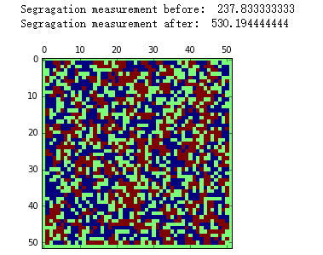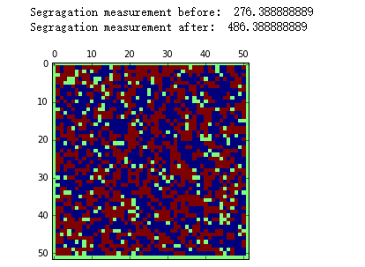

Figure 4. 0.9 occupancy probability

Figure 3. 0.7 occupancy probability

1. **Tribe A population bias**

Fix M*N and occupancy probability, we vary the Tribe A population bias within [0.3, 0.5, 0.7, 0.9].

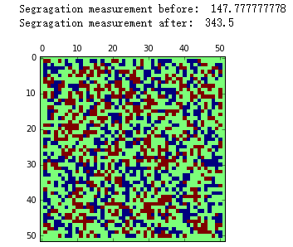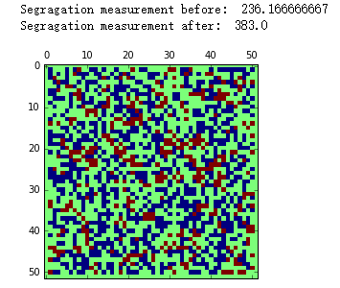As you can see from the following four plots, as Tribe A population bias grows, more Tribe A cells populate in the graph as expected. The *segregation measurement after* at Tribe A population bias = 0.5 is the smallest. This is because as Tribe A population bias is greater than 0.5, there are more tribe A cells and vice versa. This means more cells from the same tribe are there to cause segregation resulting in higher segregation measurement. When Tribe A population bias = 0.5, the number of tribe A and B cells are roughly the same. Cells in this graph have the highest probability of being influence by the opposite tribe.

Figure 6. 0.5 Tribe A population bias

Figure5. 0.3 Tribe A population bias

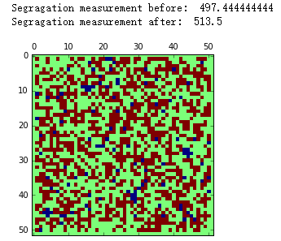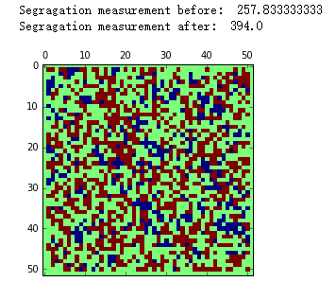

Figure8. 0.9 Tribe A population bias

Figure7. 0.7 Tribe A population bias

1. **M by N**

Fix Tribe A population bias and occupancy probability, we vary the M*N within [20*20, 40*40, 60*60, 80*80].

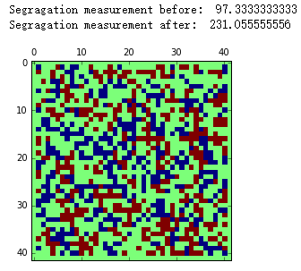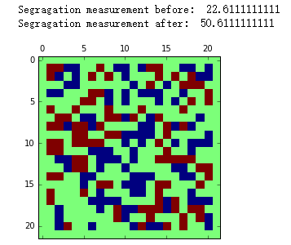Increasing the size of graph does not affect too much on the segregation quality. As the size grows, however, the segregation measurement of both before and after segregation increas significantly. This is because the color value of a given cell only involves neighbors that lies within radius 1 of the given cell. As the size grows, more cells have positive color values and therefore it results in higher segregation measurement.

Figure10. 40*40 M*N

Figure9. 20*20 M*N

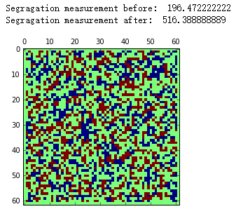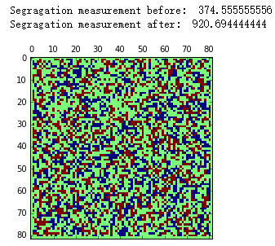

Figure10. 60*60 M*N

Figure12. 80*80 M*N

**Baseline Model Extensions**

Our team decided to implement 2 extensions to the baseline model; one from each of the team members. The 2 extensions we chose were the addition of the concept of radius and the second were the addition of probability of a cell being influenced by the neighbors. The first extension was chosen so that the model would be a better representations of a world with neighborhoods. In real world, a cell is more likely to be influenced by cells more than distance 1 away. A more realistic model of the influences should be represented by a Gaussian distribution as a function of radius; to simplify, we decided to use a fixed influence for all cells in the radius. By introducing this radius, we can change the radius, thus change the number of neighboring cells a cell is influenced by and see how the interactions would change. The second extension was chosen so that the model would factor in the human influence of the segregation phenomena. There should be a non-zero probability that a cell ‘s happiness would be affected by ONLY some of the cells. By introducing the probability of a cell being influenced by a neighboring cell, some of the neighboring cells will not contribute to the happiness score calculation, thus show a difference when comparing the segregation measurement with the baseline mode’s.

1. **Radius**

Fix all other parameters and vary the radius parameter over the same graph. The default radius value in baseline model is one.

As you can see from the following three graphs, as the radius increases, the segregation measurement both before and after decreases significantly. Although we analyze the segregation over the same grid population, the color values are computed differently owing to the radius value. With higher radius value, cells will be influenced by more neighbor cells. Since Tribe A population bias is set as 0.5, once normalized, the cells will have fewer color values close to zero, thus a lower happiness value. Thus, segregation measurement decreases as the radius value increases.

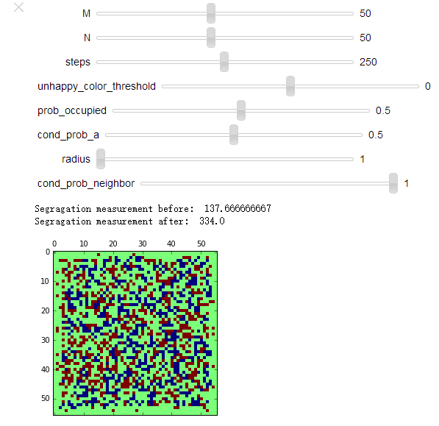

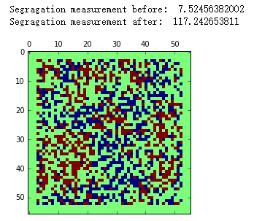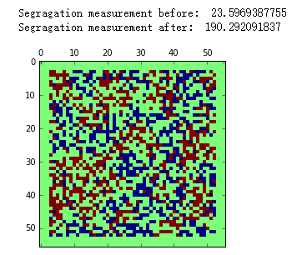Figure 13. Radius 1

Figure 15. Radius 5

Figure 14. Radius 3

1. **Probability of being influenced by neighbors**

The baseline model has a 100% probability of a cell being influenced by the surrounding cells. This means that all neighbors will influence the given cells. When computing the color values, baseline model takes all neighbor cells into account. This, however, does not represent the real life as we know it; therefore, we added in this probability parameter as an extension to the baseline model. By adding probability scheme, not all neighbor cells would be taken into account. When probability = 0, no segregation exists since all color values are zero. As the probability increases, it yields higher *segregation measurement after.* This is because most neighbor cells have positive value after segregation and the value for happiness will be higher at each cell when the probability of being influenced by the neighbors is higher, thus the segregation value will be higher.

Notice that the *segregation measurement before* is randomly generated based on the probability therefore it does not necessarily increase monotonically.

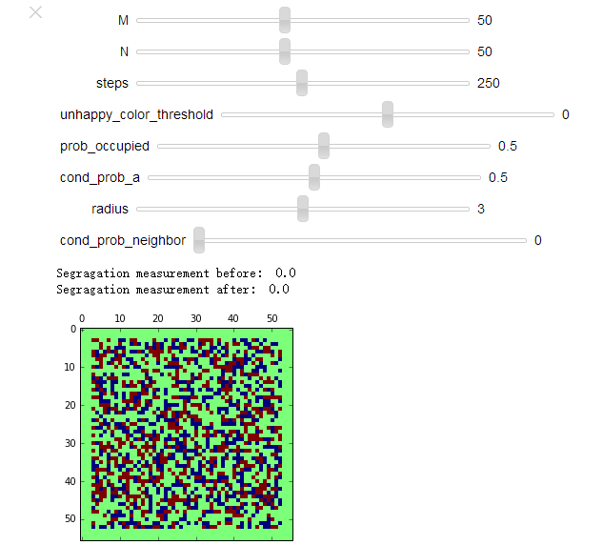

Figure 16. Probability neighbor 0

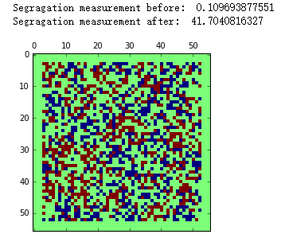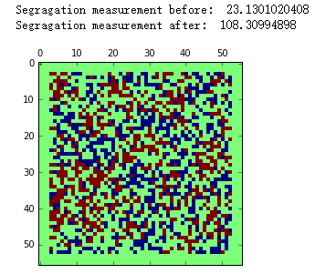

Figure 18. Probability neighbor 0.6

Figure 17. Probability neighbor 0.4

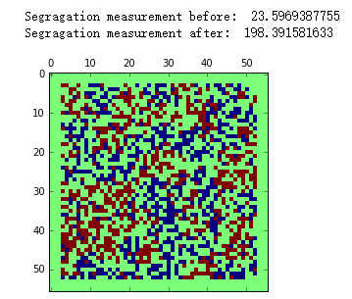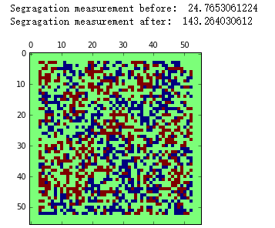

Figure 19. Probability neighbor 0.8

Figure 20. Probability neighbor 1