DeMarcus Campbell

903885028

COMP3700

Assignment 2

**Data Layer:**

SQLiteDataAccess, ProductModel

**Business Layer:**

MenuController, CheckoutController, ProductController

**Presentation Layer:**

MenuView, CheckoutView, ProductView, StoreManager

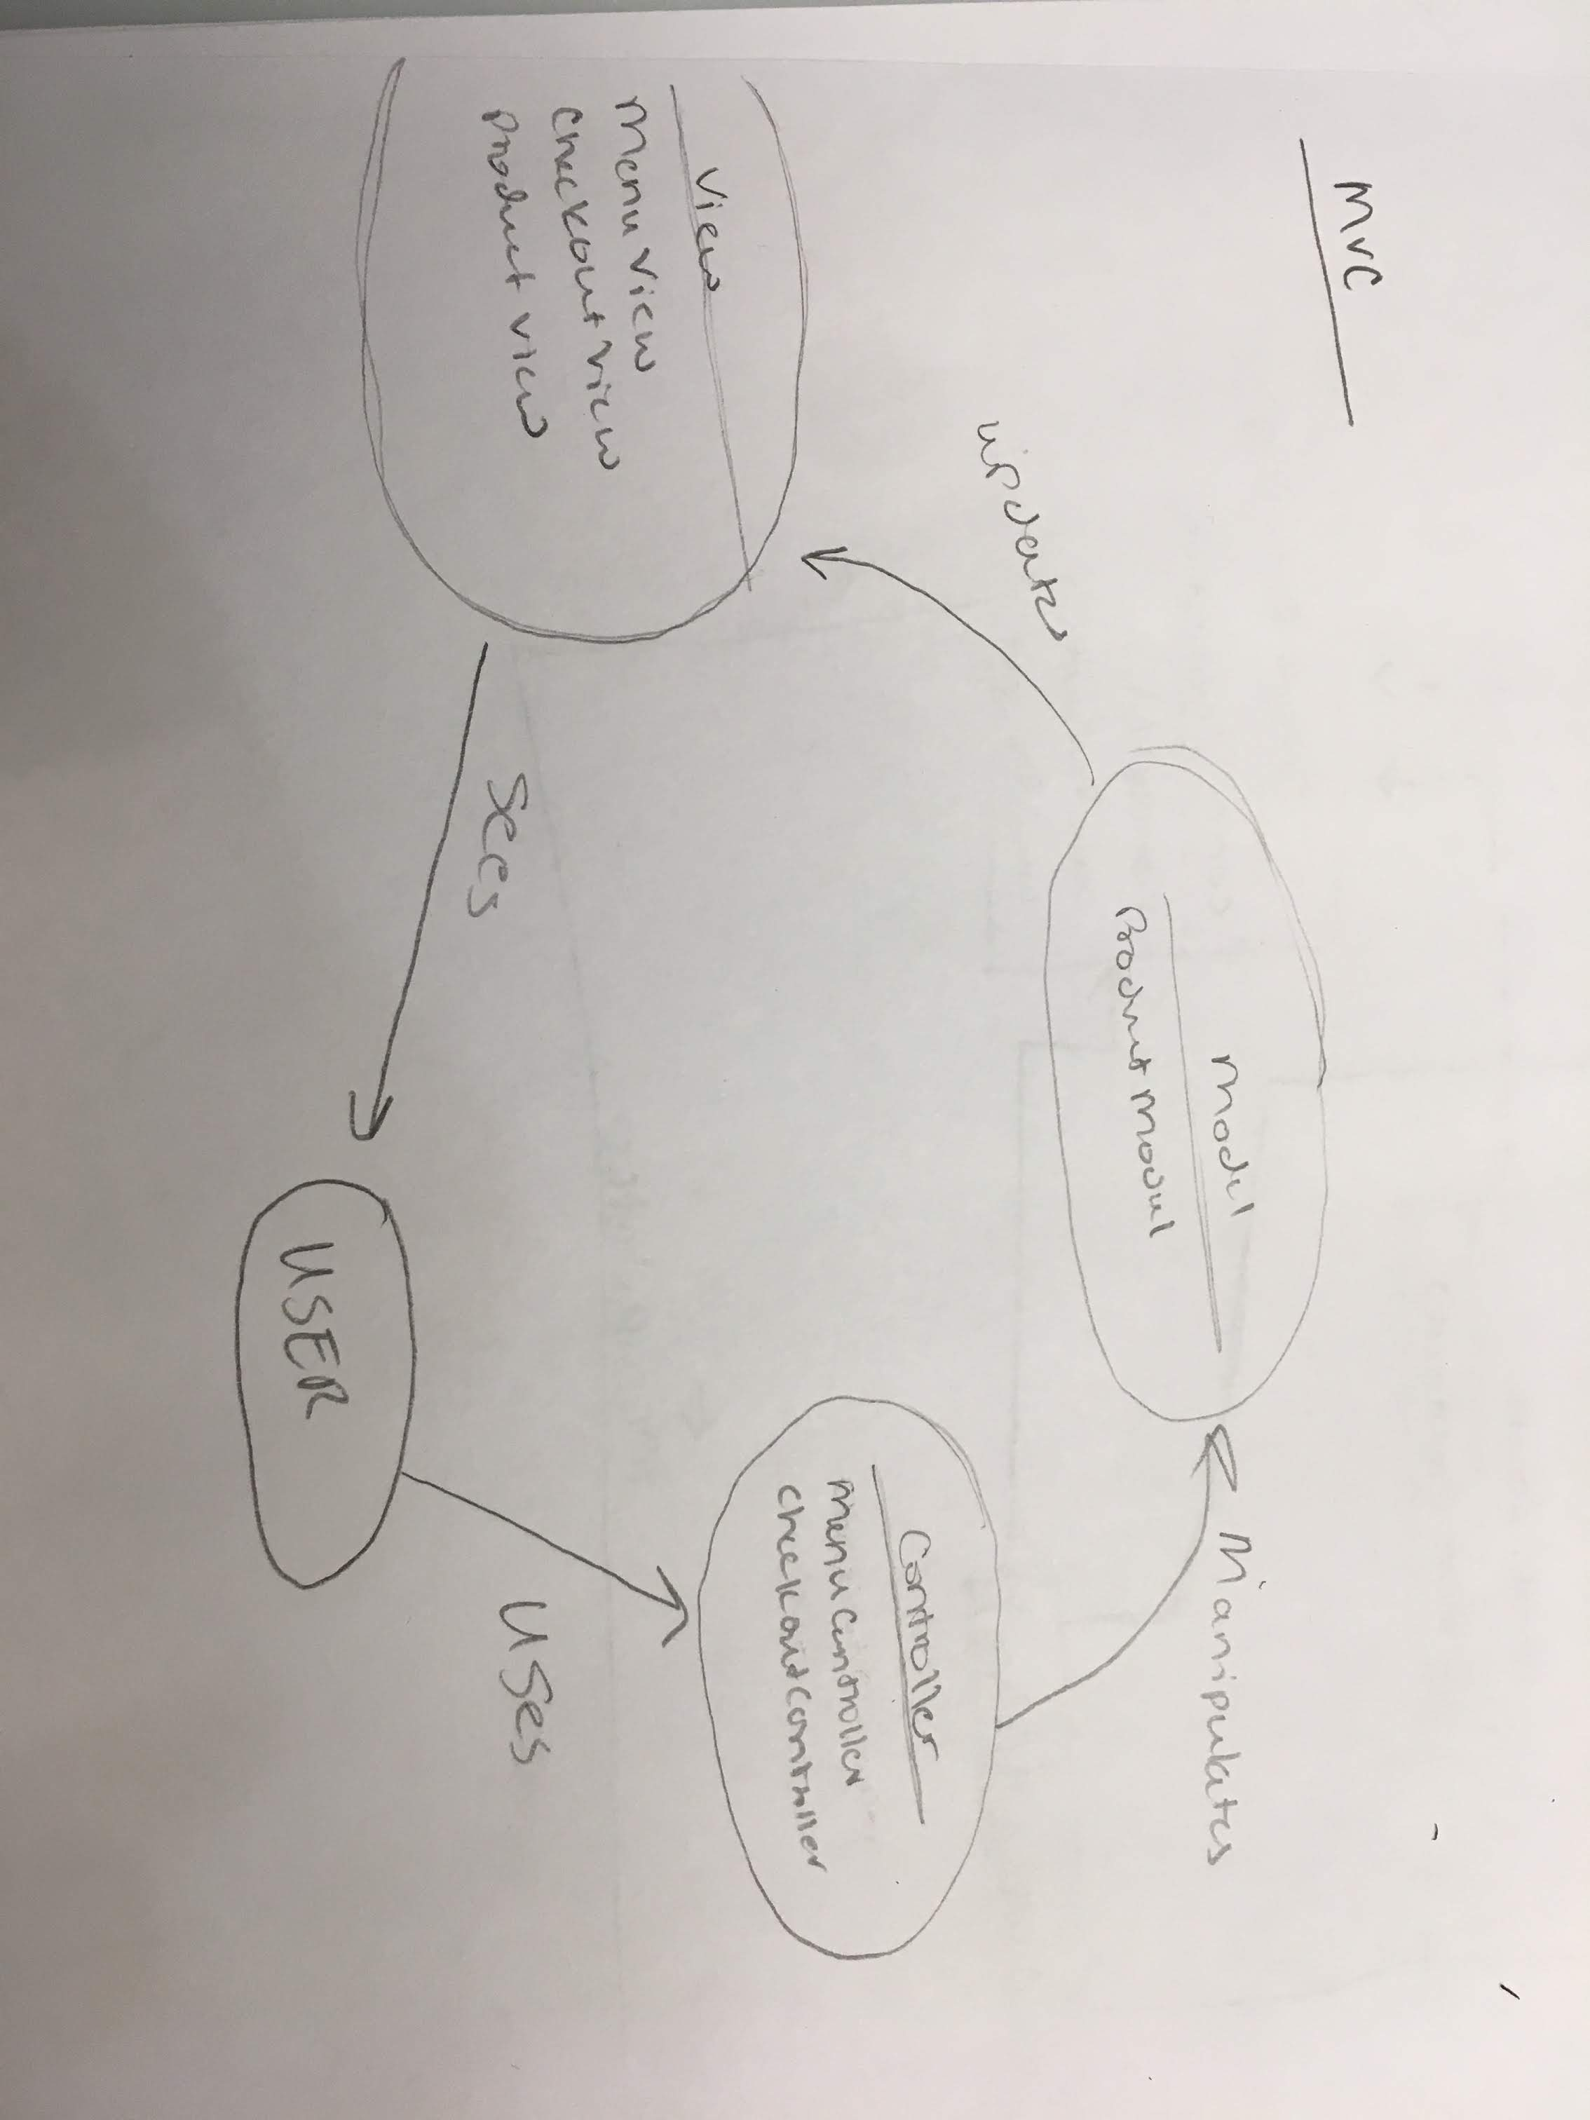

**Models:**

Product

NOTE: Menu and Checkout do not have any fields, so there is no need for a Model

**Views:**

Product

Menu

Checkout

**Controllers:**

Product

Menu

Checkout

