DeMarcus Campbell

Class #1 VM Setup

Screenshot of VM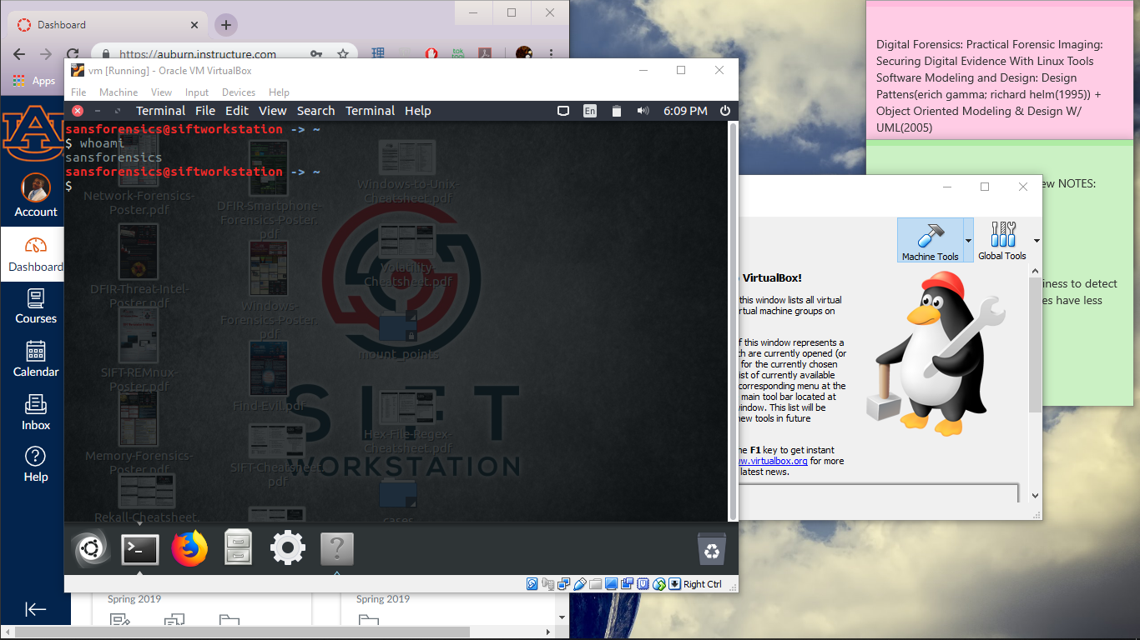

Installed using the provided .ova file on website.