Demarcus Campbell  
Quiz 3   
Digital Forensics

Create a USB drive with equally sized partitions, with the second partition being bootable

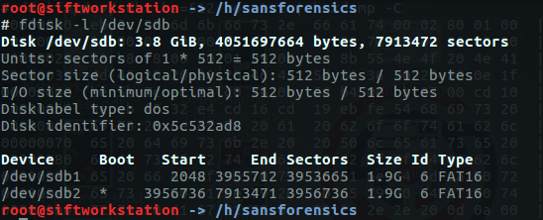

Sectors per partition  
 Partition 1 = 3953665  
 Partition 2 = 3956736

Hexdump of boot sector of the second partition

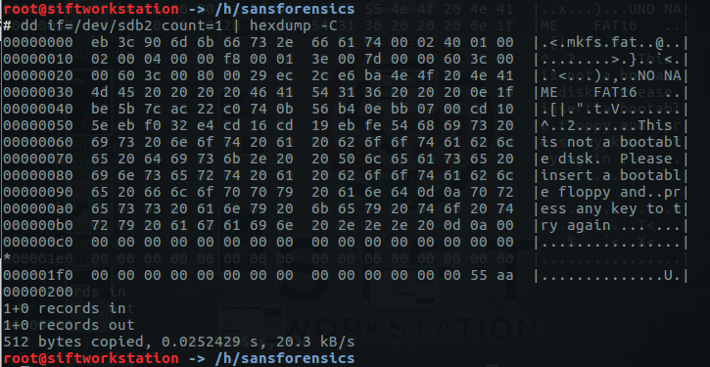

Reserved Area

Offset 0xE = 1= 1 sector

FAT Area 1/2

Offset 0x16 = 100 = 256 sectors

Root Directory

Offset 0x11 = 400 = 1024 entries

(1024 \* 32) / 512 = 64 sectors

Data Section

Total sectors – reserved sectors – 2 \* FAT sector – root sectors = data section sectors

3956736 – 1 – 256 – 64 = 3956415 sectors