DeMarcus Campbell

HW 4

FTK Imager

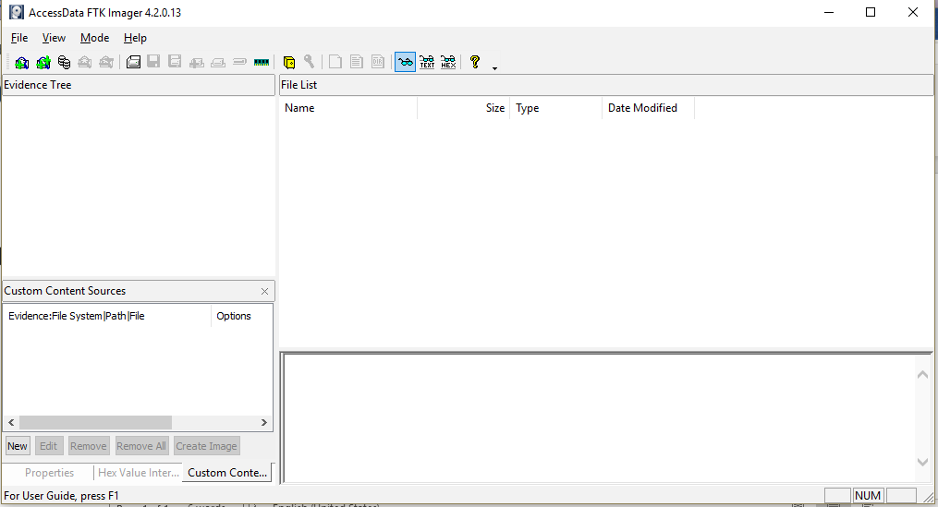

Disk Editor

