Statistical Inference - Simulation

Joe DeMaro

November 6, 2018

## Set Parameters

setwd("c:\\rprograms\\statinference")  
  
  
n <- 1000  
group <- 40  
lambda <- 0.2

## Calculate Theoretical Mean and SD

theoreticalmean <- 1 / lambda  
theoreticalsd <- 1 / lambda

## Run Simulation

# run the simulation  
data <- rexp(n * group, lambda)  
matrixdata <- matrix(data, n, group)  
  
matrixmean <- apply(matrixdata,1,mean)

## Tabulate Simulation Data

simmean <- mean(matrixmean)  
simsd <- sd(matrixmean)  
simvar <- var(matrixmean)  
  
#compare to CLT  
simse = simsd / sqrt(group)  
#calculate confidence  
low <- simmean - 1.96 * simse  
high <- simmean + 1.96 * simse  
  
simmean

## [1] 5.055371

simsd

## [1] 0.8187304

theoreticalmean

## [1] 5

theoreticalsd

## [1] 5

low

## [1] 4.801644

high

## [1] 5.309099

## Histogram of Means from Simulation

hist(matrixmean)

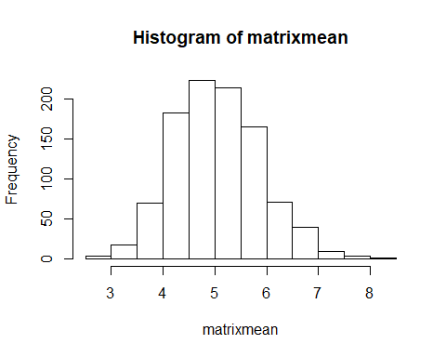 ## Analysis

### Simulation data provides us with available means to under the concepts of population and sample data in regards to Normal Distribution, the leader of all distributions. After generating and tabulating the sample data, comparison clearly show that rejecting the null hypothesis is the appropriate action in this experiment. The null hypothesis states