Tooth Growth Data Analysis

Joe DeMaro

March 6, 2019

## Load ToothGrowth data to a df

tgrowth <- ToothGrowth

# 

## Generate summary statistics for tgrowth data frame.

## len supp dose   
## Min. : 4.20 OJ:30 Min. :0.500   
## 1st Qu.:13.07 VC:30 1st Qu.:0.500   
## Median :19.25 Median :1.000   
## Mean :18.81 Mean :1.167   
## 3rd Qu.:25.27 3rd Qu.:2.000   
## Max. :33.90 Max. :2.000

## Boxplot data to demonstrate confidence intervals for supp and dose with regards to length of tooth

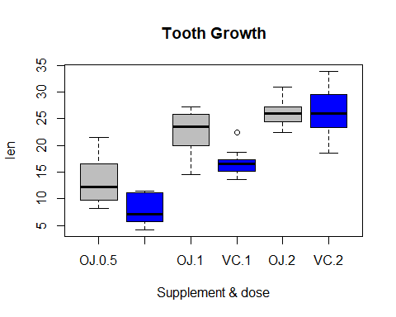

## Conclusion

### From the data, since the supplement dose combinations are not outside the standard deviations of the means, it cannot be concluded that the length of guinea pig teeth are significantly effected by the dose or supplement applied to the teeth.