Lab 5: Repetition Structures
This lab accompanies Chapter 5 of Starting Out with Programming Logic & Design.

Name: ___Kat Engelbrecht_______

Lab 5.1 –Repetition Structures Pseudocode: Condition Controlled Loops
Iteration
Critical Review

A repetition structure causes a statement or set of statements to execute repeatedly.

Repetition structures are used to perform the same task over and over.

Repetition structures are commonly called loops

A condition-controlled loop uses a true/false condition to control the number of times that it repeats.

The general structure of a While loop with a condition-controlled statement is:

//Declare loop control variable
While condition
Statement
Statement
Etc.
//Ask Question that changes the loop control variable
End While

The general structure of a Do While loop with a condition-controlled statement is:

//Declare loop control variable
Do
Statement
Statement
Etc.
//Ask Question that changes the loop control variable
While Condition
Iteration
Help Video: View video: Lab 5.1
NOTE: THE VALUES LISTED IN THE VIDEO ARE DIFFERENT THAN THIS WORKSHEET. USE THE VALUES IN THIS WORKSHEET.

This lab requires you to implement a condition controlled loop.

Step 1: Examine the following main Module from Lab 4.2. Loops are commonly used to call modules multiple times. The best design is to use a loop around the module calls in Main.

Module main()Iteration
//Declare local variables
Declare Real monthlySales
Declare Real storeBonus
Declare Real empSupplement
Declare Real percentIncrease

//Function calls
Call getStoreSales(monthlySales)
Call getIncrease(percentIncrease)
Call getStoreBonus (monthlySales, storeBonus )
Call getEmpSupplement (percentIncrease, empSupplement)
Call printBonus(getStoreBonus , empSupplement)
End Module

Step 2: In the space provided, create a loop control variable named keepGoing of the data type string. Initialize this variable to “y”. (Reference: Modularizing the Code in the Body of a Loop, page 172).

Step 3: In the space provided, write a while statement.

Module main ()
//Declare local variables
Declare Real monthlySales
Declare Real storeAmount
Declare Real empSupplement
Declare Real percentIncrease
Declare String keepGoing = ‘y’

//Function calls
While keepGoing == “y”
Call getStoreSales(monthlySales)
Call getIncrease(percentIncrease)
Call getStoreBonus (monthlySales, storeBonus)
Call getEmpSupplement(percentIncrease, empSupplement)
Call printBonus(storeBonus , empSupplement)
Display “Do you want to run the program again? (Enter y for yes).”
Input keepGoing
End While
End Module

LSCNH Watermark Iteration
Step 4: In the space provided, create a loop control variable named keepGoing of the data type string. Initialize this variable to “y”. (Reference: Writing a Do-While Loop, page 175).

Step 5: In the space provided, write a do while statement.

Module main ()
//Declare local variables
Declare Real monthlySales
Declare Real storeAmount
Declare Real empAmount
Declare Real percentIncrease
Declare String keepGoing = “y”

//Function calls Iteration
Do
Call getStoreSales(monthlySales)
Call getIncrease(percentIncrease)
Call getStoreBonus (monthlySales, storeBonus )
Call getEmpSupplement(percentIncrease, empSupplement)
Call printBonus(getStoreBonus , empSupplement)
Display “Do you want to run the program again? (Enter y for yes).” Iteration
Input keepGoing
While keepGoing == “y”
End Module
LSCNH Watermark

Lab 5.2 –Repetition Structures Pseudocode: Counter Controlled Loops

Critical Review

A count-controlled loop repeats a specific number of times.

The loop keeps a count of the number of times that it iterates, and when the count reaches a specified amount the loop stops.

A variable, known as a counter variable, is used to store the number of iterations that it has performed.

The three actions that take place are initialization, test, and increment.
- Initialization: Before the loop begins, the counter variable is initialized to a starting value.
- Test: The loop tests the counter variable by comparing it to a maximum value.
- Increment: To increment a variable means to increase its value. This is done by adding one to the loop control variable.

Any loop can be used with a count-controlled loop.

A running total is a sum of numbers that accumulates with each iteration of a loop. The variable used to keep the running total is called an accumulator.

Help Video: View video: Lab 5.2

This lab requires you to write a complete program using a condition controlled loop, a counter controlled loop, and an accumulator. The program is a follows:
Iteration
Your friend runs a day laborer temporary agency. Each day, employers call in to request a number of employees for that day. The agency collects a commission on each employee they send out. Write a program that will allow the agency to keep track of the total number of employees sent out for seven days. The program should allow the user to enter the number of employees sent out each day for the 7 day period. The program will then calculate the total number of employees sent out for the week and the amount paid out to the agency (The agency collects $2.50 a day for each employee sent out). The output of the program should include the total number of employees sent out for the week and the total payout.

Step 1: In the pseudocode below, declare the following variables under the documentation for Step 1.
- A variable called totalEmployees that is initialized to 0
  - This variable will store the accumulated employee total
- A variable called counter and that is initialized to 1
  - This variable will control the loop
- A variable called todayEmployees that is initialized to 0
  - This variable will store the number of employees sent out on a day
- A variable called totalPayout that is initialized to 0
  - This variable will store the calculated value of totalEmployees times 2.50
- A variable called keepGoing that is initialized to “y”
  - This variable will be used to run the program again
Iteration
Step 2: In the pseudocode below, make calls to the following functions under the documentation for Step 2.
- A function call to getEmployees that passes totalEmployees , todayEmployees, and counter.
- A function called calcPayout that passes totalPayout and totalEmployees .
- A function called printInfo that passes totalEmployees and totalPayout

Step 3: In the pseudocode below, write a condition controlled while loop around your function calls using the keepGoing variable under the documentation for Step 3.

Complete Steps 1-3 below:
Iteration
Module main ()

//Step 1: Declare variables below
Declare real totalEmployees
Declare real counter
Declare real todayEmployees
Declare real totalPayout
Declare real keepGoing
Set totalEmployees to 0
Set counter to 1
Set todayEmployees to 0
Set totalPayout to 0
Set keepGoing to y

//Step 2: Call functions
getEmployees( Real ref totalEmployees, Real ref todayEmployees, Real ref counter )
calcPayout( Real ref totalPayout, Real ref totalEmployees)
printInfo( Real ref totalEmployees, Real ref totalPayout )

//Step 3: Loop to run program again
While keepGoing equals y

Display “Do you want to run the program again? (Enter y for yes).”
Input “enter y for yes”
End While
End Module
Iteration
Step 4: In the pseudocode below, write the missing lines, including:
- The missing parameter list
- The missing condition (Hint: should run seven iterations)
- The missing input variable
- The missing accumulator
- The increment statement for the counter

//getEmployees module
Module getEmployees(a. Real totalEmployees, Real todayEmployees, Real counter)
While b._counter <= 7
Display “Enter number of employees sent out that day:”
Input c. todayEmployees
d. totalEmployees += todayEmployees
e. count++

End While
End Module
LSCNH Watermark
Iteration
Step 5: In the pseudocode below, write the missing lines, including:
- The missing parameter list
- The missing calculation

//getEmployees module
Module calcPayout(a. Real totalPayout, Real totalEmployees)
totalPayout = 0 //resets to 0 for multiple runs
b. totalPayout = totalEmployees * 2.50
End Module
Iteration
Step 6: In the pseudocode below, write the missing lines, including:
- The missing parameter list
- The missing display statement
- The missing display statement

//printInfo module
Module printInfo(a. Real totalEmployees, Real totalPayout)
- Display “Total number of employees sent out is “ + totalEmployees
- Display “Total payout is “ + totalPayout
End Module
Iteration
Lab 5.3 – Flowcharts
Iteration
Critical Review

In a while loop, the question is asked first. After the statements process, the control goes back above the condition.
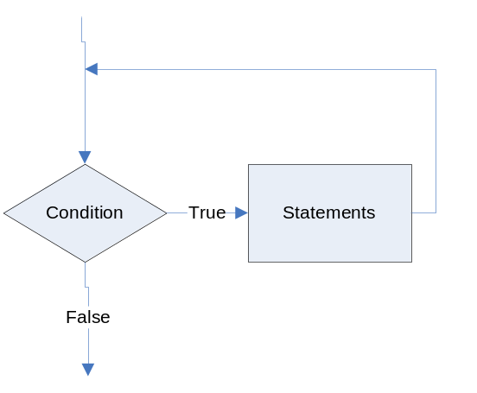

In a do-while loop, the question is asked last. The statements always process at least one time.
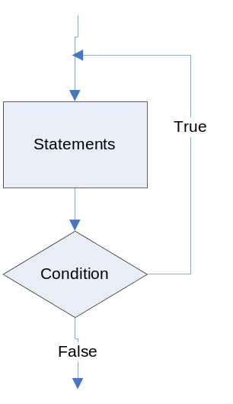

In Raptor, you can place the modules before or after the condition depending on whether you want to use a do-while or a while loop.

Help Video: View video: Lab 5.3a

Iteration
This lab requires you to convert your pseudocode in Lab 5.2 to a flowchart. Use an application such as Raptor or Visio.
LSCNH Watermark

Step 1: Start Raptor and save your document as Lab 5-3. The .rap file extension will be added automatically. Start by adding a Comment box that declares your variables. The only variable from Lab 5.2 that is different is the keepGoing variable. Name this endProgram instead.
Iteration
Step 2: Click the Loop symbol and drag and drop it between the Start and the End symbol.

Step 3: Click the Input symbol and drag and drop it between the Loop symbol and the Diamond symbol.

Step 4: Double click the Input symbol and ask the question “Do you want to end the program? Enter yes or no:”. Store the answer in the endProgram variable.
Iteration
Step 5: Double click the Diamond symbol, and type endProgram = "yes" as the condition. When the program executes, the user must type "yes" exactly, in order for the program to end. Now, main should look as the following:
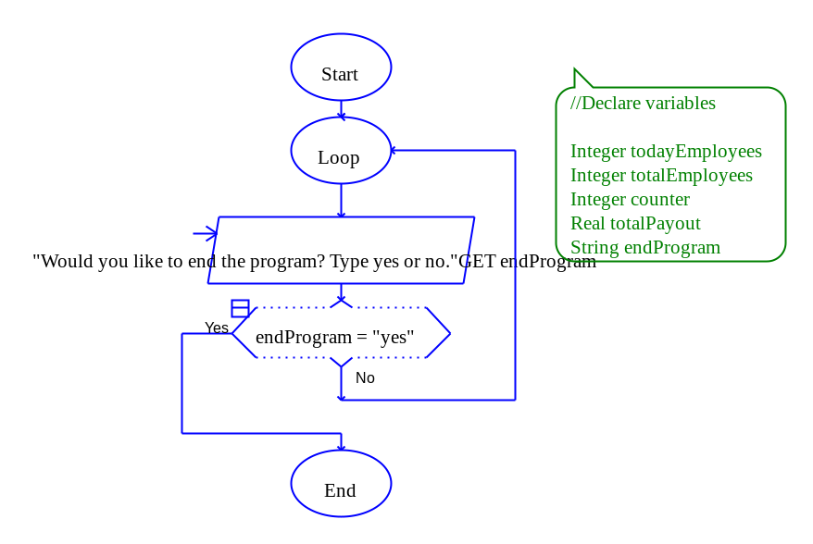
Iteration
Step 6: The next step in your flowchart should be to call your methods. Add your modules under the Loop oval. Be sure to click yes to add new tabs for each module. Now, main should look as the following: LSCNH Watermark

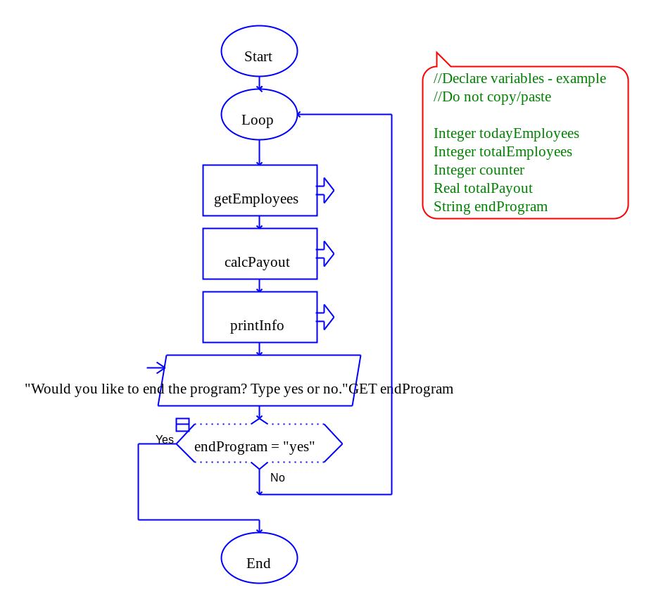
Step 7: Click on the getEmployees tab. Add a Loop symbol between the Start and End symbols. Double click the Diamond symbol and enter the condition as counter >7.

Step 8: Add an Input symbol and add the code “Enter the number of employees sent out today:” Store the value in the todayEmployees variable.
Iteration
Step 9: Add an Assignment symbol next and set totalEmployees to totalEmployees + todayEmployees.

Step 10: Add another Assignment symbol next and set counter to counter + 1.

Step 11: Save your program and try running it. You’ll notice an error occur when the loop starts processing in the getEmployees module. This is because totalEmployees does not have a starting value.
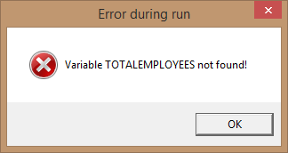
Iteration
Step 12: To fix the error, to set the counter to 1, and to reset the todayEmployees back to 0 for multiple repetitions, add three Assignment symbols above the Loop symbol. In one symbol, set counter to 1. In the other, set totalEmployees to 0. In the other, set todayEmployees to 0. It’s important to set all variables used, todayEmployees, totalEmployees and counter to a number. This tells your program to create the variable in memory and to store an initial value (0 or 1)
Your getEmployees module should look as follows:
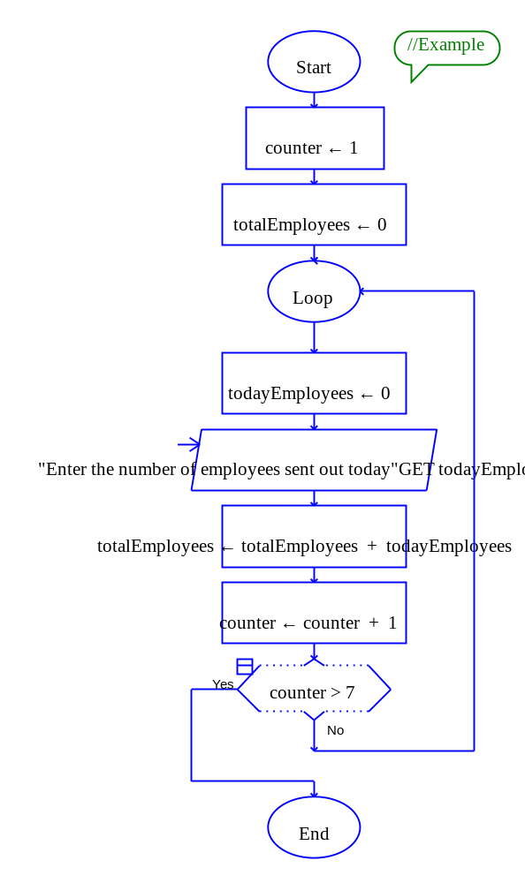LSCNH Watermark
LSCNH Watermark

Step 13: Click the calcPayout module and add an Assignment symbol. Set totalPayout to totalEmployees times 2.50.
Iteration
Step 14: Click the printInfo module and add two Output symbols that print the total employees returned and the total amount paid out.

Step 15: Test your program against the following values. If there is an error, go back through the steps to locate the problem.

Input Values | Expected Output
Seven days of employees:  346  238  638  890  1035  899  536 | The total number of employees collected were: 4582  The total amount paid out is $11455.00
Iteration
Step 16: The final step is to insert your finished flowchart in the space below.

PASTE FLOWCHART BELOW
Lab 5.4 – Python Code Iteration
Critical Review

In Python, you use the while statement to write a condition-controlled loop. The loop has two parts: (1) a condition that is tested for a true or false value, and (2) a statement or set of statements that is repeated as long as the condition is true.

A while loop can also be used for count-controlled loops.

Here is the general format of the while loop in Python:

while condition:
statement
statement
etc.

Since the while loop is a pre-test, it is important to initialize your loop control variable to a starting value so that the first iteration will be true.

As with all loops, be sure to change the loop control variable either by incrementing or asking a question.

Help Video: View video: Lab 5.4

The goal of this lab is to convert the Employee tracking program to Python code.

Step 1: Start the IDLE Environment for Python. Prior to entering code, save your file by clicking on File and then Save. Select your location and save this file as Lab5-4.py. Be sure to include the .py extension.
Iteration
Step 2: Document the first few lines of your program to include your name, the date, and a brief description of what the program does.

Step 3: Start your program with the following code for main:

#Lab 5-4 The Employee tracking Program

#the main function
def main():

#calls main
main()
LSCNH Watermark

Step 4: Python only supports While loops, so endProgram must be initialized to ‘no’. Under def main():, create a variable called endProgram and set it to ‘no’ such as:

endProgram = 'no'
Iteration
Step 5: The next step is to write a while statement with the condition of endProgram == ‘no’:. The statement should be aligned with the statement in Step 4. The code should be as follows:

while endProgram == 'no':

Step 6: The code inside of the while statement should be tabbed over and include your function calls. The function getEmployees() will return totalEmployees so the call should be set to that variable. The function calcPayout should pass totalEmployees as an argument and will return totalPayout from the function. The function printInfo should pass totalEmployees and totalPayout as arguments. The code should look as follows:
Iteration
totalEmployees = getEmployees()
totalPayout = calcPayout(totalEmployees)
printInfo(totalEmployees , totalPayout)

Step 7: The next step is to modify the loop control variable. This is done with a simple raw_input statement such as:

endProgram = raw_input('Do you want to end the program? (Enter yes or no): ')

Step 8: The next function to code is getEmployees. Write a definition for getEmployees that accepts no arguments. The code should look as follows:

#this function will get the number of employees returned
def get Employees():
Iteration
Step 9: The first step in your function should be to set your variables to values. In Python and most programming languages, in order for variables to be used, they need to have a starting value. This also allows for a reset of the variables when the program runs again. Set totalEmployees and todayEmployees to 0 and counter to 1. Your code should look as follows:

totalEmployees = 0
todayEmployees = 0
counter = 1

Step 10: Write a while loop with the condition of counter <= 7. This code should look as follows:

while counter <= 7:
Iteration
Step 11: Inside the while loop, write a statement that allows the user to enter the number of employees for today. This code should look as follows:

todayEmployees = input('Enter number of employees for today: ')

Step 12: Next, write the accumulator statement. This code should look as follows:

totalEmployees = totalEmployees + todayEmployees

Step 13: The last statement inside the loop should increment counter by one so the loop will end after seven iterations. This code should look as follows:

counter = counter + 1

Step 14: The final statement in the getEmployees function is to return totalEmployees back to main. This code should look as follows:

return totalEmployees
Iteration
Step 15: Create a function definition for calcPayment that accepts totalEmployees in the parameter list. This function should first reset totalPayout to 0. This is done so that on multiple iterations of the program, totalPayout is reset to 0. The second step in this function is to calculate totalPayout as totalEmployees times .10. The last step is to return totalPayout. Your code should look as follows:

#this function will calculate the payout
def calcPayout(totalEmployees):
totalPayout = 0
totalPayout = totalEmployees * 2.50
return totalPayout

Step 16: The final function in this program is printInfo. This function accepts two variables in the parameter list so that it can display the total number of employees returned and the total amount paid out. Your code should look as follows:
Iteration
#this function will display the information
def printInfo(totalEmployees , totalPayout):
print 'The total number of employees sent out is', totalEmployees
print 'The total paid out for employees is $', totalPayout

Step 17: Click Run and Run Module to see how your program processes. Test the following values to verify the expected output.

>>>
LSCNH Watermark

Enter number of employees for today: 346
Enter number of employees for today: 238
Enter number of employees for today: 638
Enter number of employees for today: 890
Enter number of employees for today: 1035
Enter number of employees for today: 899
Enter number of employees for today: 536
The total number of employees sent out is 4582
The total paid out is $ 11,455

Do you want to end the program? (Enter yes or no): no

Enter number of employees for today: 425
Enter number of employees for today: 342
Enter number of employees for today: 235
Enter number of employees for today: 539
Enter number of employees for today: 485
Enter number of employees for today: 321
Enter number of employees for today: 128
The total number of employees sent out is 2475
The total paid out is $ 6,187.50

Do you want to end the program? (Enter yes or no): yes
>>>
Iteration
Step 18: Execute your program so that it works and paste the final code below

PASTE CODE BELOW

Lab 5.5 – Programming Challenge 1 – Some Fun Sushi Bar

Write the Flowchart and Python code for the following programming problem and the pseudocode below.
Iteration
Help Video for Raptor: View video: Lab 5.5 Raptor

Help Video for Python: View video: Lab 5.5bPython

Write a program that will calculate the cost of purchasing sushi. This program will include decisions and loops. Details of the program are as follows:
- Your menu items only include the following food with accompanied price:
  - Some Fun Sushi Fish piece = 10.99
  - Some Fun Squid piece = 7.79
  - Some Fun Rice = 2.99
- Allow the user of the program to purchase any quantity of these items on one order.
- Allow the user of the program to purchase one or more types of these items on one order.
- After the order is placed, calculate total and add a 6% sales tax.
- Print to the screen a receipt showing the total purchase price.
Iteration
Your sample output might look as follows:

Enter 1 for Some Fun Sushi Fish piece
Enter 2 for Some Fun Squid piece
Enter 3 for Some Fun Rice
Enter now ->1
Enter the number of fish pieces you want: 3
Do you want to end your order? (Enter yes or no): no
Enter 1 for Some Fun Sushi Fish piece
Enter 2 for Some Fun Squid piece
Enter 3 for Some Fun Rice
Enter now ->3
Enter the number of Rice you want: 2
Do you want to end your order? (Enter yes or no): no
Enter 1 for Some Fun Sushi Fish piece
Enter 2 for Some Fun Squid piece
Enter 3 for Some Fun Rice
Enter now ->1
Enter the number of fish pieces you want: 1
Do you want to end your order? (Enter yes or no): no
Enter 1 for Some Fun Sushi Fish piece
Enter 2 for Some Fun Squid piece
Enter 3 for Some Fun Rice
Enter now ->2
Enter the number of Squid pieces you want: 2
Do you want to end your order? (Enter yes or no): yes
The total price is $ 65.52
Do you want to end program? (Enter no to process a new order): no
Enter 1 for Some Fun Sushi Fish piece
Enter 2 for Some Fun Squid piece
Enter 3 for Some Fun Rice
Enter now ->2
Enter the number of Squid pieces you want: 2
Do you want to end your order? (Enter yes or no): no
Enter 1 for Some Fun Sushi Fish piece
Enter 2 for Some Fun Squid piece
Enter 3 for Some Fun Rice
Enter now ->3
Enter the number of Rice you want: 2
Do you want to end your order? (Enter yes or no): yes
The total price is $ 21.56
Do you want to end program? (Enter no to process a new order): yes
Iteration
The Pseudocode

Module main()

Call declareVariables(endProgram, endOrder, totalFish, totalSquid, totalRice, total, tax, subtotal, option, fishCount, squidCount, riceCount)

//Loop to run program again
While endProgram == “no”

Call resetVariables(totalFish, totalSquid, totalRice, total, tax, subtotal, endProgram)
//Loop to take in order
While endOrder == “no”
Display “Enter 1 for Some Fun Sushi Fish piece”
Display “Enter 2 for Some Fun Squid piece”
Display “Enter 3 for Some Fun Rice”
Input option
If option == 1 Then
Call getFish(totalFish, fishCount)
Else If option == 2 Then
Call getSquid(totalSquid, squidCount)
Else If option == 3 Then
Call getRice(totalRice, riceCount)
End If

Display “Do you want to end your order? (Enter no to add more items:)”
Input endOrder
End While

Call calcTotal(fishTotal, squidTotal, riceTotal, total, subtotal, tax)
Call printReceipt(total)

Display “Do you want to end the program? (Enter no to process a new order)”
Input endProgram
End While

End Module

Module declareVariables(String Ref endProgram, String Ref endOrder, Real Ref totalFish, Real Ref totalSquid, Real Ref totalRice, Real Ref total, Real Ref tax, Real Ref subtotal, Real Ref option, Real Ref fishCount, Real Ref squidCount, Real Ref riceCount)
Declare String endProgram = “no”
Declare String endOrder = “no”
Declare Real totalFish = 0
Declare Real totalSquid = 0
Declare Real totalRice = 0
Declare Real total = 0
Declare Real tax = 0
Declare Real subtotal = 0
Declare Integer option = 0
Declare Integer fishCount = 0
Declare Integer squidCount = 0
Declare Integer riceCount = 0
End Module

Module resetVariables (Real Ref totalFish, Real Ref totalSquid, Real Ref totalRice, Real Ref total, Real Ref tax, Real Ref subtotal, Real Ref endProgram)

//reset variables
totalFish = 0
totalSquid = 0
totalRice = 0
total = 0
tax = 0
subtotal = 0
endProgram = ‘no’
End Module

Module getFish(Real Ref totalFish, Integer fishCount)
Display “Enter the number of Fish you want”
Input fishCount
Set totalFish = totalFish + fishCount * 10.99
End Module

Module getSquid(Real Ref totalSquid, Integer squidCount)
Display “Enter the number of Squid you want”
Input squidCount
Set totalSquid = totalSquid + squidCount * 7.79
End Module

Module getRice(Real Ref totalRice, Integer riceCount)
Display “Enter the number of Rice you want”
Input riceCount
Set totalRice = totalRice + riceCount * 2.99
End Module

Module calcTotal(Real totalFish, Real totalSquid, Real totalRice, Real Ref total, Real subtotal, Real tax)
Set subtotal = totalFish + totalSquid + totalRice
Set tax = subtotal * .06
Set total = subtotal + tax
End Module

Module printReceipt(Real total)
Display “Your total is $”, total
End Module

The Flowchart

PASTE FLOWCHART BELOW

The Python Code

PASTE CODE BELOW

LSCNH Watermark

