Object Views: Fine-Grained Sharing in Browsers

Policy 1:
limit the content of a frame to URLs specified by a whitelist:
This works by reassigning the original assign function by early loading this method into a page.
Wrapping the policy code in a function is an attempt to keep other scripts from accessing the wlist variable which contains the items that are white listed.
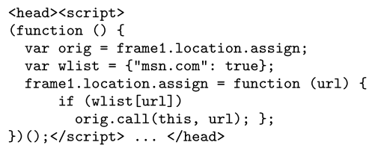

Keywords: White list, web, URL, wrapping

Policy 2:
Alice defines a policy whereby she can white list the desired behavior of bob.
For example : Bob may read the amount property and invoke the deposit method
Keywords: White list, wrapping, method execution, read and write
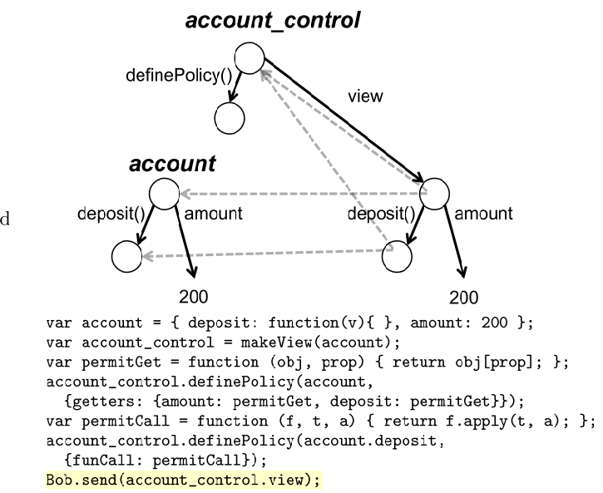

Policy 3:
A policy that restricts a subtree to read-only if the root’s class name includes example. Methods named shake may also be invoked.
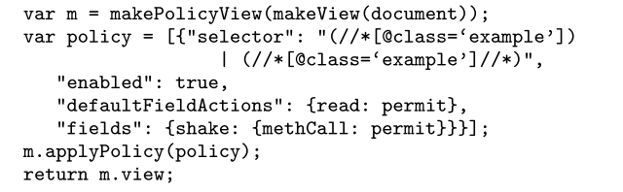

Policy 4:
var x = {y: function () {}, secret: "secret"};
var c = makeView(x); var permitSet = function (o, p, rhs) { o[p] = rhs; };
c.definePolicy(x, {getters: {y: permitGet}, setters: {y: permitSet}}]]);
mallory.send(c.view); // gives Mallory the view of x Object

Policy 1:
if permitted(M, params, SecurityState) then SecurityState := update(SecurityState, M, params); Morig(params);
else abort;
end if
where“permitted” determines whether theM call is allowed in the current state, and if so the security state is updated and the call proceeds.

Policy 2:

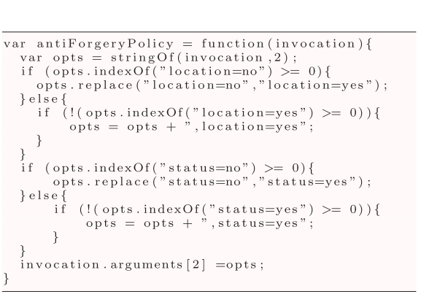
function that can monitor and tune popup parameters at runtime to ensure that new popup window contains a location bar and status bar in order to prevent potential forgery attacks.

Policy 3:
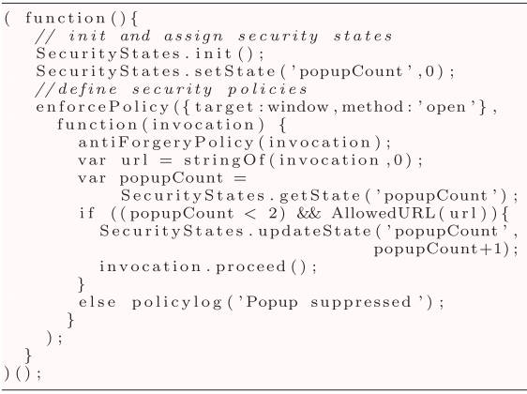
the application should never raise more than two popup windows

Policy 4:
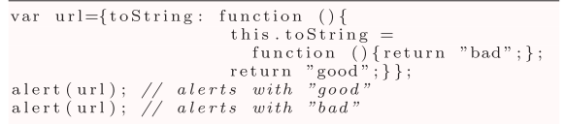
The policy checks whether the provided URL is in a whitelist.

Policy 5:
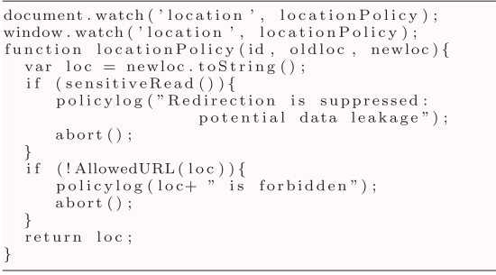
A policy using watch(…) to prevent leakage of sensitive data by changing the location
of the window

Policy 6:
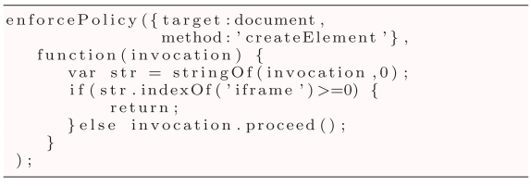
Policy to disallow iframe creation

Policy 7:

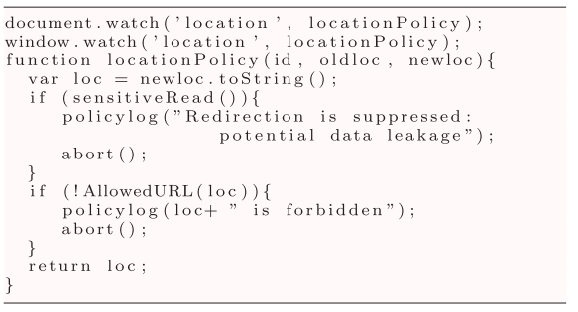
Policy controlling the redirection of a webpage

policy 8:
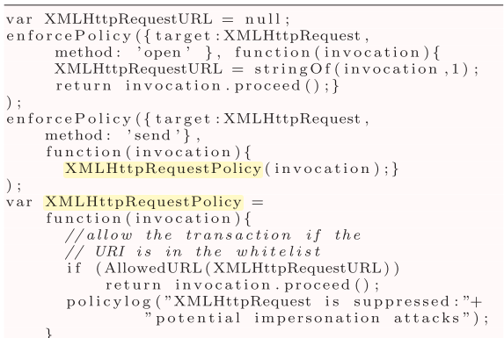
Policy preventing impersonation attacks using XMLHttpRequest object.

Policy 9:
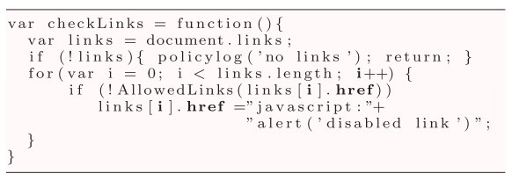
Policy preventing potential forgery attacks by injecting bad links.

Policy 10:
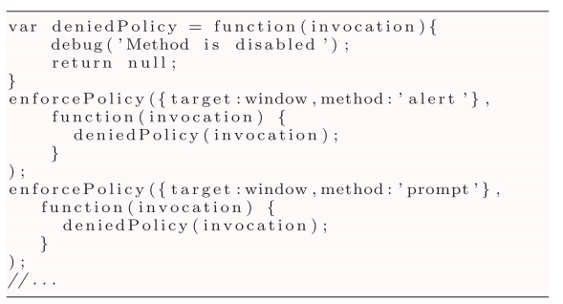
Policy to disable methods that might cause resource abuse.

