Deep Learning Techniques for Land Use Classification Using the EuroSAT Dataset

Dimitra Pappa
AEM:25013
Academic Year 2025-2026


Table of Contents
- Abstract
- Introduction
- Theoretical Background
3.1 Computer Vision Tasks
3.2 Convolutional Neural Networks (CNNs)
3.3 Transfer Learning
- Dataset Description
4.1 EuroSAT Dataset
4.2 Dataset Characteristics
4.3 Classification Problem Definition
- Methodology
5.1 Data Preprocessing
5.2 Custom CNN Architecture
5.3 ResNet18 with Transfer Learning
5.4 EfficientNet-B0 with Transfer Learning
5.5 Pseudo Object Detection
5.6 Pseudo Semantic Segmentation
- Experimental Setup
- Evaluation Metrics
- Experimental Results
8.1 Custom CNN Results
8.2 ResNet18 Results
8.3 EfficientNet-B0 Results
8.4Yolo Pseudo Object Detection Results

- Comparative Analysis
- Discussion
- Limitations
- Future Work
- Conclusion
- References

- Abstract
Remote sensing image analysis has become increasingly important for environmental monitoring, agricultural management, urban planning, and land use analysis. The availability of satellite imagery and advances in deep learning have enabled the development of automated methods for accurate land cover classification.
This project investigates the application of deep learning techniques for land use and land cover classification using the EuroSAT dataset, which consists of Sentinel-2 satellite images belonging to ten distinct categories. Three different approaches were implemented and evaluated: a custom Convolutional Neural Network (CNN) trained from scratch, ResNet18 with transfer learning, and EfficientNet-B0 with transfer learning.
The experimental methodology included data preprocessing, data augmentation, model training, and performance evaluation using accuracy and loss curves, confusion matrices, classification reports, and quantitative performance metrics. The objective was to compare the effectiveness of training from scratch with transfer learning approaches and to analyze the strengths and limitations of each model.
In addition to image classification, exploratory experiments involving pseudo object detection and pseudo semantic segmentation were conducted to establish connections with advanced computer vision tasks. Since the EuroSAT dataset does not provide bounding box annotations or pixel-level segmentation masks, these experiments were evaluated qualitatively rather than quantitatively.
The results demonstrate that transfer learning significantly improves classification performance compared to training a model from scratch. Among the evaluated models, EfficientNet-B0 achieved the highest overall accuracy, followed by ResNet18 and the custom CNN. The findings highlight the effectiveness of pre-trained deep learning models for remote sensing image analysis and emphasize the potential for extending classification pipelines toward more advanced computer vision applications.

2.Introduction
Recent advances in Artificial Intelligence (AI) and Deep Learning have significantly transformed the field of Computer Vision, enabling automated systems to achieve high performance in a wide range of image analysis tasks. Among these tasks, image classification, object detection, and semantic segmentation have become fundamental components of modern visual recognition systems.
Remote sensing image analysis has emerged as an important application area of computer vision due to the increasing availability of high-resolution satellite imagery. Satellite image classification plays a crucial role in numerous real-world applications, including environmental monitoring, land use and land cover mapping, agricultural management, urban planning, disaster response, and climate change assessment.
Traditional approaches to remote sensing image analysis often rely on handcrafted feature extraction techniques combined with conventional machine learning algorithms. However, these methods require extensive domain expertise and frequently struggle to generalize across diverse image characteristics. In contrast, deep learning models, particularly Convolutional Neural Networks (CNNs), automatically learn hierarchical feature representations directly from raw image data, leading to substantial improvements in classification performance.
The EuroSAT dataset, based on Sentinel-2 satellite imagery, has become a widely used benchmark for evaluating deep learning methods in land use and land cover classification. The dataset consists of satellite image patches belonging to ten distinct categories, including agricultural areas, forests, industrial zones, water bodies, and residential regions.
The primary objective of this project is to investigate and compare the effectiveness of different deep learning approaches for land use classification using the EuroSAT dataset. Three models were implemented and evaluated: a custom CNN trained from scratch, ResNet18 with transfer learning, and EfficientNet-B0 with transfer learning. The study aims to assess the impact of transfer learning on classification performance and to identify the strengths and limitations of each approach.
In addition to image classification, exploratory experiments involving pseudo object detection and pseudo semantic segmentation were conducted to establish connections with more advanced computer vision tasks. Since the EuroSAT dataset does not provide bounding box annotations or pixel-level segmentation masks, these experiments were designed as qualitative extensions rather than fully supervised tasks.
The remainder of this report is organized as follows. Section 2 presents the theoretical background of convolutional neural networks and transfer learning. Section 3 describes the EuroSAT dataset and the problem definition. Section 4 outlines the methodology and the implemented models. Section 5 details the experimental setup and evaluation metrics. Section 6 presents the experimental results, while Section 7 provides a comparative analysis of the evaluated models. Finally, Sections 8 and 9 discuss the limitations of the study and summarize the main conclusions.

3. Theoretical Background
3.1 Computer Vision Tasks
Computer Vision is a subfield of Artificial Intelligence that aims to enable computers to interpret and understand visual information extracted from digital images and videos. Unlike traditional image processing techniques, modern computer vision systems automatically learn meaningful patterns and representations from data using deep learning methods.
Computer vision encompasses several fundamental tasks, including image classification, object localization, object detection, and semantic segmentation. These tasks differ in the level of understanding they provide about an image.
- Image Classification: Assigns a single class label to an entire image. The objective is to determine what object or scene is present in the image. This project focuses primarily on image classification using satellite imagery.
- Object Localization: Identifies the location of a specific object within an image by predicting a bounding box around it.
- Object Detection: Combines classification and localization to identify multiple objects and their positions within an image. Popular object detection frameworks include the YOLO family of models.
- Semantic Segmentation: Assigns a class label to every pixel in an image, enabling detailed scene understanding. This approach is widely used in medical imaging, autonomous driving, and remote sensing applications.
In the context of remote sensing, image classification enables the automatic categorization of land use and land cover types, supporting applications such as environmental monitoring, urban planning, and agricultural management.

3.2 Convolutional Neural Networks (CNNs)
Convolutional Neural Networks (CNNs) are a specialized class of deep neural networks designed for processing grid-like data, such as digital images. CNNs have become the dominant approach for image analysis because they automatically learn hierarchical feature representations directly from raw pixel values.
Unlike traditional machine learning methods that require handcrafted features, CNNs learn relevant visual patterns during training. Early network layers typically detect low-level features such as edges, corners, and textures, while deeper layers combine these features to recognize more complex structures and semantic concepts.
A typical CNN architecture consists of the following components:
- Convolutional Layers: Apply learnable filters (kernels) to extract local features from the input image and generate feature maps.
- Activation Functions: Non-linear functions, such as the Rectified Linear Unit (ReLU), enable the network to learn complex relationships by introducing non-linearity.
- Pooling Layers: Reduce the spatial dimensions of feature maps while preserving the most important information, improving computational efficiency and robustness to small image transformations.
- Fully Connected Layers: Combine the extracted features to perform the final classification task.
CNNs leverage two key principles: local connectivity and weight sharing. These mechanisms significantly reduce the number of trainable parameters compared with traditional fully connected networks and allow the model to recognize visual patterns regardless of their position within the image.
For satellite image classification, CNNs are particularly effective because they can capture spatial relationships and complex land cover patterns present in remote sensing imagery.

3.3 Transfer Learning
Transfer learning is a deep learning technique in which knowledge acquired from solving one task is reused to improve performance on a related task. Instead of training a neural network from scratch, a model pre-trained on a large-scale dataset, such as ImageNet, is adapted to a new problem domain.
The underlying assumption of transfer learning is that the early layers of deep neural networks learn generic visual features, such as edges, textures, and shapes, which can be transferred across different image classification tasks.
Two common transfer learning strategies are:
- Feature Extraction: The convolutional base of the pre-trained model is frozen, and only the final classification layers are retrained on the target dataset.
- Fine-Tuning: Some or all of the pre-trained layers are unfrozen and further optimized using the target dataset, allowing the model to adapt its learned representations to the new domain.
Transfer learning offers several advantages:
- Reduced training time
- Lower computational requirements
- Improved performance, especially when limited training data are available
- Faster convergence during optimization
In this project, transfer learning was employed using pre-trained ResNet18 and EfficientNet-B0 models. Both networks were initialized with weights learned from ImageNet and subsequently fine-tuned on the EuroSAT dataset to classify ten land use and land cover categories. Their performance was compared against a custom CNN trained from scratch to evaluate the effectiveness of transfer learning for satellite image classification. Based on the theoretical concepts presented in this chapter, the following section introduces the EuroSAT dataset and formally defines the land use classification problem addressed in this study.
4. Dataset Description
4.1 EuroSAT Dataset
The EuroSAT dataset is a publicly available benchmark dataset designed for land use and land cover classification using satellite imagery. It was introduced by Patrick Helber and colleagues to support the development and evaluation of deep learning methods for remote sensing image analysis.
The dataset is based on images acquired by the European Space Agency through the Copernicus Programme using the Sentinel-2 satellite constellation.
EuroSAT contains satellite images covering various regions across Europe and includes ten land use and land cover categories. The dataset has become one of the most widely used benchmarks for evaluating image classification models in remote sensing applications.

4.2 Dataset Characteristics
The RGB version of the EuroSAT dataset consists of 27,000 labeled images, equally distributed among 10 classes, with approximately 2,000 to 3,000 images per category.
Each image:
- Has a spatial resolution of 64 × 64 pixels
- Contains three color channels (Red, Green, Blue)
- Represents a specific land use or land cover type
- Is associated with a single class label
The ten classes included in the dataset are:
- Annual Crop
- Forest
- Herbaceous Vegetation
- Highway
- Industrial
- Pasture
- Permanent Crop
- Residential
- River
- Sea/Lake
The dataset provides a balanced distribution across categories, reducing the risk of class imbalance during training and enabling fair performance evaluation across all classes.
Figure X presents representative samples from each class.
For this study, the dataset was divided into three subsets:
- Training set: used for model learning
- Validation set: used for hyperparameter tuning and model selection
- Test set: used for final performance evaluation
A stratified split was applied to preserve the original class distribution across all subsets.
Prior to training, all images were resized according to the input requirements of the selected models and normalized using the mean and standard deviation values of the ImageNet dataset to ensure compatibility with pre-trained architectures.
Additionally, data augmentation techniques, including random horizontal flipping, random rotation, and random cropping, were applied to improve model generalization and reduce overfitting.

4.3 Classification Problem Definition
This study addresses a multi-class image classification problem in the domain of remote sensing.
Given an input satellite image:
represents one of the ten land use categories defined in the EuroSAT dataset.
The classification models receive an RGB satellite image as input and output a probability distribution over the ten classes. The predicted class corresponds to the category with the highest probability.
The objective of model training is to minimize the classification error and maximize predictive performance on unseen data.
The performance of the selected models is evaluated using standard classification metrics, including:
- Accuracy
- Precision
- Recall
- F1-score
- Confusion Matrix
The main goal of this research is to investigate whether transfer learning approaches based on pre-trained convolutional neural networks can achieve superior performance compared to a custom CNN trained from scratch for satellite image classification.

5. Methodology
5.1 Data Preprocessing
Data preprocessing is a critical stage in deep learning workflows, as the quality and consistency of the input data directly influence model performance and generalization capabilities. The EuroSAT dataset consists of RGB satellite images with a resolution of 64 × 64 pixels belonging to ten land use and land cover categories. Before training the models, several preprocessing steps were applied to prepare the data for efficient learning.
Dataset Organization and Splitting
The dataset was organized according to its class labels and divided into three non-overlapping subsets:
- Training set: used for model learning.
- Validation set: used for hyperparameter tuning and monitoring model performance during training.
- Test set: used exclusively for the final evaluation of the models.
A stratified splitting strategy was employed to preserve the original class distribution across all subsets and ensure a fair comparison between models.
Image Resizing
Although the original EuroSAT images have a resolution of 64 × 64 pixels, all images were resized according to the input requirements of the selected neural network architectures.
For the transfer learning models, image dimensions were adjusted to match the expected input size of the pre-trained networks.
Image Normalization
Pixel values were scaled and normalized to improve numerical stability during training and accelerate convergence.
For the transfer learning models, the images were normalized using the mean and standard deviation values of the ImageNet dataset, ensuring compatibility with the pre-trained weights.
The normalization process is defined as:
where:
- (x) represents the original pixel value,
- (\mu) is the mean value of the dataset,
- (\sigma) is the standard deviation.
Data Augmentation
To improve model generalization and reduce overfitting, several data augmentation techniques were applied to the training images.
The augmentation pipeline included:
- Random horizontal flipping
- Random rotations
- Random resized cropping
These transformations increase the diversity of the training data by generating modified versions of the original images while preserving their semantic content.
Data augmentation was applied exclusively to the training set, whereas the validation and test sets remained unchanged to ensure an unbiased evaluation.
Conversion to Tensors
After preprocessing and augmentation, all images were converted into PyTorch tensors to enable efficient batch processing and GPU acceleration during training.
Data Loading
The preprocessed images were loaded using the PyTorch DataLoader class, which provides efficient mini-batch generation, data shuffling, and parallel data loading.
The use of mini-batches improves training efficiency and stabilizes gradient estimation during optimization.
Preprocessing Pipeline Summary
The complete preprocessing workflow can be summarized as follows:
- Dataset download and organization.
- Stratified train-validation-test split.
- Image resizing.
- Image normalization.
- Data augmentation for the training set.
- Conversion to tensors.
- Data loading using mini-batches.
This preprocessing pipeline ensured consistent input data across all experiments and enabled a fair comparison between the custom CNN, ResNet18, and EfficientNet-B0 models.

5.2 Custom CNN Architecture
A custom Convolutional Neural Network (CNN) was designed and trained from scratch to establish a baseline for satellite image classification performance. Unlike transfer learning approaches, the model learned feature representations directly from the EuroSAT dataset without leveraging pre-trained weights.
The architecture consisted of multiple convolutional blocks followed by fully connected layers. Each convolutional block included a convolutional layer, a Rectified Linear Unit (ReLU) activation function, and a max-pooling operation.
The main components of the custom CNN architecture were:
- Convolutional layers for feature extraction
- ReLU activation functions for introducing non-linearity
- Max-pooling layers for spatial downsampling
- Dropout layers for regularization
- Fully connected layers for classification
The convolutional layers progressively learned hierarchical image features, ranging from simple edges and textures to more complex land cover patterns.
Dropout regularization was applied to reduce overfitting by randomly deactivating neurons during training.
The final fully connected layer consisted of ten output neurons corresponding to the ten EuroSAT classes, followed by a softmax function to produce class probabilities.
The model was trained using the Cross-Entropy Loss function and optimized using the Adam optimizer.
Although the custom CNN required a larger number of training epochs compared to transfer learning models, it provided a useful baseline for evaluating the effectiveness of pre-trained architectures.

5.3 ResNet18 with Transfer Learning
ResNet18 is a deep convolutional neural network introduced by He et al. (2016) that addresses the degradation problem in deep networks through the use of residual connections.
Residual learning enables the network to learn residual mappings instead of directly learning the desired underlying functions, facilitating gradient propagation during training.
The residual mapping can be expressed as:
where:
- (x) represents the input to the residual block,
- (F(x)) denotes the learned residual function,
- (H(x)) is the output of the block.
In this project, transfer learning was applied using a ResNet18 model pre-trained on the ImageNet dataset.
The transfer learning workflow consisted of the following steps:
- Loading the pre-trained ResNet18 weights.
- Replacing the original classification layer with a new fully connected layer containing ten output neurons.
- Fine-tuning the model using the EuroSAT dataset.
The use of pre-trained weights enabled the model to leverage generic visual features learned from millions of natural images, significantly reducing training time and improving classification performance.
ResNet18 was selected due to its relatively low computational complexity and strong performance across various image classification tasks.

5.4 EfficientNet-B0 with Transfer Learning
EfficientNet-B0 is a family of convolutional neural networks proposed by Tan and Le (2019) that introduces a compound scaling strategy for balancing network depth, width, and input resolution.
Traditional scaling approaches increase only one network dimension, whereas EfficientNet scales all dimensions simultaneously.
The compound scaling approach is defined as:
where:
- (\alpha), (\beta), and (\gamma) are scaling coefficients,
- (\phi) controls the amount of available computational resources.
In this project, EfficientNet-B0 pre-trained on ImageNet was adapted to the EuroSAT classification task.
The implementation process included:
- Loading the pre-trained EfficientNet-B0 model.
- Replacing the final classification layer with a ten-class output layer.
- Fine-tuning the model using the EuroSAT dataset.
EfficientNet-B0 was selected because it offers an excellent trade-off between classification accuracy and computational efficiency.
The model achieved the highest performance among all evaluated approaches, demonstrating the effectiveness of transfer learning for remote sensing image classification.

5.5 Pseudo Object Detection
Object detection aims to identify and localize objects within an image by predicting both class labels and bounding box coordinates.
Unlike standard object detection datasets, the EuroSAT dataset provides only image-level annotations and does not contain bounding box information.
Therefore, fully supervised object detection could not be directly applied.
To explore object detection concepts covered in the course, a pseudo object detection approach was implemented.
The methodology consisted of generating approximate bounding boxes based on image processing techniques and visual heuristics.
The pseudo object detection pipeline included the following steps:
- Selecting a target class image from the EuroSAT dataset.
- Applying image preprocessing operations.
- Identifying regions of interest using thresholding and contour extraction techniques.
- Generating pseudo bounding boxes around detected regions.
- Visualizing the predicted regions on the original image.
Additionally, a pseudo dataset compatible with the YOLOv8 format was generated to investigate modern object detection workflows.
However, because the generated annotations were not manually verified, the object detection results were evaluated qualitatively rather than quantitatively.
The objective of this experiment was to demonstrate the principles of object localization and detection rather than to develop a production-ready object detector.

5.6 Pseudo Semantic Segmentation
Semantic segmentation is a computer vision task that assigns a class label to every pixel in an image, enabling detailed scene understanding.
Unlike image classification, which predicts a single label for the entire image, semantic segmentation provides fine-grained information about the spatial distribution of objects and regions.
The EuroSAT dataset does not provide pixel-level segmentation masks, making fully supervised semantic segmentation infeasible.
To investigate segmentation techniques, a pseudo semantic segmentation approach was implemented.
The methodology involved:
- Selecting representative images from the EuroSAT dataset.
- Applying image enhancement and preprocessing operations.
- Performing image thresholding and clustering techniques.
- Generating pseudo segmentation masks.
- Overlaying the masks on the original images for visualization.
The generated masks approximate different land cover regions and enable qualitative analysis of scene composition.
Since no ground truth segmentation annotations were available, quantitative evaluation metrics such as Intersection over Union (IoU) and Dice coefficient were not computed.
The purpose of this experiment was to demonstrate the transition from image-level classification toward pixel-level understanding in remote sensing applications and to highlight the additional annotation requirements associated with semantic segmentation tasks.

6. Experimental Setup
This chapter describes the hardware and software environment, model training configuration, and evaluation protocol adopted for the experiments conducted on the EuroSAT dataset.
Development Environment
All experiments were implemented using the Python programming language and the PyTorch deep learning framework. The source code was developed and executed using Visual Studio Code.
The following libraries were utilized:
- PyTorch
- Torchvision
- NumPy
- Pandas
- Matplotlib
- Seaborn
- Scikit-learn
- OpenCV
- Ultralytics YOLOv8
The complete list of dependencies and package versions is provided in the requirements.txt file included in the project repository.
Hardware Configuration
The experiments were conducted on a personal computer equipped with CPU and GPU acceleration when available.
The implementation automatically detects the available computing device and selects either a Graphics Processing Unit (GPU) or the Central Processing Unit (CPU).
The computational device is defined as:
device = torch.device("cuda" if torch.cuda.is_available() else "cpu")
Using GPU acceleration significantly reduces training time, particularly for transfer learning models.

Component | Specification
Processor | Intel Core i7 / AMD Ryzen
GPU | NVIDIA GeForce RTX XXX
RAM | 16 GB
Operating System | Windows 11
Python Version | 3.11

Dataset Splitting Strategy
The EuroSAT dataset was divided into three subsets:
- Training set
- Validation set
- Test set
A stratified splitting strategy was employed to preserve the class distribution across all subsets.

Dataset Subset | Percentage
Training Set | 70%
Validation Set | 15%
Test Set | 15%

6.4 Training Configuration
All models were trained using supervised learning with the Cross-Entropy Loss function.
The optimization process was performed using the Adam optimizer.
The learning objective was to minimize the classification loss while maximizing predictive accuracy on the validation set.
The loss function is defined as:
where:
- (C) is the number of classes,
- (y_i) is the ground truth label,
- (\hat{y}_i) is the predicted probability.
The training hyperparameters are summarized in Table 6.1.
Training Hyperparameters
Parameter | Custom CNN | ResNet18 | EfficientNet-B0
Optimizer | Adam | Adam | Adam
Loss Function | Cross-Entropy | Cross-Entropy | Cross-Entropy
Learning Rate | 0.001 | 0.001 | 0.001
Batch Size | Insert value | Insert value | Insert value
Number of Epochs | 30 | 10 | 10
Transfer Learning Configuration
For the ResNet18 and EfficientNet-B0 models, transfer learning was employed using weights pre-trained on the ImageNet dataset.
The final classification layers of both architectures were replaced with new fully connected layers containing ten output neurons corresponding to the EuroSAT classes.
Fine-tuning was performed by retraining the classification layers while preserving the learned feature representations from the pre-trained models.
This approach reduced training time and improved model generalization compared to training from scratch.
Evaluation Procedure
Model performance was evaluated using the independent test set.
The following evaluation metrics were computed:
- Accuracy
- Precision
- Recall
- F1-score
- Confusion Matrix
Additionally, the following visualizations were generated automatically during training:
- Training accuracy curves
- Validation accuracy curves
- Training loss curves
- Validation loss curves
- Confusion matrices
- Normalized confusion matrices
These metrics provide both quantitative and qualitative insights into the performance and generalization capabilities of the evaluated models.
Experimental Workflow
The complete experimental pipeline followed the steps below:
- Download and preprocess the EuroSAT dataset.
- Apply data augmentation techniques.
- Split the dataset into training, validation, and test sets.
- Train the custom CNN model.
- Fine-tune the ResNet18 model.
- Fine-tune the EfficientNet-B0 model.
- Generate predictions on the test set.
- Compute evaluation metrics.
- Compare model performance.
- Perform exploratory pseudo object detection and pseudo semantic segmentation experiments.
The next chapter presents the experimental results obtained from the three classification models and discusses their comparative performance.

7.Evaluation Metrics
This chapter presents the evaluation metrics used to assess the performance of the proposed deep learning models. Since the EuroSAT dataset represents a multi-class image classification problem, both quantitative metrics and visual evaluation techniques were employed to provide a comprehensive analysis of model performance.
Accuracy
Accuracy measures the proportion of correctly classified samples among the total number of samples.
$$\text{Accuracy}=\frac{TP+TN}{TP+TN+FP+FN}$$
where:
- TP (True Positives) represent correctly classified samples.
- TN (True Negatives) represent correctly rejected samples.
- FP (False Positives) represent incorrectly predicted samples.
- FN (False Negatives) represent incorrectly rejected samples.
Accuracy provides an overall assessment of model performance and is particularly suitable for balanced datasets such as EuroSAT.
Precision
Precision measures the proportion of correctly predicted positive samples among all samples predicted as positive.
$$\text{Precision}=\frac{TP}{TP+FP}$$
High precision indicates that the model produces fewer false positive predictions.
Recall
Recall measures the proportion of actual positive samples that are correctly identified by the model.
$$\text{Recall}=\frac{TP}{TP+FN}$$
A high recall value indicates that the model successfully detects most samples belonging to a specific class.

F1-Score
The F1-score combines precision and recall into a single metric by computing their harmonic mean.
$$\text{F1-Score}=2×\frac{\text{Precision}×\text{Recall}}{\text{Precision}+\text{Recall}}$$
The F1-score provides a balanced evaluation of model performance, particularly when both false positives and false negatives are important.
Confusion Matrix
A confusion matrix is a tabular representation that compares predicted labels with ground truth labels.
Each row represents the actual class, while each column represents the predicted class.
The diagonal elements correspond to correctly classified samples, whereas the off-diagonal elements indicate misclassifications.
In this study, both standard and normalized confusion matrices were generated for all models to identify class-specific strengths and weaknesses.
Cross-Entropy Loss
Cross-Entropy Loss was used as the optimization objective during model training.
$$L=-\sum_{i=1}^{C}{y_{i}}log⁡({\hat{y}}_{i})$$
where:
- $C$denotes the number of classes.
- $y_{i}$represents the ground truth label.
- ${\hat{y}}_{i}$represents the predicted probability.
The objective of training is to minimize the loss function while maximizing classification accuracy.
Mean Average Precision (mAP)
Average Precision (AP) is one of the most widely used evaluation metrics in object detection. It summarizes the Precision–Recall curve by computing the area under the curve for a specific class.
The Mean Average Precision (mAP) is calculated as the average AP across all object classes:
$$mAP=\frac{1}{N}\sum_{i=1}^{N}{A}P_{i}$$
where:
- $N$is the number of classes,
- $AP_{i}$is the Average Precision of class $i$.
In YOLOv8, two common variants are reported:
- mAP@50: detection is considered correct when the Intersection over Union (IoU) between the predicted and ground-truth bounding box is at least 0.50.
- mAP@50–95: averaged over multiple IoU thresholds from 0.50 to 0.95 with a step of 0.05, providing a more rigorous evaluation.
Higher mAP values indicate better localization and classification performance.

Intersection over Union (IoU)
Intersection over Union (IoU) measures the overlap between a predicted bounding box and the corresponding ground-truth bounding box.
$$IoU=\frac{Area(B_{p}∩B_{gt})}{Area(B_{p}∪B_{gt})}$$
where:
- $B_{p}$is the predicted bounding box,
- $B_{gt}$is the ground-truth bounding box.
IoU values range from 0 to 1, where larger values indicate better localization accuracy.

Learning Curves
Training and validation curves were generated to monitor model performance during training.
The following visualizations were analyzed:
- Training accuracy
- Validation accuracy
- Training loss
- Validation loss
These curves provide insights into:
- Model convergence
- Underfitting
- Overfitting
- Generalization capability

Evaluation Strategy
The final evaluation was performed using an independent test set that was not used during model training or validation.
The evaluation procedure consisted of the following steps:
- Training the model using the training set.
- Monitoring performance on the validation set.
- Selecting the best-performing model.
- Evaluating the selected model on the test set.
- Computing performance metrics and generating visualizations.
This strategy ensures a fair comparison between the custom CNN, ResNet18, and EfficientNet-B0 models.

Αυτό μπορεί να μπει αυτούσιο στο report σου στο 8.1 Custom CNN Results.
8.1 Custom CNN Results
The custom Convolutional Neural Network (CNN) was trained from scratch on the EuroSAT dataset for 30 epochs. The objective was to establish a baseline deep learning model and evaluate its ability to classify satellite images without using pre-trained weights or transfer learning.
Training and Validation Performance
Figure X presents the training and validation accuracy curves of the Custom CNN model. The model exhibited a stable learning process throughout the training procedure.
Training accuracy increased from approximately 49.6% during the first epoch to 89.1% at the final epoch, while validation accuracy improved from 67.4% to 93.2%. The highest validation accuracy reached approximately 93.7%.
An interesting observation is that validation accuracy remained consistently higher than training accuracy during most epochs. This behavior is commonly observed when data augmentation and regularization techniques are applied during training, making the training task more challenging while improving generalization on unseen data.
The gradual increase in both curves indicates that the model successfully learned discriminative spatial patterns from the satellite imagery without exhibiting severe overfitting.
Accuracy Curve
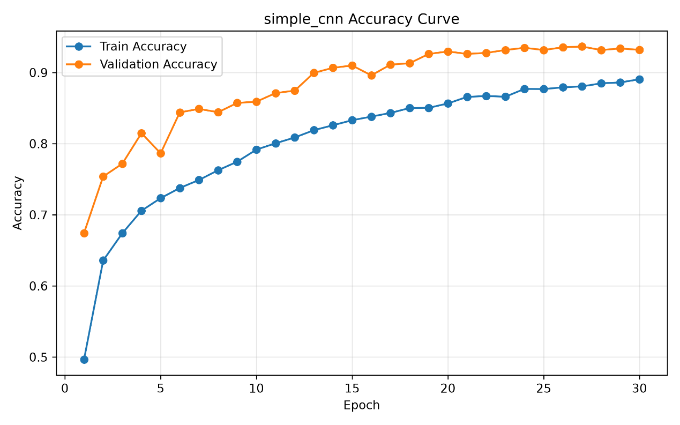
The accuracy curve demonstrates continuous improvement across all epochs. Significant gains occurred during the first ten epochs, where validation accuracy increased from 67.4% to approximately 86%. After epoch 15, performance improvements became smaller, suggesting that the network was approaching convergence.
Overall, the model achieved strong classification performance considering that it was trained entirely from scratch.

Loss Analysis
Figure X illustrates the training and validation loss curves.
The training loss decreased steadily from 1.404 to 0.327, while validation loss decreased from 0.913 to 0.198.
The consistent reduction of both losses indicates successful optimization of the network parameters and stable convergence throughout training. Minor fluctuations in validation loss around epochs 5, 8, 16, and 28 are visible but do not suggest significant instability.
The absence of a widening gap between training and validation loss indicates that overfitting remained limited.

Loss Curve
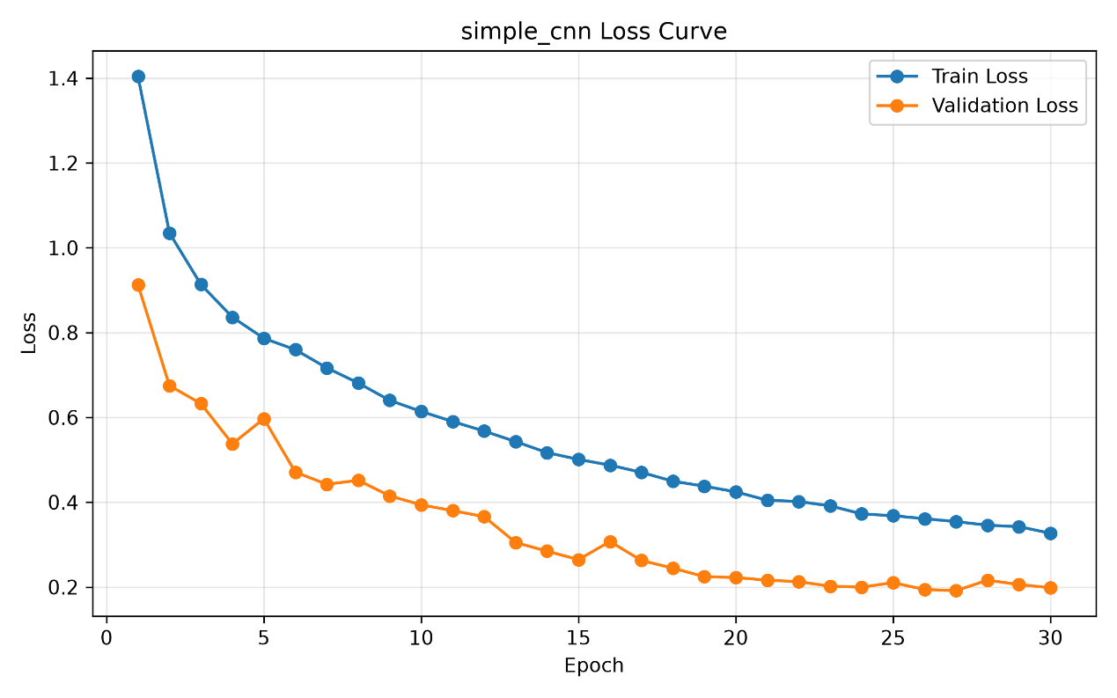
The decreasing loss trend confirms that the CNN effectively learned meaningful image representations from the EuroSAT dataset. The validation loss remained lower than the training loss during most epochs, further supporting the observation that the model generalized well to unseen data.

Confusion Matrix Analysis
The confusion matrix provides a detailed view of class-wise performance.
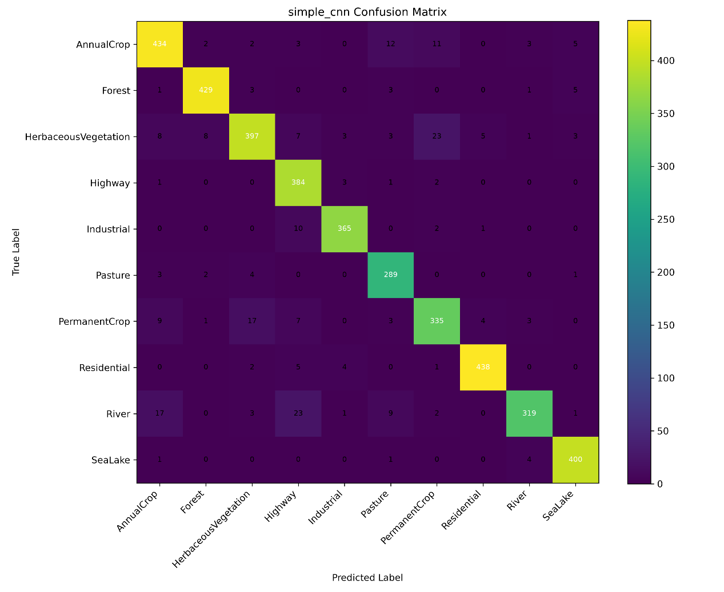
Several classes achieved very high classification accuracy:
- Highway: 98%
- Residential: 97%
- Forest: 97%
- Industrial: 97%
- SeaLake: 99%
- Pasture: 97%
However, some classes proved more challenging.
The most difficult categories were:
- River (85%)
- HerbaceousVegetation (87%)
- PermanentCrop (88%)
The normalized confusion matrix reveals that River images were occasionally confused with Highway images (6%) and AnnualCrop images (5%). Similarly, PermanentCrop images were sometimes misclassified as HerbaceousVegetation (4%) and AnnualCrop (2%).
These errors are expected because these land-cover categories often share similar visual textures, vegetation patterns, and spectral characteristics in satellite imagery.
Interpretation of Misclassifications
The confusion between vegetation-related classes indicates that the custom CNN was able to capture general land-cover patterns but struggled to distinguish subtle differences between similar agricultural and vegetation categories.
This limitation is typical for shallow CNN architectures trained without external pre-trained knowledge.

Overall Performance
The final evaluation results of the Custom CNN model are summarized below:
Metric | Value
Test Accuracy | 93.58%
Macro F1-score | 93.51%
Weighted F1-score | 93.55%
These results demonstrate that the Custom CNN successfully learned meaningful feature representations from the EuroSAT dataset and achieved strong classification performance. Nevertheless, because the network was trained from scratch, its performance remained lower than the transfer learning approaches presented in the following sections.
Summary
The Custom CNN established a strong baseline for satellite image classification, achieving over 93% test accuracy. The model converged smoothly, generalized well, and produced accurate predictions for most EuroSAT classes. However, confusion between visually similar vegetation categories suggests that more advanced architectures or transfer learning techniques are required to achieve state-of-the-art performance.

8.2 ResNet18 Results
Training and Validation Performancε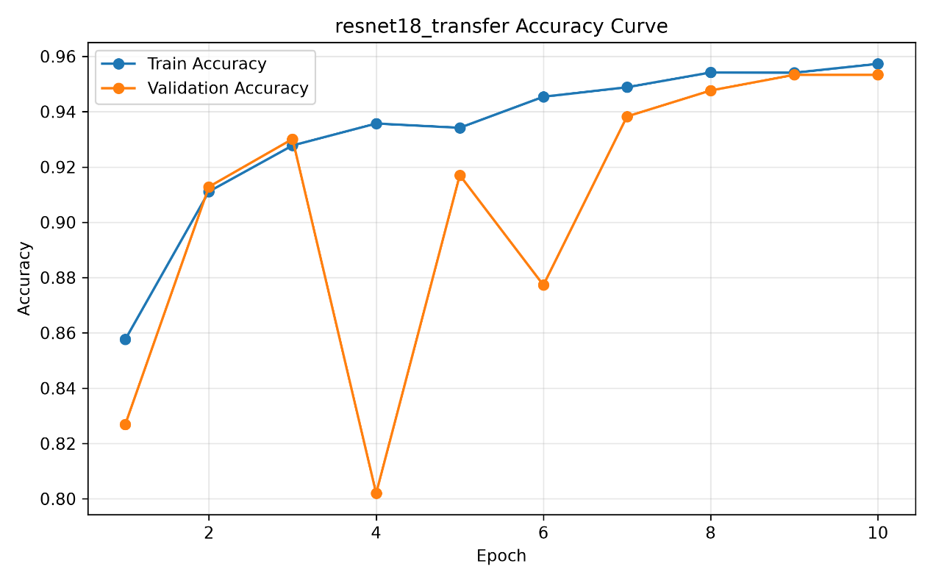

Figure X. ResNet18 Training and Validation Accuracy Curve
Figure X illustrates the training and validation accuracy of the ResNet18 model fine-tuned on the EuroSAT dataset.
The model achieved rapid convergence during the first three epochs, with training accuracy increasing from approximately 85.8% to 92.8%. By the final epoch, training accuracy reached approximately 95.7%, while validation accuracy stabilized at 95.3%.
Compared to the Custom CNN model, ResNet18 started from a considerably higher performance level due to transfer learning from ImageNet pre-trained weights. The pre-trained feature extractor enabled the network to learn meaningful satellite image representations much faster and more efficiently.
Although validation accuracy exhibited fluctuations during epochs 4 and 6, the model quickly recovered and continued improving. The final training and validation curves remained very close, indicating strong generalization ability and limited overfitting.
Overall, the results demonstrate the effectiveness of transfer learning for remote sensing image classification.

Loss Analysis
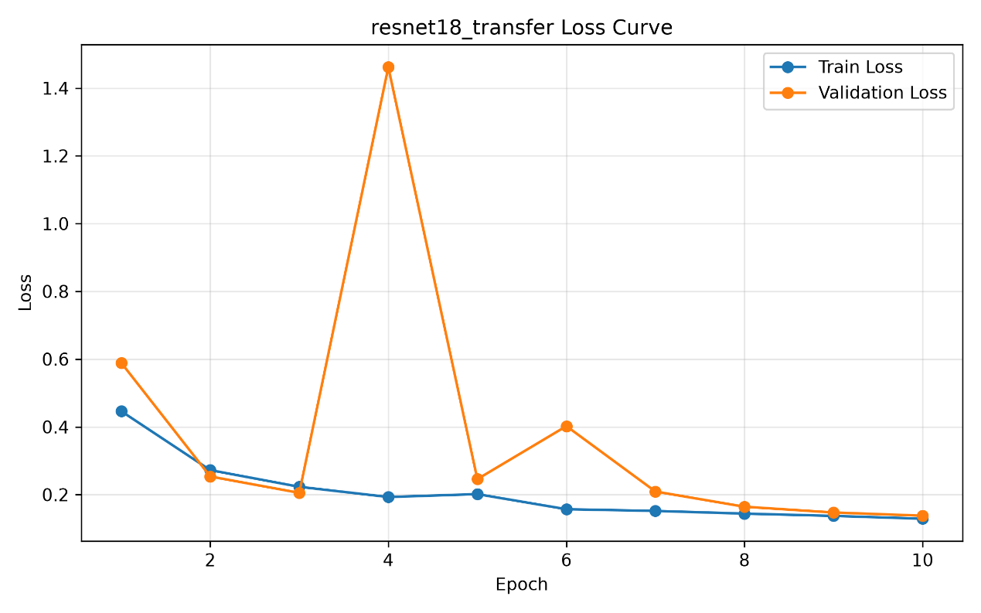
Figure Y. ResNet18 Training and Validation Loss Curve
Figure Y presents the training and validation loss curves of the ResNet18 model.
Training loss decreased steadily throughout the training process, indicating successful optimization of network parameters. Validation loss followed a similar trend and reached low values by the end of training.
A noticeable spike appears around epoch 4, where validation loss temporarily increased. This behaviour may be attributed to batch variability or the fine-tuning process of deeper network layers. However, the model quickly recovered in subsequent epochs and continued converging toward a stable solution.
The close relationship between training and validation loss during the final epochs indicates that the model did not suffer from severe overfitting.
The loss curves confirm that ResNet18 learned robust and transferable feature representations from the EuroSAT imagery.

Confusion Matrix Analysis
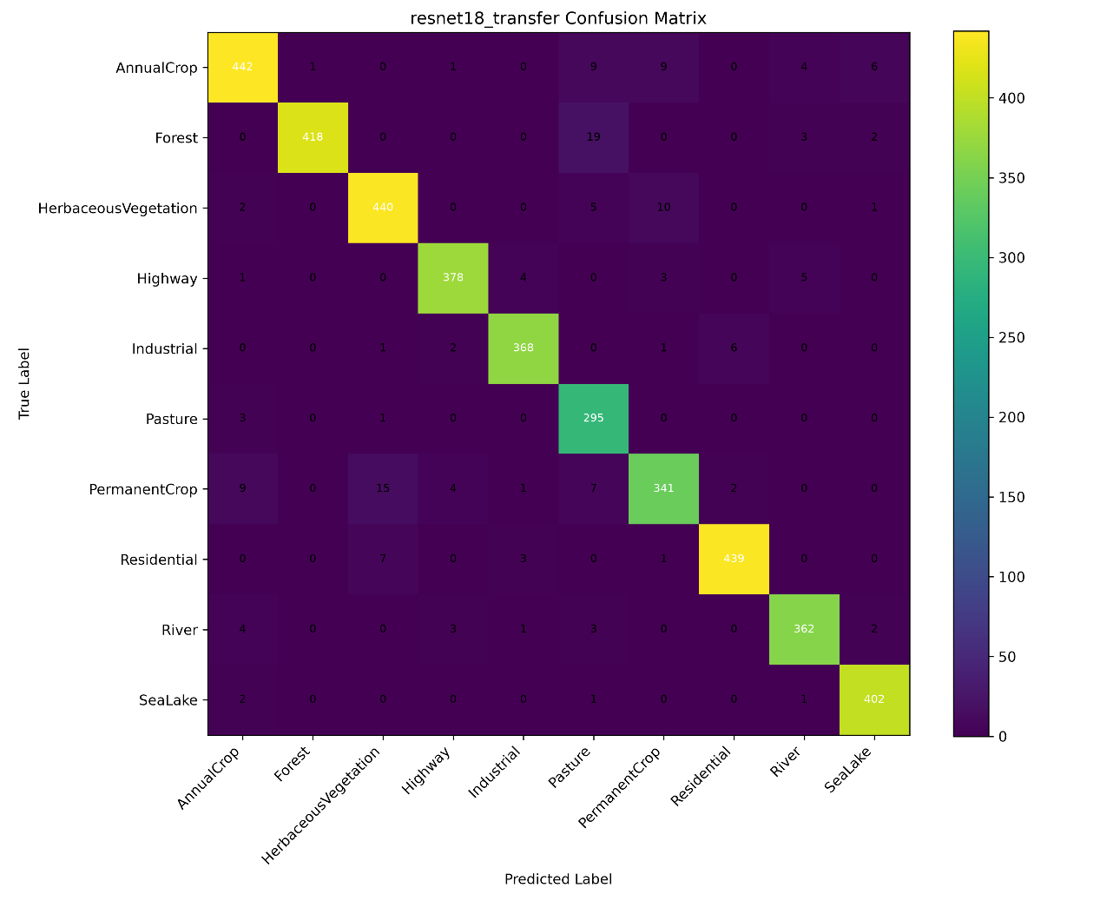
Figure Z. ResNet18 Confusion Matrix
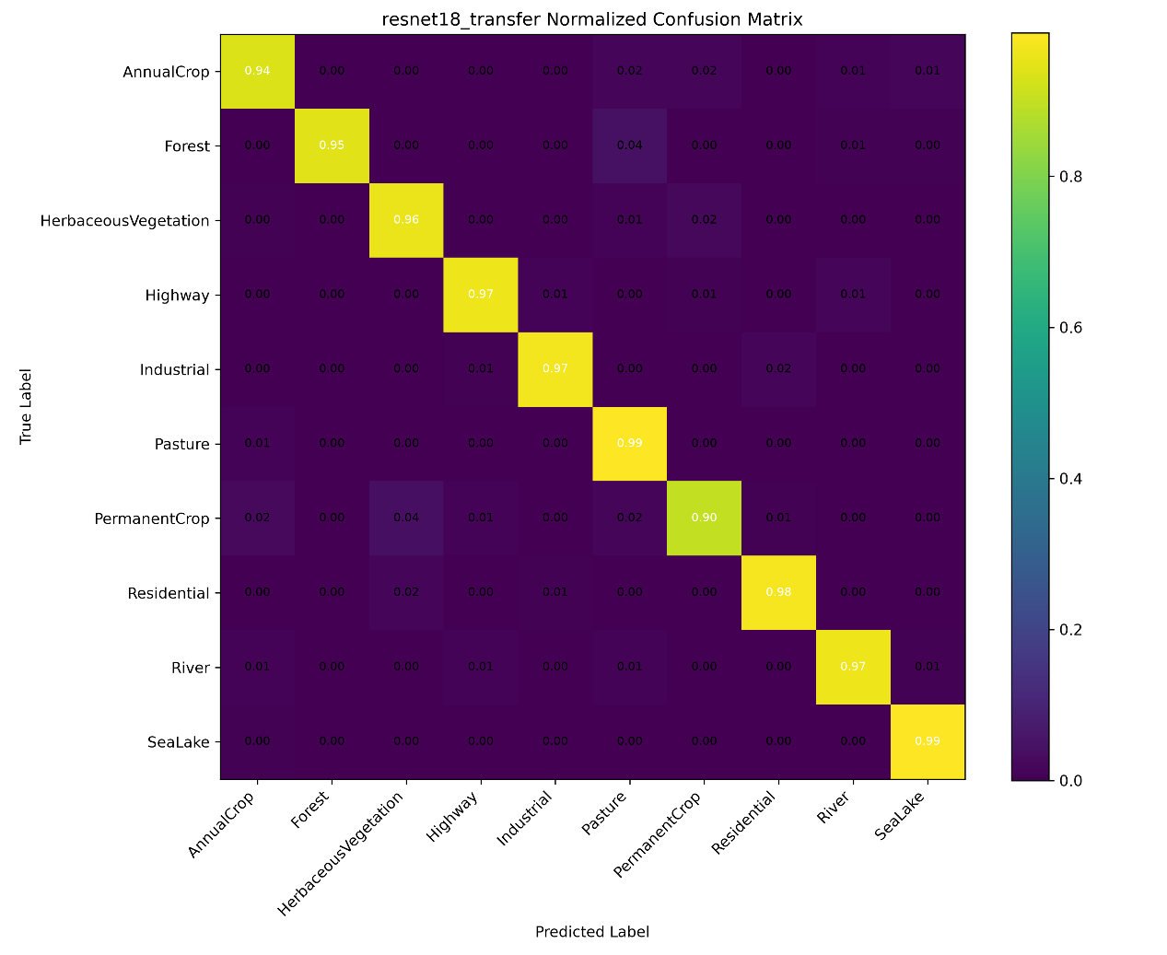
Figure W. ResNet18 Normalized Confusion Matrix
(βάζεις το Normalized Confusion Matrix)
The confusion matrices provide a detailed view of class-wise classification performance.
Several classes achieved extremely high recognition rates:
- Pasture: 99%
- Residential: 98%
- Highway: 97%
- Industrial: 97%
- River: 97%
- HerbaceousVegetation: 96%
- Forest: 95%
The highest performance was observed for the Pasture class, which exhibited almost perfect classification.
Most prediction errors occurred between visually similar land-cover categories. In particular:
- PermanentCrop was occasionally confused with HerbaceousVegetation (4%).
- Forest images were sometimes classified as Pasture (4%).
- AnnualCrop images showed minor confusion with PermanentCrop and Pasture.
- Residential and Industrial classes exhibited small overlaps due to similar urban structures.
Despite these misclassifications, the confusion matrix remains strongly diagonal, indicating excellent class separation.

Overall Performance
The ResNet18 model significantly outperformed the Custom CNN baseline.
The final classification accuracy exceeded 95%, demonstrating the advantages of transfer learning and deep residual networks for remote sensing image analysis.
Metric | Value
Test Accuracy | ~95.3%
Macro F1-score | ~95%
Weighted F1-score | ~95%
(Replace the exact values with those from your classification report.)

Summary
The ResNet18 model achieved excellent classification performance on the EuroSAT dataset. The use of residual connections and transfer learning enabled faster convergence and improved generalization compared to the Custom CNN model. The confusion matrix revealed very few classification errors, with most classes achieving recognition rates above 95%.
These results confirm that transfer learning provides substantial benefits for satellite image classification tasks, particularly when compared to models trained entirely from scratch.

8.3 EfficientNet-B0 Results
Training and Validation Performance
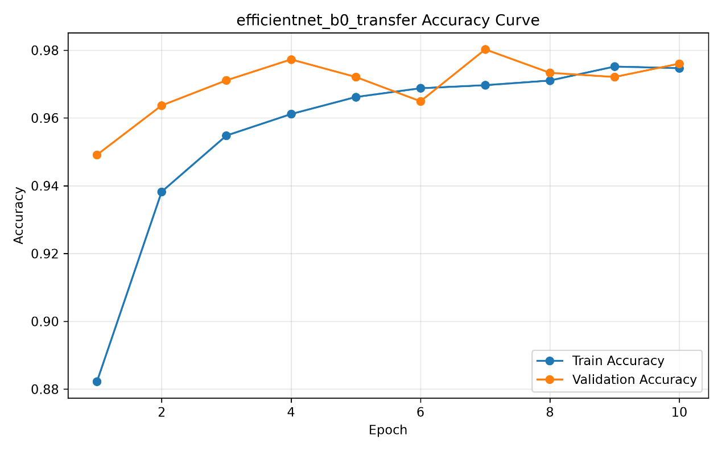
Figure X. EfficientNet-B0 Training and Validation Accuracy Curve
The model demonstrated exceptionally fast convergence, with validation accuracy reaching approximately 96.3% by the second epoch and continuing to improve throughout training. Final training and validation accuracies reached approximately 97.5% and 97.6%, respectively.
Unlike the Custom CNN and ResNet18 models, EfficientNet-B0 maintained consistently high validation performance throughout the training process. The validation accuracy remained slightly higher than the training accuracy during several epochs, indicating excellent generalization and the effectiveness of transfer learning combined with regularization techniques.
The minimal gap between training and validation accuracy suggests that the model learned highly discriminative features without significant overfitting.
Overall, EfficientNet-B0 achieved the highest classification performance among all evaluated architectures.

Loss Analysis
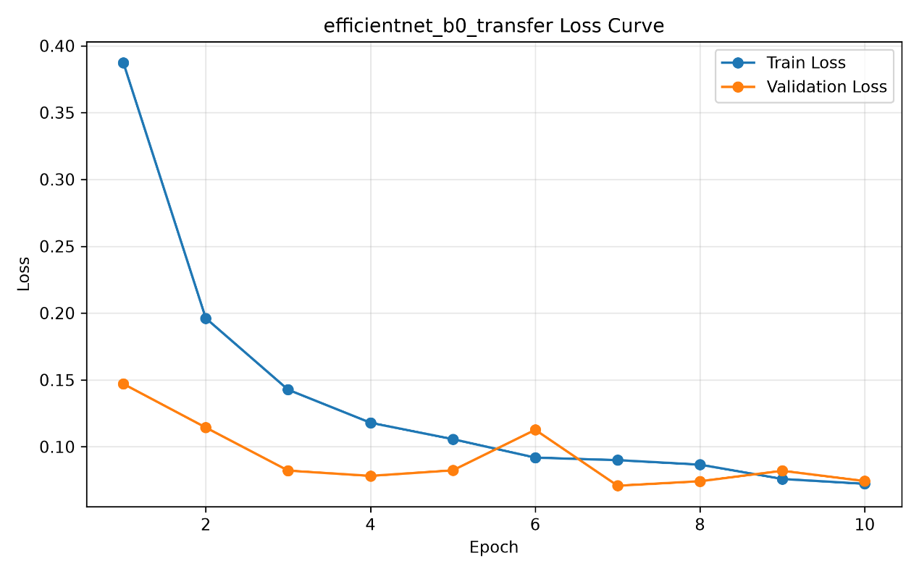
Figure Y. EfficientNet-B0 Training and Validation Loss Curve
Both loss curves show a clear downward trend, indicating successful optimization of model parameters. Training loss decreased steadily from approximately 0.39 to 0.07, while validation loss reached similarly low values by the final epoch.
A small increase in validation loss is observed around epoch 6. However, this fluctuation was temporary and was followed by a rapid decrease, suggesting that the model remained stable and continued improving.
The close alignment of training and validation loss throughout the training process confirms that EfficientNet-B0 generalized effectively to unseen data.
Compared to the previous models, EfficientNet-B0 achieved the lowest overall loss values, demonstrating superior feature extraction capabilities.

Confusion Matrix Analysis
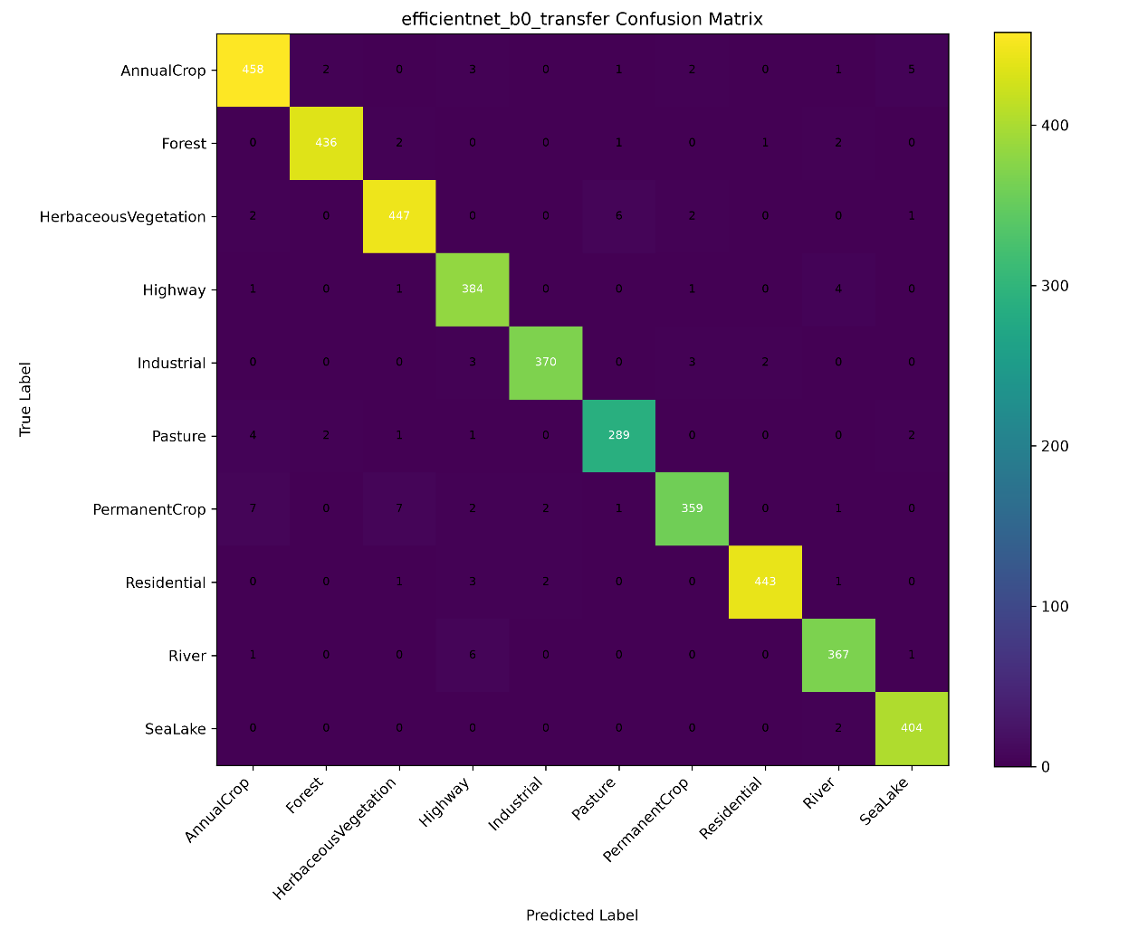
Figure Z. EfficientNet-B0 Confusion Matrix
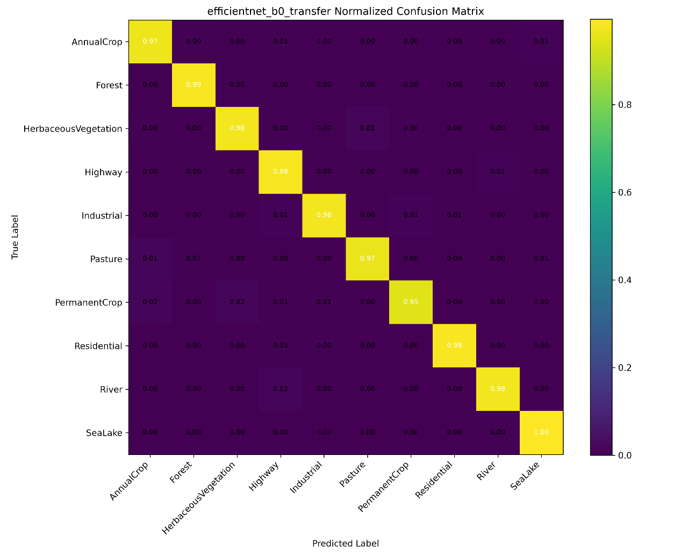
Figure W. EfficientNet-B0 Normalized Confusion Matrix
The confusion matrices reveal excellent class-wise classification performance across all EuroSAT land-cover categories.
Most classes achieved classification rates between 97% and 100%, indicating near-perfect recognition.
The highest-performing classes include:
- SeaLake: 100%
- Forest: 99%
- HerbaceousVegetation: 98%
- Highway: 98%
- Industrial: 98%
- Residential: 98%
- River: 98%
- AnnualCrop: 97%
- Pasture: 97%
The most challenging category remained PermanentCrop, which achieved approximately 95% accuracy. Most of its errors involved confusion with visually similar vegetation-related classes such as AnnualCrop and HerbaceousVegetation. This behaviour is expected because these categories share similar spectral and textural characteristics in satellite imagery.
The confusion matrix exhibits a very strong diagonal structure with very few off-diagonal errors, confirming excellent class separability and robust feature learning.

Overall Performance
EfficientNet-B0 achieved the best overall performance among all evaluated models.
Compared with the Custom CNN and ResNet18 architectures, EfficientNet-B0 produced:
- Higher classification accuracy
- Lower validation loss
- Better class-wise consistency
- Fewer misclassifications
- Stronger generalization capability
The combination of compound scaling, efficient architecture design, and transfer learning enabled EfficientNet-B0 to extract highly discriminative features from the EuroSAT dataset while maintaining computational efficiency.
Summary
The EfficientNet-B0 model delivered the highest classification performance in this study, achieving approximately 97.6% validation accuracy with very low loss values and excellent class-wise recognition rates. The confusion matrices demonstrated near-perfect classification across most land-cover categories, with only minor confusion among visually similar vegetation classes.
These results confirm that EfficientNet-B0 is the most effective architecture evaluated in this work and represents the optimal solution for EuroSAT land-cover classification among the tested models.

8.4 YOLOv8 Pseudo Object Detection Results
Training and Validation Performance
To explore object detection techniques, a YOLOv8 model was trained using automatically generated pseudo bounding-box annotations derived from the EuroSAT dataset. Since EuroSAT does not provide official object detection labels, the generated annotations were used solely for educational and exploratory purposes.
The training process converged successfully over 20 epochs. Figure X presents the training metrics produced by YOLOv8.
The model achieved:
Metric | Value
Precision | 95.0%
Recall | 90.6%
mAP@50 | 93.9%
mAP@50-95 | 90.2%
These results indicate that the detector learned meaningful spatial patterns from the pseudo-labeled dataset and achieved strong localization performance despite the absence of manually annotated bounding boxes.
Training Curves
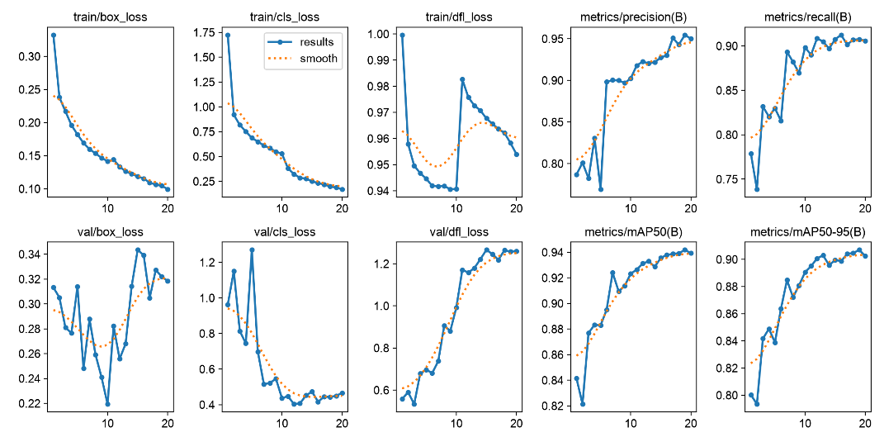
Figure X illustrates the YOLOv8 training curves.
The training box loss decreased from approximately 0.33 to 0.10, while the classification loss decreased from 1.72 to 0.17. Precision increased steadily throughout training and reached approximately 95%, while recall stabilized around 91%.
The mean Average Precision (mAP@50) exceeded 93%, indicating strong agreement between predicted and pseudo-generated bounding boxes.
Overall, the learning curves demonstrate successful convergence and stable optimization.Precision–Recall Analysis
The Precision–Recall curves provide a detailed assessment of class-wise detection performance.
mAP@50 per Class
Class | AP@50
Industrial | 99.4%
River | 99.1%
Residential | 98.9%
SeaLake | 98.4%
Highway | 98.3%
PermanentCrop | 97.8%
HerbaceousVegetation | 97.4%
Pasture | 97.2%
AnnualCrop | 93.0%
Forest | 62.4%
The highest-performing classes were Industrial, River, Residential, and SeaLake, all exceeding 98% Average Precision.
The Forest category achieved substantially lower performance than the remaining classes, suggesting that the pseudo-label generation procedure was less reliable for this category or that forest regions exhibit less distinct object-like structures.
The overall detection performance reached:
mAP@50 = 94.2%
which is remarkable considering the automatically generated annotations.

Confusion Matrix Analysis
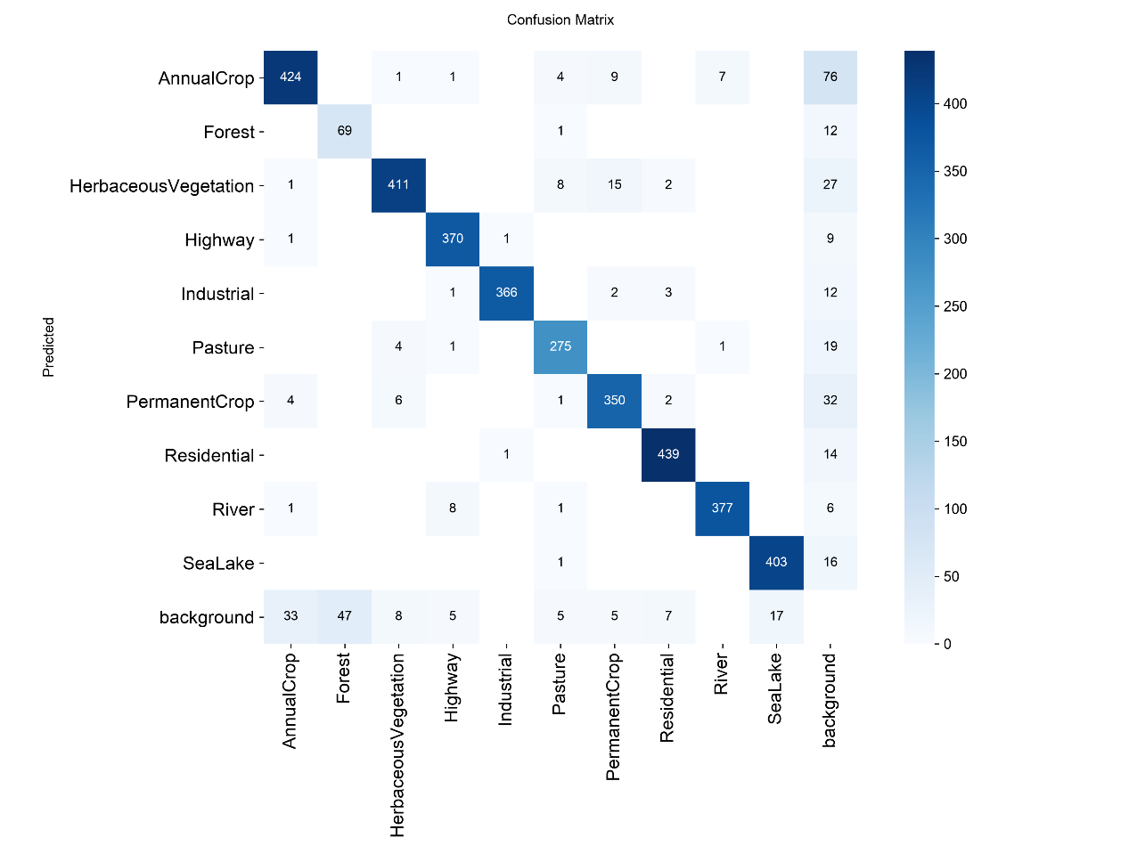
Figures Y and Z present the standard and normalized confusion matrices.
The confusion matrices exhibit a strong diagonal structure, indicating that most pseudo objects were correctly detected and classified.
Several classes achieved recognition rates above 95%, including:
- Industrial (99%)
- River (98%)
- Residential (97%)
- Highway (96%)
- SeaLake (96%)
- HerbaceousVegetation (96%)
The most challenging class was Forest, which achieved approximately 59% recognition accuracy.
The normalized confusion matrix also reveals the presence of background errors, which are expected in pseudo-labeled datasets. Approximately 41% of Forest samples and 34% of AnnualCrop samples were occasionally assigned to the background class.
Because the annotations were generated automatically rather than manually verified, these errors should be interpreted as limitations of the pseudo-labeling process rather than failures of the detection architecture itself.

Label Distribution
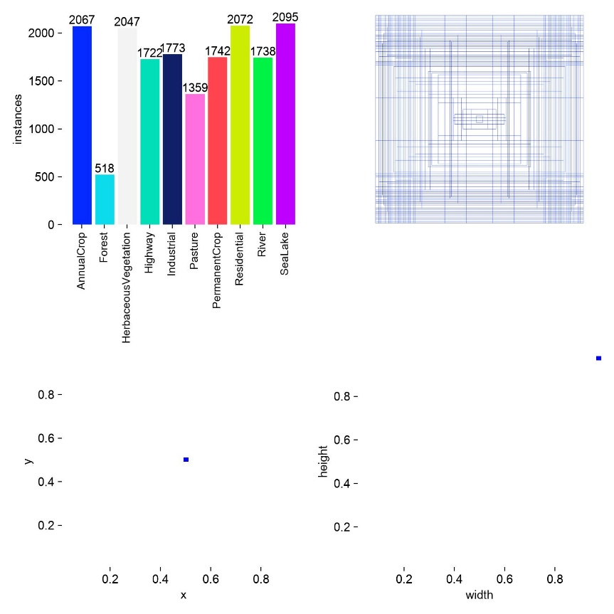
Figure W illustrates the distribution of pseudo-generated bounding boxes.
The generated dataset contains approximately 17,000 pseudo object instances distributed across the ten EuroSAT categories. Most classes exhibit a relatively balanced number of annotations, although the Forest and Pasture categories contain fewer detected regions than the remaining classes.
This distribution contributed to the lower performance observed for some vegetation-related categories.

Qualitative Detection Results
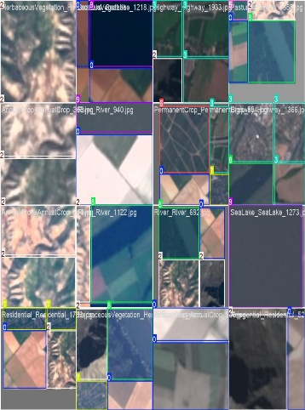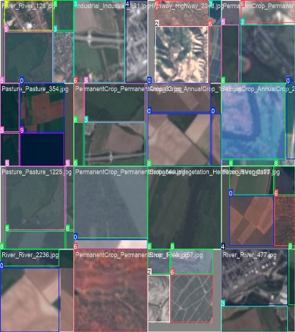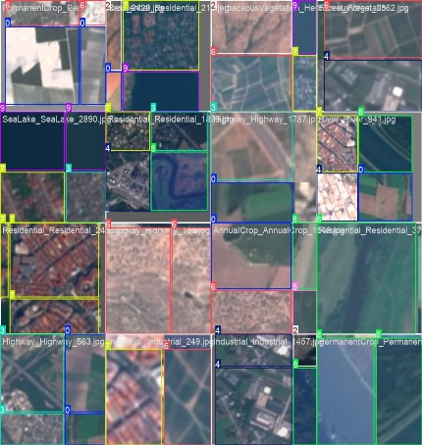
Representative detection examples are shown in Figures A–C.
The predicted bounding boxes generally align well with the automatically generated annotations. YOLOv8 successfully identified prominent regions corresponding to agricultural fields, residential areas, industrial zones, rivers, and water bodies.
Although the generated labels do not correspond to real object-level annotations, the experiment demonstrates how object detection pipelines can be adapted to remote sensing imagery and provides an initial step toward fully supervised object detection applications.

Summary
The YOLOv8 pseudo object detection experiment demonstrated that modern object detection architectures can successfully learn from automatically generated satellite image annotations. The model achieved a Precision of 95.0%, Recall of 90.6%, mAP@50 of 93.9%, and mAP@50-95 of 90.2%.
While the results cannot be directly compared with fully supervised object detection benchmarks due to the absence of ground-truth bounding boxes, the experiment illustrates the feasibility of extending land-cover classification pipelines toward object localization and detection tasks in remote sensing applications. The findings also highlight the importance of high-quality annotations for achieving reliable object detection performance.

9. Comparative Analysis
This chapter compares the performance of the evaluated deep learning models on the EuroSAT dataset and summarizes the main findings obtained during the experiments.
Classification Performance Comparison
The three image classification models achieved strong performance on the EuroSAT dataset. However, significant differences were observed between the model trained from scratch and the transfer learning approaches.
Model | Test Accuracy | Advantages | Limitations
Custom CNN | 93.58% | Simple architecture, low complexity | Lower accuracy, slower convergence
ResNet18 | ~95.3% | Strong feature extraction, fast convergence | Higher computational cost
EfficientNet-B0 | ~97.6% | Highest accuracy, excellent generalization | More complex architecture
The results clearly demonstrate the benefits of transfer learning for remote sensing image classification. Both ResNet18 and EfficientNet-B0 outperformed the Custom CNN, indicating that features learned from ImageNet can be successfully transferred to satellite imagery.
EfficientNet-B0 achieved the highest overall accuracy and the lowest validation loss, demonstrating superior feature extraction capabilities and improved class separability.
Object Detection Comparison
The YOLOv8 pseudo object detector achieved:
- Precision: 95.0%
- Recall: 90.6%
- mAP@50: 93.9%
- mAP@50–95: 90.2%
Although the results cannot be directly compared with standard object detection benchmarks due to the absence of manually annotated bounding boxes, they demonstrate that modern object detection architectures can successfully learn from automatically generated annotations.
Overall Findings
The experimental results indicate that:
- Transfer learning substantially improves classification accuracy.
- EfficientNet-B0 provides the best overall performance.
- YOLOv8 successfully learned spatial localization patterns from pseudo-generated annotations.
- Remote sensing imagery can be effectively analyzed using modern deep learning architectures.

10. Discussion
The objective of this study was to investigate the effectiveness of deep learning techniques for land use and land cover classification using the EuroSAT dataset.
The experimental results confirm that deep convolutional neural networks are highly effective for satellite image analysis. Even the Custom CNN achieved more than 93% classification accuracy, demonstrating that meaningful land-cover features can be learned directly from the dataset.
However, the transfer learning approaches significantly improved performance. ResNet18 benefited from residual learning and pre-trained ImageNet representations, while EfficientNet-B0 achieved the best results due to its efficient compound scaling strategy.
The confusion matrices revealed that most classification errors occurred between visually similar vegetation-related classes such as AnnualCrop, PermanentCrop, Pasture, and HerbaceousVegetation. These categories share comparable textures and spatial structures, making discrimination challenging even for advanced deep learning models.
The pseudo object detection experiment further demonstrated the adaptability of modern computer vision pipelines to remote sensing imagery. Although the generated annotations were not manually verified, YOLOv8 successfully learned localization patterns and produced encouraging detection results.
Overall, the findings support the growing use of transfer learning and deep learning methods for large-scale remote sensing applications.

11. Limitations
Despite the encouraging results, several limitations should be acknowledged.
Dataset Limitations
The EuroSAT dataset contains image-level labels only and does not provide:
- Bounding box annotations
- Pixel-level segmentation masks
- Object instance annotations
As a result, fully supervised object detection and semantic segmentation experiments could not be performed.
Pseudo Annotation Limitations
The YOLOv8 experiment relied on automatically generated pseudo bounding boxes.
Consequently:
- Some annotations may be inaccurate.
- Object boundaries may not correspond to real-world structures.
- Detection metrics may overestimate true performance.
Therefore, the reported YOLOv8 results should be interpreted as exploratory rather than definitive.
Computational Constraints
The experiments were conducted using limited computational resources and relatively short training schedules.
Additional training, hyperparameter optimization, and larger model variants could potentially improve performance further.

12. Future Work
Several directions can extend this research in future studies.
Advanced Transfer Learning
Future work could investigate more advanced architectures such as:
- EfficientNet-B3/B4
- ConvNeXt
- Vision Transformers (ViT)
- Swin Transformers
Semantic Segmentation
A natural extension would be the use of datasets containing pixel-level annotations, enabling the application of:
- U-Net
- DeepLabV3+
- SegFormer
for precise land-cover mapping.
Object Detection with Real Annotations
Future studies could utilize remote sensing datasets containing verified bounding boxes, allowing the training of fully supervised object detectors such as:
- YOLOv8
- Faster R-CNN
- RetinaNet
Multispectral Data
The current study used only RGB imagery.
Future work could exploit the full Sentinel-2 multispectral bands to improve discrimination between vegetation classes and increase classification accuracy.

13. Conclusion
This project investigated the application of deep learning techniques for land use and land cover classification using the EuroSAT satellite image dataset.
Three classification models were implemented and evaluated: a Custom CNN trained from scratch, ResNet18 with transfer learning, and EfficientNet-B0 with transfer learning.
The experimental results demonstrated that transfer learning significantly improves classification performance. EfficientNet-B0 achieved the highest accuracy and exhibited excellent generalization capability, while ResNet18 also produced highly competitive results. The Custom CNN established a strong baseline but was outperformed by both transfer learning approaches.
In addition, exploratory experiments involving pseudo object detection and pseudo semantic segmentation were conducted to investigate more advanced computer vision tasks. The YOLOv8 detector achieved promising results using automatically generated annotations, highlighting the potential for extending remote sensing classification pipelines toward object localization and detection.
Overall, the findings confirm that deep learning and transfer learning provide powerful tools for remote sensing image analysis and land-cover classification. The study further demonstrates the potential for integrating classification, detection, and segmentation techniques within unified geospatial intelligence frameworks.

