Term-Project Proposal

**1) Project Description**:

**The name of my project is “Nemo” and basically it is an interactive and fun game to play. You as a player represent a fish called Nemo from the famous movie “Nemo”, which has to avoid sharks that are moving around in the ocean and eat fish in order to grow in size. As you eat other fish you gain score and gold coins which can later on be used to purchase some cool items from the shop to upgrade Nemo. One of the sharks as I call it the smart shark will be chasing you by altering its vertical location and also one of the prey fish, called a goldfish, will try to run away from you if you get close to it. Obviously if you catch the goldfish your score will increase significantly and you will gain a lot more coins than if you would have by just eating normal fish.**

**2) Competitive Analysis**: <https://www.y8.com/games/fishy>

The game displayed below is called “Fishy” and it is somewhat similar to my project. On this game you as a player also represent a fish and in order to grow in size you need to eat fish that are smaller than you. If you bump into fish that is bigger u die. That is the whole concept of the game. You also have a score displayer at the top. The idea and GUI are simple with almost no extra cool features such as earning gold coins and going to the shop or even having smart fish that can chase you. All fish in this game move in a straight line and they all look like each other expect they have different colors. My game will have different real life species of fish as well as different types and sizes of sharks. Also in this game as you grow larger you still move with same speed which in real life is not possible because of the viscosity of water so my project will take that into account. However one cool feature this game has is that your fish can not come to a halt instantly because there it has some momentum, so as you would expect in real water the speed decreases gradually as let go the button. That is a feature that I am planning to implement in my game as well.

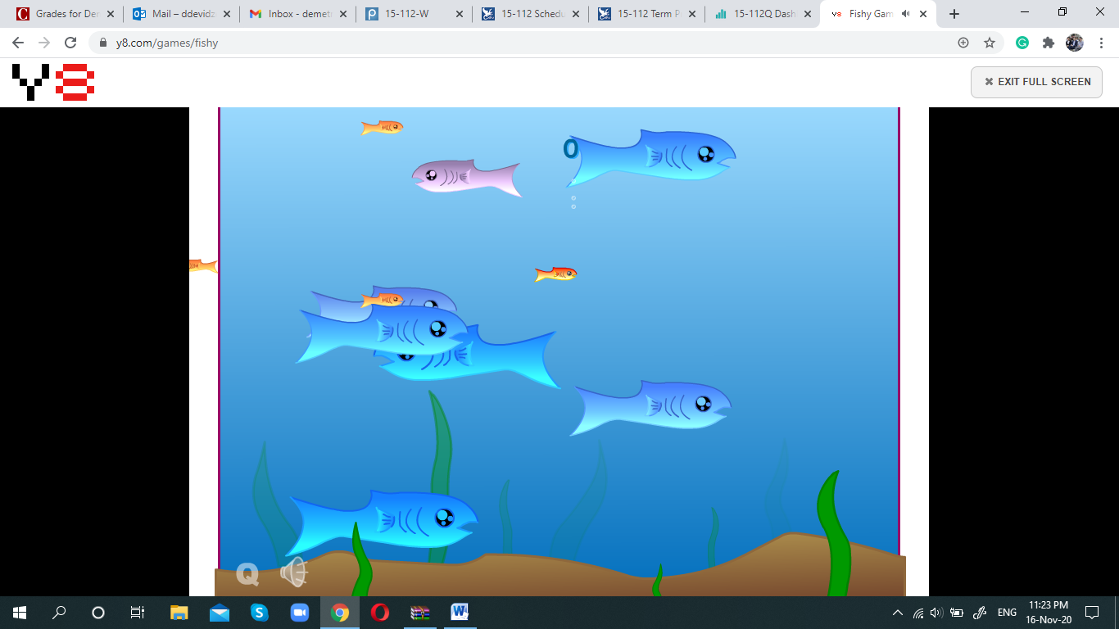

**3) Structural Plan**:

The code for the game will be organized into functions for displaying lots of different type of objects such as sharks, fish etc. There will be the main game loop using pygame, which will make use of all predefined function at the start. The code will be organized in a neat manner divided into sections with simple variable names, which will all be related to objects and activities associated with the game. The intro, the shop, the pause functionality etc. will be separate functions, but similar to one another. I am also planning to make the use of OOP, to create objects of specific classes for examples different sized bubbles which will go up to the water surface and then disappear.

**4) Algorithmic Plan**:

The trickiest part of this project is to deal with the collisions of the character with other objects in this game such as sharks or other fish. At first I would approach this problem by approximating my character and objects shapes to specific polygons or different sizes, rectangles for example and then run loop to keep checking if they ever overlap. However my objects have curved shapes so I need a more sophisticated algorithm to deal with the collisions in a more accurate manner.

**5) Timeline Plan**:

I am planning to complete major features of this game by TP2 including collisions as well. After TP2 before final presentation I am going to polish up the GUI and add and refine some cool features such as the shop, water viscosity, conservation of momentum and so on.

**6) Version Control Plan**:

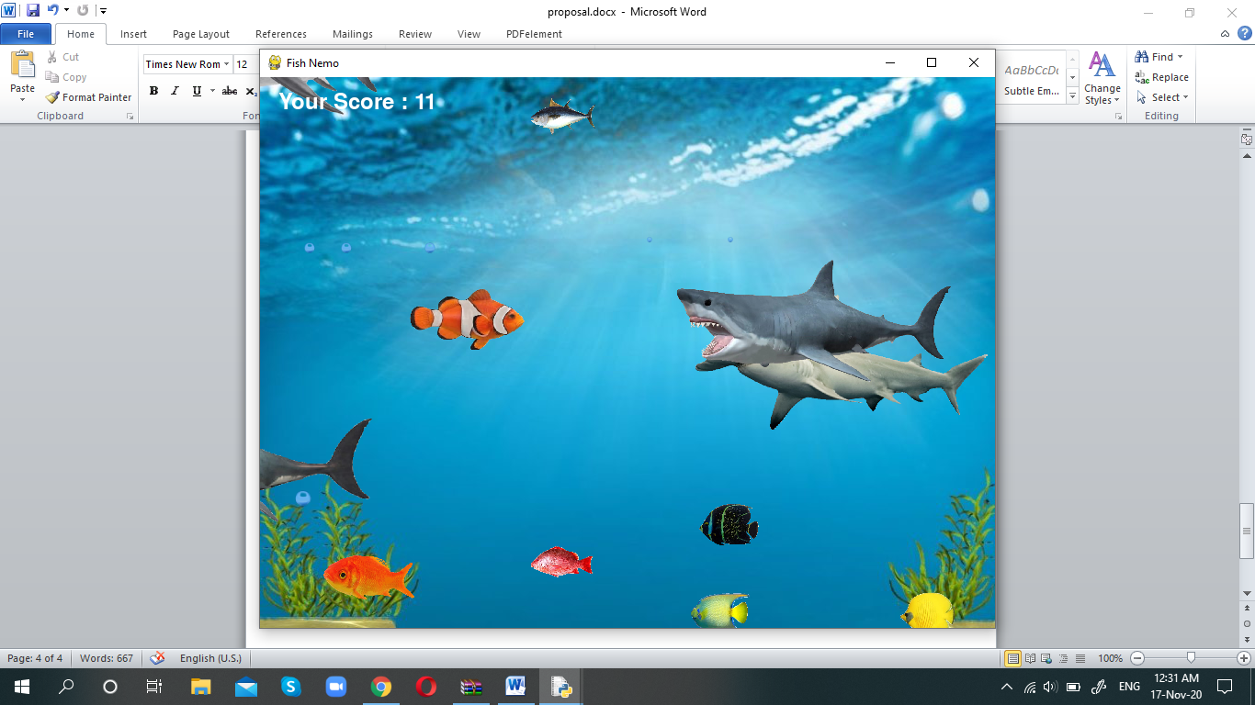

**7) Module List**:

I will be using pygame library. No other external modules.