* **(~) = /1\ = min(x,y):**

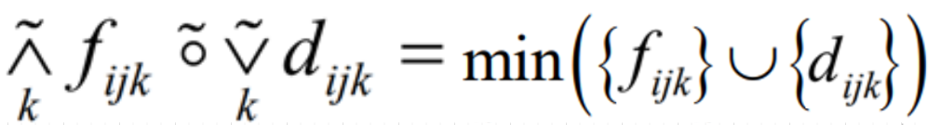

* **(~) = /2\ = x*y:**

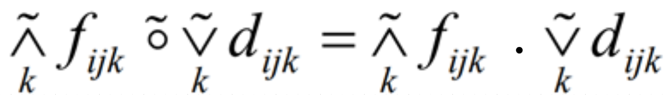

* **(~) = /3\ = max(x+y-1, 0):** 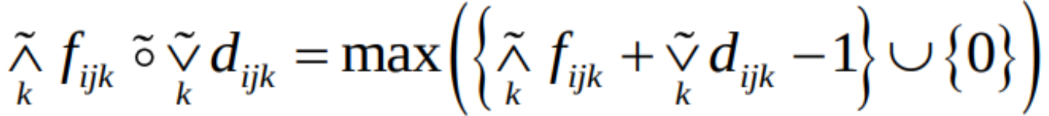
* **/~\ = /1\ = min(x,y):**

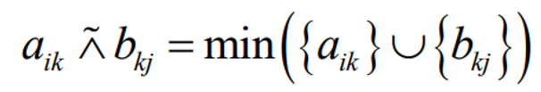

* **/~\ = /2\ = x*y:**

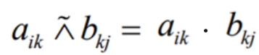

* **/~\ = /3\ = max(x+y-1, 0):**

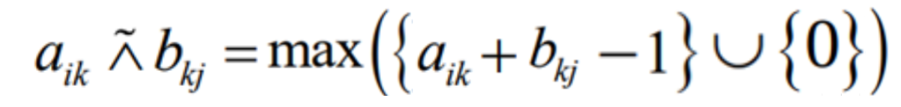

* **x ~> y = 1 + x*(y-1):**

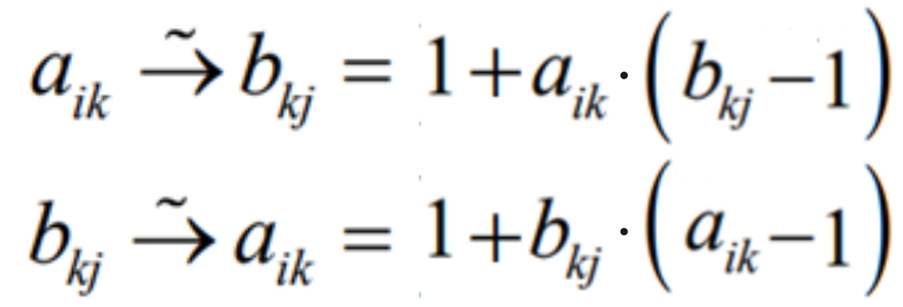

* **x ~> y = max(1-x, y):**

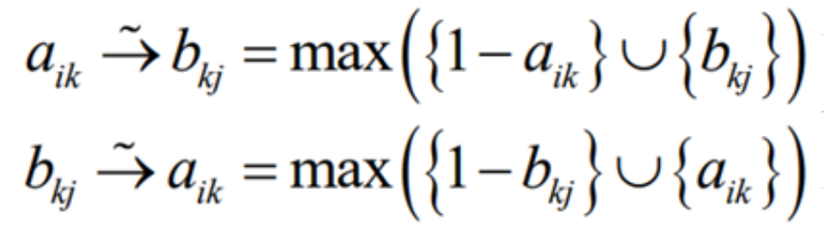

* **x ~> y = min(1-x+y, 1):**

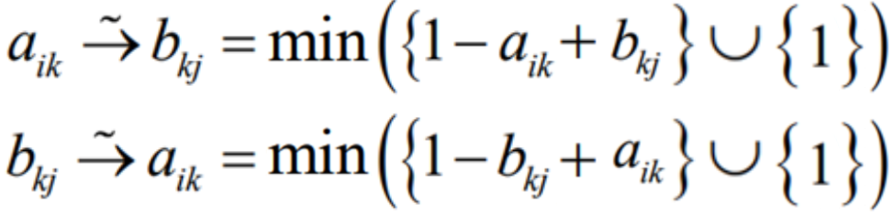

* **x ~> y = sup({ z| ((1-x)*z<=y) /\ (z<=1) }):**

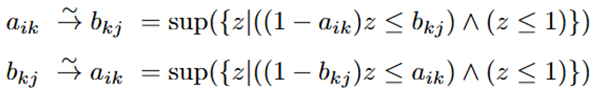

* **x ~> y = sup({ z| (min({1-x) \/ {z})<=y) /\ (z<=1) }):**

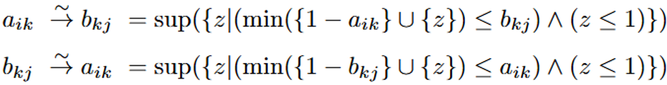

* **x ~> y = sup({ z| (max({1-x+z) \/ {0})<=y) /\ (z<=1) }):**

