GPA
概要设计说明书

- 文档属性
属性 | 内容
- 用户名称：
- 文档标题：
- 文档编号：
- 版本日期：
- 发布版本：
- 适用范围：
- 作者：

- 文档审批
审批人 | 职务 | 审批时间 | 审批意见 | 发文编号

- 修订内容
版本 | 修正章节 | 日期 | 修正人 | 变更记录

- 模板修订历史
版本 | 生效时间 | 变更概要 | 作者 | 审核 | 批准

目录
1 系统概述 1
2 模块设计 3
2.1 登陆模块 3
2.1.1 登陆模块 3
2.1.2 信息导入 4
2.1.3 在线提交成绩 5
2.1.4 成绩表导出 6

系统概述
- User
  - SL/TA: Each SL/TA has one unique ID. They could use the ID to log in the portal, input attendance and letter grade for each student in their seminar A B C D. SL/TA could only see information only related to their seminar.
  - Admin: Beijing and Shanghai should have one Admin account each. Admin account could upload [Student input sheet] and [Seminar input sheet] for Beijing and Shanghai site separately, and download a [Master output sheet] that includes each student’s course list, letter grade for each course, and whether they could graduate as honor student. Admin could see information of all seminars.
- ID type: Student ID, SL ID, TA ID, Admin ID, Seminar ID, and House
- Function
  - Admin should be able to upload the excel version of [Student input sheet] and [Seminar input sheet]; and download the [Master output sheet] as excel file.
  - TA/ SL should be able to submit each student’s grade online. Letter grade for both seminar and honor program essays.
  - The grading portal could instantly calculate and auto update the student grade once admin upload the sheet and SL/TA submit the grade.
- Input & Output
  - Input of [Student input sheet] and [Seminar input sheet]
  - There are two option for SL/TA upload the grade
(1) Input a letter grade for each day for each student, and the portal will automatically calculated the cumulative GPA (GPAi) for that student→ highly recommend SL/TA to choose this, easier to keep track student’s performance
(2) Input an overall GPA (GPAo) that could overwrite the cumulative GPA as student’s final grade for this seminar.
  - The way we calculate the GPAi are as follows:
Wi={1, 0} 1 meaning attending the seminar, 0 meaning missing; Gi= { A+, A, A-, B+, B, B-, C+, C, F }

Input 3 days’ of student’s daily letter grade [Gi | G1, G2, G3], and student attendance weight [Wi | 0, 1];
count (Wi=0) >= 2;
if true GPAi= F;
if false GPAi= (1/3)*Σ(Wi*Gi), Wi={1, 0}, Gi= {A+, A, A-, B+, B, B-, C+, C, F};
Output GPAi

  - The way for student earn the honor is to get A or A+ for all four seminar and get at B+ or above for the two seminar research paper they choose to write.
  - The letter grade scales are as follows
A+ | 4.3
A | 4.0
A- | 3.7
B+ | 3.3
B | 3.0
B- | 2.7
C+ | 2.3
C | 2.0
F | 0

  - When TA and SL log on the portal, they see a web page as in the excel tab “web page”
    - They can choose attendance (yes/no) for each student in each day of each session of their seminar
    - They can choose letter grade for each
    - They can write an overwrite GPA
    - They can mark grade for students’ paper
    - They need to click “submit” every time they make any changes

  - Admin ID could export an excel spreadsheet with the following info:
    - A master excel sheet that includes the “web page” sheet data of all seminars of the corresponding site (Beijing/shanghai)
    - A master excel sheet that includes all information of all students of the corresponding site (Beijing/shanghai), listed by students (see excel tab: master export spreadsheet)
。

模块设计

登陆模块

登陆模块

用户验证

模块描述
用户登陆验证

业务流程
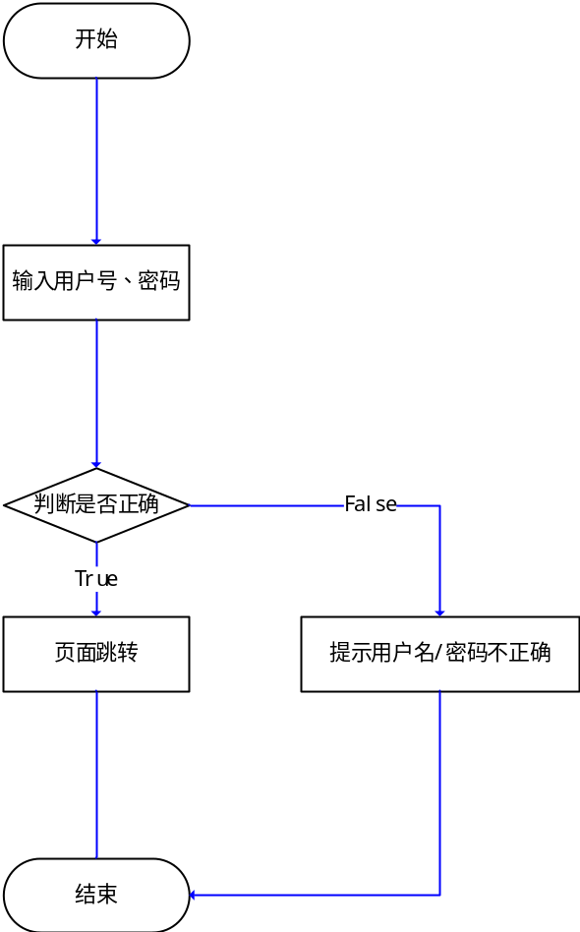

设计说明
验证用户身份，校验用户密码

实现要点
无

页面跳转

模块描述
根据登陆用户类别进行区分，如果为管理员，则跳转到信息导入界面；如果为高级讲师或者助教，则跳转到在线提交成绩界面。

业务流程
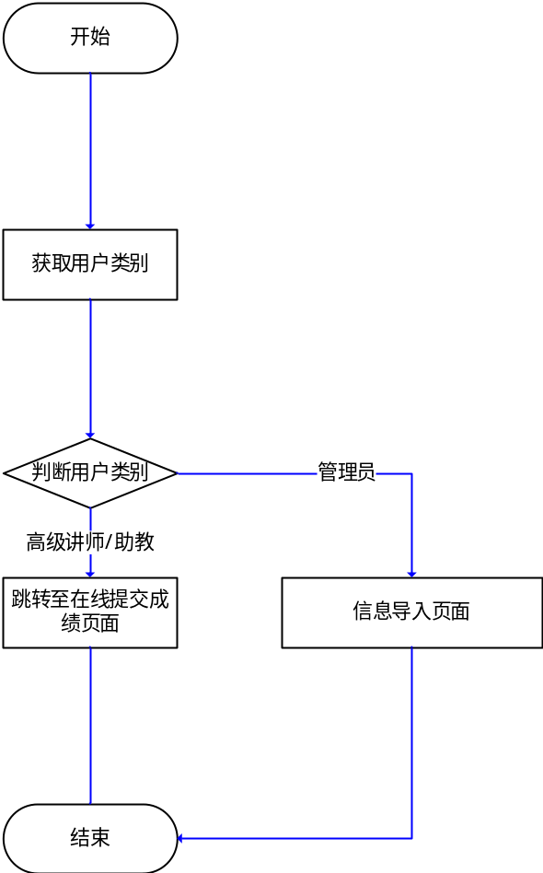

设计说明

实现要点

信息导入

学生信息导入

模块描述
将学生信息导入到数据库表studentinfo。

业务流程
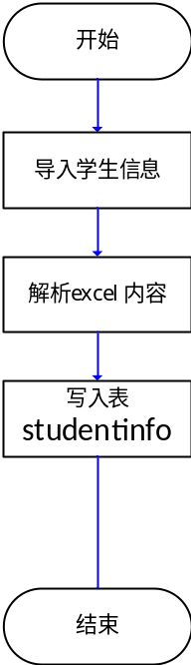

设计说明

实现要点
无

研讨课信息导入

模块描述
将研讨课信息导入到数据库表seminarinfo。

业务流程
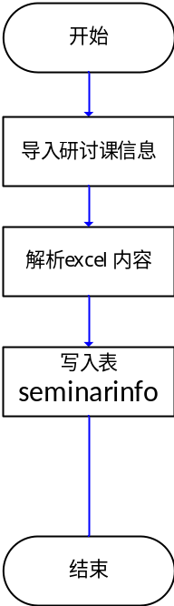

设计说明

实现要点
无

在线提交成绩

在线提交成绩

模块描述
在线提交成绩

业务流程
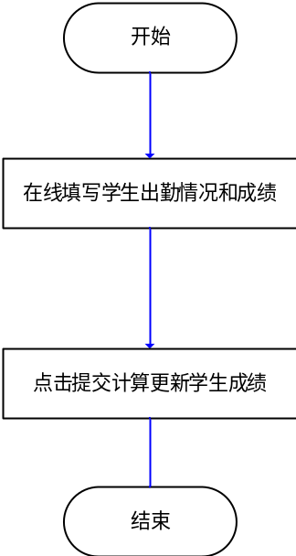

设计说明

实现要点
无

成绩表导出

教师输出表

模块描述
关联数据库表gpainfo、studentinfo导入教师输出表为excel文件。

业务流程
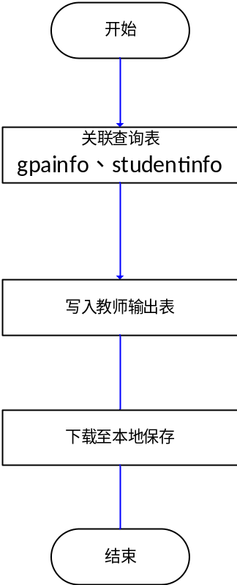

设计说明

实现要点
无

