RetailCo Online Ltd
E-Commerce Sales Performance Report
December 2010 – December 2011
─────────────────────────────────────
Prepared by: Okunowo Oluwademilade David
Date: July 2025
Tools: Python | PostgreSQL | Microsoft Power BI

Executive Summary
This report analyses 392,692 transactions from RetailCo Online Ltd between December 2010 and December 2011, totaling £8.74M in revenue across 4,334 unique customers. Revenue is heavily concentrated in Q4 and dependent on the UK market, which accounts for 82.9% of total revenue, with November 2011 generating £1.14M — the strongest trading month of the year. Key opportunities exist to improve customer retention, reduce an above-average return rate of 15.99%, and explore targeted expansion into high-value international markets.

Key Performance Indicators
Metric | Value
Total Revenue | £8.74M
Total Orders | 18,405
Unique Customers | 4,334
Average Order Value | £475.08
Return Rate | 15.99%

Top Recommendations
- Investigate and resolve the 15.99% return rate — significantly above the industry average of 8–10%
- Implement a post-purchase retention programme targeting the 1,505 one-time buyers within 30 days of first purchase
- Activate a VIP account strategy for Customer 14646 who contributes £279,138 — nearly 4x more than the tenth-highest spender

Business Problem & Objectives
RetailCo Online Ltd required a comprehensive analysis of its transactional data to understand revenue performance, customer behaviour, product demand, and return patterns across its e-commerce operations. Without this analysis, the business lacks visibility into which periods, products, customers, and markets drive the most value — and which represent the greatest risk.

The following business questions guided this analysis:
- When does the business generate the most and least revenue, and what drives the seasonal pattern?
- Which products drive the most value by revenue and by volume sold?
- How loyal are customers and which segments require urgent attention?
- Which international markets represent the greatest revenue opportunity?
- Is the return rate within acceptable industry bounds and which products are most affected?
Dataset & Methodology
This analysis is based on transactional data sourced from RetailCo Online Ltd, covering the period December 2010 to December 2011. The dataset was sourced from the UCI Machine Learning Repository and is publicly available on Kaggle. The raw dataset contained 541,910 transactions across 38 countries, primarily representing a UK-based online retail business selling giftware and homeware products. Following data cleaning — which removed null CustomerIDs, cancellations, duplicates, and invalid entries — 392,692 valid completed transactions were retained for analysis, representing 72.5% of the original dataset.

Exploratory data analysis was conducted in Python using Pandas for data manipulation and Matplotlib and Seaborn for visualization. Business queries were written in PostgreSQL to validate Python findings and demonstrate structured querying capability. An interactive dashboard was built in Microsoft Power BI for executive-level reporting and stakeholder communication.

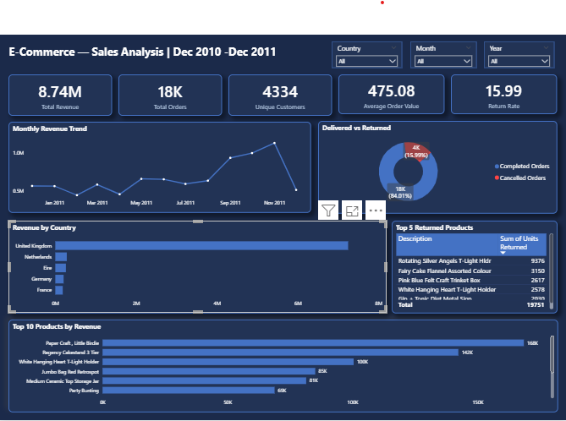
Figure 1: E-Commerce Sales Analysis Dashboard — Power BI (Dec 2010 – Dec 2011)
Analysis & Key Findings
The following five findings represent the most significant insights derived from the analysis. Each finding is supported by specific data points and contextualised within the business environment.
1. Revenue is Heavily Seasonal
Monthly revenue analysis reveals a pronounced seasonal pattern across the full 13-month period, with performance varying significantly between the weakest and strongest trading months:
- £442,493 — February 2011 was the weakest month, consistent with a typical post-Christmas retail slowdown following the December 2010 holiday period
- Revenue recovered steadily through spring and summer before accelerating sharply from September onwards
- £1,137,634 — November 2011 was the strongest month, more than double the February low, driven by early Christmas gifting demand in the weeks leading up to December
- £512,378 — December 2011 shows an apparent drop, reflecting an incomplete month in the dataset rather than a genuine revenue decline
The business generates the majority of its annual revenue in Q4 (September to November), creating significant dependency on a single trading period. A poor Q4 performance — driven by supply chain disruption, competitor activity, or macroeconomic factors — could have a disproportionate impact on the full year result.

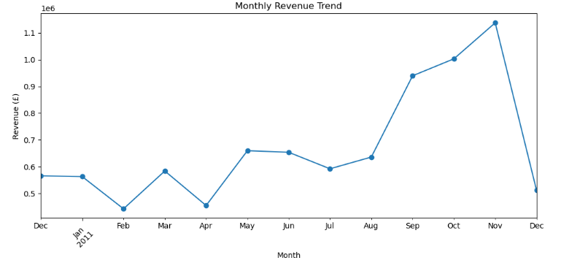
Figure 2: Monthly Revenue Trend (Dec 2010 – Dec 2011)
2. Product Performance is Polarised
Product performance analysis across the top 10 lists shows a clear divide between products that lead by revenue, by volume, or by both:
- £168,469 in revenue and 80,995 units sold — Paper Craft, Little Birdie emerged as the standout product, ranking first by both revenue and quantity sold, making it the single most important SKU in the entire catalogue
- £142,264 — Regency Cakestand 3 Tier ranked second by revenue but did not appear in the top 10 by quantity, indicating a premium-priced product selling in lower volumes at higher margins
- 54,319 units — World War 2 Gliders Asstd Designs ranked third by quantity but did not appear in the revenue top 10, suggesting a high-volume low-price product with thin margins
Six out of ten top products appear in both the revenue and quantity lists simultaneously, confirming that the majority of bestsellers drive value through both volume and price. The four products appearing in only one list represent either a pricing opportunity (increase price on high-volume low-revenue items) or a promotional opportunity (drive volume on high-revenue low-volume items).
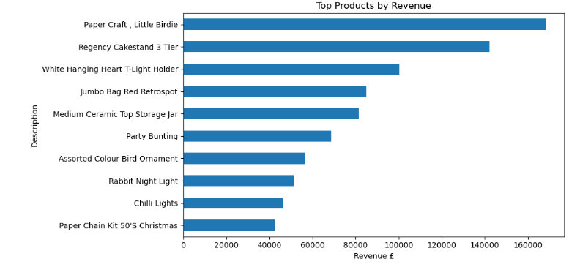
Figure 3: Top 10 Products by Revenue (Dec 2010 – Dec 2011)
3. Customer Loyalty is Shallow
Customer loyalty analysis across the 4,334 unique customers in the dataset reveals a shallow base of repeat engagement:
- 65.3% (2,829 customers) — are repeat buyers, a positive baseline signal
- 34.7% (1,505 customers) — never returned after their first purchase, representing significant lost lifetime value
- 4 Champion customers out of 4,334 (0.09%) — RFM segmentation reveals individuals who are simultaneously recent, frequent, and high-spending
- 2,070 customers (47.7%) — are Loyal customers, the largest segment, forming the backbone of business revenue
- 818 customers (18.9%) — are classified as At Risk, meaning they purchased historically but have not returned recently and are likely to churn permanently without targeted intervention
Customer 14646 is the single highest-value customer at £279,138 — nearly four times more than the tenth-highest spender at £72,708. This level of revenue concentration in a single customer represents a notable business risk if that relationship is lost.
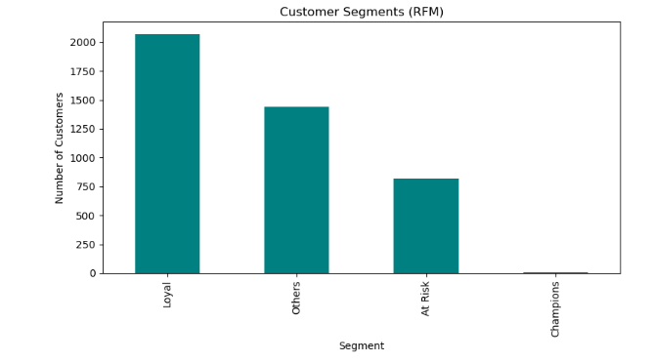

Figure 4: Customer Segments by RFM Score
4. Geographic Concentration is a Business Risk
Revenue is heavily concentrated by geography, with the UK dominating and creating exposure to UK-specific economic conditions, regulatory changes, or market disruptions:
- £7,244,330 (82.9% of total revenue) — the United Kingdom dominates revenue from 16,579 orders
- £205,381 — Germany is the next largest market, representing less than 3% of total revenue
- £183,987 — France is the third largest market, also representing less than 3% of total revenue
The most striking international insight is the United States, which generated the highest revenue per order at £716 despite recording only 5 transactions. American customers spend significantly more per order than any other market — 64% above the UK average of £436 — suggesting strong premium demand that warrants targeted investigation for potential expansion.
5. Return Rate Exceeds Industry Average
Return rate analysis shows the business is operating well above healthy industry benchmarks:
- 15.99% — the overall return rate by order volume, significantly above the retail industry average of 8–10%
- 9,376 units — Rotating Silver Angels T-Light Hldr is the most returned product, nearly three times more than the second-highest returned product (Fairy Cake Flannel Assorted Colour at 3,150 units)
- Top 10 by revenue, quantity sold, and returns simultaneously — White Hanging Heart T-Light Holder appears in all three lists — a particularly concerning combination. While it drives significant revenue, its return volume suggests a quality or product description mismatch that could be eroding profitability
An anomalous cancellation record of 80,995 units for Paper Craft, Little Birdie was identified and excluded from returns analysis, as it likely represents a system correction rather than a genuine customer return. Its inclusion would have inflated the return rate significantly.

Recommendations
The following seven recommendations are directly supported by the analytical findings above and are prioritised by estimated business impact.

1. Investigate and Resolve Return Rate Issues
The overall return rate of 15.99% may indicate issues related to product quality, unmet customer expectations, inaccurate product descriptions, or fulfilment errors. Rotating Silver Angels T-Light HLDR records 9,376 returned units-nearly three times more than the second most returned product – and should be prioritised for an in-depth investigation through customer return surveys, product quality inspection, and supplier engagement. Depending on findings, the business should consider redesigning the product, improving its description, changing suppliers, or discontinuing it if returns continue to negatively impact profitability.
Target: Reduce overall return rate from 15.99% to the industry average of 10% within 12 months of implementation
2. Implement a Post-Purchase Retention Programme
Target the 1,505 one-time buyers with an automated email sequence within 30 days of their first purchase. Offer a personalised discount, product recommendation based on their initial order, or loyalty incentive. Converting even 20% of one-time buyers into repeat customers would add approximately 300 new repeat customers to the base — directly reducing the current 34.7% one-time buyer rate.
Target: Convert 20% of one-time buyers to repeat customers within 6 months of programme launch
3. Activate VIP Customer Strategy for Customer 14646
Customer 14646 is the single highest-value customer at £279,138 — nearly four times more than the tenth-highest spender — representing a notable revenue concentration risk if that relationship is lost. The business should implement a dedicated VIP account strategy for this customer including personalised communication, exclusive offers, early product access, and dedicated support. Regular structured engagement would strengthen the relationship, encourage continued purchases, and reduce the risk of significant revenue loss from a single customer departure.
Target: Maintain Customer 14646 revenue contribution above £250,000 annually through structured quarterly engagement
4. Develop a Q4 Revenue Resilience Strategy
The business should increase inventory levels, strengthen supplier coordination, and launch targeted marketing campaigns in the months leading up to November to maximise peak season sales. During February — the weakest month at £442,493 — a demand-driven strategy of reducing stock for slower-moving products while promoting existing inventory through targeted discounts and product bundles would improve sell-through rates and reduce holding costs.
Target: Grow Q1 and Q2 revenue by 15% year-on-year to reduce Q4 dependency
5. Activate an At-Risk Customer Win-Back Campaign
The 818 customers classified as At Risk through RFM segmentation represent a significant churn threat. A targeted re-engagement campaign — personalised to their historical purchase behaviour and offering an incentive to return — should be prioritised for launch in the near term. Each recovered customer has a demonstrated spending history, making them far more valuable to re-acquire than acquiring a new customer from scratch.
Target: Re-engage a minimum of 30% of the 818 At-Risk customers (approximately 245 customers) within 90 days of campaign launch.
6. Pilot International Market Expansion Strategy
The United Kingdom contributes £7.22M (82%) of total revenue, highlighting its importance while also exposing the business to geographic concentration risk. The business should explore expanding into high-potential international markets — particularly the United States, where customers generate the highest average revenue per order at £716 despite relatively few orders, indicating a tendency toward higher-value purchases. Belgium records a high order volume but comparatively low revenue per order, suggesting the business should evaluate its product mix, pricing strategy, and promotional activities in that market through bundling, cross-selling, or revised pricing strategies.
Target: Achieve a minimum of 50 US transactions within a defined 6-month pilot period before evaluating full-scale expansion.
7. Investigate Product-Specific Issues and Protect Star Products
Paper Craft, Little Birdie ranks first by both revenue (£168,469) and quantity sold (80,995 units) — making it the single most important SKU in the catalogue — and the business should prioritise stock availability and marketing campaigns to maximize its revenue contribution. White Hanging Heart T-Light Holder appears simultaneously in the top 10 by revenue, quantity sold, and returns — suggesting a quality or description mismatch that may be eroding its profitability despite strong sales performance. World War 2 Gliders Asstd Designs ranks among the highest-selling and most returned products, indicating high volume popularity combined with a potentially high customer dissatisfaction rate that warrants investigation.
Target: Reduce White Hanging Heart T-Light Holder return volume by 40% within 6 months through description improvements and quality review, while maintaining its current revenue ranking
Next Steps
- Commission an urgent quality review of Rotating Silver Angels T-Light Hldr within 30 days — brief operations and supplier management teams on findings.
- Brief CRM team on post-purchase email sequence requirements and define the 30-day trigger workflow for first-time buyers.
- Identify and personally contact Customer 14646 to initiate a structured VIP account relationship.
- Present Q4 resilience plan to procurement team by July each year to ensure stock availability ahead of peak season.
- Define US market pilot budget, target transactional volume, and KPIs for board approval before end of quarter.
- Schedule 6-month progress review to measure performance against all seven recommendation targets.
Conclusion
RetailCo Online Ltd demonstrates strong revenue potential — generating £8.74M across 392,692 transactions in a single year — but faces three structural challenges that limit sustainable growth: heavy seasonal and geographic concentration, shallow customer loyalty, and an above-average return rate. The seven recommendations outlined in this report address these risks directly and represent the highest return-on-investment commercial opportunities currently available to the business.
Resolving customer retention through a post-purchase programme, reducing return rate leakage through product quality investigation, and piloting US market expansion would collectively reduce revenue volatility, improve customer lifetime value, and position RetailCo Online Ltd for more balanced and sustainable growth beyond its current Q4 and UK dependency. The analytical foundation presented in this report provides a clear, data-driven basis for each of these strategic decisions.

Limitations
The following data quality issues were identified and addressed during the analysis. They are documented here in the interest of analytical transparency.

Issue | Description
Null CustomerIDs | 132,220 transactions (24.4%) lacked a CustomerID and were excluded from customer-level analysis. Revenue figures for these transactions were not captured in customer segmentation.
Duplicate Rows | 5,268 fully duplicated transaction rows were identified and removed to prevent revenue double-counting.
Cancelled Orders | 9,288 cancellation records were separated from completed transactions and analyzed independently for returns analysis.
Missing Descriptions | 1,454 transactions with missing product descriptions were removed during data cleaning.
Anomalous Return Record | One cancellation record of 80,995 units for Paper Craft, Little Birdie was excluded from returns analysis as it likely represents a system correction rather than a genuine customer return.
Incomplete December 2011 | The dataset ends mid-December 2011, causing an apparent revenue drop that does not reflect actual business performance.

