**LOVELY PROFESSIONAL UNIVERSITY**

**Assignment on Age Detector in Artificial Intelligence**

**Submitted by**

**GitHub link -** [**https://github.com/demin13/agedetectionv**](https://github.com/demin13/agedetectionv)

**Forked and contributed by other members of my team**

|  |  |  |  |
| --- | --- | --- | --- |
| **Name** | **Registration No** | **Roll No** | **Section** |
| **Shekhar Anand** | **11803983** | **B43** | **K18KH** |
| **Anand Gupta** | **11803419** | **B41** | **K18KH** |
| **Jatin Gupta** | **11803885** | **B42** | **K18KH** |
| **Adithya Shankar L** | **11803986** | **B44** | **K18KH** |

**Submitted to**

**Name – Dr Sukhvir Kaur**

**Course Code – INT404**

**Course Title – Artificial Intelligence**

**Abstract: -**

To build a age detector that can approximately guess the age of the

person (face) in a picture or through webcam**.**

**Introduction**

In this Python Project, We have used Machine Learning to accurately identify the age of **a person's**from **one**image of a face and also by webcam.

**The anticipated**age **could also be one among the subsequent**ranges- (0 – 2), (4 – 6), (8 – 12), (15 – 20), (25 – 32), (38 – 43), (48 – 53), (60 – 100).

**It's**very difficult to accurately guess **a particular**age from **one**image **due to**factors like makeup, lighting, obstructions, and facial expressions. And so, I made this a classification problem **rather than**making it **one among**regression.

In this project we tried to detect age about 80 to 90 % and as of now the availability of datasets we are able to detect about 70 to 80 % accuracy level.

In this project we have use different libraries of python like OpenCV and different datasets of images to train our convolutional neural network.

**OBJECTIVES**

The main objectives of this project is to detection of age by recognizing face of human from Image of any image file type such as jpg, png, jpeg, etc or from webcam.

Also, at the end of this project we are able to work with different library and convolution neural network that how machines train themselves using some datasets and accurately able to detect such things like age of human.

METHODOLOGY

Content of the project: -

1. Script.py
2. h_face.py
3. age_deploy.prototxt
4. age_net.caffemodel
5. opencv_face_detector.pbtxt
6. opencv_face_detector_uint8.pb

**Details about each contents:** -

1. **Script.py**

In this python file the main script is written related to this project and also imported h_face.py file for highlighting the face in images or in case of webcam.

With the help of commenting in script described about each line.

1. **h_face.py**

In this python file script in python is written to highlight the face in front of webcam. With the help of commenting in script described about each line.

1. **age-deploy.prototxt**

In this step, we choose a CNN architecture and we define its parameters in a configuration file with extension .prototxt.

The solver is responsible for model optimization. We define the solver parameters in a configuration file with extension. prototxt.

1. **age_net.caffemodel**

Model training, We train the model by executing one Caffe command from the terminal. After training the model, we will get the trained model in a file with extension .caffemodel.

1. **openface_face_detector.pbtxt and opencv_face_detector_uint8.pb**

A very useful functionality was added to OpenCV’s DNN module: a Tensorflow net importer

Tensorflow models usually have a fairly high number of parameters. Freezing is the process to identify and save just the required ones (graph, weights, etc) into a single file that you can use later. So, in other words, it’s the TF way to “export” your model. The freezing process produces a Protobuf ( .pb ) file.

 Additionally, OpenCV requires an extra configuration file based on the .pb, the  .pbtxt. It is possible to import your own models and generate your own .pbtxt files by using one of the following files from the OpenCV Github repository.

**Working: -**

**Requirements :-** python 3 , OpenCV, argparse

For webcam:-

Run : - python script.py

For Image which should be available in same directory and all project files.

Run - python script.py --image “name of image with extension”

To end the programme – press ctrl+c

**RESULTS**

**# python script.py - - image shekhar.jpeg**

* 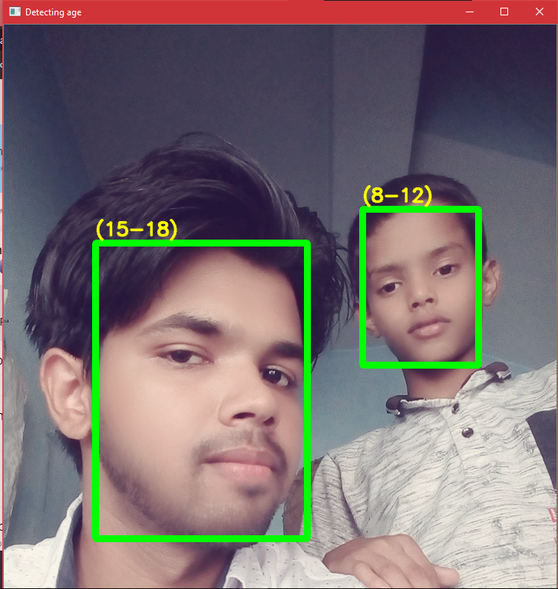age - 15-18
* Age - 8-12

**# python script.py - - image jatin.jpeg**

* 15-18
* 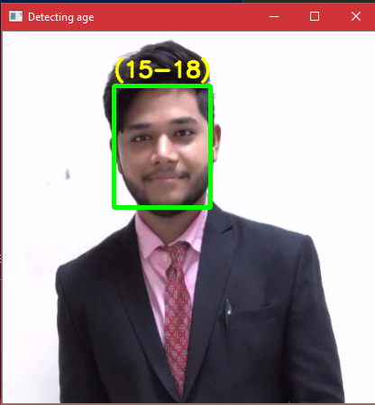real – 19
* 80% accuracy

**# python script.py - - image anand.jpeg**

* Age- 19-22
* Real - 20

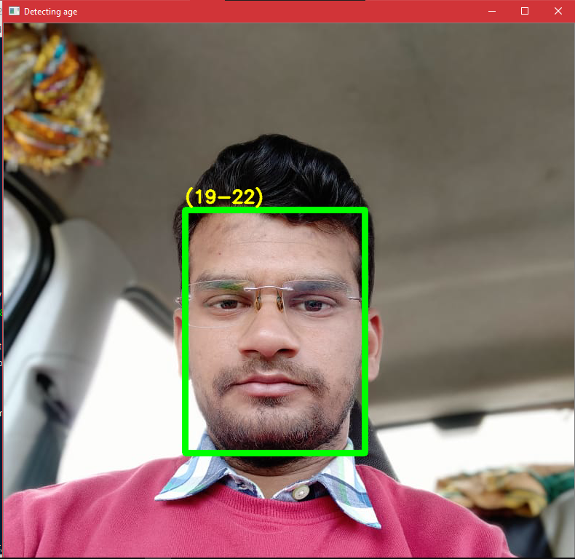

**# python script.py - - image shekhar.jpeg**

* **Age- 15-18**
* **Real - 20**

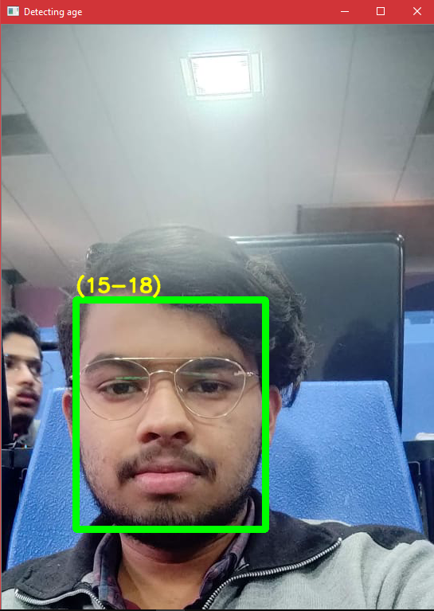

**CONCLUSION**

At the end , our project is able to detect age from image approximately 80- 90 % accuracy. And also we all gain knowledge and practical experience over some popular library in python such as OpenCV and also hand on practice with CNN.

**FUTURE SCOPE**

As we know that as of now many company are using face recognition technique on their web app or app for their commercial purpose or for any other use. Age detection is one of the main thing among these like if we talk about future then this can be use to detecting age of those person whose identity are unknown (DOB), or in case of filling the submitted form in govt sector in villages, as many people don’t know their date of birth.