Binary Heaps: Homework

Exercise 1: Implement the array-based representation of binary heap together with the functions HEAP MIN, REMOVE MIN, HEAPIFY, BUILD HEAP, DECREASE KEY, and INSERT VALUE.
Solution: Array- based representation of binary heap has been already implemented in lecture 6, lecture 7 and lecture 8. All the implementations can be found in `binheap.c`.
Firstly, representation of binary heaps are defined and this struct includes the following properties.
`void *A`: This is the array used to store heap nodes
`num_of_elem`: This is the number of nodes in the heap
`max_size`: This is the maximum number of size
`key_size`: Size of the key type
`leq`: This is the heap total order which is user defined (total_order_type)
`max_order_value`: This is the maximum value stored in the heap
Also common heap operations are implemented as well as useful ones such as heapify, build_heap, insert, find_max and extract.

Exercise 2: Implement an iterative version of HEAPIFY.
Solution: Again iterative version of heapify has been implemented in lectures 6,7 and 8. Function takes two arguments `binheap_type *H` and `node`. Destination node is containing the minimum among the nodes its children.
Idea is correcting a single violation of the heap property in a sub-trees root, of course by making necessary comparisons (total_order is used, good candidates are chosen by checking right and left children) and swaps.

Exercise 3: Test the implementation on a set of instances of the problem and evaluate the execution time.
Solution: In the folder tests, `performance_test.c` file has been written. It is a simple code which measures the time to insert random value to heap and produce a file named `output.txt`. One can easily compile the `performance_test.c` by using following command `gcc performance_test.c -I /usr/local/lib ../libbinheap.so -o insert_test.o`.
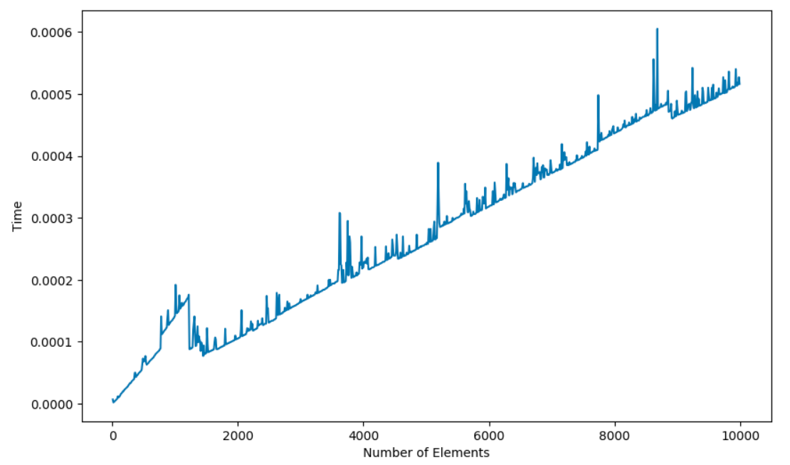

Above you can find the the asymptotic complexity of the `insert_value` function.

