CEN449 – Project I: Autonomous Navigation Mobile Robot Simulation
Student Name: Cagri DEMİR
Date: 21 December 2025
Course: CEN449 - Introduction to Autonomous Robots

1. Introduction and Objectives
The primary objective of this project is to simulate an autonomous mobile robot capable of navigating an unknown environment without relying on a pre-saved map. To achieve this, the ROS 2 Humble middleware and the Gazebo simulation environment were utilized.
The specific goals of the project include:
- Setting up a simulation environment with the TurtleBot3 Waffle Pi model.
- Implementing a SLAM (Simultaneous Localization and Mapping) algorithm to generate a 2D occupancy grid map of the environment in real-time.
- Developing a reactive control algorithm to enable the robot to explore the area autonomously while avoiding obstacles using Lidar sensor data.

2. System Architecture
The system is built upon the Robot Operating System (ROS 2 Humble) running on Ubuntu 22.04 LTS. The architecture consists of three main components communicating via ROS 2 topics:
- Simulation Layer: The Gazebo simulator hosts the TurtleBot3 Waffle Pi robot model and the physical environment (turtlebot3_world). It publishes sensor data (LaserScan, Odom, TF).
- Mapping Layer: The Google Cartographer package is used for SLAM. It subscribes to the /scan and /odom topics to construct a real-time map of the environment.
- Control Layer: A custom Python node (otonom_surus.py) serves as the "brain" of the robot. It processes raw Lidar data to detect obstacles and publishes velocity commands to the /cmd_vel topic.
Middleware Configuration: During development, standard ROS 2 discovery issues were encountered. To resolve high latency and packet loss in the simulation, the default middleware was replaced with Eclipse CycloneDDS (rmw_cyclonedds_cpp), ensuring stable communication between nodes.

3. Implementation Details
3.1. Autonomous Navigation Logic Unlike standard navigation stacks that require a known map (e.g., Nav2), this project implements an exploratory navigation approach. A custom Python script was developed to handle obstacle avoidance reactively:
- Sensing: The robot monitors the LaserScan data, specifically focusing on a 20-degree cone in the forward direction.
- Decision Making:
  - If the minimum distance to an obstacle falls below 0.6 meters, the robot halts linear motion and rotates (Angular Velocity: 0.5 rad/s) until the path is clear.
  - If no obstacle is detected, the robot moves forward (Linear Velocity: 0.2 m/s).
3.2. Mapping (SLAM) For mapping, the turtlebot3_cartographer package was launched with the use_sim_time:=True parameter to synchronize with the simulation clock. This allowed the generation of a high-resolution 2D occupancy grid map (.pgm and .yaml) as the robot explored the arena.

4. Results
The simulation was successfully executed, and the robot demonstrated the ability to navigate the entire environment without collision.
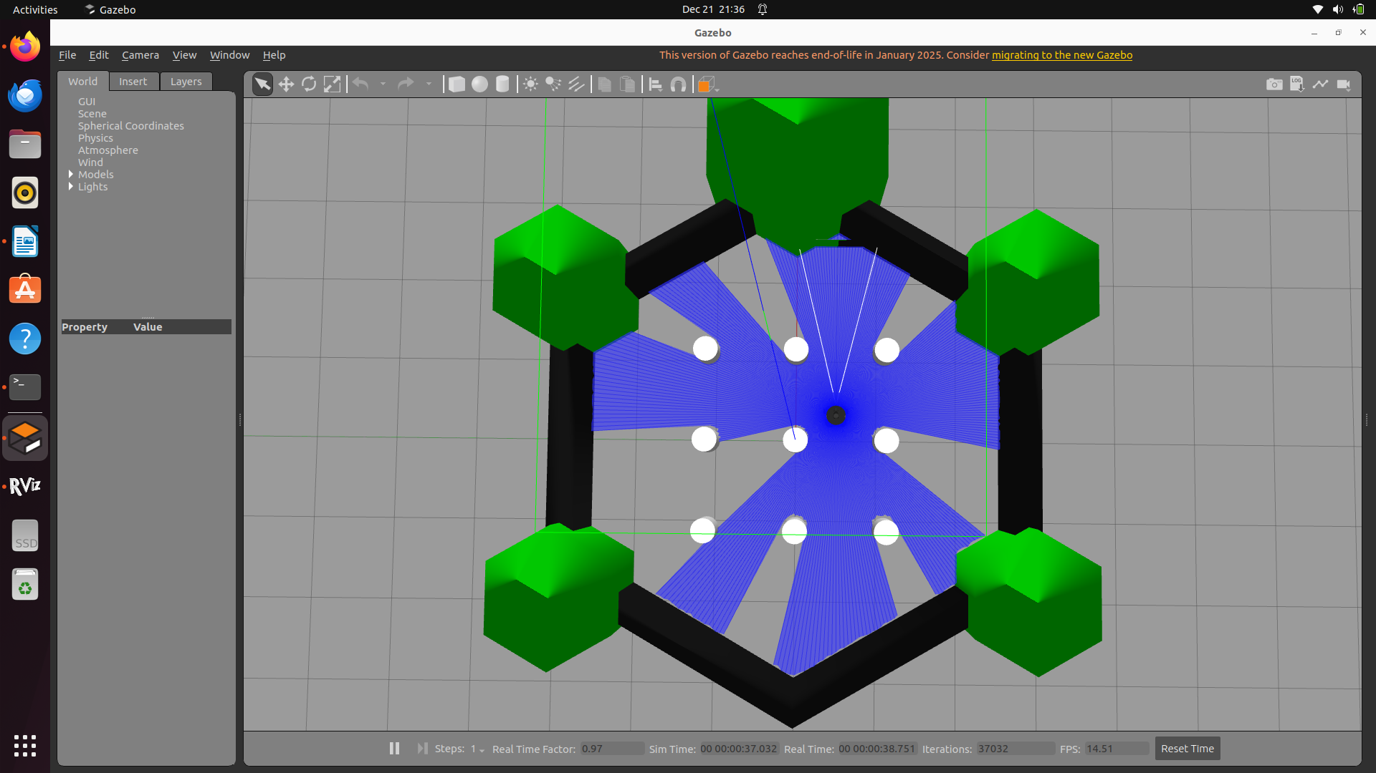
Figure 1: Simulation Environment [Figure 1 shows the TurtleBot3 Waffle Pi navigating through the obstacles in the Gazebo environment.
Figure 2: Mapping Output (RViz) [Figure 2 displays the completed occupancy grid map generated by the SLAM algorithm. The black lines represent walls/obstacles, while the white areas represent free space.
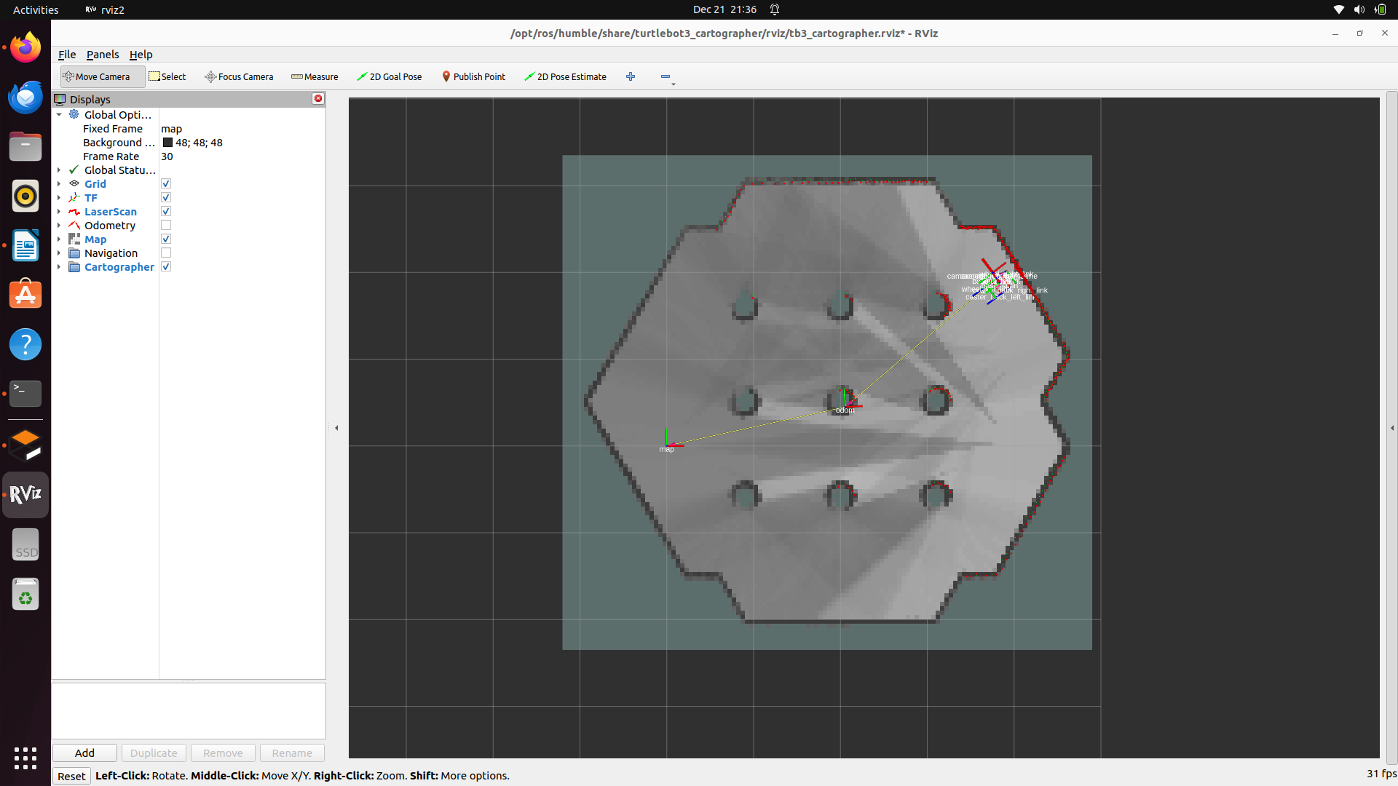

5. Conclusion
In this project, a fully autonomous mobile robot simulation was developed using ROS 2. By integrating the Cartographer SLAM algorithm with a custom Python-based obstacle avoidance logic, the robot successfully mapped an unknown environment. The project demonstrated the practical application of ROS 2 nodes, topics, and sensor integration, satisfying all course requirements.

