
Ankara Yıldırım Beyazıt University
Department of Computer Engineering
CENG 201 – Object Oriented Programming
Course Project

G3: periodiC++

Analysis Report

Ahmet Kaan Demirci - 21050111031
Mehmet Emre Cebeci - 21050111037
Mustafa Özdemir -
Teoman Güven -

Instructor: Muhammed Abdullah Bülbül
Teaching Assistant: Elif Şanlıalp
Date: 31/11/2023

Table of Contents

1. Introduction 2
2. Requirements 2
2.1. Functional Requirements 2
2.2. Non-Functional Requirements 3
3. System Models 3
3.1. Scenarios 3
3.2. Use Cases 3
3.3. Object and Class Model 3
3.4. User Interfaces 3
4. Conclusion 3

Introduction

The periodiC++ application is a comprehensive periodic table application that have several features: A user-friendly interface allows you to explore chemical properties, delve into insightful learning sections, and participate in integrated quizzes to master periodic table. “periodiC++” have two engaging quiz modes: “Levels” and “Challenge Mode”, where users can test their knowledge against the clock, earn points and perform at their best. The Compounds section further enhances the learning journey. With a customisable viewing experience, users can personalise their periodic table display, choosing properties to highlight and tailoring the visual representation to their preferences. The Achievements section, that is primarily designed for quizzes adds a competitive edge and motivates users to reach new milestones in their chemical knowledge journey. Embark on a captivating educational adventure with “periodiC++”, where chemistry comes to life through interactive exploration and dynamic learning tools.

Requirements

Functional Requirements

General Application Requirements
- There will be a menu, the user will be able to select the desired section from the menu:
  - Table Section (Default)
  - Search Section
  - Learn Section
  - Quiz Section
  - Compounds Section
  - Achievements Section
  - Settings Section

Periodic Table Section Requirements
- The user will be able to choose the periodic table coloring according to the properties they want in the periodic table, there will be special coloring for each option.
  - Classes (Default)
  - Blocks
  - Metallic
  - Phase
  - Radioactivity
- The user will determine which property he/she wants to display the elements in the table
  - Simple
  - Detailed
  - Element name (Default)
  - Atomic weight
  - Discovery Year
  - Electron configuration
  - Elements per shell
  - Common oxidations
  - Melting Point
  - Boiling Point
  - Density
  - Cas Number
- Possibly there will be two different modes for viewing the periodic table:
- In Default mode, the element information mode will be pop-up and more detailed.
- In Wide mode, the element information will be simplified on the left side.
- The user will be able to select the element he/she wants to obtain information from the periodic table:
  - In the pop-up window, the picture or the model of the element can be changed, and clicking on it will switch between the two.
  - In the window that opens, there will be information about the element. Some possible informations:
    - Brief Information Part:
      - Name
      - Description
      - Discovered by
      - Discovery Tear
    - Element Properties Part:
      - Atom Number
      - Atomic Weight
      - Group Number
      - Period
      - Block
      - Radioactivity
    - Atomic Properties Part:
      - Electron configuration
      - Electrons Per Shell
      - Oxidation States
      - Common Oxidation States
      - Electronegativity
      - Covalent Radius
      - Van der Waals Radius
    - Physical Properties Part:
      - Appearance
      - Phase
      - Melting Point
      - Density
      - Heat of Fusion
      - Heat of Vaporization
      - Molar Heat Capacity

Search Section Requirements
- Display elements in a listed form.
- The user will be able to search for the desired element

Learn Section Requirements
- There will be a section where the user can learn the properties of the periodic table.
- There will be selectable separate properties here. You will select whatever you want.

Quiz Section Requirements
- There will be various Quiz modes, the user will choose one of the modes: 1. Levels: - level1, level2, level3, level4 (as the user finishes levels, others are unlocked, basic questions about elements) 2. Challenge Mode: - Try to get the highest score in this time-limited mode!
- There will be an automatic recording system, even if the user closes the application, he will be able to continue from the level he left when he reopens it.
- The scorekeeper for Challenge mode will give a score according to the element and time the user knows correctly.
- The user will be able to see the highest score of all times.

Compounds Section Requirements
- Example: H and O are entered, the compounds that can be formed from the entered elements are displayed.

Achievements Section Requirements
- There will be achievements related to quizzes.
- example1: Completing level 1 in Level mode (possible achievement name: "fire, water, earth, wood!")
- example2: Completing all Levels (possible achievement name: "")
- example3: In Challenge Mode, reach score at least 1000 (possible achievement name: "Chemistry Master")

Settings Section Requirements
- Dark-Light mode
- Language
- Window mode: fullscreen, windowed...
- Report a bug

Non-Functional Requirements
- The application should respond quickly to user interactions.
- Quiz questions should load without noticeable delays.
- Elements in the periodic table should be easily accessible and identifiable.
- The periodic table interface should provide clear and visually appealing representations of element properties.
- The scoring system should accurately reflect user performance in quizzes.

System Models

Scenarios

Scenario 1:

Emre, who wants to see the periodic table blocks, opens the periodiC++ application and sees the elements colored according to their classes. Then, he/she selects the "Blocks" option from the left menu to see which elements are in which block, and sees that the elements are colored according to their blocks.

Scenario 2:

Ahmet needs the properties of the elements iron, oxygen and beryllium in his homework. He quickly opens peridiC++ and goes to the "Search" section. He type the elements he needs to the search bar and accesses the element information.

Scenario 3:

Mustafa, who has a chemistry homework about nonmetals, opens the periodiC++ application. He chooses coloring based on "metallic properties" from the left menu. He then sees the nonmetals colored and notes which elements are nonmetals. Then, he enters the “Learn” section from the top menu and from there enters the metallic property section. He then takes notes on the information about nonmetal and submits his homework.

Scenario 4:

Teoman, who wants to learn the elements in the periodic table, opens the application. First, he sees the names of the elements on the periodic table. Then, he selects "atomic weight" from the interactive button and sees the atomic weights of the elements written on the periodic table. Emre, who thinks that he has learned the table sufficiently, enters the "Quiz" section and reinforces what he has learned by solving the questions in the "Levels" mode.

Use Cases
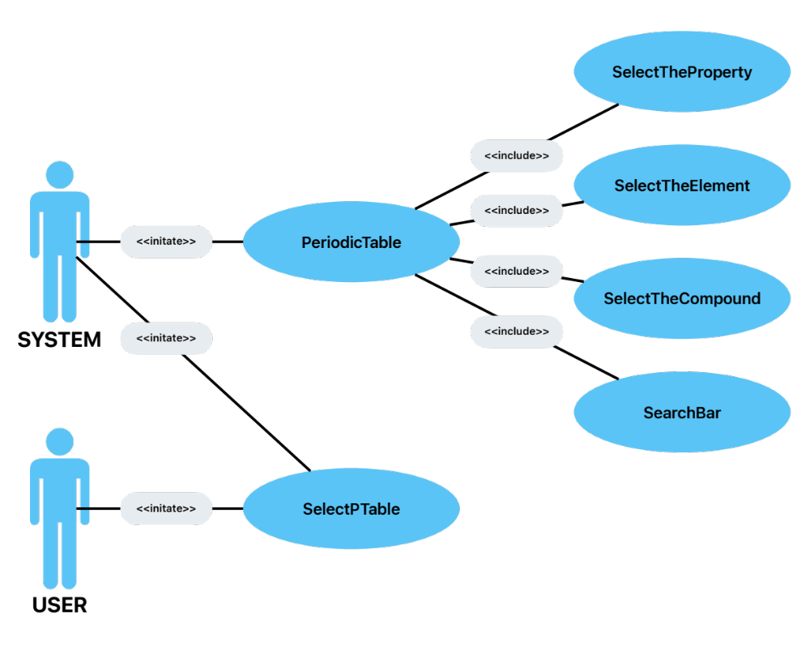
Use Case-1
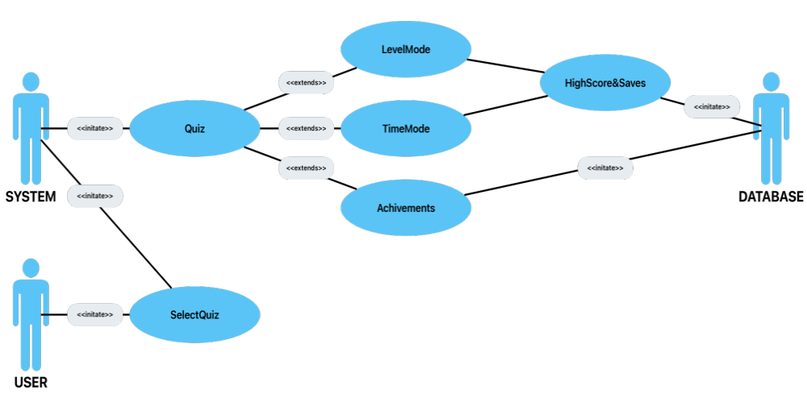
Use Case-2

Object and Class Model
Try to identify the classes and their relations. They don’t need to be detailed. You don’t need to capture all fields and methods.

User Interfaces
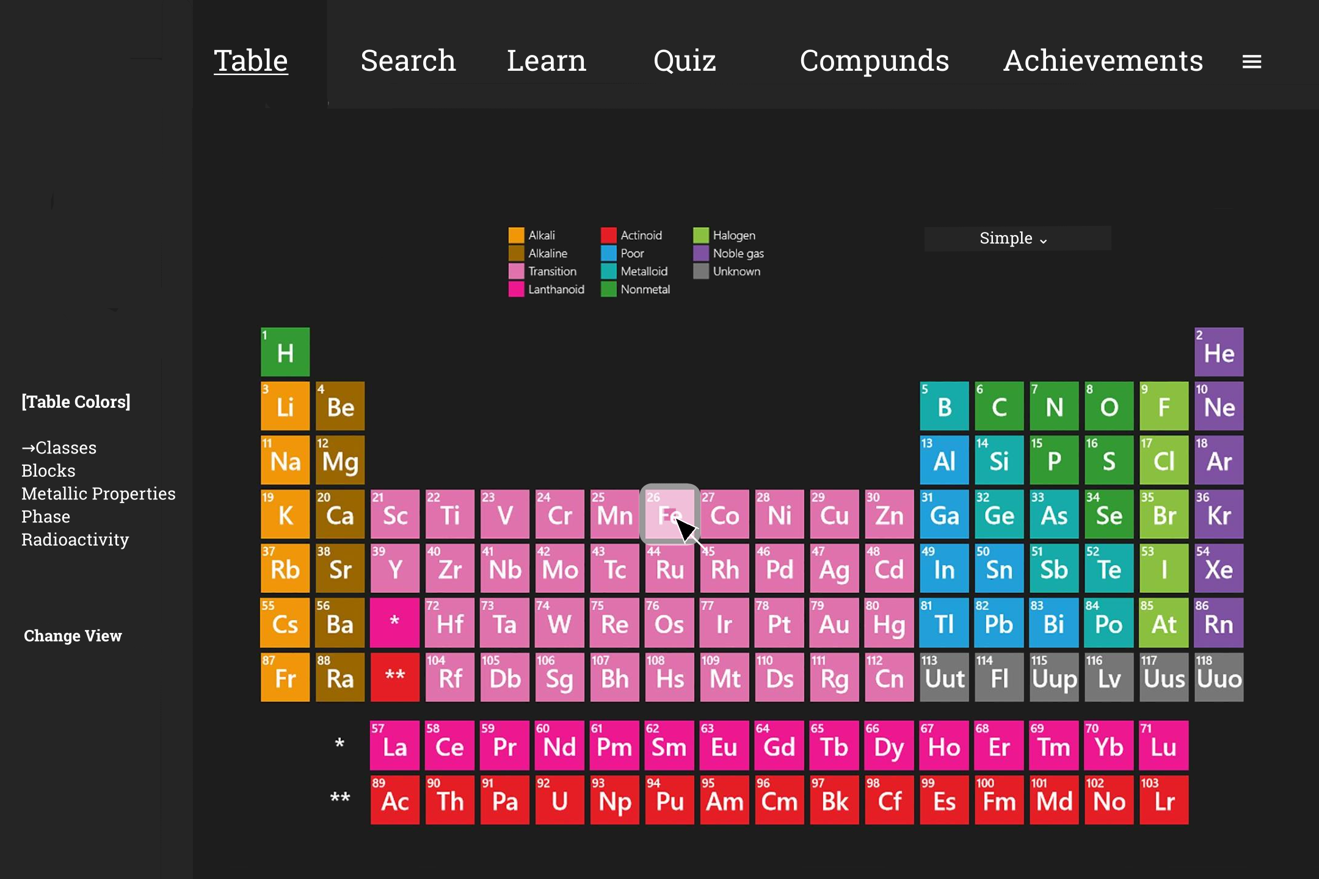
(1)
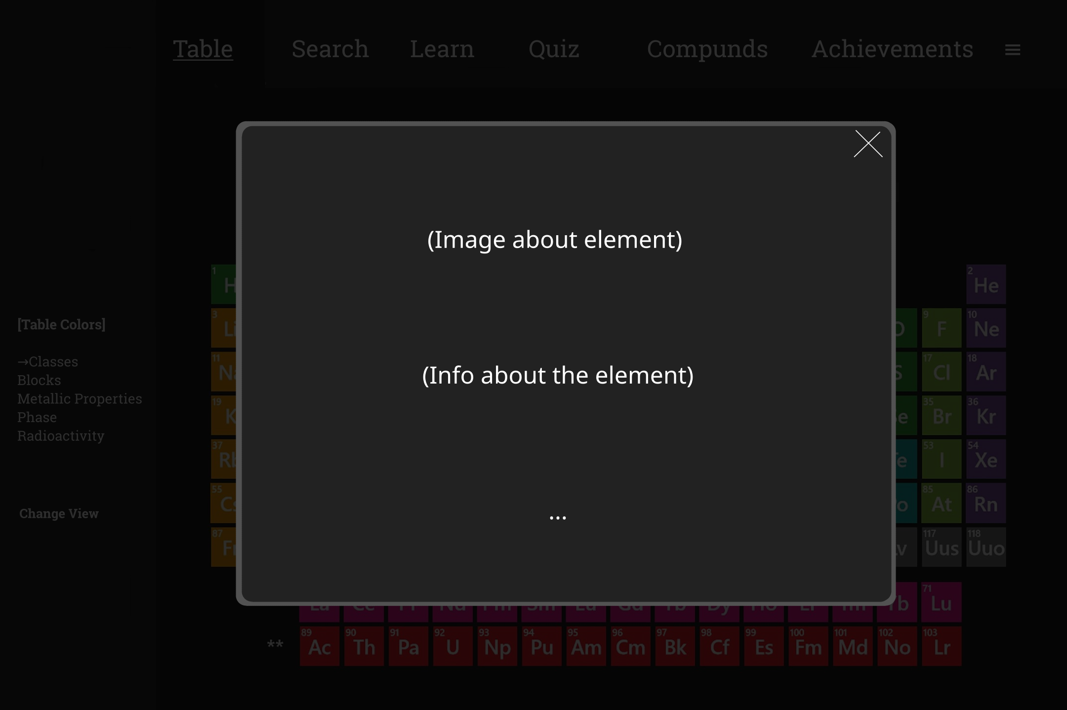
(2)
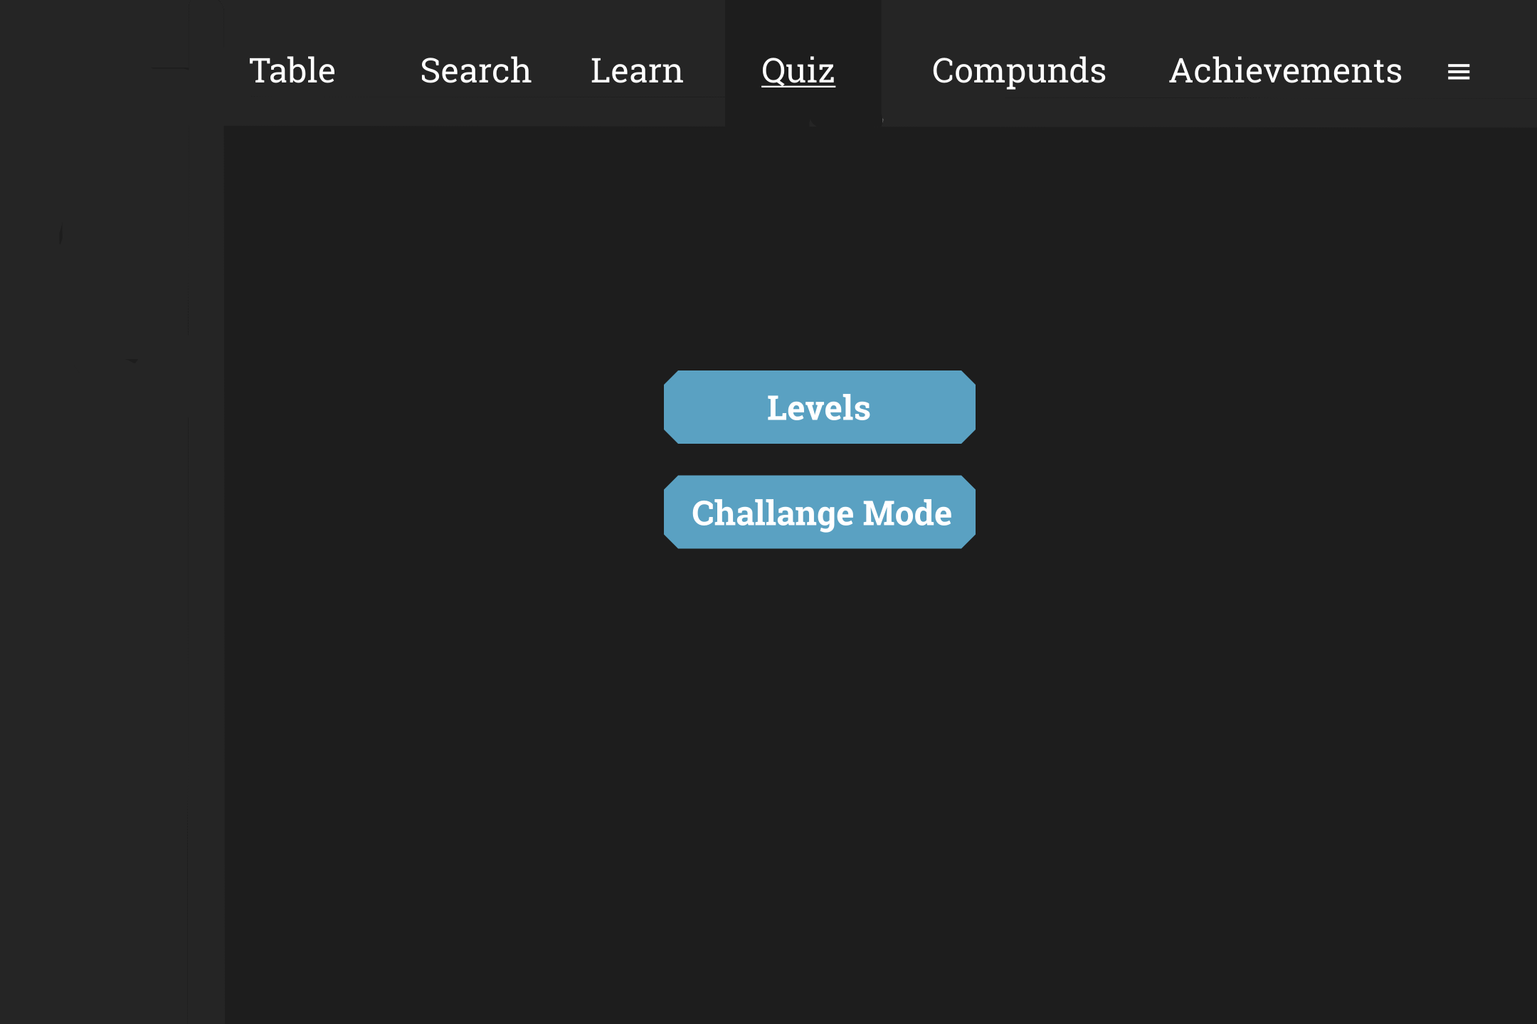
(3)

Conclusion
In this report, we created an outline of the project. We decided which sections will be in the project, how these sections will be designed and how the general interface will look like. We wrote 2 use cases related to the project and created an object and class model based on them. When we were designing the project, we agreed that everyone would work collaboratively in all phases of the project in the later stages of the project.

