
Ankara Yıldırım Beyazıt University
Department of Computer Engineering
CENG 201 – Object Oriented Programming
Course Project

G3: periodiC++

Analysis Report

Ahmet Kaan Demirci
Mehmet Emre Cebeci
Mustafa Özdemir
Teoman Güven

Instructor: Muhammed Abdullah Bülbül
Teaching Assistant: Elif Şanlıalp
Date: 31/11/2023

Table of Contents

1. Introduction 2
2. Requirements 2
2.1. Functional Requirements 2
2.2. Non-Functional Requirements 3
3. System Models 3
3.1. Scenarios 3
3.2. Use Cases 3
3.3. Object and Class Model 3
3.4. User Interfaces 3
4. Conclusion 3

Introduction

The periodiC++ application is a comprehensive periodic table application that have several features: A user-friendly interface allows you to explore chemical properties, delve into insightful learning sections, and participate in integrated quizzes to master periodic table. “periodiC++” have two engaging quiz modes: “Levels” and “Challenge Mode”, where users can test their knowledge against the clock, earn points and perform at their best. The Compounds section further enhances the learning journey. With a customisable viewing experience, users can personalise their periodic table display, choosing properties to highlight and tailoring the visual representation to their preferences. The Achievements section, that is primarily designed for quizzes adds a competitive edge and motivates users to reach new milestones in their chemical knowledge journey. Embark on a captivating educational adventure with “periodiC++”, where chemistry comes to life through interactive exploration and dynamic learning tools.

Requirements

Functional Requirements

General Application Requirements
- There will be a menu, the user will be able to select the desired section from the menu:
  - Table Section (Default)
  - Search Section
  - Learn Section
  - Quiz Section
  - Compounds Section
  - Achievements Section
  - Settings Section

Periodic Table Section Requirements
- The user will be able to choose the periodic table colouring according to the properties they want in the periodic table, there will be special colouring for each option.
  - Classes (Default)
  - Blocks
  - Metallic
  - Phase
  - Radioactivity
- The user will determine which property he/she wants to display the elements in the table
  - Simple
  - Detailed
  - Element name (Default)
  - Atomic weight
  - Discovery Year
  - Electron configuration
  - Elements per shell
  - Common oxidations
  - Melting Point
  - Boiling Point
  - Density
  - Cas Number
- There will be two different modes for viewing the periodic table:
- In Default mode, the element information mode will be pop-up and more detailed.
- In Wide mode, the element information will be simplified on the left side.
- The user will be able to select the element he/she wants to obtain information from the periodic table:
  - In the pop-up window, the picture or the model of the element can be changed, and clicking on it will switch between the two.
  - In the window that opens, there will be information about the element. Some possible informations:
    - Brief Information Part:
      - Name
      - Description
      - Discovered by
      - Discovery Tear
    - Element Properties Part:
      - Atom Number
      - Atomic Weight
      - Group Number
      - Period
      - Block
      - Radioactivity
    - Atomic Properties Part:
      - Electron configuration
      - Electrons Per Shell
      - Oxidation States
      - Common Oxidation States
      - Electronegativity
      - Covalent Radius
      - Van der Waals Radius
    - Physical Properties Part:
      - Appearance
      - Phase
      - Melting Point
      - Density
      - Heat of Fusion
      - Heat of Vaporization
      - Molar Heat Capacity

Search Section Requirements
- Display elements in a listed form.
- The user will be able to search for the desired element

Learn Section Requirements
- There will be a section where the user can learn the properties of the periodic table.

Quiz Section Requirements
- There will be various Quiz modes, the user will choose one of the modes: 1. Levels: - level1, level2, level3, level4 (as the user finishes levels, others are unlocked, basic questions about elements) 2. Challange Mode: - Try to get the highest score in this time-limited mode!
- There will be an automatic recording system, even if the user closes the application, he will be able to continue from the level he left when he reopens it.
- The scorekeeper for Challange mode will give a score according to the element and time the user knows correctly.
- The user will be able to see the highest score of all times.

Compounds Section Requirements
- Example: H and O are entered, the compounds that can be formed from the entered elements are displayed.

Achievements Section Requirements
- There will be achievements related to quizzes.
- example1: Completing level 1 in Level mode (possible achievement name: "fire, water, earth, wood!")
- example2: Completing all Levels (possible achievement name: "")
- example3: In challange mode, reach score at least 1000 (possible achievement name: "Chemistry Master")

Settings Section Requirements
- Dark-Light mode
- Language
- Window mode: fullscreen, windowed...
- Report a bug

Non-Functional Requirements
• The application should respond quickly to user interactions.
• Quiz questions should load without noticeable delays.
• Elements in the periodic table should be easily accessible and identifiable.
• The periodic table interface should provide clear and visually appealing representations of element properties.
• The scoring system should accurately reflect user performance in quizzes.

System Models

Scenarios
Scenario 1:Ahmet, who started to take chemistry lessons, would like to get more information about the periodic table and periodic table elements. For this, it opens periodiC++ and clicks on these elements in order to learn more about the few elements it sees after examining the periodic table that appears. When he sees the changing properties of the elements, his curiosity about the elements increases. In order to see more clearly the change of the element properties of the periodic table, it uses the sorting feature according to the existing feature in the program.
Scenario 2:Musab Chemistry needs the properties of iron, oxygen and beryllium elements in his homework. Instead of searching the internet one by one, it quickly opens peridiC++ and reaches the properties of the elements with one click.
Scenario 3:Eren turns on the app's quiz mode to reinforce the information he has learned. Here, it solves quizs with increasing difficulty, whether against time or by level. In these quises, Eren's score, record and highest score are kept. He achieves various achievements depending on the quiz he solves.
Scenario 4:Ali, who opens the periodic table program, notices that he is missing information about some properties while navigating between the elements in the table. In order to compensate for the lack of knowledge, he enters the learning section and completes the parts he does not know or knows missing.

Use Cases
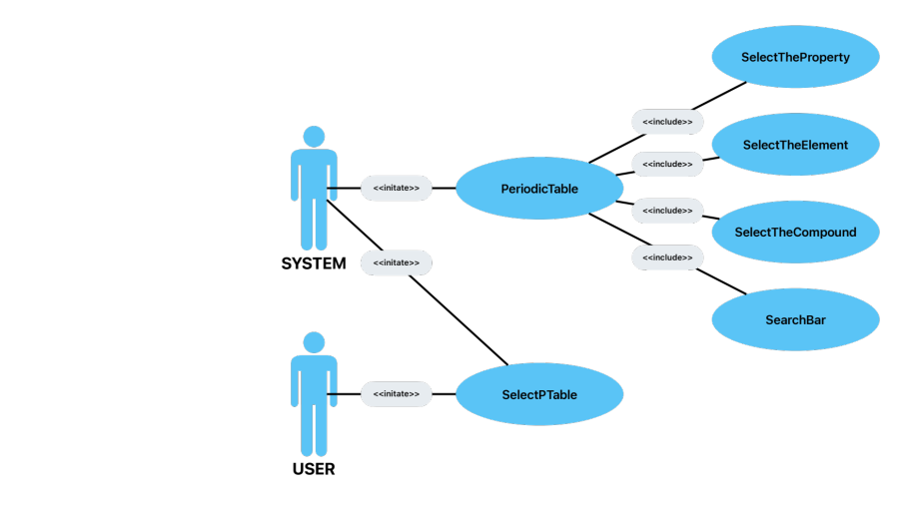
Use Case-1
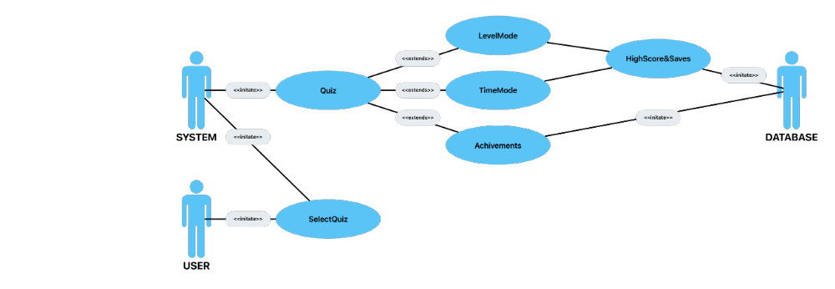
Use Case-2

Object and Class Model
Try to identify the classes and their relations. They don’t need to be detailed. You don’t need to capture all fields and methods.

User Interfaces

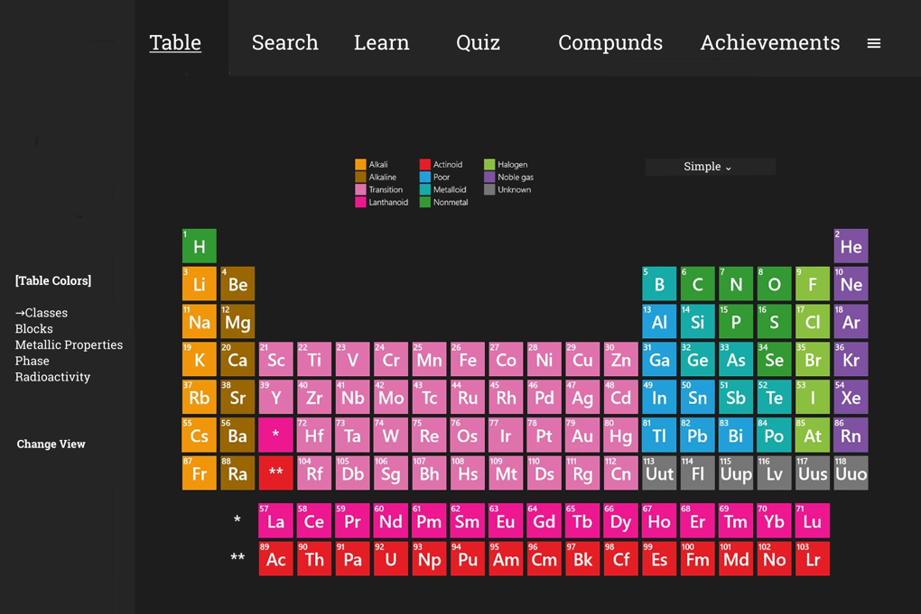

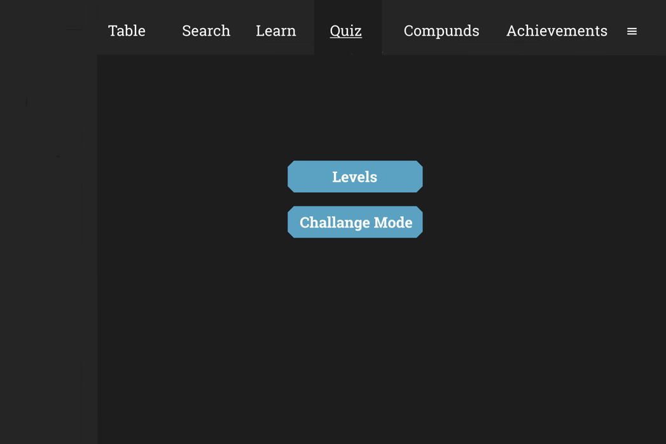

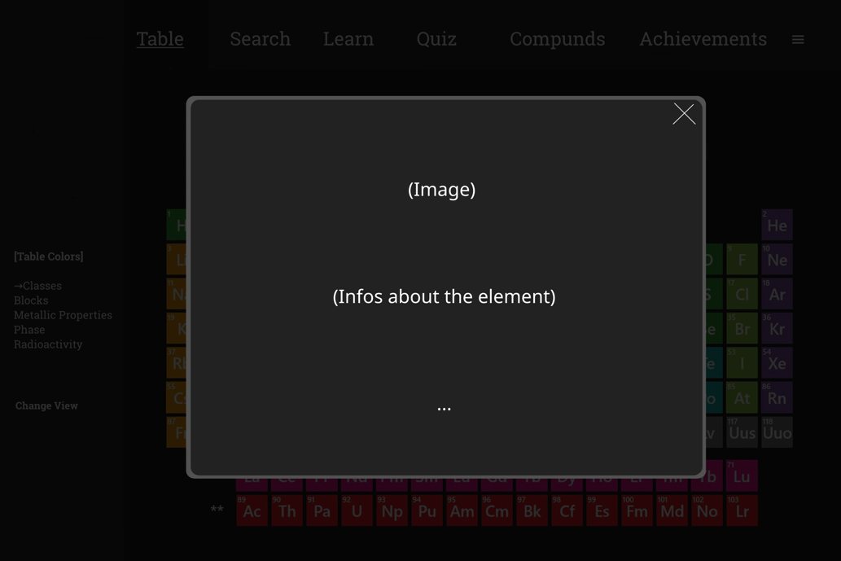

Conclusion
In this report, we created an outline of the project. We decided which sections will be in the project, how these sections will be designed and how the general interface will look like. We wrote 2 use cases related to the project and created an object and class model based on them. When we were designing the project, we agreed that everyone would work collaboratively in all phases of the project in the later stages of the project.

