**Author:** Ahmet Eroğlu nickname:demirhindi

**Purpose:** Creating a simple built application for drones will rented.

**Features:** Listing of drones, Renting the drone that the user is interested in at certain date intervals, only those with personnel permission can enter and edit products, only those with personnel permission approve or reject the application, list the user's rental applications,

**Technology and Design Tools Used:** Django and Django rest framework, djoser library on backend, vue js 3 on frontend, vuex for auhtantication, Bootstrap 5 for Design

**Images:**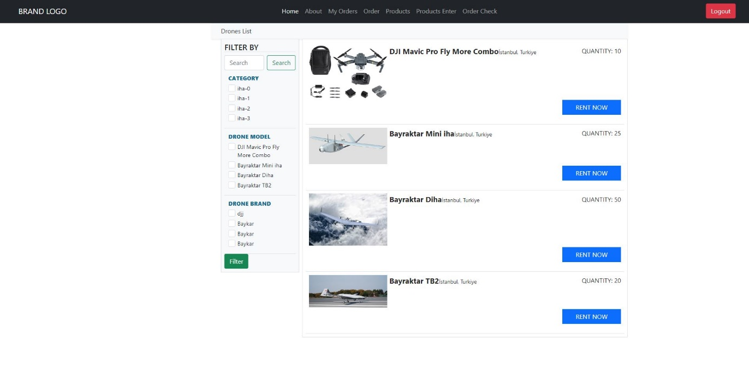

Figure 1Home Page

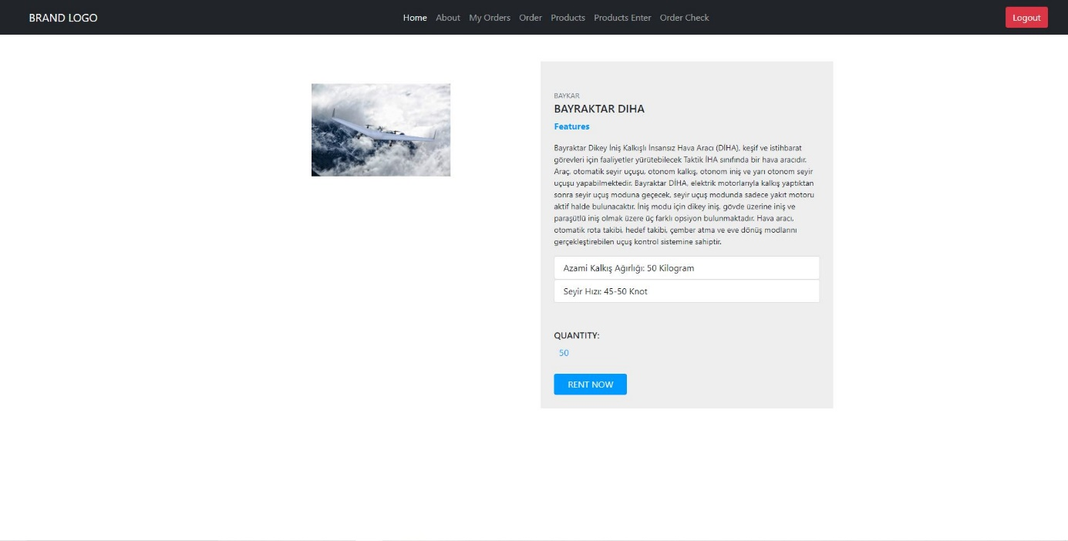

Figure 2Detail Page

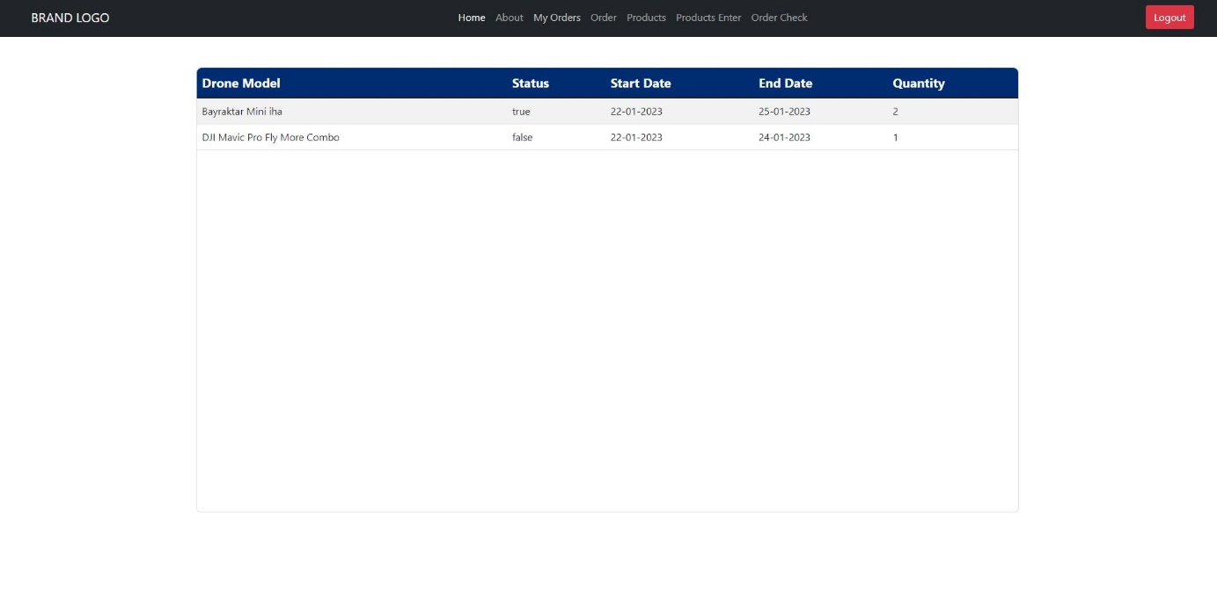

Figure 3 User Orders

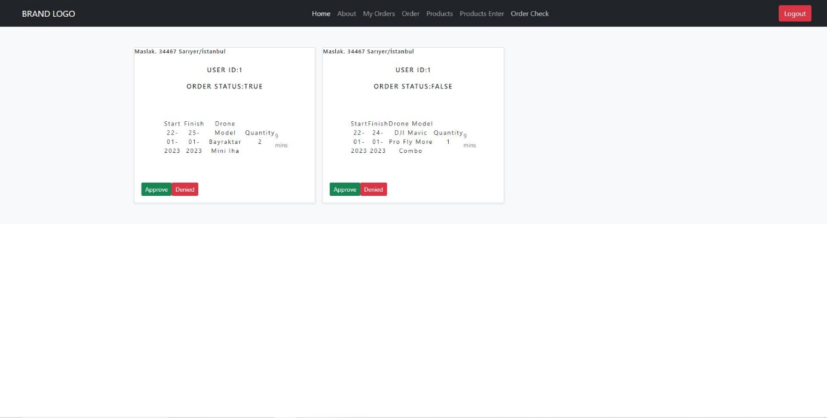

Figure 4 Personel Orders View

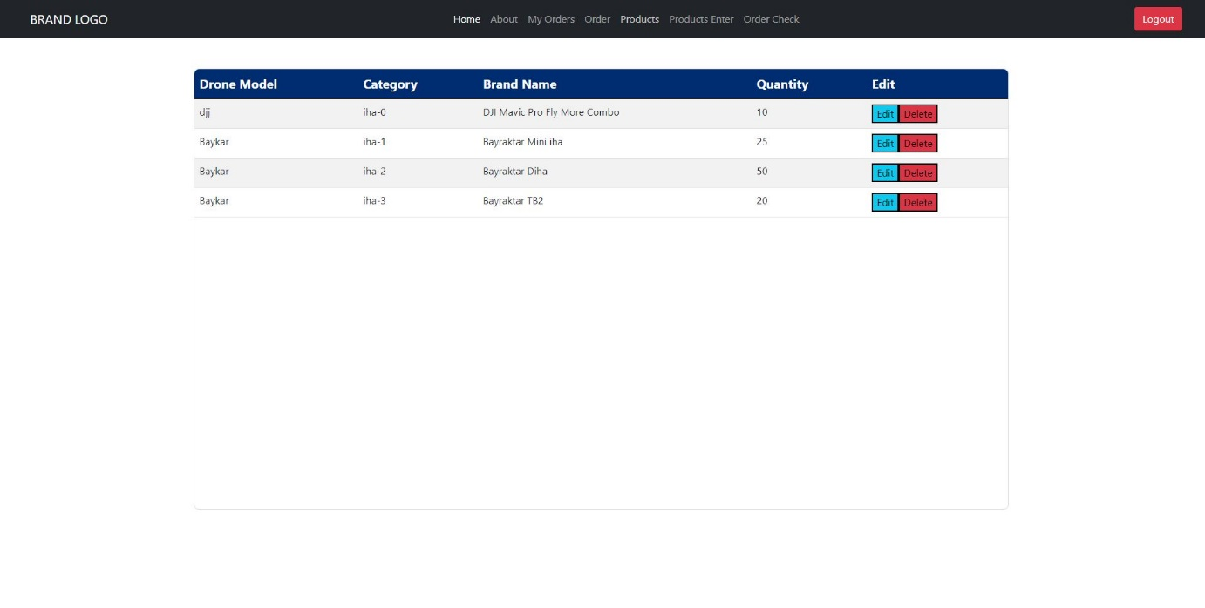

Figure 5 Personel Edit Products

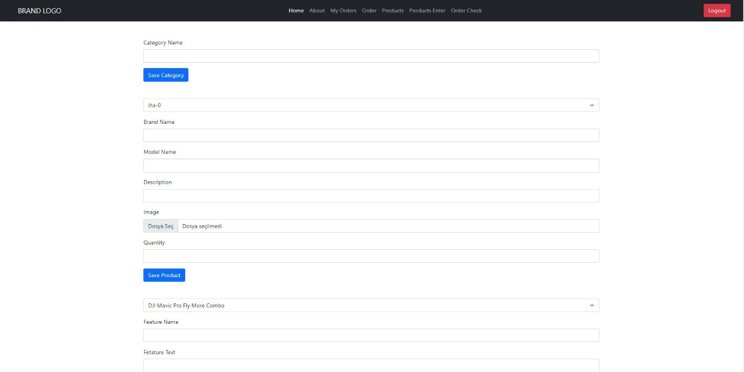

Figure 6 Personel Enter Products View

**Additional info:** You need to create a superuser on django to be able to login as staff.