Appendix D: Original Project Plan (Gantt Chart)
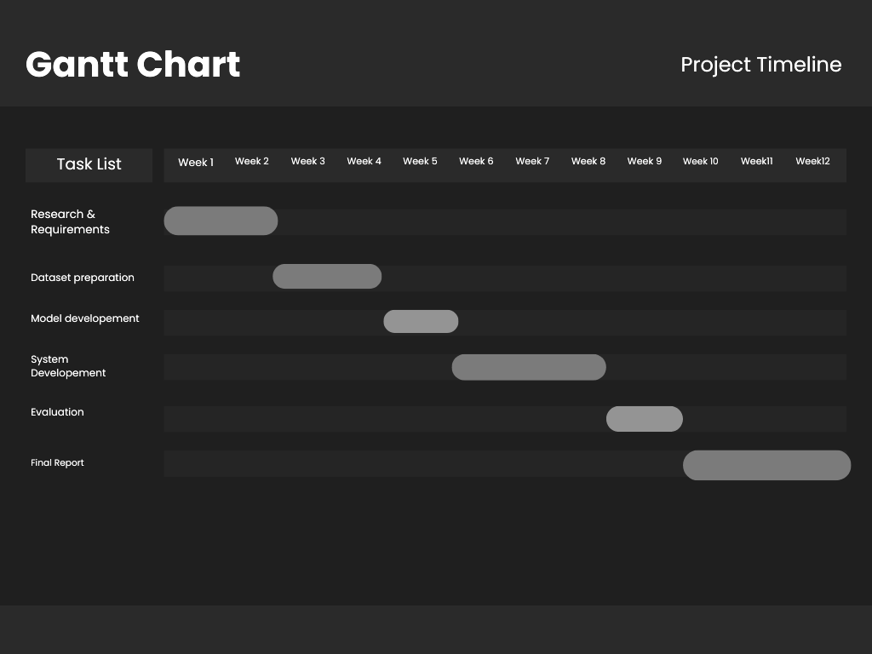
Figure D.1: Original twelve-week activity schedule reproduced from the project contract.

