Regression Modelling

DainaE

Saturday, May 23, 2015

Context

You work for Motor Trend, a magazine about the automobile industry. Looking at a data set of a collection of cars, they are interested in exploring the relationship between a set of variables and miles per gallon (MPG) (outcome). They are particularly interested in the following two questions:

"Is an automatic or manual transmission better for MPG" "Quantify the MPG difference between automatic and manual transmissions"

Take the mtcars data set and write up an analysis to answer their question using regression models and exploratory data analyses.

data(mtcars)  
attach(mtcars)  
names(mtcars)

## [1] "mpg" "cyl" "disp" "hp" "drat" "wt" "qsec" "vs" "am" "gear"  
## [11] "carb"

head(mtcars)

## mpg cyl disp hp drat wt qsec vs am gear carb  
## Mazda RX4 21.0 6 160 110 3.90 2.620 16.46 0 1 4 4  
## Mazda RX4 Wag 21.0 6 160 110 3.90 2.875 17.02 0 1 4 4  
## Datsun 710 22.8 4 108 93 3.85 2.320 18.61 1 1 4 1  
## Hornet 4 Drive 21.4 6 258 110 3.08 3.215 19.44 1 0 3 1  
## Hornet Sportabout 18.7 8 360 175 3.15 3.440 17.02 0 0 3 2  
## Valiant 18.1 6 225 105 2.76 3.460 20.22 1 0 3 1

pairs(~mpg+am+hp+wt,panel=panel.smooth,main="MTCARS Data",pch=21,bg = c("red", "green3")[unclass(am)])

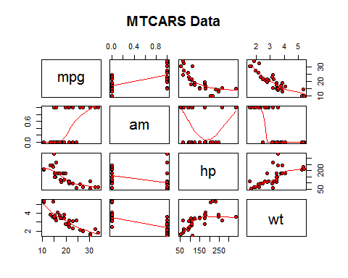

layout(matrix(c(1,2,3,4),2,2))  
  
plot(glm(mpg ~ as.factor(cyl) + as.factor(am) + hp + wt, data=mtcars))

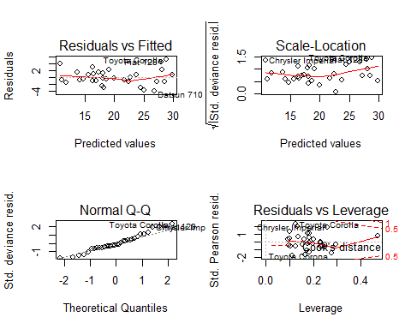

Based on the final model fitting results, we can conclude:

1. wt increases per 1000lb (0.5 tons), the mpg will decrease by 2.5. mpg will decrease very slighly with hp increase. Automatic transmission has higher mpg compared to manual tranmission.