MOA 403b Valuation Package Assemble Explanation

A. COVER PAGE:
- Make sure you are working on a MOA Plan. The upper right of the Cover Letter should show this Company stamp:


- Verify the Company Name, Company Address, Plan Name, and Plan Year End is pulling correctly for the Plan and PYE you are assembling.
- We need to check whether the date of valuation file is showing today’s date or not, if not need to edit with current date.
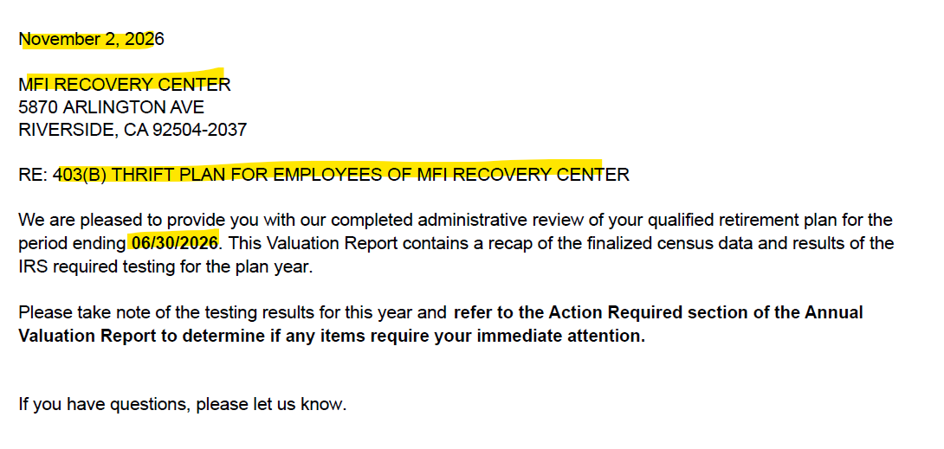

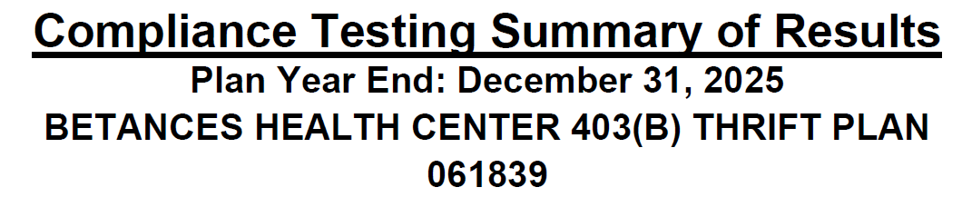
- Tester has been updated the results and required %, while doing assemble need to check all results are correct as per test Reports.

410(b) Coverage Test

Standard: Pass/Fail Ratio percent 100% - This % denote the result of PS & SHNE contributions

401(m): Pass/Fail Ratio percent 100% - This % denote the result of Match & SH match contributions.

401k result should not reflect under 410(b) Coverage Test
401m and Standard should be reflect (if contribution is there)

If 410B fails, Testing done with ABPT test. Then Tester had included the wording like below snip
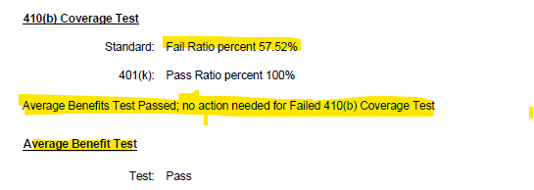

Benefits Right and Features Test
Test: Pass/Fail - This result denotes of BRF test result.

Note – we are only adding BRF test result in Result summary, do not include any report regarding BRF test (Result summary only enough)

401(a)(4) Test

Test: Pass/Fail - This result denotes of 401(a) test result.

402(g) Deferral Limits

Test: Pass/Fail - Tester edited the result as per 402g report.

415(c) Annual Additions

Test: Pass/Fail – Tester edited the result as per the 415 reports.

Average Contribution Percentage (ACP)

Test: Pass/Fail – Tester edited the result as per ADP/ACP test result

***See Next Page for Action Required Items

Annual Valuation Report

If any Testing has been failed the below Action required wordings are required

1. We will be using the below wordings if both 402g and 415 fails.
- We can find the result of 402g and 415 in Result Summary page, if any of one is mentioned as fail, we need to use the below wordings.

- NOTE: do not include if 402g failure is not processed by 4/15 deadline and this is noted on the 402(g) test or result summary page.
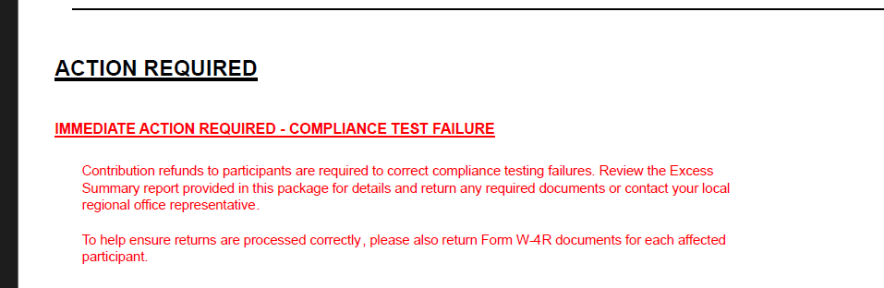
- Below paragraphs required, if ACP testing fails and returns are required (does not apply if failure does not cause a return) otherwise remove

- a. We can find the type of testing in the Valuation package log if in the log it has been mentioned PRIOR YEAR and if ACP fails Leave the below wordings.
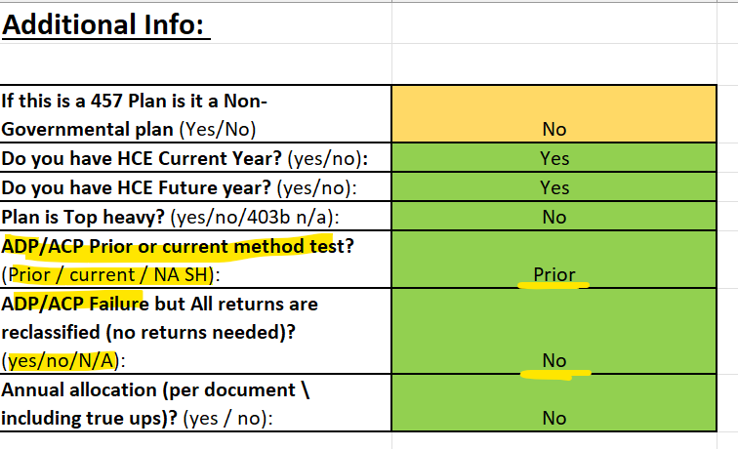

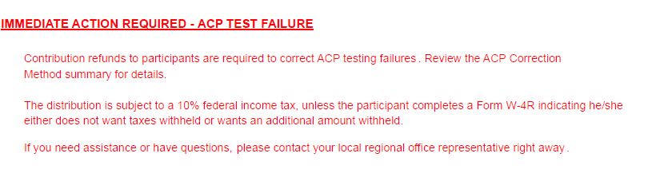

- b. We can find the type of testing in the Valuation package log if in the log it has been mentioned CURRENT YEAR and if ACP fails Leave the below wordings.
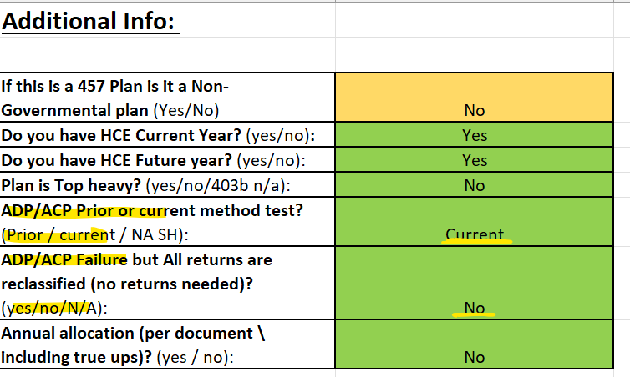
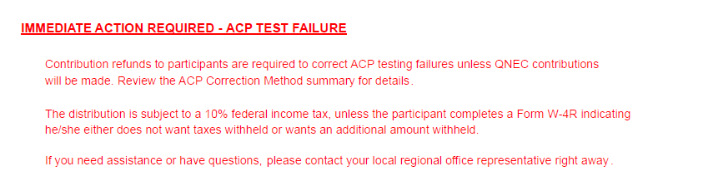

- Leave the below wordings if any true up or annual allocation is done.
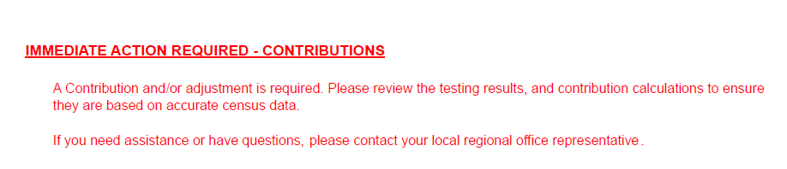
- In val pkg log tester will mention include contributions wordings. Then we need to include this, or even in val pkg folder If we saw any variance sheet client copy, we need to keep these wordings.
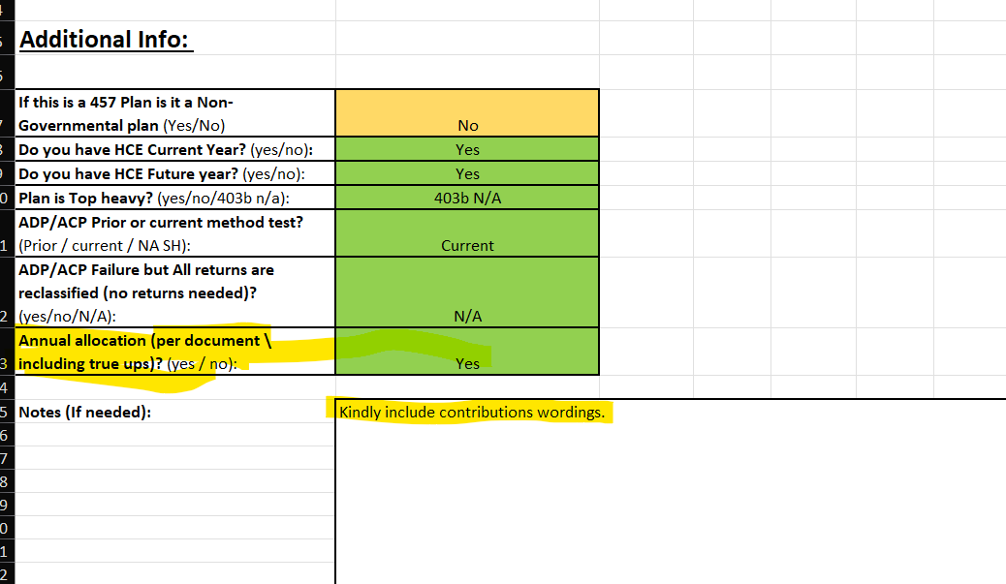

- c. Leave the below wordings if ACP fails AFTER 12 MONTHS where testing method is PRIOR YEAR

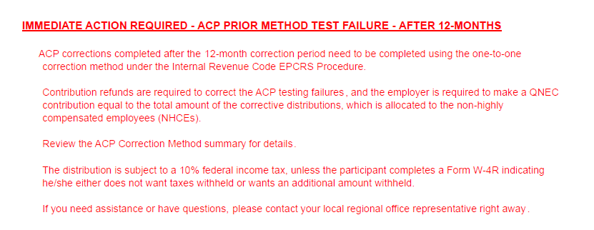

- d. Leave the below wordings if ACP fails AFTER 12 MONTHS where testing method is CURRENT YEAR.

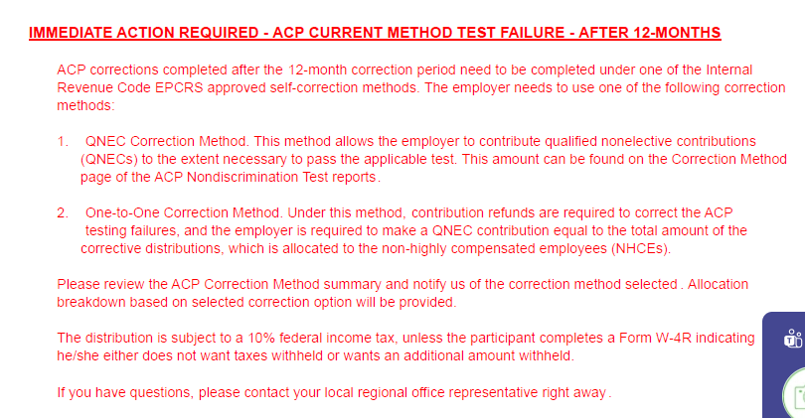

- If none of the Immediate Action Items listed above apply, then only show the green line item below on the Annual Valuation Report/Action Required page.

***See Next Page for Failure excess Notice

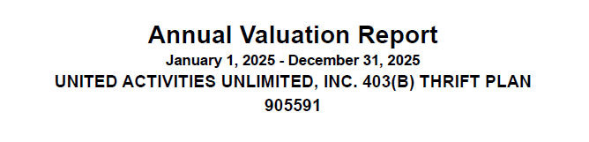

Excess return Notice for ADP/ACP, 415 or 402g Failures

- Cross verifies the plan number, Plan year and Plan name

- ACP Failure Notice
1. If the plan fails ACP testing using the CURRENT method ONLY and returns are required, then you will include the following ACP Failure notice:
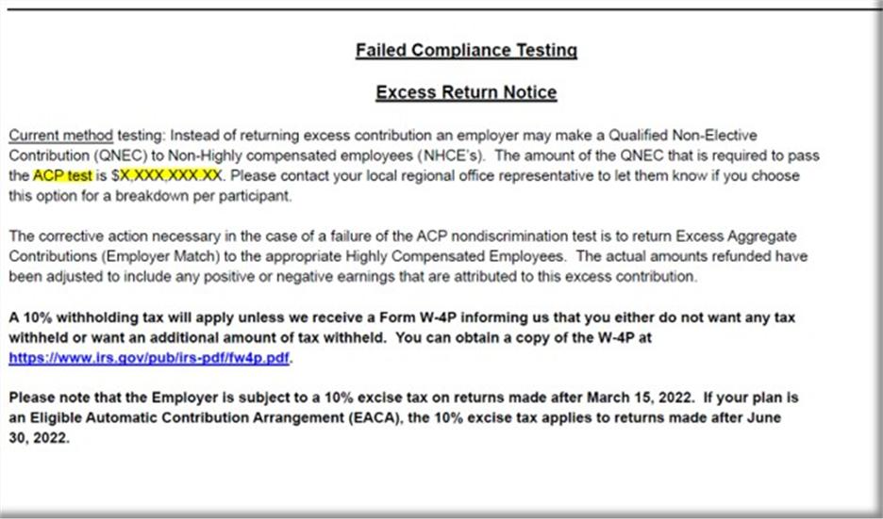
- You will need to input the QNEC amount on this CURRENT testing failure notice which will be found on the correction page of the ACP test.
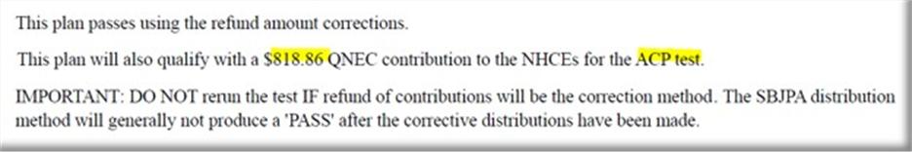

(e.g., “ACP test is $X,XXX,XXX.XX” = $818.86)

NOTE: If the ACP test is not showing an ACP QNEC total then you will remove from the Failure notice since an ACP QNEC is not represented on the ACP Correction Test Page.

NOTE: If the ACP test using PRIOR method fails, with returns we do NOT include this Failure notice in the Val Package.

- 2. Leave the below wordings if ACP fails After 12 months by using current year testing method. Here we need to edit the value by update in first QNEC of ACP and followed by next.
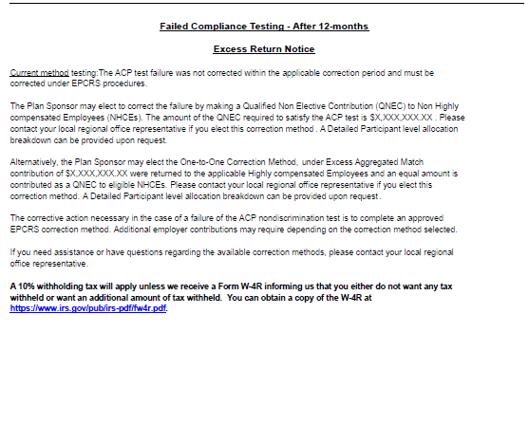

- B. Leave the below wordings if ACP fails after 12 months by using prior year testing method.

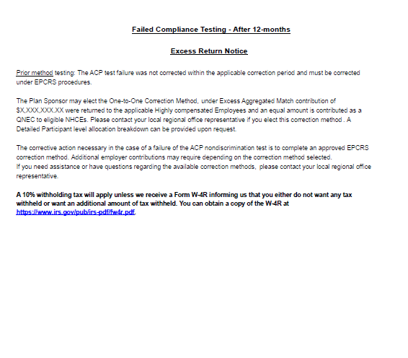

***See Next Page for some failure notice

Annual Additions (IRC 415) Test Failure Information

- Annual Additions (IRC 415) Test Failure Information - Remove if Plan did not fail 415 (no 415 returns)
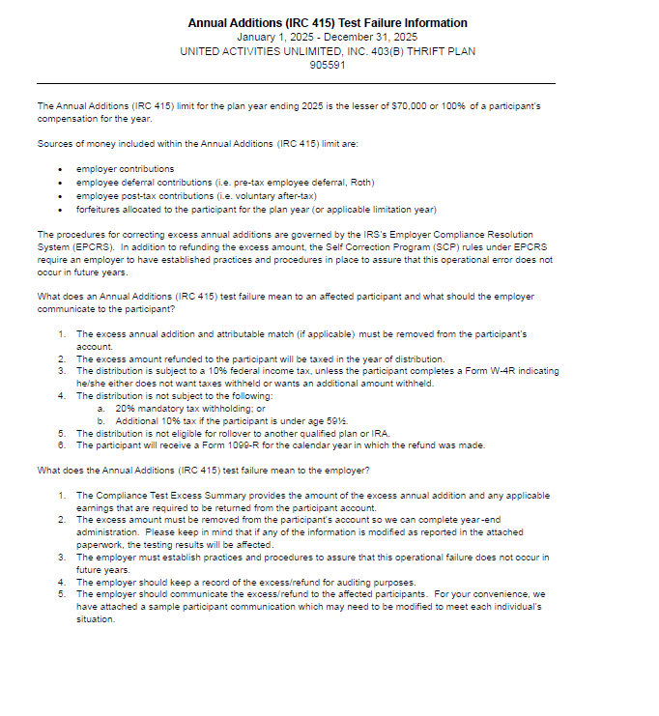



- Sample Letter for ACP Failure

- Remove if Plan did not have ACP
- Remove if Plan did not Fail or Failed and did not have returns required.
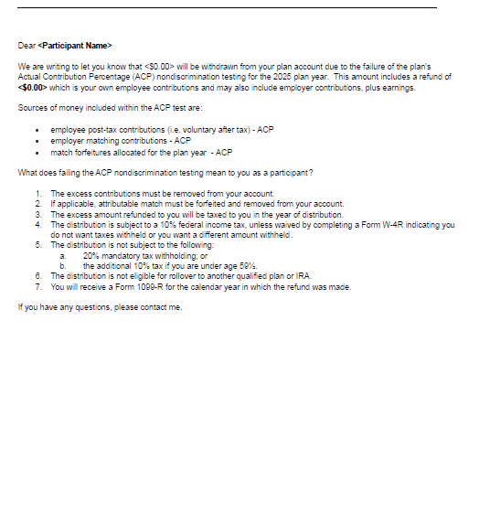

- Sample Letter for failed 402(g)

- Remove if Plan did not have returns for 402(g)

- NOTE, if 402g not processed prior to 4/15 deadline and this is noted on 402g report do not include the sample letter.
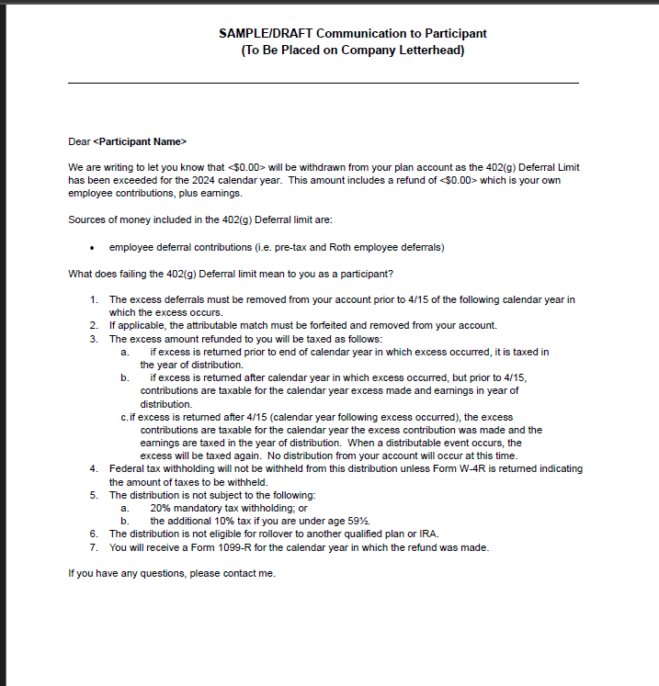

- Sample Letter for failed 415 annual additions

- Remove if Plan did not fail 415 (no 415 returns)
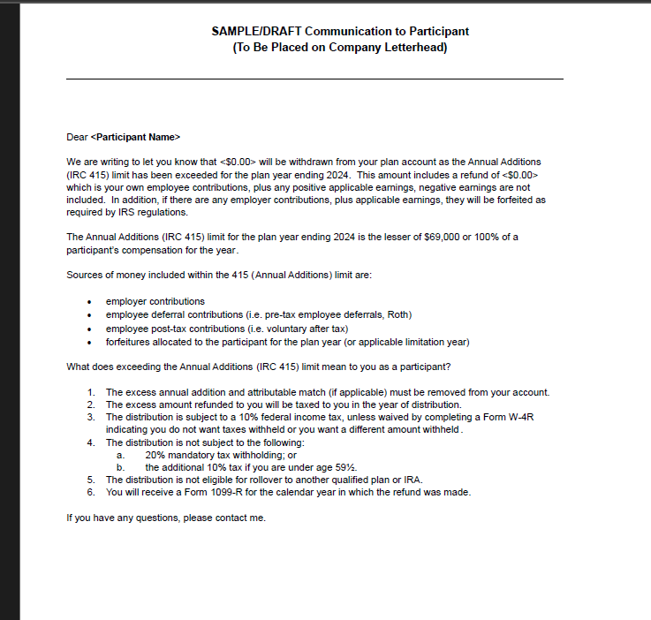

- If Plan has Employer Contribution True-up – Need to include Client variance report here.

- Client copy of Variance, if applicable
  - Make sure names in alphabetical order & not cut off
  - Recheck plan name, plan number and plan year end are correct
  - Make sure SSN should not be there
  - Consistent font size
  - Zeroes formatted as 0.00
Note – Bookmarks not applicable for client variance pdf.

***See Next Page for Year End Recap

YEAR END RECAP
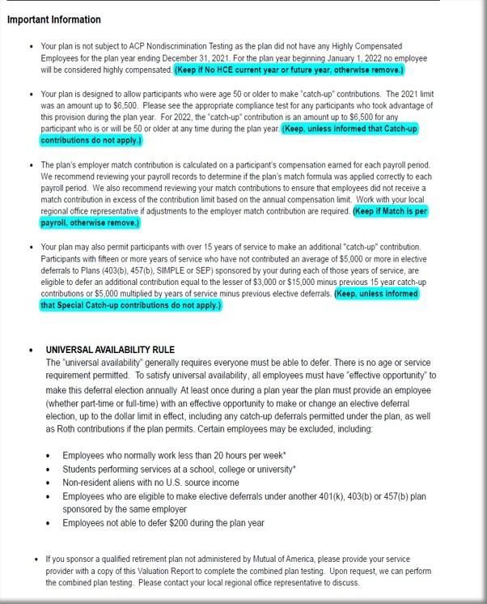

***See Next Page for Admin Reports and Bookmarks


- Must be Include 3 pages in all the reports.

- Bookmarks:

- Once Valuation Package is assembled you will need create bookmarks for each section:

- On left side of screen click on “bookmark” icon and delete all current bookmarks, start on first page of Val Package and begin to create your bookmarks with the following titles:

1. Cover Letter
2. Test Summary
3. Contribution Analysis
4. HCE (if 403b Plan)
5. Future HCE
- ACP Tests - Make sure in correct order: Summary / Detail / Corrections
7. 402(g) Test
**Please note, 402(g) Test for Off Calendar Plans, the Plan Year Dates will use Calendar Year Beginning Date, the dates will not match the Plan Year End Date. (i.e., Off Calendar PYE 06/30/2026, 402(g) Report will have these dates 01/01/2025-12/31/2025).
8. 410(b) Test
9. 401(a)(4) Test, if applicable
10. Average Benefit Percentage Test, if applicable
11. 414(s) Test, if applicable
12. 415 Limit Test
13. Top Heavy
14. Census

Workflow and page wise list for assembly

- The ordering of Reports/Misc. should be as follows:

- Cover Letter (Date on letter head should be single digit, i.e. 1 not 01)
- Test Summary
- Combined Testing Report, if applicable
- Action Required Page
- Failed Test Notice/Letter/Excess Summary, if applicable
- Variance Report(s), if applicable
- Year End Recap: Important Information
- Compliance and Administrative Reports: Overview and Descriptions
- Contribution Analysis
- HCE (403b Plans should only indicate HCE)
- Future HCE
- ADP/ACP Tests, if only ADP Test should only indicate ADP Test, if only ACP Test should only indicate ACP Test.
Order below for ADP/ACP test pages if applicable
- Summary Page (NOTE: some Plans may not have this page, this is ok, do not request)
- ADP/ACP Test Detail
- ADP/ACP Excluded
- ADP/ACP Corrections Page
- 402(g) Test
- 410(b) Test
- Detail report
- Excludable report
- Includable report
- Summary report
- 401(a)(4) Test, if applicable
- Average Benefit Percentage Test, if applicable (if component Plan may have more individual test which go in this order)
- Average Benefit Percentage Test
- 401a1 Comp Test
- Gateway Test, if applicable (may be part of the ABPT, if so leave with it)
- Overall Comp test
- Rate Group Comp Test
- Sum Comp Test
- BRF Test (Benefits, Rights and Features test)
- 414(s) Test, if applicable
- 415 Limit Test
- Top Heavy
- Census

MOA Valuation Package Assembly Additional Info:

1. MOA Plans DO NOT have the following items in the Val Package:
a. Audited wording
b. SOC
c. 5500 wording
a.) Also
- Support does not sweep MOA Plans nor do we create any Workflow Tasks for these Plans.

2. For Plans that have Locations
- When assembling these put each test with all locations. Contribution Analysis Loc 1, Contribution Analysis Loc 2, etc.
- For Control Groups – The Tester Specialist should have already combined and put the appropriate Plan Names on the Tests.
3. Deadlines for failed testing returns
- MOA Plans will NOT use escalation wording for failed tests.
4. Please cross-check the following points while assembling the package:
- Ensure all test reports are included and do not contain any SSNs.
- Ensure all reports are arranged in the correct order as noted above
- Verify that all reports display the correct plan name and plan number.
- Confirm that the bookmarks are accurate for each section (except the Variance Report).
- Assembly Done.

- Email the person who signed up the Val assembly to notify them the Val has been assembled and is ready for review.
- The subject line of the email MUST start with “MOA” then “Plan Number”, then “Plan Name” then “PYE”
- Update the Val Assembly log with the date sent back to tester and time took to build.

Be sure this is fully completed & saved as ******_2025-Valuation in plan Testing folder. (****** is plan number)

MOA Valuation Package Assembly Additional Info:

1. MOA Plans DO NOT have the following items in the Val Package:
- Audited wording
- SOC
- 5500 wording

a.) Also
- Support does not sweep MOA Plans nor do we create any Workflow Tasks for these Plans.

2. For Plans that have Locations

- When assembling these put each test with all locations. Contribution Analysis Loc 1, Contribution Analysis Loc 2, etc.
- For Control Groups – The Tester Specialist should have already combined and put the appropriate Plan Names on the Tests.

3. Deadlines for failed testing returns

- MOA Plans will NOT use escalation wording for failed tests.

when assembling needs to stop

- Employer Address – Verify that the employer address is complete and properly formatted on all applicable documents. The address must include:
Address Line 1
Address Line 2 (Optional)
City, State ZIP/Postal Code

- If any of these required address components are missing, incomplete, or incorrectly formatted, the assembly process must be stopped immediately, and the issue must be corrected before proceeding.
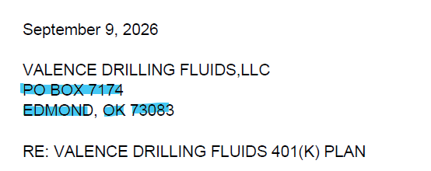

- Plan name - If the plan name listed in the Validation Package Log does not match the plan name in the email subject line or the test reports, the assembly process must be stopped immediately, and the discrepancy must be resolved before proceeding.

- Social Security Number – If a Full or Partial/Masked Social Security Number (SSN) appears in any test report, the assembly process must be stopped immediately and the issue escalated for correction.

- Plan Name & Employer Name Verification - The Plan Name and Employer Name must match across all reports. If any discrepancy is identified between reports, the assembly process must be stopped immediately, and the issue must be corrected before proceeding. You can find the Plan # in the mail & the Valpkg log and Employer name mostly like the plan name.

- Plan Year End – The Plan Year End date must match across all pages and reports included in the assembly package. If any page displays a different Plan Year End date, the assembly process must be stopped, and the discrepancy must be corrected before proceeding. Exception: The Future HCE Report display a future Year End date, which is expected and acceptable.
**Please note, 402(g) Test for Off Calendar Plans, the Plan Year Dates will use Calendar Year Beginning Date, the dates will not match the Plan Year End Date. (i.e., Off Calendar PYE 06/30/2026, 402(g) Report will have these dates 01/01/2025-12/31/2025).

- Missing Test Reports – For a standard MOA 401(k) plan, the assembly package should typically include the following 11 reports

- Valuation Package (Val Package)
- Result Summary
- 402(g) Test Report
- 415 Test Report
- ADP/ACP Test Report
- 410(b) Test Report
- HCE Key Report
- Future HCE Report
- Top Heavy Report
- Census Report
- Contribution Analysis Report

- If any required report is missing, the assembly process must be stopped immediately, and the missing report must be obtained before proceeding.
**Please note, The ADP/ACP Test Report is not required for Safe Harbor Plans. Additional reports may be required based on plan provisions or testing results, including Variance Client Copy, 414(s) Test, 401(a) Test Report & ABP Test Report

MOA 403b Valuation Package Assemble Explanation

- COVER PAGE:
- Make sure you are working on a MOA Plan. The upper right of the Cover Letter should show this Company stamp:

- Verify the Company Name, Company Address, Plan Name, and Plan Year End is pulling correctly for the Plan and PYE you are assembling.
- We need to check whether the date of valuation file is showing today’s date or not, if not need to edit with current date.

- Tester has been updated the results and required %, while doing assemble need to check all results are correct as per test Reports.

410(b) Coverage Test

Standard: Pass/Fail Ratio percent 100% - This % denote the result of PS & SHNE contributions

401(m): Pass/Fail Ratio percent 100% - This % denote the result of Match & SH match contributions.

- 401k result should not reflect under 410(b) Coverage Test
- 401m and Standard should be reflect (if contribution is there)

- If 410B fails, Testing done with ABPT test. Then Tester had included the wording like below snip

Benefits Right and Features Test
Test: Pass/Fail - This result denotes of BRF test result.

- Note – we are only adding BRF test result in Result summary, do not include any report regarding BRF test (Result summary only enough)

401(a)(4) Test

Test: Pass/Fail - This result denotes of 401(a) test result.

402(g) Deferral Limits

Test: Pass/Fail - Tester edited the result as per 402g report.

415(c) Annual Additions

Test: Pass/Fail – Tester edited the result as per the 415 reports.

Average Contribution Percentage (ACP)

Test: Pass/Fail – Tester edited the result as per ADP/ACP test result

***See Next Page for Action Required Items

Annual Valuation Report

If any Testing has been failed the below Action required wordings are required

1. We will be using the below wordings if both 402g and 415 fails.
- We can find the result of 402g and 415 in Result Summary page, if any of one is mentioned as fail, we need to use the below wordings.

- NOTE: do not include if 402g failure is not processed by 4/15 deadline and this is noted on the 402(g) test or result summary page.
- Below paragraphs required, if ACP testing fails and returns are required (does not apply if failure does not cause a return) otherwise remove

- a. We can find the type of testing in the Valuation package log if in the log it has been mentioned PRIOR YEAR and if ACP fails Leave the below wordings.

- b. We can find the type of testing in the Valuation package log if in the log it has been mentioned CURRENT YEAR and if ACP fails Leave the below wordings.

- Leave the below wordings if any true up or annual allocation is done.
- In val pkg log tester will mention include contributions wordings. Then we need to include this, or even in val pkg folder If we saw any variance sheet client copy, we need to keep these wordings.

- c. Leave the below wordings if ACP fails AFTER 12 MONTHS where testing method is PRIOR YEAR

- d. Leave the below wordings if ACP fails AFTER 12 MONTHS where testing method is CURRENT YEAR.

- If none of the Immediate Action Items listed above apply, then only show the green line item below on the Annual Valuation Report/Action Required page.
***See Next Page for Failure excess Notice

Excess return Notice for ADP/ACP, 415 or 402g Failures

- Cross verifies the plan number, Plan year and Plan name

- ACP Failure Notice
1. If the plan fails ACP testing using the CURRENT method ONLY and returns are required, then you will include the following ACP Failure notice:
- You will need to input the QNEC amount on this CURRENT testing failure notice which will be found on the correction page of the ACP test.

(e.g., “ACP test is $X,XXX,XXX.XX” = $818.86)

NOTE: If the ACP test is not showing an ACP QNEC total then you will remove from the Failure notice since an ACP QNEC is not represented on the ACP Correction Test Page.

NOTE: If the ACP test using PRIOR method fails, with returns we do NOT include this Failure notice in the Val Package.

- 2. Leave the below wordings if ACP fails After 12 months by using current year testing method. Here we need to edit the value by update in first QNEC of ACP and followed by next.

- B. Leave the below wordings if ACP fails after 12 months by using prior year testing method.

***See Next Page for some failure notice

Annual Additions (IRC 415) Test Failure Information

- Annual Additions (IRC 415) Test Failure Information - Remove if Plan did not fail 415 (no 415 returns)

- Sample Letter for ACP Failure

- Remove if Plan did not have ACP
- Remove if Plan did not Fail or Failed and did not have returns required.

- Sample Letter for failed 402(g)

- Remove if Plan did not have returns for 402(g)

- NOTE, if 402g not processed prior to 4/15 deadline and this is noted on 402g report do not include the sample letter.

- Sample Letter for failed 415 annual additions

- Remove if Plan did not fail 415 (no 415 returns)

- If Plan has Employer Contribution True-up – Need to include Client variance report here.

- Client copy of Variance, if applicable
  - Make sure names in alphabetical order & not cut off
  - Recheck plan name, plan number and plan year end are correct
  - Make sure SSN should not be there
  - Consistent font size
  - Zeroes formatted as 0.00
Note – Bookmarks not applicable for client variance pdf.

***See Next Page for Year End Recap

YEAR END RECAP

***See Next Page for Admin Reports and Bookmarks

- Must be Include 3 pages in all the reports.

- Bookmarks:

- Once Valuation Package is assembled you will need create bookmarks for each section:

- On left side of screen click on “bookmark” icon and delete all current bookmarks, start on first page of Val Package and begin to create your bookmarks with the following titles:

- Cover Letter
- Test Summary
- Contribution Analysis
- HCE (if 403b Plan)
- Future HCE
- ACP Tests - Make sure in correct order: Summary / Detail / Corrections
- 402(g) Test
**Please note, 402(g) Test for Off Calendar Plans, the Plan Year Dates will use Calendar Year Beginning Date, the dates will not match the Plan Year End Date. (i.e., Off Calendar PYE 06/30/2026, 402(g) Report will have these dates 01/01/2025-12/31/2025).
- 410(b) Test
- 401(a)(4) Test, if applicable
- Average Benefit Percentage Test, if applicable
- 414(s) Test, if applicable
- 415 Limit Test
- Top Heavy
- Census

Workflow and page wise list for assembly

- The ordering of Reports/Misc. should be as follows:

- Cover Letter (Date on letter head should be single digit, i.e. 1 not 01)
- Test Summary
- Combined Testing Report, if applicable
- Action Required Page
- Failed Test Notice/Letter/Excess Summary, if applicable
- Variance Report(s), if applicable
- Year End Recap: Important Information
- Compliance and Administrative Reports: Overview and Descriptions
- Contribution Analysis
- HCE (403b Plans should only indicate HCE)
- Future HCE
- ADP/ACP Tests, if only ADP Test should only indicate ADP Test, if only ACP Test should only indicate ACP Test.
Order below for ADP/ACP test pages if applicable
- Summary Page (NOTE: some Plans may not have this page, this is ok, do not request)
- ADP/ACP Test Detail
- ADP/ACP Excluded
- ADP/ACP Corrections Page
- 402(g) Test
- 410(b) Test
- Detail report
- Excludable report
- Includable report
- Summary report
- 401(a)(4) Test, if applicable
- Average Benefit Percentage Test, if applicable (if component Plan may have more individual test which go in this order)
- Average Benefit Percentage Test
- 401a1 Comp Test
- Gateway Test, if applicable (may be part of the ABPT, if so leave with it)
- Overall Comp test
- Rate Group Comp Test
- Sum Comp Test
- BRF Test (Benefits, Rights and Features test)
- 414(s) Test, if applicable
- 415 Limit Test
- Top Heavy
- Census

MOA Valuation Package Assembly Additional Info:

1. MOA Plans DO NOT have the following items in the Val Package:
  - Audited wording
  - SOC
  - 5500 wording
a.) Also
- Support does not sweep MOA Plans nor do we create any Workflow Tasks for these Plans.

2. For Plans that have Locations
- When assembling these put each test with all locations. Contribution Analysis Loc 1, Contribution Analysis Loc 2, etc.
- For Control Groups – The Tester Specialist should have already combined and put the appropriate Plan Names on the Tests.
3. Deadlines for failed testing returns
- MOA Plans will NOT use escalation wording for failed tests.
4. Please cross-check the following points while assembling the package:
- Ensure all test reports are included and do not contain any SSNs.
- Ensure all reports are arranged in the correct order as noted above
- Verify that all reports display the correct plan name and plan number.
- Confirm that the bookmarks are accurate for each section (except the Variance Report).
- Assembly Done.

- Email the person who signed up the Val assembly to notify them the Val has been assembled and is ready for review.
- The subject line of the email MUST start with “MOA” then “Plan Number”, then “Plan Name” then “PYE”
- Update the Val Assembly log with the date sent back to tester and time took to build.

Be sure this is fully completed & saved as ******_2025-Valuation in plan Testing folder. (****** is plan number)

MOA Valuation Package Assembly Additional Info:

1. MOA Plans DO NOT have the following items in the Val Package:
- Audited wording
- SOC
- 5500 wording

a.) Also
- Support does not sweep MOA Plans nor do we create any Workflow Tasks for these Plans.

2. For Plans that have Locations

- When assembling these put each test with all locations. Contribution Analysis Loc 1, Contribution Analysis Loc 2, etc.
- For Control Groups – The Tester Specialist should have already combined and put the appropriate Plan Names on the Tests.

3. Deadlines for failed testing returns

- MOA Plans will NOT use escalation wording for failed tests.

when assembling needs to stop

- Employer Address – Verify that the employer address is complete and properly formatted on all applicable documents. The address must include:
Address Line 1
Address Line 2 (Optional)
City, State ZIP/Postal Code

- If any of these required address components are missing, incomplete, or incorrectly formatted, the assembly process must be stopped immediately, and the issue must be corrected before proceeding.

- Plan name - If the plan name listed in the Validation Package Log does not match the plan name in the email subject line or the test reports, the assembly process must be stopped immediately, and the discrepancy must be resolved before proceeding.

- Social Security Number – If a Full or Partial/Masked Social Security Number (SSN) appears in any test report, the assembly process must be stopped immediately and the issue escalated for correction.

- Plan Name & Employer Name Verification - The Plan Name and Employer Name must match across all reports. If any discrepancy is identified between reports, the assembly process must be stopped immediately, and the issue must be corrected before proceeding. You can find the Plan # in the mail & the Valpkg log and Employer name mostly like the plan name.

- Plan Year End – The Plan Year End date must match across all pages and reports included in the assembly package. If any page displays a different Plan Year End date, the assembly process must be stopped, and the discrepancy must be corrected before proceeding. Exception: The Future HCE Report display a future Year End date, which is expected and acceptable.
**Please note, 402(g) Test for Off Calendar Plans, the Plan Year Dates will use Calendar Year Beginning Date, the dates will not match the Plan Year End Date. (i.e., Off Calendar PYE 06/30/2026, 402(g) Report will have these dates 01/01/2025-12/31/2025).

- Missing Test Reports – For a standard MOA 401(k) plan, the assembly package should typically include the following 11 reports

- Valuation Package (Val Package)
- Result Summary
- 402(g) Test Report
- 415 Test Report
- ADP/ACP Test Report
- 410(b) Test Report
- HCE Key Report
- Future HCE Report
- Top Heavy Report
- Census Report
- Contribution Analysis Report

- If any required report is missing, the assembly process must be stopped immediately, and the missing report must be obtained before proceeding.
**Please note, The ADP/ACP Test Report is not required for Safe Harbor Plans. Additional reports may be required based on plan provisions or testing results, including Variance Client Copy, 414(s) Test, 401(a) Test Report & ABP Test Report

