Architecture Design Document - MOA Valuation Assembly Procedure Automation
Document Version: 1.3
27 October 2026

1. Executive Summary
The MOA Valuation Assembly Procedure Automation solution reduces manual work when assembling a valuation package. It reads uploaded PDFs and the supplied Val Assembly Excel, applies configured keep/remove and text-rewrite rules to existing pages, checks package content and identity, orders pages, adds bookmarks, drafts an email, updates the Val Assembly Log, and creates a separate JSON audit record.
The reviewer opens the application in a browser on the same computer. One Process run orders files, applies rules, performs selected checks, and saves the named valuation PDF only if assembly is not stopped. A stopped attempt does not save the valuation PDF, email draft, or Val Assembly Log row. Once package processing reaches its audit stage, a JSON audit record is written for a completed run or a validation stop.

2. Business Objectives
Primary Objectives
- Assemble the valuation package from the uploaded PDFs.
- Reduce the time spent deciding which notices and letters stay.
- Apply the same keep-or-remove rules on every package.
- Check the Result Summary, the cover date, the compliance pages, and the variance copy.
- Complete the bookmarks, the email draft, and the Val Assembly Log row.
- Create a privacy-aware audit record for completed assemblies and processing attempts stopped by validation.

3. Solution Scope
In Scope
- Verify the three Compliance and Administrative overview pages are present; report missing pages without generating them.
Cover Page Validation | Action Required Classification | Notices and Letters | Information Processing | Output Automation
Plan number | Compliance failure | ADP/ACP notice kept or removed | Excess Summary | Bookmarks
Company name | PRIOR method | ADP sample letter | Year End Recap | Email draft
Company address | CURRENT method | ACP sample letter | BRF report left out | Val Assembly Log row
Plan name | After 12 months | 402(g) letter | Variance checks | Named valuation PDF
Plan year end | Variance | 415 letter | Three compliance pages checked | Optional copy in the Testing folder
Mutual of America stamp | Top heavy above 60% | Amounts filled on the letter | Audited, 5500, and escalation wording removed | Highlighted preview
Cover date set to today when requested | No action required
Audit and presentation controls | Individually selectable assembly-stop checks | Failure-only modal with exact messages | JSON audit artifact and source hashes | Date-range, heading-divider, and edited-page spacing corrections

Out of Scope
- Network deployment or multi-user access without an external authenticated and access-controlled gateway.
- User authentication, role-based access, encryption-at-rest management, centralized log collection, and automated audit-log retention/deletion.
- Reading a scanned PDF that is only a picture. There is no optical character recognition.
- Sending the email. The application writes the draft. The reviewer sends it.
- Signing the reviewer’s name on the shared Testing Log to claim the plan.
- Converting Word, Excel, or image files into PDF.
- Creating the three compliance pages when they were not in the upload.
- Filling the tester columns on the assembly log: FIS, related plans, MEP, and safe harbor.
- Confirming that no company name other than Mutual of America appears. The stamp is checked. Other names remain a visual check.

4. High-Level Architecture
The reviewer works in a browser on the same computer that runs the application. By default the server binds to 127.0.0.1 and there is no separate application server or database. Package PDFs and audit JSON files are written to local disk; the Val Assembly Log workbook is a separate output artifact.
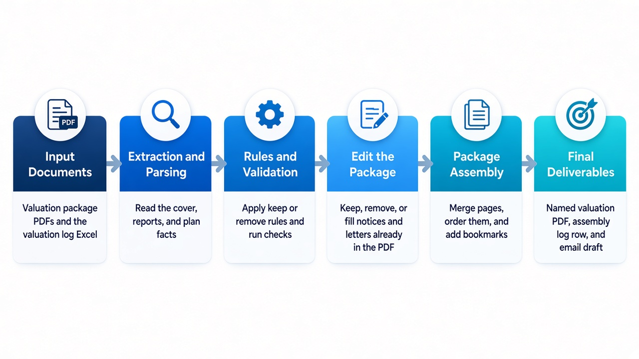

5. Logical Architecture Components

5.1 User Interface Layer
Responsibilities
- Upload valuation package PDFs and the valuation log Excel, or use a folder path.
- List the files, split a multi-page cover, and offer keyword order. The reviewer can move or remove a row.
- Every Process sets the cover date to today and rewrites off-calendar 402(g) dates. The reviewer can also check a box to rewrite the prior-year HCE %. That box is off by default. Assembly stops is on by default and does not save a package that fails a required check.
- Run Process and show the checks, the rules, and the plan facts.
- Provide a downloadable audit-log link after a successful run or a processing failure that generated an audit record.
- When Assembly stops is enabled, a failed run opens a large dialog containing one checkbox per exact failure message. Initially all failing checks are enforced. The reviewer can check individual messages to ignore only those checks on retry; unchecked and newly appearing failures remain enforced. The failure messages are also presented as a numbered list.
- Preview with highlights on or off, and download the clean PDF.
Technology
- HTML in the browser
- FastAPI on this computer

5.2 Document Processing Layer
Responsibilities
- Read each uploaded PDF.
- Extract the text and the page headings.
- Identify the sections that remain after pages are removed.
- Reorder inner pages when the headings match: ADP/ACP, 410(b), and the component Average Benefit Percentage test.
- For an ADP/ACP test PDF, move a page headed TEST RESULTS to the first page of that source report before merging. Track source-section tags through page processing for report recognition, ordering, bookmarks, and HCE-year handling. HCE files with an explicit Future/FY marker or a future year are classified using the valuation year and companion current HCE/Key filename when available.
Technology
- PyMuPDF
- Layout normalization is targeted to known rules (for example date-range spacing, missing summary divider, cover-address spacing, and preserving source alignment when keep/remove edits move text). It is not a general pixel-perfect comparison or OCR system.
Inputs
- Valuation package PDFs
Outputs
- The merged package and the text used by the rules

5.3 Metadata Parsing Engine
Responsibilities
- Read the plan number, plan name, and plan year from the cover and the Result Summary.
- Read PRIOR or CURRENT, pass or fail, top heavy, and HCE from the package and the valuation log Excel.
- Recognize current and future HCE reports from explicit Future/FY markers or year-tagged HCE filenames, using the valuation year and companion current HCE/Key report where available.
- Locate QNEC and refund amounts.
- Read allocation notes, including whether contributions are required.
Output example
{
"plan_number": "",
"plan_name": "",
"plan_year_end": "",
"testing_method": "PRIOR or CURRENT",
"adp_result": "",
"acp_result": "",
"qnec_amount": "",
"refund_amount": ""
}

5.4 Business Rules Engine
This is the decision layer. The rules use the plan facts. They do not decide keep or remove by reading the PDF a second time.
Rule categories
- Cover page: plan number, company, address, plan name, plan year end, and the Mutual of America stamp.
- Action Required: compliance failure, PRIOR, CURRENT, after 12 months, variance, contributions, top heavy above 60%, and no action required.
- Notices and letters: ADP and ACP stay when that test failed and returns are required. The 402(g) letter also stays only when the failure was processed by 15 April. The 415 information and letter stay when the plan failed 415. Returns are not required for 415.
- Information pages: Excess Summary, Year End Recap bullets, and wording that must not ship.
- Assembly-stop checks cover SSNs, unresolved Result Summary wording, cover stamp/address/identity, company and plan consistency, Result Summary versus test reports, year-end consistency, required reports, report order, coverage results, and the three compliance overview pages. Checks are enabled by default and may be individually ignored by the reviewer after they fail. Ignoring a check is an explicit override and should be used only after review.

5.5 Notice and Letter Handling
Notices and sample letters are edited on the pages the reviewer uploaded. The application does not create a new notice page.
Responsibilities
- Keep or remove the ADP failure notice and the ADP sample letter.
- Keep or remove the ACP failure notice and the ACP sample letter.
- Remove the 402(g) letter when there are no returns, or when the failure was not processed by 15 April.
- Remove the 415 failure information and the 415 letter when the plan did not fail 415.
- Fill QNEC and refund amounts on a letter that stays.
Inputs
- Plan facts
- The rule decision for that test
Outputs
- The same PDF, with notices kept, removed, or filled
- When keep/remove rules delete a paragraph, surviving text is shifted upward by the removed vertical space while retaining its source horizontal position, font style, and size. Action Required content maintains a minimum gap below the header divider.

5.6 Package Assembly Engine
Responsibilities
- Merge the uploaded pages in the order on the screen.
- Leave out a 401(k) BRF report. A 403(b) package keeps the BRF report. The Result Summary line can remain.
- Remove audited wording, Statement of Contribution, 5500 wording, and escalation wording. A 457 package keeps Statement of Contribution wording.
- Apply the inner page order when the headings match.
- Normalize known date-range connector spacing (for example, 01/01/2024 To 12/31/2024) and add a divider below the Result Summary heading when one is absent; existing dividers are not duplicated.
- Write one bookmark for each section that remains. A 401(k) package does not bookmark BRF. A 403(b) package does. Variance is not bookmarked.
- A 401(k) plan uses HCE/Key, and ADP Test, ACP Test, or ADP/ACP Tests. A 403(b) plan uses HCE and ACP Test.
Outputs
- The file is named {Plan number}_{Beginning plan year}-Valuation.pdf. Example: 800643_2025-Valuation.pdf.

5.7 Completion Services
Email subject
The draft subject uses dashes. Rush or Rework is added when the valuation log says so:
MOA - {plan number} - {plan name} - PYE {plan year end}
Example: MOA - 800643 - Example Plan - PYE 12/31/2025. Both Rush and Rework: MOA - Rush Rework - 800643 - Example Plan - PYE 12/31/2025.
The file is an Outlook draft with an empty To line. The reviewer sends it.
Valuation log update
One row is added to the Val Assembly Log, using the client columns:
- Omni Plan Number and Plan Name.
- Future HCE and current-year HCE: Yes or No.
- Allocation: Variance, Annual, or Annual-Var. A true-up with no variance is noted as a 0.00 variance.
- ADP/ACP, 402(g), 410(b), ABP, 414(s), 401(a)(4), 415, and BRF: P, F, or N/A.
- Top Heavy: Yes or No. Compensation limit: N/A.
- FIS, related plans, MEP, and safe harbor are left blank for the tester.
Preview
Highlight changes can be turned on or off. Yellow marks show rewritten words. They are drawn for the preview only. The downloaded PDF does not contain them.
Audit record: write one JSON file to the local logs folder for a completed run, a validation stop, or a handled processing error after processing begins. The filename is {plan type}_{plan number}_{UTC timestamp}_{job id}.json.
- The optional browser-console step trace is a separate, temporary in-memory diagnostic feature. It is not the persistent audit record.
- Pattern-based redaction covers detected SSNs, email addresses, phone numbers, Windows paths, and /Users paths in recorded text; it cannot guarantee detection of every sensitive value. Plan numbers and report filenames remain identifiable. Review the audit before sharing and use an approved secure transfer channel. Audit files are local, unencrypted, and have no automated retention or deletion policy.
- The audit JSON contains the run status and time, sanitized output/source filenames, source-file sizes and SHA-256 hashes, selected options, plan identifiers/year, keep/remove decisions, validations, warnings, and stop reasons. It excludes PDF bytes and page text. Source hashes support file-integrity comparison but do not make the JSON itself tamper-proof or cryptographically signed.

6. Data Flow
Processing Workflow
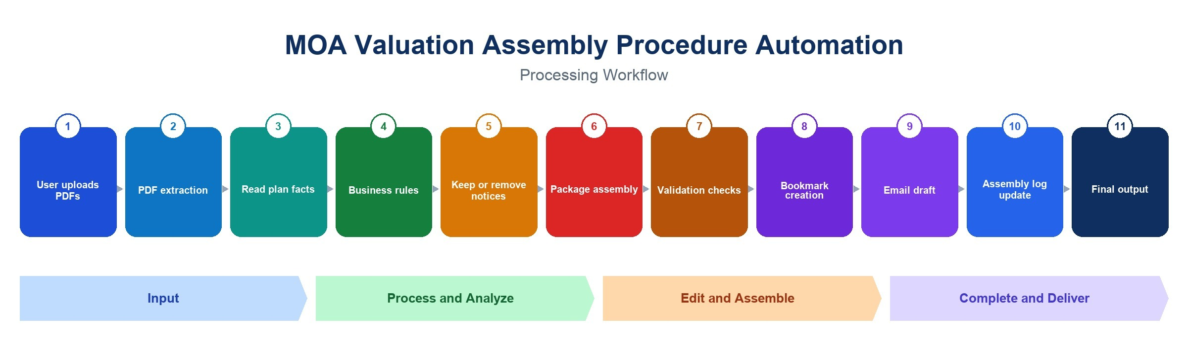
- The reviewer uploads the PDFs and, when they have it, the valuation log Excel.
- The application reads the PDFs, splits a multi-page cover, and leaves out a 401(k) BRF report file. A 403(b) BRF report stays.
- Plan facts are read from the cover, the Result Summary, and the Excel log.
- The rules decide what stays.
- Notices and letters already in the PDF are kept, removed, or filled. Every Process sets the cover date to today and rewrites off-calendar 402(g) dates. If the reviewer checked the HCE box, the prior-year HCE % is rewritten where the printed text matches. A missing Action Required fact removes that paragraph.
- Pages are assembled: inner pages are reordered when their headings match, and wording that must not ship is removed.
- Checks run on the finished pages.
- Bookmarks are written.
- The Outlook draft is created.
- A row is added to the Val Assembly Log.
- The named PDF is saved unless Assembly stops is on and a required check failed. The reviewer downloads the clean file.
- A JSON audit record is written under logs after a completed run, a validation stop, or a handled processing error. Failures rejected before package processing starts (for example, an invalid request or unusable upload) may not produce an audit record. Validation-stop responses include a download link to the record.

7. Deployment Architecture
Each reviewer runs the application on their own computer. The supported default is local use at 127.0.0.1:8002; no shared multi-user service or authenticated network deployment is provided.
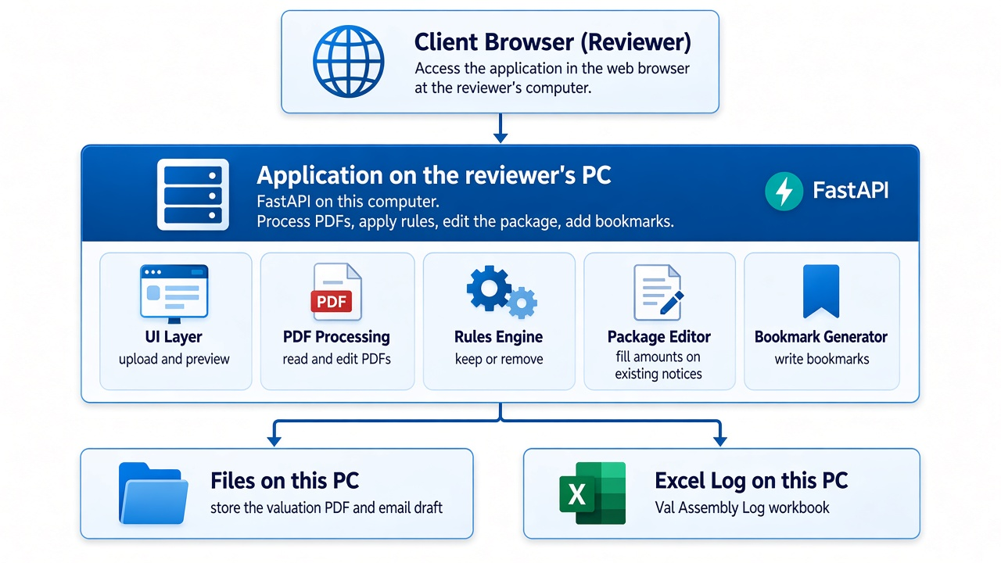
- Opened in a browser at http://127.0.0.1:8002.
- PDF, Excel, and the email draft are stored on that computer. There is no database.
- On Windows, run.bat in the application folder creates the local environment if needed and starts the application.
- The first run on a new computer needs a network connection to install the PDF and Excel libraries.

8. Security, Audit, and Operational Controls
Security boundary
- The application has no built-in user authentication or role-based authorization. The API accepts requests without user credentials.
- The default bind address is 127.0.0.1, limiting access to the local computer by default. CORS is currently configured permissively. Changing the bind address or exposing the service to a network requires an approved authenticated/access-controlled gateway and network restrictions before deployment.
- Audit files are stored in the application logs folder. The folder inherits local operating-system permissions; this application does not encrypt audit files, upload them centrally, enforce retention, or securely erase them.
- Audit files include plan numbers, filenames, and source-file hashes, which may be sensitive or linkable. Review before sharing with cybersecurity, auditors, or other external parties, and use an approved secure transfer channel.
- The JSON audit record is a process record, not a tamper-proof or cryptographically signed audit trail. Hashes identify source files but do not sign or protect the audit JSON itself.

9. Risks & Mitigation
Risk | Impact | Mitigation
A PDF is a scan with no text | Rules, bookmarks, the filename, and the log cannot be filled | The package is still combined. The checks show that the facts were not read. Optical character recognition is out of scope.
The printed date or percentage does not match the pattern | Retype leaves that line as printed | The result notes say what was left as printed. The cover-date check fails until the date is today.
Wording on a source letter changes | A keep or remove can miss a paragraph | The match text is configuration, so it can be updated without rewriting the application.
Two people assemble the same plan | Duplicate work | Claiming the plan stays on the Testing Log, which the reviewer signs before starting.
An off-calendar plan year | 402(g) dates can be wrong if retype is skipped | When retype is checked, those dates are rewritten only on pages that contain 402.
Audit record contains identifiers or linkable hashes | A shared audit file may expose plan identifiers or reveal which source file was used | Store logs on a restricted local folder, review before sharing, and use an approved secure transfer method. The app does not encrypt logs or enforce retention.
API is exposed beyond the local computer | Unauthenticated users may submit jobs or access artifacts if network controls are absent | Default to 127.0.0.1. Do not change the bind address for network access without an authenticated and access-controlled gateway. CORS is permissive and is not an authentication control.
Audit file changed after creation | JSON records are not tamper-evident | Treat the log as operational evidence only. Preserve it in an approved controlled repository if audit-grade immutability is required.

10. Dependencies
Business dependencies
- The valuation package procedure and the quick review checklist.
- The client column list for the Val Assembly Log.
- A reviewer available to confirm a keep-or-remove decision during testing.
Technical dependencies
- Python on the reviewer’s computer.
- FastAPI.
- PyMuPDF.
- Excel read and write.
- Writable local folders for output PDFs, email drafts, the Val Assembly Log, and audit JSON files in the application logs folder.
Test data dependencies
- CURRENT method, pass and fail.
- PRIOR method, pass and fail.
- 402(g), including a failure not processed by 15 April.
- 415 failure, and a plan that did not fail 415.
- Top heavy above 60%, and a plan at 60% or below.
- Variance, and a package with no variance.
- No immediate action.
- An off-calendar plan year.
- A 403(b) plan, for the HCE and ACP Test bookmark titles and for keeping the BRF report.

11. Proposed Technology Stack
Layer | Technology
Front End | HTML
API Layer | FastAPI
Backend Language | Python
PDF Processing | PyMuPDF
Business Rules | Configuration files read by the application
Data Store | Excel and files on this computer
Email | An Outlook draft file, not a mailbox connection
Deployment | The reviewer’s computer. No separate server.
Audit record | Local JSON file with SHA-256 source hashes and redacted diagnostic text; not cryptographically signed

