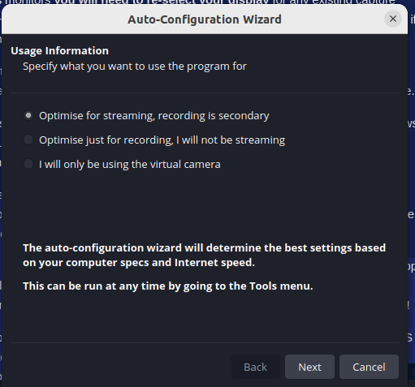

Click on Next
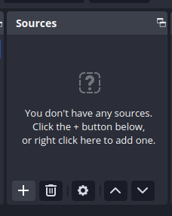

click on ‘+’ icon

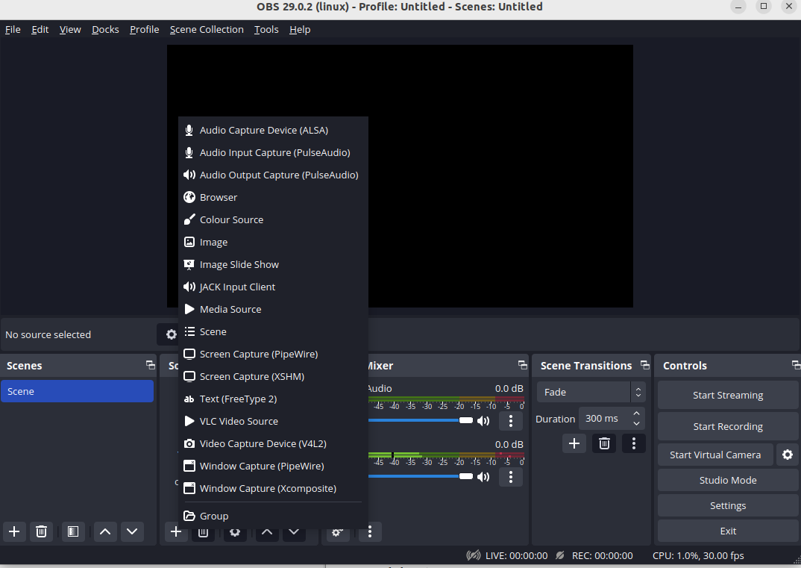
Window Capture(Pipewire)

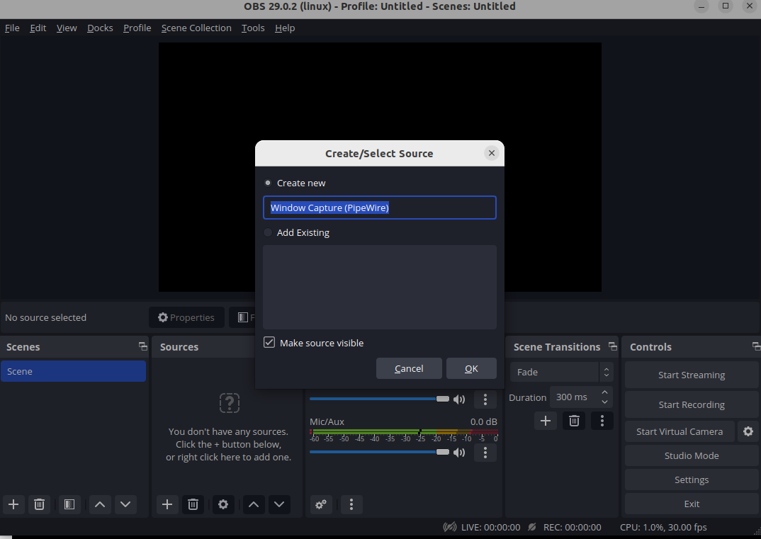

then click on OK

sudo add-apt-repository ppa:obsproject/obs-studio
sudo apt update
sudo apt install ffmpeg obs-studio

Connect with TP-Link Router (With Sim Facility) Connect to the laptop

following settings required to update the settings

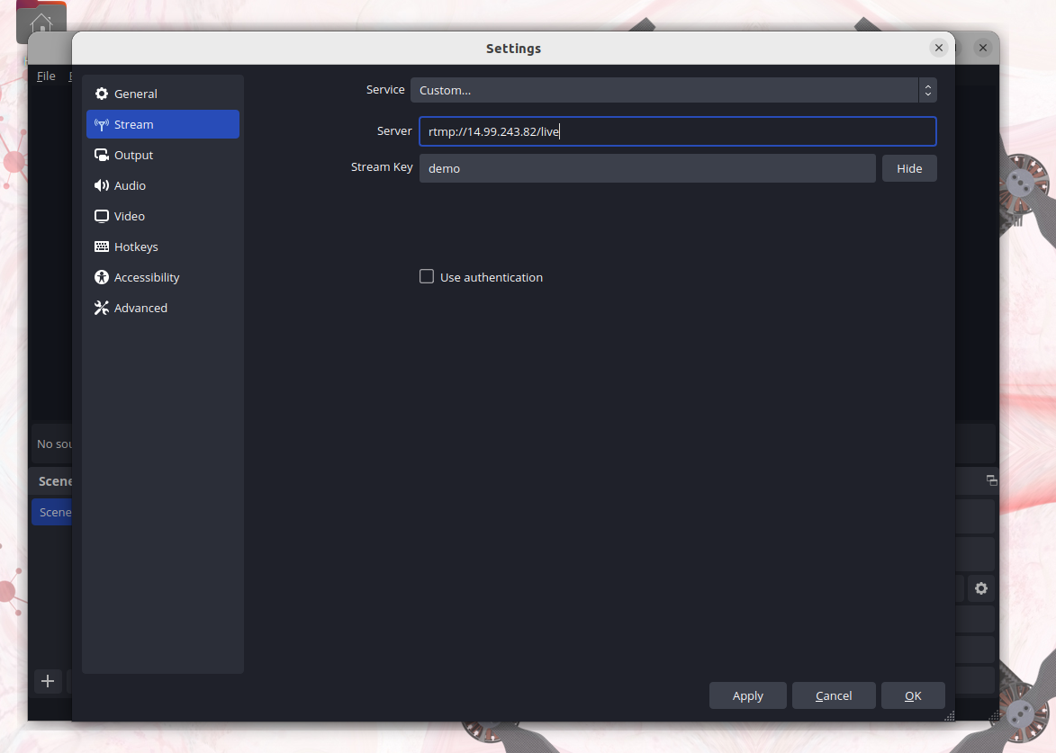

Click on Settings > Stream > select Custom > then enter
rtmp://14.99.243.82/live

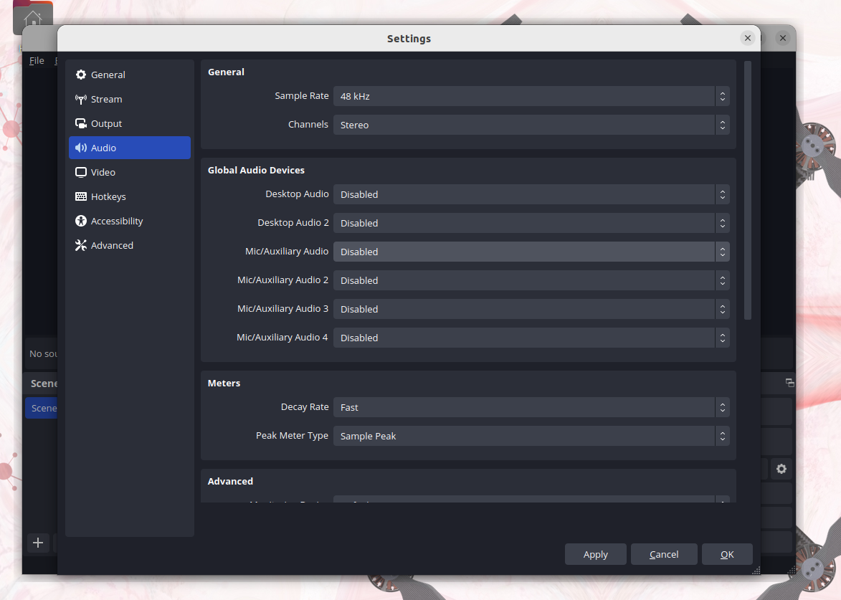
Audio setting required for the obs

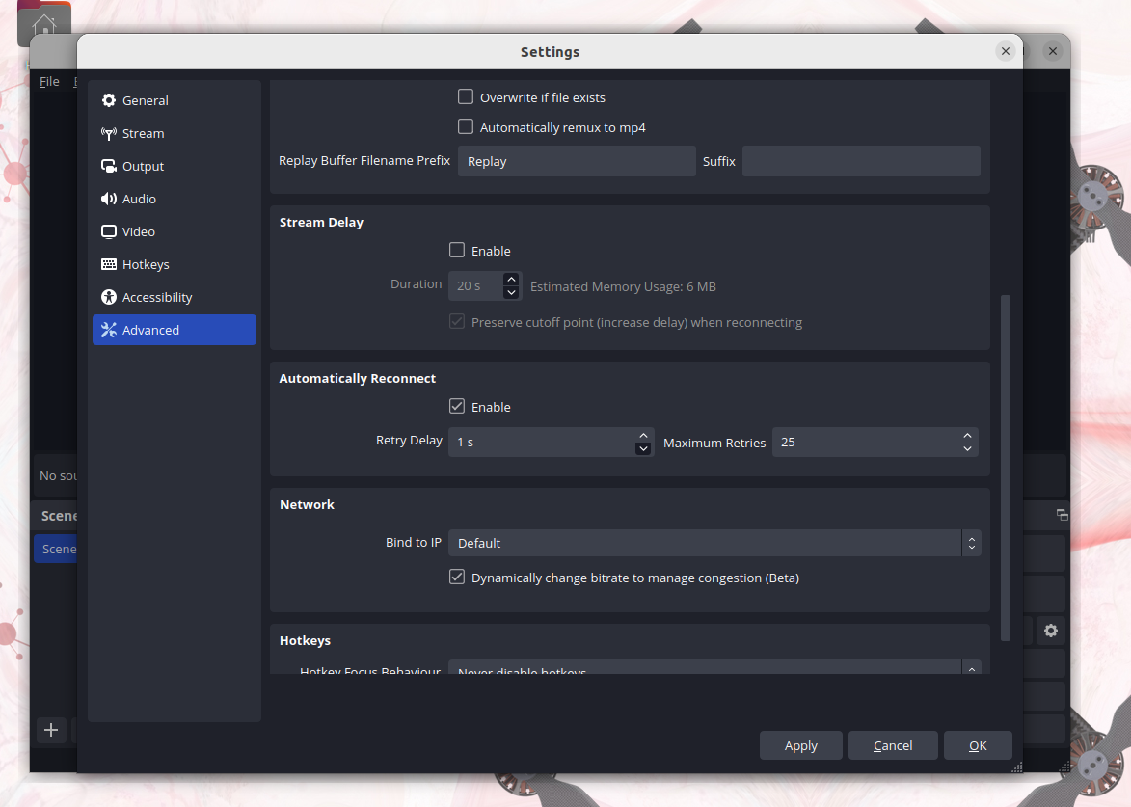
Advanced > Network > Dynamically change
then Bind IP set Default

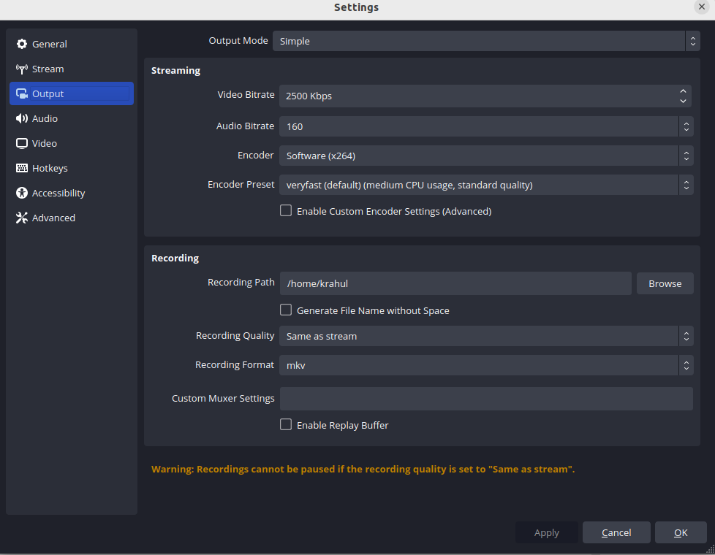
Output settings will be like this

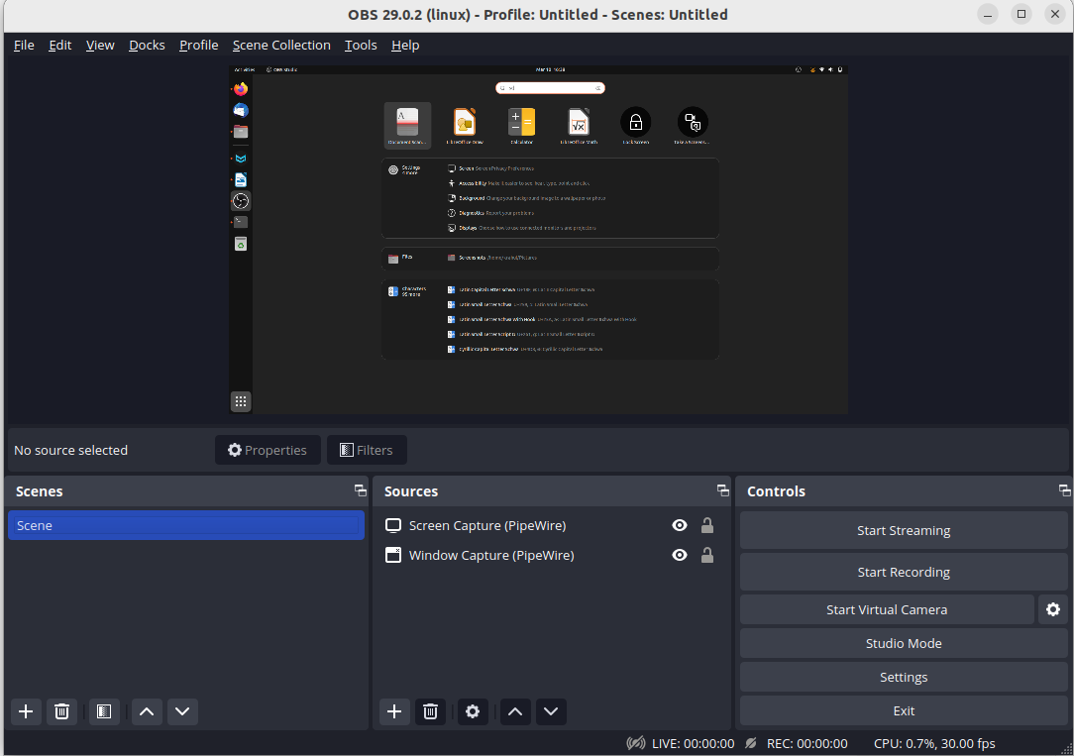

remove all the screens from the below section only keep
“Sources” and “Controls”

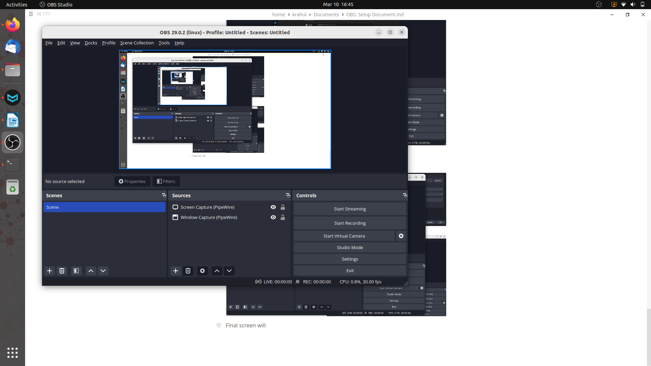

final output

Prerequisite :

i) Install OBS in your Laptop.
ii) Connect this Lapotp with a internet based TPLink Router(Sim inserted)
iii) Then run the OBS Setup which will store live data on remote system or server.

