OEM image flashing on Ground Unit.

Step1 : Connect USB to Controller
Check on Controller

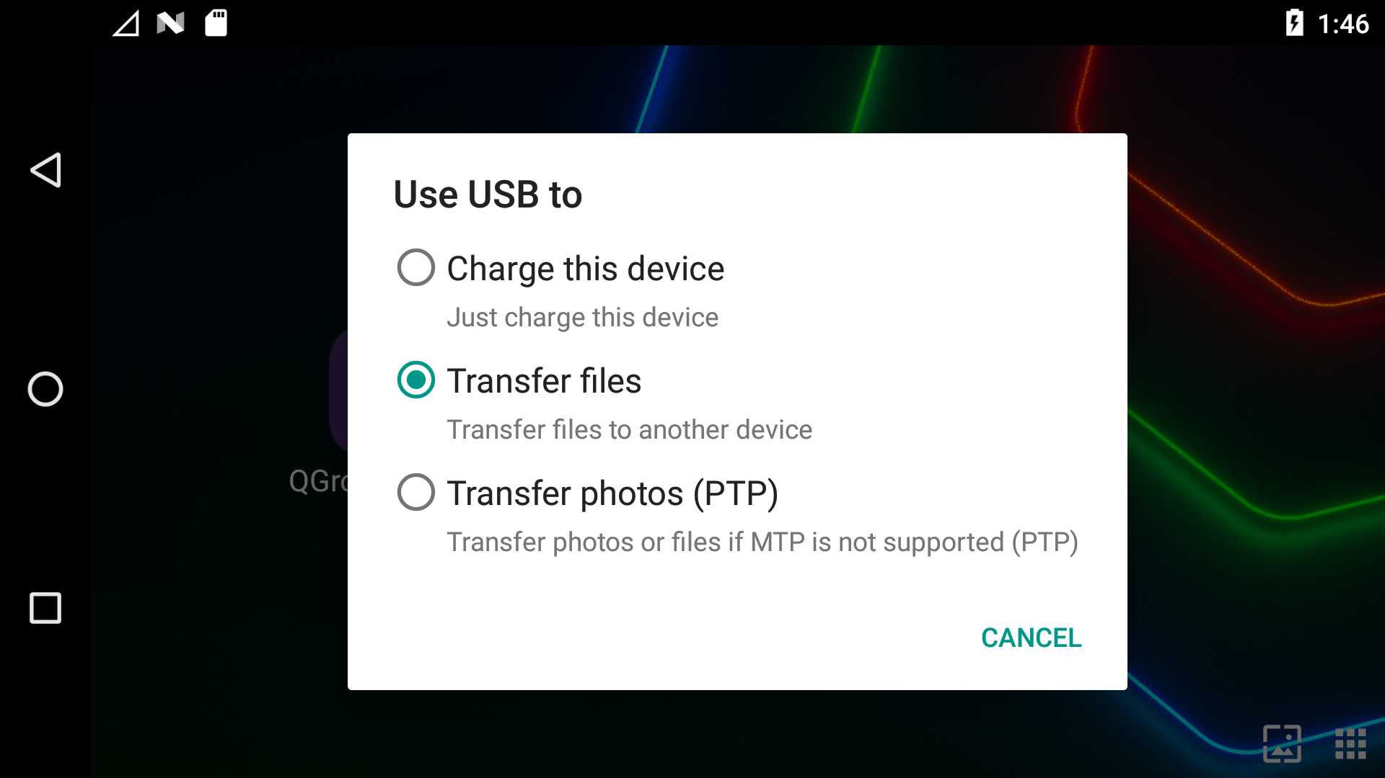

Open oem image folder and right click inside the folder and open terminal and run the following command.

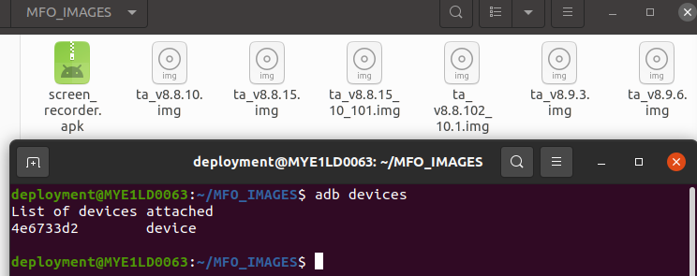

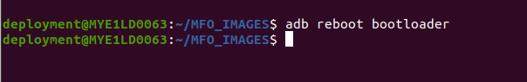
Output: Fastboot mode will be appear on the screen.

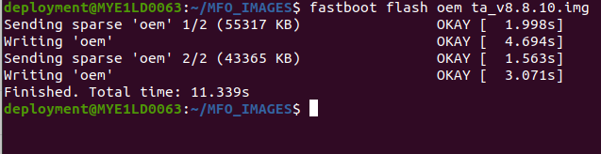
This command will trasfter the image to the controller

This command will restart the controller.

