Git hub server:

github ->user credential -> username + password

REPO(Remote) : https://github.com/repo.git

features: profile, repositories, projects, stars, gists

create a branch : git branch testing
change to branch : git checkout testing

find extension file from directory :
deployment@MYE1LD0063:~/all_ws/ardupilot$ ls | grep ".*.git"
deployment@MYE1LD0063:~/all_ws/ardupilot$ ls | grep ".*.parm"
mav_2_1.parm
mav.parm

git check with branches and tags :
deployment@MYE1LD0063:~/all_ws/ardupilot$ git log --graph --simplify-by-decoration --pretty=format:'%d' --all
* (origin/master, origin/HEAD)
* (HEAD -> master)
| * (origin/Plane-4.3)
| * (tag: Plane-4.3.3)
| * (tag: Plane-4.3.2)
| * (tag: ArduPlane-beta)
| * (tag: Plane-4.3.1, tag: ArduPlane-stable)
| * (tag: Plane-4.3.0)
|/
| * (origin/Rover-4.3)
| * (tag: APMrover2-beta)
|/
| * (tag: Copter-4.3.3, origin/Copter-4.3)
* (origin/master, origin/HEAD)
* (HEAD -> master)
| * (origin/Plane-4.3)
| * (tag: Plane-4.3.3)

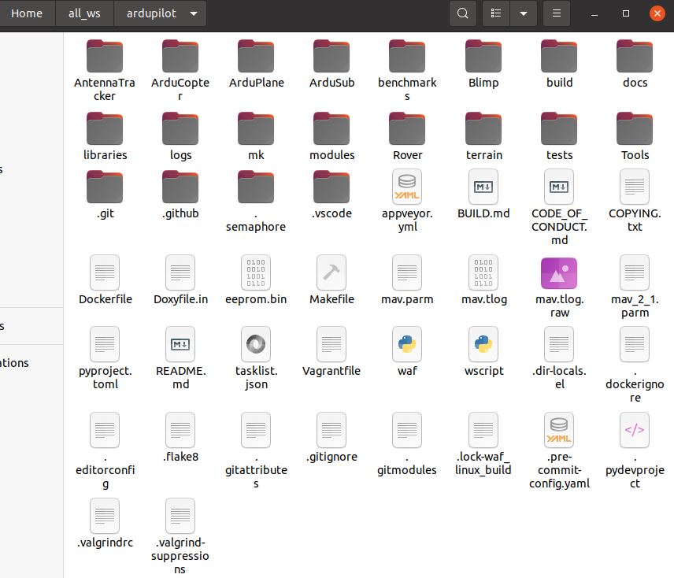
some hidden files in git repository directory

.git
.github

Read all commands of git and github
https://git-scm.com/docs

deployment@MYE1LD0063:~$ git --version
git version 2.25.1

Start a new Git repository for an existing code base
deployment@MYE1LD0063:~/all_ws$ mkdir abc
deployment@MYE1LD0063:~/all_ws$ cd abc/
deployment@MYE1LD0063:~/all_ws/abc$ git init
Initialized empty Git repository in /home/deployment/all_ws/abc/.git/
deployment@MYE1LD0063:~/all_ws/abc$ ls
deployment@MYE1LD0063:~/all_ws/abc$ ls -a
. .. .git
$ git add . (2)
$ git commit (3)

Note: it is created the git directory and files inside the directory

deployment@MYE1LD0063:~/all_ws/ardupilot$ git fetch
remote: Enumerating objects: 4508, done.
remote: Counting objects: 100% (2424/2424), done.
remote: Compressing objects: 100% (87/87), done.
remote: Total 4508 (delta 2354), reused 2377 (delta 2335), pack-reused 2084
Receiving objects: 100% (4508/4508), 8.66 MiB | 5.65 MiB/s, done.
Resolving deltas: 100% (3384/3384), completed with 766 local objects.
From https://github.com/ArduPilot/ardupilot
ba51b56865..3f21946d50 master -> origin/master
c0123bdc2f..7898097b0c Copter-4.1 -> origin/Copter-4.1
6a694642ed..245996c860 Copter-4.2 -> origin/Copter-4.2
34e8e02c48..c33653cd4e Copter-4.3 -> origin/Copter-4.3

$git status

deployment@MYE1LD0063:~/all_ws/ardupilot$ git log
commit 11ab5e3f3d5ac640fadf0a6279d1f3c72839282b (HEAD -> master)
Author: James O'Shannessy <12959316+joshanne@users.noreply.github.com>
Date: Thu Dec 1 21:31:22 2022 +1100
AP_Periph: Adds a parameter to allow for user configurable timeout
Timeout defaults to 200ms. Timeout can be disabled by setting parameter to 0. Timeout should be configured to be able to handle at small number of missed packets.

commit 4679cb4265e1ff98a6019e340c205081125d543d
Author: James O'Shannessy <12959316+joshanne@users.noreply.github.com>
Date: Mon Nov 28 15:45:59 2022 +1100
AP_Periph: Add timeout to ESC driving when CAN packets are lost
Fixes a periph continuing to drive an ESC to an output when the esc_rawcommand packets are lost
commit dfb88839d3b23c9dd2467b0f78e68bee97834c5e
Author: Peter Barker <pbarker@barker.dropbear.id.au>
Date: Fri Dec 2 09:05:41 2022 +1100

$ git clone <https://github.com/repo_url.git>

deployment@MYE1LD0063:~/all_ws/ardupilot$ git show-branch
[master] AP_Periph: Adds a parameter to allow for user configurable timeout

//difference between two commit
deployment@MYE1LD0063:~/all_ws/ardupilot$ git diff 11ab5e3f3d5ac640fadf0a6279d1f3c72839282b dfb88839d3b23c9dd2467b0f78e68bee97834c5e

$ git add .
$ git commit -m “your message”
$git push origin

Branching and Merging
//create two branches
$ git branch one two
//switch to another branch
$git switch two

branch to tag
git tag -l
git push origin <tagname>

$ git push origin v1.5
Counting objects: 14, done.
Delta compression using up to 8 threads.
Compressing objects: 100% (12/12), done.
Writing objects: 100% (14/14), 2.05 KiB | 0 bytes/s, done.
Total 14 (delta 3), reused 0 (delta 0)
To git@github.com:schacon/simplegit.git
* [new tag] v1.5 -> v1.5

$ git push origin --tags
Counting objects: 1, done.
Writing objects: 100% (1/1), 160 bytes | 0 bytes/s, done.
Total 1 (delta 0), reused 0 (delta 0)
To git@github.com:schacon/simplegit.git
* [new tag] v1.4 -> v1.4
* [new tag] v1.4-lw -> v1.4-lw

$git checkout v2.0.0

