TALKTOTASTE – A VOICE CONTROLLED COOKING ASSISTANT
(Web Application Project)

A
PROJECT REPORT
ON

TALKTOTASTE
SUBMITTED BY
KHUSHI DINESH CHOUDHARY
UNDER THE GUIDENCE OF
PROFESSOR: SHRADDHA KOKATE

EXAMINATION BSC.IT, SEMESTER


UNIVERSITY OF MUMBAI
DEPARTMENT OF INFORMATION TECHNOLOGY

GHANSHYAMDAS SARAF COLLEGE OF ARTS AND COMMERCE
(Affiliated to university of Mumbai) MUMBAI 400064 MAHARASHTRA
2025-2026

TALKTOTASTE
A Project Report
Submitted in partial fulfillment of the Requirements for the award of the Degree of

BACHELOR OF SCIENCE (INFORMATION TECHNOLOGY)
By

KHUSHI DINESH CHOUDHARY
Roll No: 5
Under the esteemed guidance of
Prof. Shraddha Kokate


DEPARTMENT OF INFORMATION TECHNOLOGY

GHANSHYAMDAS SARAF COLLEGE OF ARTS AND COMMERCE
(Affiliated to university of Mumbai) MUMBAI 400064 MAHARASHTRA
2025-2026


(Note: All entries of the proforma of approval should be filled up with appropriate and complete information. Incomplete proforma of approval in any respect will be summarily rejected.)

PNR No: ……………………  1. Name of the Student |  | Roll no:
2. Title of the Project
3. Name of the Guide
4. Teaching experience of the Guide
5. Is this your first submission? | Yes |   No
Signature of the Student  Date: ………………… |  | Signature of the Guide  Date: …………………

Signature of the Coordinator

Date: ………………….

DEPARTMENT OF INFORMATION TECHNOLOGY GHANSHYAMDAS SARAF COLLEGE OF ARTS AND COMMERCE
(Affiliated to university of Mumbai)


CERTIFICATE

This is to certify that the project entitled, "TalktoTaste ", is bonafied work of Khushi Choudhary bearing Seat No: (5) submitted in partial fulfilment of the requirements for the award of degree of BACHELOR OF SCIENCE in INFORMATION TECHNOLOGY from University of Mumbai.

Internal Guide Coordinator

External Examiner

Date: College Seal

ABSTRACT
The TalktoTaste web application is a smart, voice-controlled food assistant designed to make cooking and food discovery more convenient and interactive. It allows users to search recipes, follow step- by-step cooking instructions, submit reviews, and receive personalized food recommendations through voice commands. With integrated speech recognition and text-to-speech, the system provides real-time narration and hands-free assistance, making it especially useful while cooking. Unlike traditional food and recipe apps that rely on manual input, TalktoTaste focuses on accessibility, innovation, and user- friendliness, offering a more effective and engaging experience.

ACKNOWLEDGEMENT

I take this opportunity to express my profound gratitude and indebtedness to my project guides Prof. Shraddha Kokate for giving me the opportunity to accomplish this project.

I am very much thankful to Prof. Shraddha Kokate for being very much resourceful, kind and helpful. Their positive attitude, unassailable optimism and unawaring faith in me assured that I came out of problems whenever I encountered difficulties.

Finally I wish to thank all my friends and IT department to directly or indirectly helped me in completion of this project. Last but not the least I would thank my family without whose support, motivation and encouragement this would not have been possible.

DECLARATION
I hereby declare that the project entitled, “TalktoTaste” done at Malad, has not been in any case duplicated to submit to any other university for the award of any degree. To the best of our knowledge other than us, no one has submitted to any other university.
The project is done in partial fulfillment of the requirements for the award of degree of BACHELOR OF SCIENCE (INFORMATION TECHNOLOGY) to be submitted as final semester project as part of our curriculum.

Khushi Dinesh Choudhary

TABLE OF CONTENT
CHAPTER 1: Introduction 10
  - Background 10
  - Objective 10
  - Purpose, Scope and Applicability 11
    - Purpose 11
    - Scope 12
    - Applicability 13
  - Organization of Report 14
CHAPTER 2: SURVEY OF TECHNOLOGY 15
  - Survey of Programming Languages 15
  - Survey of AI Algorithms and Modules 17
  - Survey of Databases 19
  - Survey of Design Software 21
  - Survey of Frontend Technologies 22
  - Survey of Backend Technologies 24
  - Survey of Development Tools 25
  - Survey of Version Control System 27
  - Survey of Development Infrastructure 28
  - Survey of Project Management System 29
CHAPTER 3: REQUIREMENT AND ANALYSIS 31
  - Problem Definition 31
  - Requirement Specification 32
  - Planning and Scheduling 33
  - Hardware Requirement 35
  - Software Requirement 36
  - Conceptual Models 37
    - Data Flow Diagram 37
    - Use Case Diagram 38
    - Activity Diagram 39
    - Sequence Diagram 40
    - Class Diagram 41
    - Entity Relationship Diagram 42
    - Event Table 43
CHAPTER 4: SYSTEM DESIGN 29
  - Basic Modules 29
  - Data Design 30
    - Schema Design 30
    - Data Integrity 30
  - Procedure Design 31
    - Flow Chart 31
  - Algorithm Design 32
  - UI Design 34
  - Test Case Design 35

LIST OF TABLES
Table 1 Comparison table for Programming languages 3
Table 2 Comparison Table for AI Algorithm 6
Table 3 Comparison Table for database and data storage solutions 8
Table 4 Comparison Table for design software 10
Table 5 Comparison Table for Frontend Technologies 11
Table 6 Comparison Table for backend Technologies 13
Table 7 Comparison Table for development tools 14
Table 8 Comparison Table for version controls 16
Table 9 Comparison Table for Deployment Infrastructure 18
Table 10 Comparison Table for project management software 18
Table 11 Planning and scheduling table 21
Table 12 Event Table 30
Table 13 Schema Design 33
Table 14 Data Integrity Design 48
Table 15 Test Case 50

LIST OF FIGURES
Fig 1: Gantt Chart 15
Fig 2: Pert Chart 15
Fig 3: Data Flow Diagram 18
Fig 4: Use Case Diagram 19
Fig 5: Activity Diagram 20
Fig 6: Sequence Diagram 21
Fig 7: Class Diagram 22
Fig 8: Entity Relation Diagram 24
Fig 9: FlowChart 28

CHAPTER 1 INTRODUCTION

Background
Cooking is an essential activity in every household. However, interacting with digital devices in a kitchen environment often proves inconvenient and unhygienic. Many people especially beginners, elderly individuals, and people with physical disabilities find it difficult to follow recipes on smartphones or tablets while handling ingredients or working with messy hands.
- Messy or wet hands make it hard to scroll or operate touch-based screens. - Most recipe formats such as apps, books, or videos demand continuous visual and physical attention.
- Touch-based interfaces are impractical in real-time cooking situations.
- Users seek a hands-free, voice-operated solution for navigating cooking steps.
- Recent studies indicate:
Over 65% of individuals use mobile devices to follow recipes while cooking.
More than 70% report frustration when trying to interact with screens mid-cooking. A growing number of users, particularly those with mobility or vision limitations, express preference for voice-assisted cooking tools.
This presents a clear opportunity to design a smart, inclusive kitchen assistant that delivers real-time recipe guidance through voice interaction, reducing manual effort and enhancing accessibility.
TalktoTaste is designed to meet this need.
It is a voice-controlled cooking assistant that guides users through Indian recipes in a fully hands-free manner. Supporting both Hindi and English, the assistant offers a safe, intuitive, and accessible way to cook especially tailored for Indian households.

Objective
The main objectives of TalktoTaste are as follows:
- develop a voice-first smart kitchen assistant that enables hands-free recipe interaction for Indian cooking.
- To offer step-by-step audio instructions in Hindi and English, ensuring accessibility across different language preferences.
- Allow users to search for recipes using voice commands, either by dish name or by specifying available ingredients.
- Integrate voice-activated timers and reminders, enhancing time management during cooking.
- promote inclusivity, especially for elderly individuals, physically disabled users, and beginners in the kitchen.

- To support a safer and cleaner cooking environment by reducing the need to touch screens or devices.

- Implement cooking duration and whistle tracking, allowing users to manage pressure cooking with voice inputs.
- serve as a personal cooking assistant, simplifying daily meal preparation through intelligent voice- guided interactions.

Purpose and Scope

Purpose
The purpose of TalktoTaste is to create a hands-free, voice-powered kitchen experience tailored for Indian home cooks. It addresses common frustrations associated with screen-based recipe formats and aims to provide a comfortable, accessible, and judgment-free cooking environment.
This assistant is especially valuable for:
      - Users who prefer not to touch devices while cooking
      - Elderly or physically challenged individuals who require voice-based assistance
      - People who want bilingual recipe instructions in Hindi and English
      - Beginners who benefit from detailed, guided steps
      - Anyone seeking an inclusive, voice-first cooking experience

Scope
TalktoTaste offers a range of features to support a seamless, touchless cooking experience. The scope includes:
      - Full voice interaction: Users can control the assistant, search for recipes, and receive spoken instructions—all hands-free.
      - Step-by-step recipe narration: The assistant walks the user through each recipe using clear voice instructions in Hindi and English.
      - Voice-based search: Recipes can be found by simply stating the dish name or listing available ingredients.
      - (e.g., “How to make Paneer Butter Masala”) or by mentioning available ingredients (e.g., “What can I cook with rice and potato?”).
      - Timer and reminder features: Users can set and manage timers using voice commands without interrupting their cooking.
      - Recipe saving and sharing: Voice-based recipe storage and sharing options promote a hygienic and efficient workflow.
      - Accessibility support: Designed with various user groups in mind—such as the elderly, disabled, or visually impaired.
      - Bilingual content: Both Hindi and English are supported in the current version, with plans to expand to regional languages.

      - YouTube video integration: For complex dishes, users can request video tutorials via voice or manual selection.
      - Whistle and cooking time tracking: The assistant can track whistle counts and cooking durations based
on voice inputs like “Started now” or “2 whistles done.”

Example:
For Rajma, the assistant says:
“Let it whistle 3 times. Tell me when it starts.” User responds: “Started now” → “2 whistles done”
Assistant replies: “One more to go. I’ll notify you after that.”

Applicability
TalktoTaste serves a wide range of users and use cases:
Where it can be used:
      - Home Kitchens: A personal tool that supports daily cooking.
      - Elderly and Disabled Users: Offers an easy, accessible way to follow recipes. - Smart Kitchens: Can be integrated with IoT devices for enhanced functionality for future plan.
      - Busy Professionals: Allows multitasking while cooking with voice-controlled guidance.
      - Students and Beginners: Provides step-by-step support while learning to cook Indian dishes.
      - Who can benefit:
      - Home cooks: For routine meal preparation.
      - Elderly and physically challenged users: Enables independence in cooking.
      - Beginners and students: Provides guided, easy-to-follow instructions.
      - Busy professionals: Supports multitasking with voice-based operation.
      - Caregivers: Helps guide individuals with special needs.
      - Non-English speakers: Hindi support ensures wider accessibility.

1.5 Organization of Report
The subsequent chapters of the project report will focus on the survey of different technologies which includes comparison of different platforms, languages, software, hardware etc.
The Survey is followed by the analysis of requirements resulting in generation of requirement specification and schedule of activities. It also includes the conceptual design that visualizes the features and operations that can be performed on the system.
The final chapter of the project report includes the system design that describes desired features and operations in detail, including screen layouts, business rules, process diagrams, pseudo code and other documentation.

CHAPTER 2 SURVEY OF TECHNOLOGY

Survey of Programming Languages

List of Technologies Considered
  - Python – Beginner-friendly language with strong AI/ML support.
  - JavaScript – Widely used for both frontend and backend development.
  - TypeScript – Superset of JavaScript with static typing for scalable and reliable web applications.

Comparison

Language | Platform Support | Performance | Ease of Learning | Community Support | Remarks
Python | Backend, AI/ML | Moderate | Very Easy | Very Strong | Ideal for AI, data processing & voice logic
JavaScript | Frontend + Backend (Node.js) | High | Easy | Very Strong | Excellent for interactive applications
TypeScript | Frontend + Backend (via JS) | High | Moderate | Strong | Best for scalable and bug-free web apps
Table 1: Comparison table for Programming languages

Why to Choose
Python
  - Provides powerful AI/ML libraries (TensorFlow, PyTorch, NLTK).
  - Simple and readable syntax speeds up development.
  - Works on multiple platforms (Windows, Linux, Mac).
  - Supported by a large developer community.

JavaScript
  - Enables full-stack development (Node.js for backend, React for frontend).
  - Supports real-time interactions essential for voice-based apps.

  - Backed by a huge ecosystem of frameworks and libraries.
  - Provides seamless API and database integration.

TypeScript
  - Adds static typing on top of JavaScript, reducing runtime errors.
  - Ideal for building Progressive Web Apps (PWAs) with reliability.
  - Scales better for long-term projects by improving code maintainability.
  - Works seamlessly with React (frontend) and Node.js + Express (backend).
  - Widely used in modern industry (Microsoft, Slack, Airbnb).

Survey of AI Algorithms and Modules

List of Technologies Considered
  - Speech-to-Text (STT) – Converts spoken words into text.
  - Text-to-Speech (TTS) – Converts text into natural-sounding speech.
  - Natural Language Processing (NLP) – Understands Hindi/English commands.
  - Recommendation Algorithms – Suggests recipes based on context.

Comparison

Algorithm/Module | Accuracy | Complexity | Use Case
Speech-to-Text | High | Moderate | Converts user voice to text
Text-to-Speech | High | Low | Reads instructions aloud
NLP | High | High | Understands bilingual commands
Recommendation | High | Moderate | Suggests recipes to users
Table 2: Comparison table for Algorithms

Why to Choose
Speech-to-Text
  - Ensures smooth voice command recognition.
  - Enhances accessibility during cooking.

Text-to-Speech
  - Provides hands-free recipe narration.
  - Improves usability in noisy or busy kitchens.

Natural Language Processing
  - Enables bilingual interaction (Hindi & English).
  - Understands intent and context in user queries.

Recommendation Algorithms
  - Personalizes recipe suggestions.
  - Adapts to user preferences and available ingredients.

Survey of Databases and Data Storage Solutions

List of Technologies Considered
  - MongoDB – NoSQL, JSON-like documents.
  - MySQL – Relational database.
  - SQLite – Lightweight, file-based.
  - PostgreSQL – Advanced relational DB.
  - Firebase Realtime DB – Cloud-hosted, real-time sync.

Comparison

Database | Type | Scalability | Offline Support | Best For | Cost Structure
MongoDB | NoSQL | Very High | Limited | JSON data, cloud apps | Free/Paid
MySQL | Relational | High | No | Structured data apps | Free/Paid
SQLite | Relational | Low | Yes | Lightweight local apps | Free
PostgreSQL | Relational | Very High | No | Enterprise-level systems | Free/Open Source
Firebase RTDB | NoSQL | Very High | Yes | Real-time apps | Free/Paid
Table 3: Comparison table for Databases

Why to Choose
MongoDB
  - Flexible document-based storage.
  - Highly scalable for cloud applications.

  - Integrates seamlessly with Node.js + Express.js.

MySQL
  - Reliable relational system with ACID compliance.
  - Excellent for structured recipe/user data.
  - Widely supported in industry.

SQLite
  - Perfect for lightweight apps and prototyping.
  - Provides offline support with no external server.

Survey of Design Software

List of Tools Considered
  - Figma – Cloud-based design and prototyping tool.
  - Adobe XD – UI/UX design software.
  - Canva – Simple online design tool.

Comparison

Tool | Collaboration | Ease of Use | Best For
Figma | Excellent | Easy | Team-based UI design
Adobe XD | Good | Moderate | Professional prototyping
Canva | Limited | Very Easy | Quick graphics and mockups
Table 4: Comparison table for list of Design Tools

Why to Choose
Figma
  - Enables real-time team collaboration.
  - Free tier supports most project needs.
  - Accessible across devices via browser.
Canva
  - Extremely beginner-friendly.
  - Useful for non-technical design needs.

Survey of Frontend Technologies

List of Technologies Considered
  - HTML, CSS, JavaScript – Core web stack.
  - Bootstrap / Tailwind CSS – Styling frameworks.
  - React.js – Component-based library.
  - Angular – Google’s frontend framework.
  - Vue.js – Lightweight alternative.

Comparison

Technology | Performance | UI Quality | Community Support | Best For
HTML/CSS/JS | High | Basic | Very Strong | Core web apps
Bootstrap/Tailwind | High | Good | Strong | Responsive design
React.js | Very High | Excellent | Very Strong | Dynamic web apps
Angular | Very High | Excellent | Strong | Enterprise projects
Vue.js | High | Excellent | Growing | Lightweight apps
Table 5: Comparison table for Frontend languages

Why to Choose
HTML / CSS / JS
  - Universal and browser-compatible.
  - Foundation for all web applications.
Bootstrap / Tailwind CSS
  - Pre-built UI components.
  - Ensures mobile-first responsive design.
React.js
  - Reusable UI components.
  - Fast rendering with Virtual DOM.
  - Backed by strong developer community.

Survey of Backend Technologies

List of Technologies Considered
  - Python (Flask/Django).
  - Node.js + Express.js.
  - REST APIs.
  - FastAPI.
  - Spring Boot.

Comparison

Technology | Performance | Scalability | AI Integration | Best For
Flask/Django | High | High | Excellent | AI&NLP apps
Node.js/Express | High | High | Medium | Real-time scalable apps
REST APIs | High | High | Medium | Cross-platform comms
FastAPI | Very High | High | Excellent | Fast Python APIs
Spring Boot | Very High | Very High | Medium | Enterprise apps
Table 6: Comparison table for Backend languages

Why to Choose
Flask/Django
  - Strong AI/ML support.
  - Quick development and integration.
Node.js + Express.js
  - Event-driven architecture.
  - Works best with MongoDB.
  - Scales well for API-driven apps.
REST APIs
  - Universal communication standard.
  - Ensures interoperability.

FastAPI
  - Extremely fast and modern Python framework.
  - Ideal for AI/ML apps needing speed.

Survey of Development Tools

List of Tools Considered
  - Visual Studio Code.
  - PyCharm.
  - Postman.
- Comparison

Tool | Best For | Ease of Use | Cost
VS Code | Multi-language coding | Easy | Free
PyCharm | Python development | Moderate | Free/Paid
Postman | API testing | Easy | Free
Table 7: Comparison table for Development tools

Why to Choose
Visual Studio Code
  - Lightweight and highly extensible.
  - Supports multiple languages.
PyCharm
  - Best for Python-heavy AI development.
  - Provides debugging and project management.
Postman
  - Simplifies API testing.
  - Automates request/response validation.

Survey of Version Control Systems

List of Tools Considered
  - Git.
  - GitHub.
  - GitLab.

Comparison

Tool | Hosting | Collaboration | Cost
Git | Local | Limited | Free
GitHub | Cloud | Excellent | Free/Paid
GitLab | Cloud | Excellent | Free/Paid
Table 8: Comparison table for Version Control tools

Why to Choose
Git
  - Reliable local version control.
  - Industry-standard tool.
GitHub
  - Simplifies collaboration and code sharing.
  - Offers free repositories.

Survey of Deployment Infrastructure

List of Platforms Considered
  - Local Machine.
  - Heroku.
  - Render.
  - Vercel.
  - Netlify.
  - Firebase Hosting.
  - Docker.

Comparison

Platform | Scalability | Ease of Use | Best For
Local Machine | Low | Easy | Development/testing
Heroku | High | Easy | Small apps, prototyping
Render | High | Easy | APIs and backend apps
Vercel | High | Very Easy | React/Next.js apps
Netlify | High | Very Easy | Static websites
Firebase Hosting | High | Easy | Real-time apps
Docker | Very High | Moderate | Containerized deployments
Table 9: Comparison table for Development Infrastructure platform

Why to Choose
Heroku
  - Simple Git-based deployment.
  - Good for prototypes.
Render
  - Modern alternative to Heroku.
  - Supports free tier apps.

Vercel
  - Specializes in frontend hosting.
  - Free plan supports serverless APIs.
Docker
  - Ensures consistency across environments.
  - Ideal for scalable cloud deployments.

Survey of Project Management Software

List of Tools Considered
  - Trello – Visual task boards for simple project tracking.
  - ClickUp – All-in-one productivity and project management tool.
  - Notion – Notes, documentation, and lightweight task management in one platform.

Comparison

Tool | Best For | Ease of Use | Cost | Relevance to TalktoTaste
Trello | Simple Kanban-style boards | Very Easy | Free | Manage recipe module tasks, bug tracking
ClickUp | Agile workflows & integrations | Easy | Free/Paid | Track AI/ML model development, deadlines
Notion | Docs + tasks in one  workspace | Easy | Free/Paid | Maintain recipe datasets,  documentation, and sprints
Table 10: Comparison table for project management

Why to Choose
For TalktoTaste, Trello is chosen for its simple visual boards that streamline recipe module tasks and bug tracking, ClickUp supports agile workflows and integrations making it effective for
managing AI/ML model development and deadlines, while Notion provides a unified space for documentation, datasets, and sprint planning. Together, these tools ensure clarity, productivity, and collaboration across the project lifecycle.

CHAPTER 3 REQUIREMENT AND ANALYSIS

Problem Definition
Cooking while hands-busy is inconvenient: users can’t easily use touch-based recipe apps. Many apps require manual interaction, causing interruptions and mistakes.
Users forget steps, timings or quantities leads to overcooking / wrong measurements. Need for real-time, hands-free guidance with natural voice commands and clear spoken feedback.
TalktoTaste = a voice-controlled assistant that listens, understands cooking commands, and speaks step-by-step instructions so users can cook hands-free.

Requirement Specification
- Voice Commands — accept spoken commands: “next”, “repeat”, “how much sugar?”, “Start timer”.
- Speech Recognition — convert user speech → actionable intents.
- Text-to-Speech (TTS) — read recipe steps aloud.
- Recipe Search — search by name, ingredient, cuisine, dietary filter (vegan, gluten-free).
- Step Navigation — next step, previous step, repeat, jump to step n.
- Timers — set/manage timers by voice.
- Favourite / Profile — save favourite recipes and user preferences.
- Usability — clear spoken instructions.
- Availability — app usable on smartphones & browsers.
- Privacy & Security — user data encrypted.
- Scalability — support growing number of recipes.
- Localization — support multiple languages like Hindi and English.

Planning and Scheduling
Number of Personnel: 1
Estimated Start Date: 17th July 2025 Estimated End Date: 28th Feb 2026

Gantt Chart

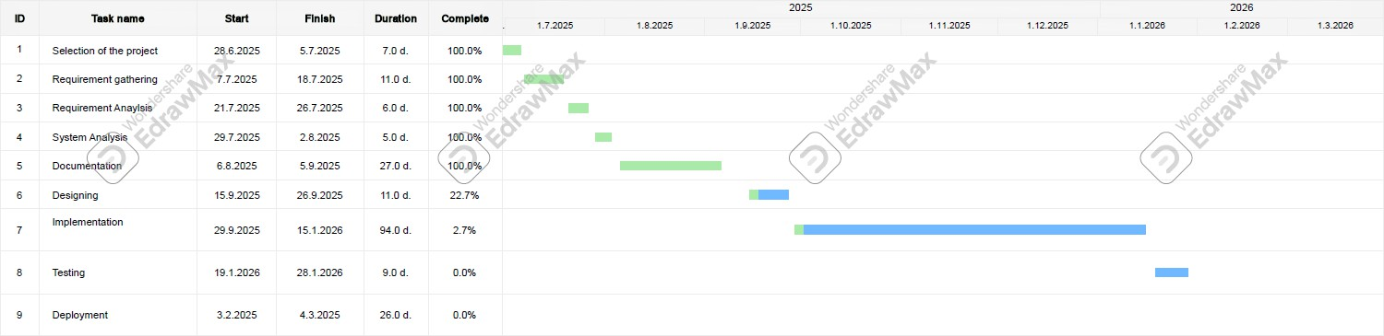

Fig: 3.3.1: GANTT CHART

PERT Chart
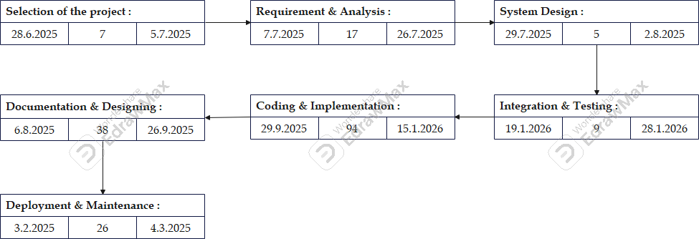

Fig 3.3 2: PERT CHART

Table 11: table of planning and scheduling task

Hardware Requirement
For Web Users (Laptop):
- Operating System: Compatible with Windows 10/11, macOS, or Linux (any OS that supports a modern browser).
- Processor: Any modern Dual-core or better processor (Intel Core i3 or higher, AMID Ryzen 3 or higher).
- RAM: Minimum 4 GB (8 GB recommended for optional performance acoss multiple tabs or applications).

Software Requirement
- Operating System: Android, Windows, Linux (Web version for browsers).
- Backend: Python (Flask/Django) or Node.js + Express.js (optional).
- Frontend: React / React Native.
- Database: SQLite / MySQL; MongoDB optional.
- Speech APIs: Speech-to-Text, Web Speech API; TTS APIs.
- IDE / Tools: VS Code, Git, Postman.
- Libraries: Speech recognition, NLP/intent parsers.

Conceptual Models
The Conceptual Models includes Diagrams such as
- Data Flow Diagram
- Use Case Diagram
- Activity Diagram
- Sequence Diagram
- Class Diagram
- Entity-Relationship Diagram.
- Event Table

Data Flow Diagram
What is DFD? (Data Flow Diagram)
DFD shows how data flows through the system — processes, data stores, external entities. Level 0 (Context): User ↔ TalktoTaste System ↔ Recipe Database
Level 1: Voice Input →Intent Processor → Recipe Manager → TTS → User Profile Manager ↔ User Profiles DB, Session Logs stored in DB.
Level 2: It consist a detail information of the project TalktoTaste

DFD Level 0 (Context Diagram)

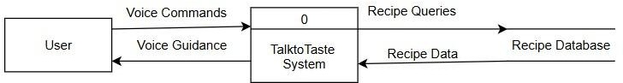

DFD Level 1

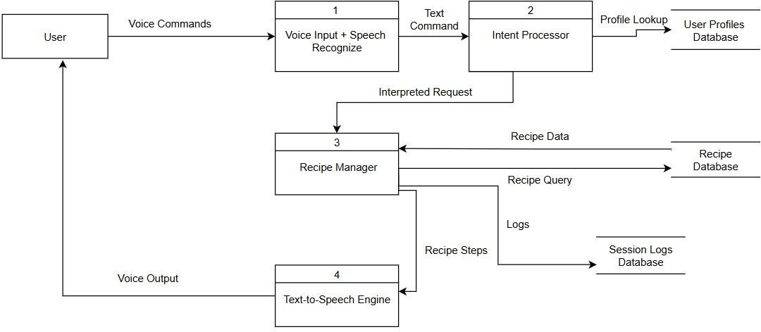

DFD Level 2
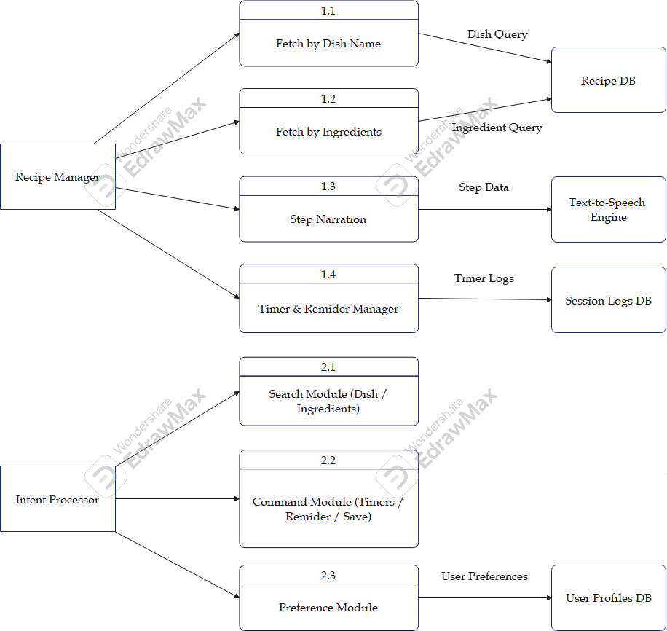

FIG 3.6.1: DATA FLOW DIAGRAM

Use Case Diagram
A use case describes a goal the user wants to achieve.
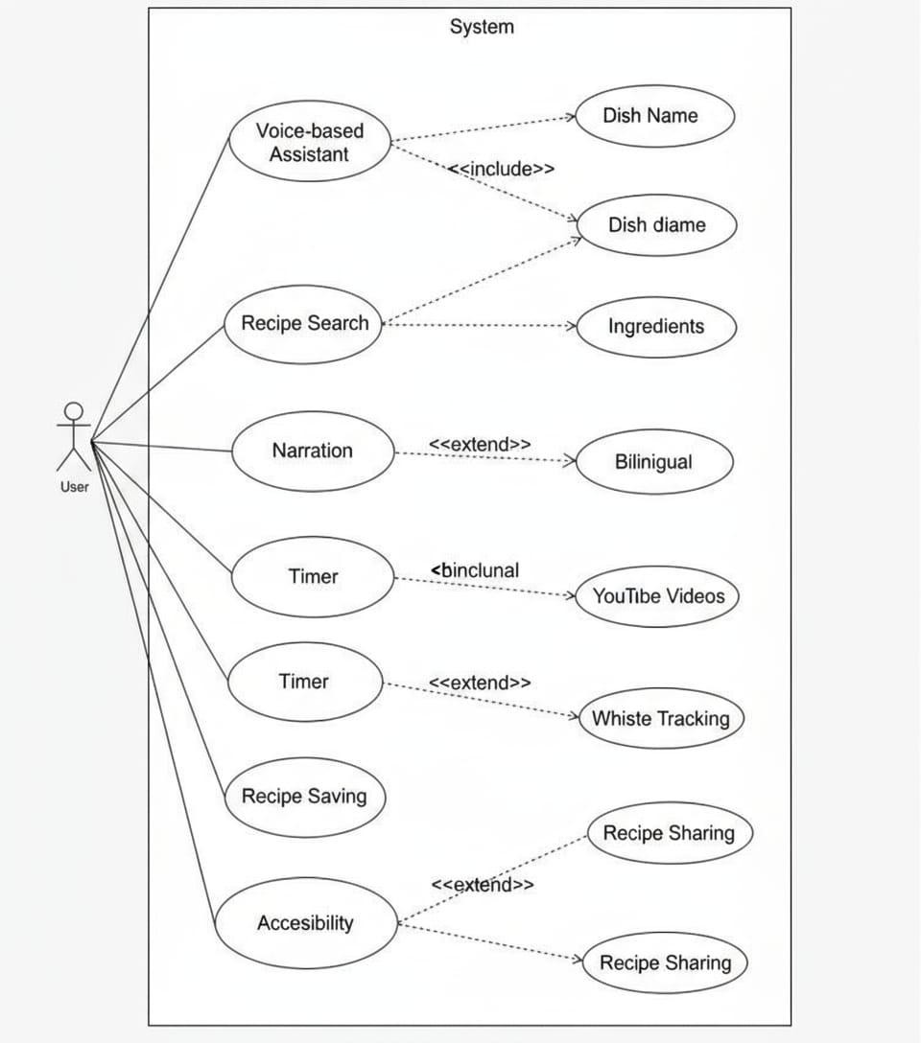

FIG 3.6.2: USE CASE DIAGRAM

Activity Diagram
Activity Diagram describes dynamic aspects of the system.

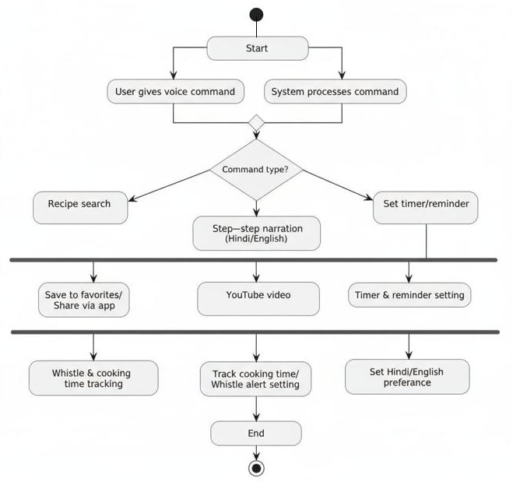

FIG 3.6.3: ACTIVITY DIAGRAM

Sequence Diagram
A sequence diagram shows the interactions between objects or components in a system over time illustrating the sequence of messages exchanged to achieve a specific goal.

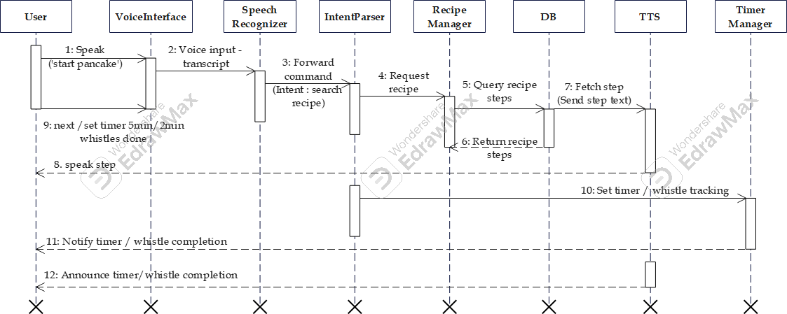

FIG 3.6.4: SEQUENCE DIAGRAM

Class Diagram
A class diagram is a visual representation of classes, attributes, methods, and relationships between them in a system, showing the structure and organization of classes.

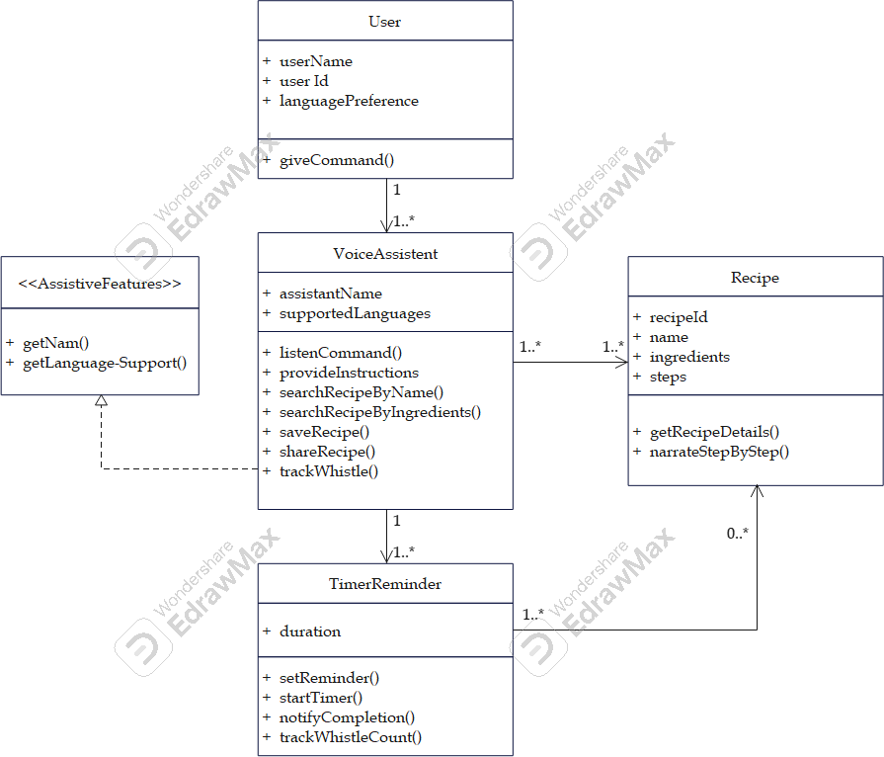

FIG 3.6.5 1: CLASS DIAGRAM

Entity Relationship Diagram
ER Diagram
An Entity-Relationship (ER) diagram is a visual representation of the structure of a database,
showing:
- Entities (tables)
- Attributes (columns)
- Relationships (connections between tables)
ER diagrams help design and visualize database schema, making it easier to understand data structures and relationships.
Entities & Attributes:
User: user_id, name, email, language_preference
Recipe: recipe_id, name, cuisine_type, difficulty_level, cooking_time Ingredient: ingredient_id, name, quantity, unit
Voice Command: command_id, command_text, timestamp Timer : timer_id, duration, status

Relationships:
User → Voice Command (1:M) User → Recipe (1:M, via search)
Voice Command → Recipe (M:1, via trigger) Recipe ↔ Ingredient (M: N, via contains) Voice Command → Timer (1:M)
User → Timer (1:M)

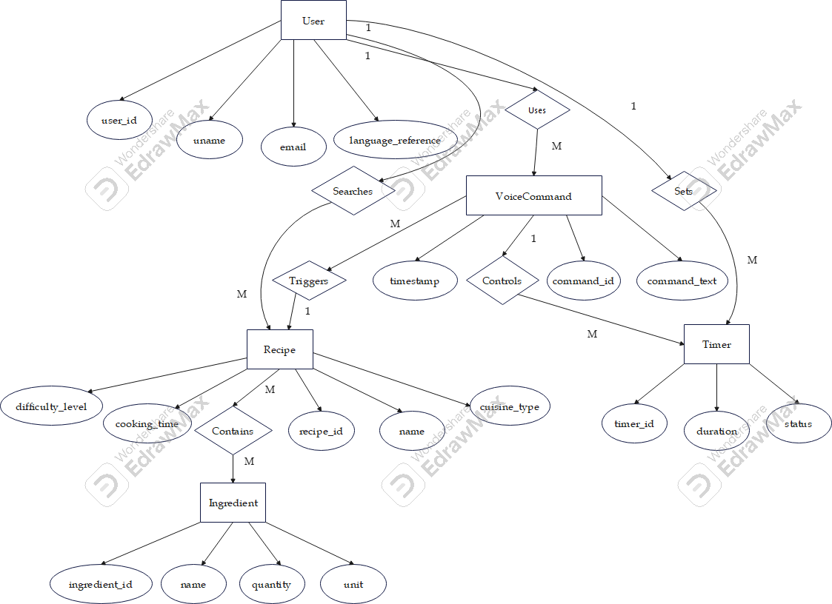

FIG 3.6.6 1: ENTITY RELATION DIAGRAM

Event Table

Event Name | Trigger | Source | Response | Destination
User Login | Voice/password | User | Validate & allow access | System
Search Recipe | Voice: find recipe | User | Return matching recipes | System/User
Start Cooking | Voice: start X | User | Load recipe & speak first step | TTS/User
Next Step | Voice: next | User | Speak next instruction | TTS/User
Repeat Step | Voice: repeat | User | Re-speak current instruction | TTS/User
Set Timer | Voice: set timer | User | Start timer & confirm | Timer/User
Save Favourite | Voice: save recipe | User | Store recipe in profile | DB
Admin Add Recipe | UI action | Admin | Add recipe to DB | Database

Table 12: table for Event table
Table 3.6.7: Event Table

  - Basic Modules

CHAPTER 4 SYSTEM DESIGN

The TalktoTaste system is structured into several functional modules, each addressing a key aspect of the user experience.
These modules work together to provide a seamless, hands-free cooking assistant.

- Voice Interaction Module:
Handles speech recognition in Hindi and English, processes user commands, and provides spoken responses.
- Recipe Management Module:
Stores and manages recipes, supports narration, and allows saving/sharing recipes.
- Cooking Assistance Module:
Delivers real-time instructions, tracks whistles and timers.
- Accessibility & Inclusivity Module:
Provides bilingual support and caters to elderly/disabled users.
- Multimedia Integration Module:
Integrates with YouTube for video tutorials.
- User Interface Module:
Provides minimal touch backup interface, displays steps, timers, and videos.
- Data Logging & Analytics Module:
Keeps logs of usage, tracks personalization, and analytics.

Data Design

Schema Design
The following tables define the database schema:
Users

Field | Data Type | Description
user_id | INT (PK) | Unique identifier
name | VARCHAR(100) | User full name
age | INT | Age

preferred_lang | VARCHAR(20) | Language preference
created_at | DATETIME | Created timestamp

Recipes

Field | Data Type | Description
recipe_id | INT (PK) | Unique recipe ID
recipe_name | VARCHAR(150) | Dish name
cuisine_type | VARCHAR(50) | Cuisine category
cooking_time | INT | Cooking time (minutes)
difficulty | VARCHAR(20) | Difficulty level
video_link | VARCHAR(255) | YouTube video link

Ingredients

Field | Data Type | Description
ingredient_id | INT (PK) | Unique ingredient ID
name | VARCHAR(100) | Ingredient name
type | VARCHAR(50) | Category
unit | VARCHAR(20) | Measurement unit

Recipe_Ingredients
Field | Data Type | Description
recipe_id | INT (FK) | Recipe reference
ingredient_id | INT (FK) | Ingredient reference
quantity | VARCHAR(50) | Quantity needed

Instructions
Field | Data Type | Description
instruction_id | INT (PK) | Step ID
recipe_id | INT (FK) | Recipe reference
step_number | INT | Step number
description | TEXT | Instruction text

Timers
Field | Data Type | Description
timer_id | INT (PK) | Timer ID
user_id | INT (FK) | User reference
recipe_id | INT (FK) | Recipe reference
duration | INT | Timer duration
status | VARCHAR(20) | Active/Completed

Whistle_Tracking
Field | Data Type | Description
whistle_id | INT (PK) | Whistle record
recipe_id | INT (FK) | Recipe reference
user_id | INT (FK) | User reference
whistle_count | INT | Count
timestamp | DATETIME | Time
Table 13: table for schema Design

Data Integrity
Users

Field Name | Data Type | Constraints | Description
user_id | INT | Primary Key | Unique identifier for each user
name | VARCHAR(100) | Not Null | Full name of the user
age | INT | Optional | Age of the user (optional)
preferred_lang | VARCHAR(20) | Must be Hindi/English | Language preference
created_at | DATETIME | Default=current timestamp | Account creation timestamp

Recipes

Field Name | Data Type | Constraints | Description
recipe_id | INT | Primary Key | Unique identifier for each recipe
recipe_name | VARCHAR(150) | Not Null, Unique | Name of the dish
cuisine_type | VARCHAR(50) | Optional | Cuisine category
cooking_time | INT | Must be ≥ 0 | Estimated cooking time (minutes)
difficulty | VARCHAR(20) | Enum(Easy,Medium,Hard) | Difficulty level
video_link | VARCHAR(255) | Optional | YouTube tutorial link
Ingredients

Field Name | Data Type | Constraints | Description
ingredient_id | INT | Primary Key | Unique identifier for each ingredient
name | VARCHAR(100) | Not Null, Unique | Ingredient name
type | VARCHAR(50) | Optional | Category (vegetable, spice, dairy, etc.)
unit | VARCHAR(20) | Optional | Measurement unit (g, ml, tbsp, etc.)
Recipe_Ingredients

Field Name | Data Type | Constraints | Description
recipe_id | INT | Foreign Key→Recipes(recipe_id) | Links to Recipes table
ingredient_id | INT | Foreign Key→Ingredients(ingredient_id) | Links to Ingredients table
quantity | VARCHAR(50) | Not Null | Required quantity
Instructions

Field Name | Data Type | Constraints | Description
instruction_id | INT | Primary Key | Unique identifier for each instruction
recipe_id | INT | Foreign Key→Recipes(recipe_id) | Links to Recipes table
step_number | INT | Sequential, Unique per recipe | Instruction step number
description | TEXT | Not Null | Instruction text

Timers

Field Name | Data Type | Constraints | Description
timer_id | INT | Primary Key | Unique identifier for each timer
user_id | INT | Foreign Key→Users(user_id) | User who set the timer
recipe_id | INT | Foreign Key→Recipes(recipe_id) | Associated recipe (if any)
duration | INT | Must be>0 | Timer duration (seconds)
status | VARCHAR(20) | Enum(Active,Completed) | Current state of timer

Whistle_Tracking

Field Name | Data Type | Constraints | Description
whistle_id | INT | Primary Key | Unique identifier for whistle record
recipe_id | INT | Foreign Key→Recipes(recipe_id) | Associated recipe
user_id | INT | Foreign Key→Users(user_id) | User cooking the recipe
whistle_count | INT | Must be ≥ 0 | Number of whistles tracked
timestamp | DATETIME | Default=current timestamp | Time of whistle entry

Table 14: table for Data Integrity Design

Procedure Design

Flow Chart
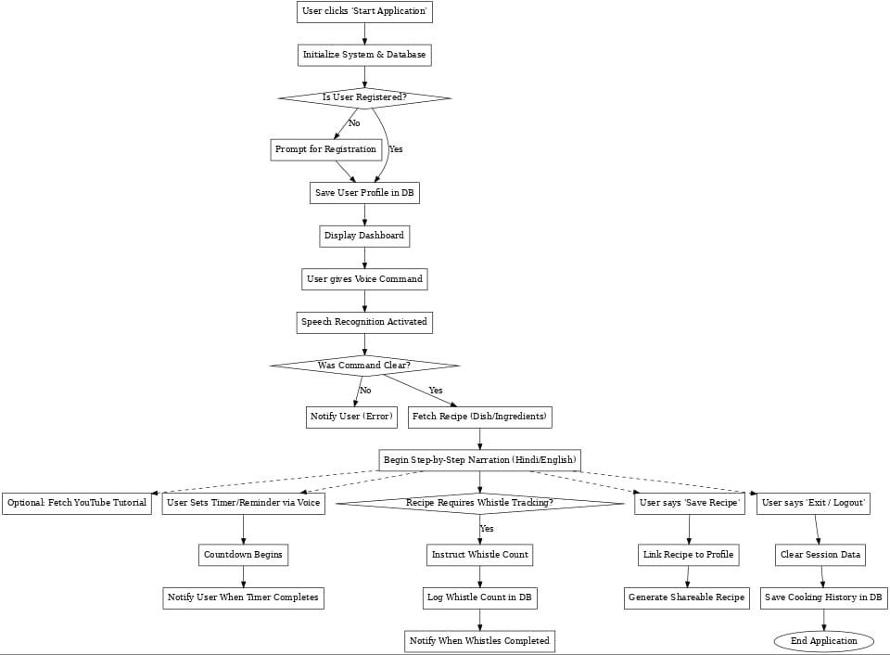

FIG 4.3.1: FLOW CHART

Algorithm Design
Algorithm: TalktoTaste Voice Cooking Assistant
- Start
- Launch Application
- Check Registration
If user is registered → Load preferences (language, history) Else → Prompt for name & language →Save profile
- Display Dashboard

Recipe Search &Narration
- Capture user’s voice command (recipe name or available ingredients)
- If invalid →Ask to repeat
- Else →Search recipes in database
- Display matching recipes + narrate aloud
- If recipe selected →Narrate ingredients and first step
- Continue narrating step-by-step instructions Wait for “next” / “repeat” voice commands
- If user requests video → Play linked YouTube tutorial
- If recipe completed →Confirm completion

Timer &Reminders
- User sets a voice-based timer
- Store timer in database
- Begin countdown
- If timer reaches zero →Notify user
- If user resets/extends → Adjust timer

Whistle Tracking
- If recipe requires pressure cooking → Start whistle tracking
- System instructs user to count whistles
- User updates whistle count by voice (e.g., “2 whistles done”)
- Log whistle count in database
- If target whistle count reached →Notify user

Recipe Save & Share
- If user says “Save” →Link recipe to profile
- If user says “Share” → Generate recipe link

Logout & Exit
- If user says “Exit” → Clear session
- Save history and cooking activity logs
- End

UI Design
The UI of TalktoTaste is designed to be minimal and accessible.
- Login Screen: Login/Sign Up buttons, voice activation, clean cooking theme.
- Dashboard: Greeting, quick options, voice command input.
- Recipe Display: Recipe cards, cooking time, difficulty, ingredients, start narration, YouTube option.
- Narration Screen: Step text, Repeat/Next buttons, progress indicator.
- Timer Screen: Active timers, pause/reset/extend, notifications.
- Whistle Tracking: Required whistles, progress bar, completion alert.
- Saved Recipes: Grid view, open by voice, delete/share options.
- Logout: Confirmation dialog.

Mockups provided as screenshots of sample UI design.
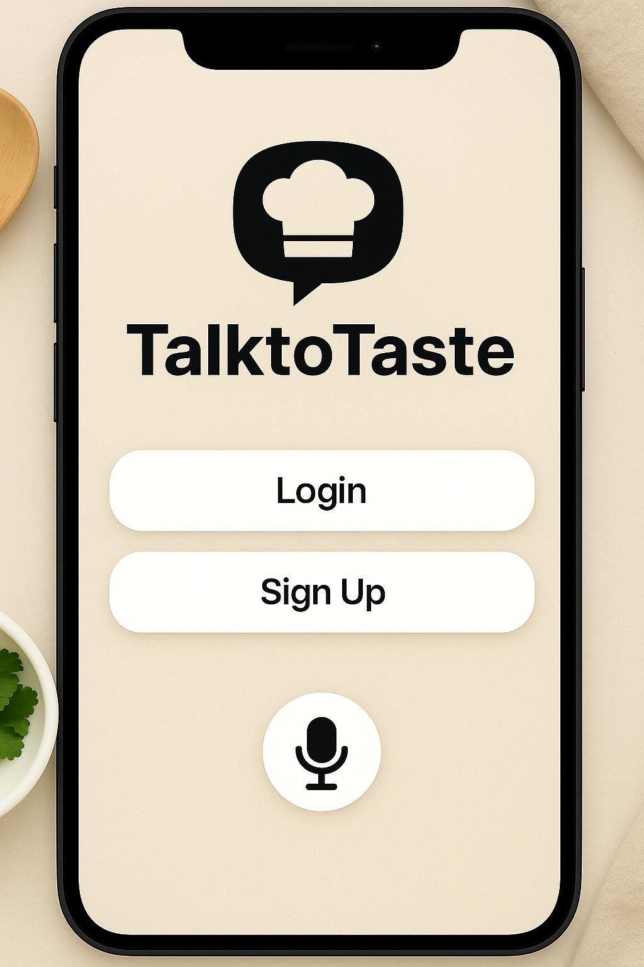

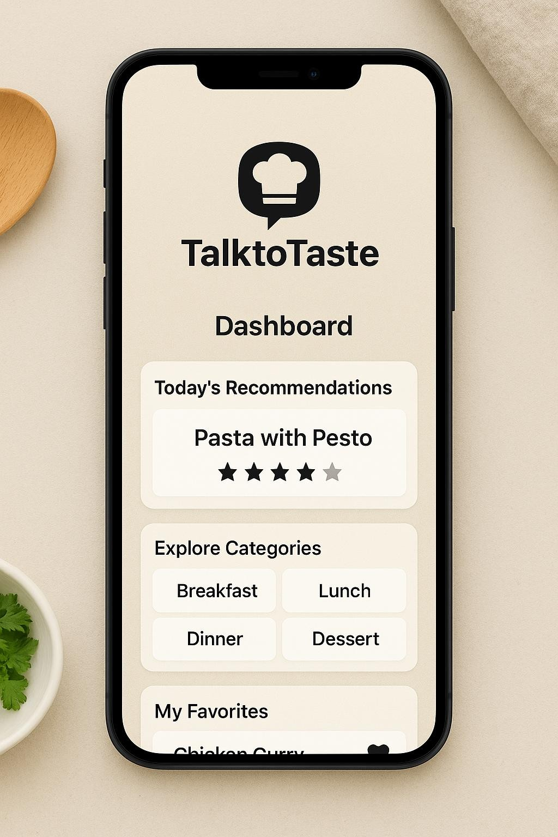

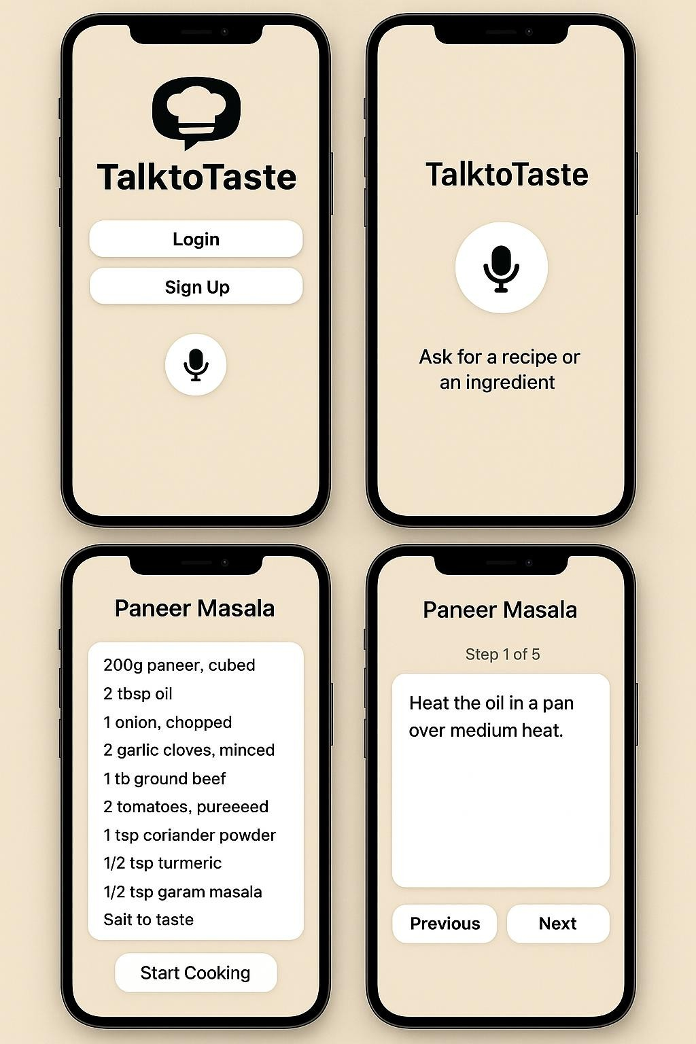

FIG 4.5: UI DESIGN

Test Case Design

Functional Test Cases
ID | Module | Description | Input (Correct) | Input (Wrong) | Expected Output | Result
TC-01 | Login | Verify user login | User: Ravi, Pass:1234 | User: Ravi, Pass: xyz | Login success | Not done
TC-02 | Registration | Register new user | Name: Anita, Lang: Hindi | Name: (empty), Lang: Hindi | Profile created | Not done
TC-03 | Recipe Search | Search by dish | Paneer Butter Masala | RandomDishXYZ | Show recipe | Not done
TC-04 | Recipe Search | Search by ingredients | Rice, Potato | asdfgh | List recipes | Not done
TC-05 | Narration | Narrate instructions | Start recipe | Starrttt | Narration begins | Not done
TC-06 | Timer | Set timer | Set 10 min | Set xyz | Timer set | Not done
TC-07 | Whistle Tracking | Track whistles | 3 whistles done | Whistle only | Whistle logged | Not done
TC-08 | Save Recipe | Save recipe | Save this recipe | Save blah | Recipe saved | Not done
TC-09 | Share Recipe | Share recipe | Share Paneer | Share recp | Link generated | Not done
TC-10 | Logout | Exit system | Exit | Exiitttt | Session closed | Not done

Non-Functional Test Cases
ID | Requirement | Description | Input | Expected Output | Result
NTC-01 | Performance | Response time of recognition | Voice command | Response<2s | Not done
NTC-02 | Accessibility | Check Hindi support | Voice in Hindi | Narrated in Hindi | Not done
NTC-03 | Reliability | Timer runs without crash | 10 min timer | Timer correct | Not done
NTC-04 | Usability | Elderly- friendly narration | Start recipe | Clear narration | Not done
NTC-05 | Scalability | Multiple logins | 10 users | All sessions stable | Not done

Table 15: table for test case Design

my project is a recipe web application project name is talktotaste its a voice controlled cooking assistent that help the users to make the indian dishes without using hands and there is a bilingual support for hindi and english this are the features :- 1.2 Objective
The main objectives of TalktoTaste are as follows:
• develop a voice-first smart kitchen assistant that enables hands-free recipe interaction for Indian cooking.
• To offer step-by-step audio instructions in Hindi and English, ensuring accessibility across different language preferences.
• Allow users to search for recipes using voice commands, either by dish name or by specifying available ingredients.
• Integrate voice-activated timers and reminders, enhancing time management during cooking.
• promote inclusivity, especially for elderly individuals, physically disabled users, and beginners in the kitchen.
genearte and give me according to this as it is same
• To support a safer and cleaner cooking environment by reducing the need to touch screens or devices.

• Implement cooking duration and whistle tracking, allowing users to manage pressure cooking with voice inputs.
• serve as a personal cooking assistant, simplifying daily meal preparation through intelligent voice- guided interactions.

