- /infra/debian/parent/pom.xml

<sshUser>usuario</sshUser>
<sshKeyFile>_dir_/.ssh/demoinfra_rsa</sshKeyFile>
<sshPassword>senha</sshPassword>
<sshHost>end_host</sshHost>
<sshDirCopyTo>diretorio_remoto(unstable/stable)</sshDirCopyTo>

- Atualizar os arquivos .gitignore

- InfraModelo

- gerarepo_stable.sh
- gerarepo_unstable.sh
- gpg-passphrase

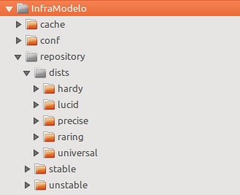

conf/apt-demoiselle-ftparchive.conf
conf/apt-demoiselle-hardy.conf
conf/apt-demoiselle-lucid.conf
conf/apt-demoiselle-precise.conf
conf/apt-demoiselle-raring.conf
conf/apt-demoiselle-universal.conf
conf/apt-demoiselle-unstable-ftparchive.conf

