EEOB 563 Final Paper – *Ficus petiolaris* fig wasps’ Olfactory Receptor (OR) gene family evolution

Devin Molnau

4/18/2019

**Introduction:**

The fig tree and its fig wasps pollinators are an example of a highly coevolved mutualistic system with each fig species producing a unique blend of volatile chemicals to attract its specific wasp pollinator to receptive inflorescences, and each pollinator species recognizing the volatile blend of its specific host (Weiblen, 2002). This specificity is not typically a result of rare chemical compounds being produced, but rather unique blends and ratios of common volatiles. The pattern of volatiles is sensed by pollinating fig wasps using the five major chemosensory gene families in insects. Of these gene families, it is the odorant receptors (OR), ionotropic receptors (IR), odorant binding proteins (OBP) and chemosensory proteins (CSP) in antennal tissues that are involved in the detection of volatile molecules. The presence of these four olfactory multi-gene families has been confirmed in an Old World pollinating fig wasp (*Ceratosolen solmsi*), with whole genome sequencing revealing a substantial contraction in OR and OBP gene diversity in this host specialist relative to other Hymenoptera (ants, bees, and wasps) (Xiao et al., 2013).

Of all of the families, the odorant receptor (OR) family is the largest and most diverse. Insects typically have anywhere from 60-400 OR gene family members, of which can be divided into three distinct groups: ligand-selective ORs that respond to general odorants, ligand-sensitive ORs that are pheromone specific, and a single highly conserved obligate co-receptor known as Orco (Nakagawa, Pellegrino, Sato, Vosshall, & Touhara, 2012). As an example, in the well-studied Hymenopteran model system, the parasitic wasp *Nasonia vitripennis,* has 301 odorant receptors (75 of which are pseudogenes). Whereas, in contrast, the Old World fig wasp *Ceratosolen solmsi* has only 46 OR family members and 2 pseudogenes (Xiao et al., 2013).

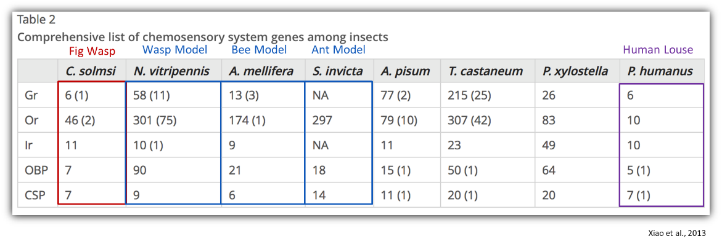

Xiao et al., 2013

ORs are expressed in the olfactory neurons of the antennae’s olfactory sensilla (primarily the basiconic and trichoid sensilla) and are characterized by their seven transmembrane (7-TM) domain with an intracellular N-terminus and extracellular C-terminus (Engsontia, Sangket, Chotigeat, & Satasook, 2014). The one to three odorant receptors function with a highly conserved odorant receptor coreceptor (Orco) to form a ligand-gated cation channel, binding lipophilic volatiles such as aromatics, terpenes, and fatty acid derivatives (Montagné, De Fouchier, Newcomb, & Jacquin-Joly, 2015) as well as polar ligands such as esters and alcohols (Silbering et al., 2011).

**Fig 1.** Schematic model of ligand gated ion channel OR+Orco (Or83b) complex (Sato et al., 2008)

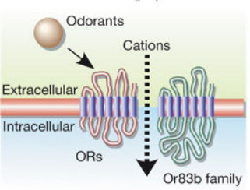

Although it is known that the odorant receptor family plays a very important role in the recognition of the receptive fig host, the history of the gene family is not well understood. In terms of a phylogenetic study, it is unclear which of these subfamilies have been retained, completely lost, or expanded upon in light of their fig specialization when compared to other Hymenoptera. Keep in mind that there are also parasites in the system that must recognize the same bouquet of the receptive host as the pollinators. In theory, even though these wasps are not closely related at all to one another, the wasps must recognize the same volatiles in order to locate the host. If the odorant receptor gene families of the parasites and the pollinators of the system are compared phylogenetically, we would expect convergence on which subfamilies have been retained, lost, reduced, or expanded upon. Also, when compared to Hymenopteran species that have not specialized to either pollinate or parasitize the fig, one would also expect that the fig specialists will have comparatively suffered severe gene reductions due to their limited life history.

**Methods:**

To test this, pollinators and parasites of the fig species *Ficus petiolaris* were collected in Baja California, Mexico, August 2017 and stored in RNAlater at 4 degrees Celsius. 150 bp paired end sequencing was done on each fig wasp species in the system on an Illumina HiSeq3000 with a targeted insert length of ~425 bp and 30X coverage. Fig wasps sequenced are *Pegoscapus, Idarnes LO1, Idarnes SO1, Idarnes SO2, Heterandrium 1, Heterandrium 2, Ficicola* (aka *Aepocerus*) and *Physothorax.* Sequences were then trimmed and assembled using Plananus which specializes in assembling highly heterozygotic sequences(Kajitani et al., 2014). The odorant receptors were identified using iterative BLASTX searches with known reference Hymenopteran OR proteins as a database(Mcginnis & Madden, 2004). BLASTX will be using a cutoff of 0.01 and ran via the commandline. The query hits were sorted and culled using the methods described by Zhou et al (Zhou et al., 2012). The Hymenopteran sequences used to build the OR reference database consisted of OR proteins from *Apis mellifera* (western honey bee), *Nasonia vitripennis* (non-fig-related parasitic wasp), *Camponotus floridanus* (Florida Carpenter ant), *Harpegnathos saltator* (Indian jumping ant), *Linepithema humile* (argentine ant), and *Pogonomyrmex barbatus* (harvester ant)(H. M. Robertson, Gadau, & Wanner, 2010; Hugh M Robertson & Wanner, 2006; C. D. Smith et al., 2011; C. R. Smith et al., 2011; Zhou et al., 2012). Putative genes were verified using the gene prediction software AUGUSUTS and *Nasonia vitripennis* as the fig wasps’ model organism(Stanke, Keller, Gunduz, Hayes, & Waack, 2006). These identified genes were aligned with the known Hymenopteran OR genes using MAFFT and a phylogenetic tree built using maximum likelihood methods in RAxML using the Le-Gascuel (LG) model and 100 bootstrap iterations (Katoh, Kuma, Toh, & Miyata, 2005; Stamatakis, 2014). These species are in no way closely related, but all recognize the host *F.petiolaris* and this should be reflected in the genes clades that are retained or expanded upon. Ideally, time abiding, I will also run build this tree in BEAST using BEAUti and compare the log likelihood of the maximum likelihood to its Bayesian generated counterpart (Drummond, Suchard, Xie, & Rambaut, 2012). Clades will be assessed using the nomenclature established by Zhou et al. in their 2012 paper (see below) (Zhou et al., 2012).

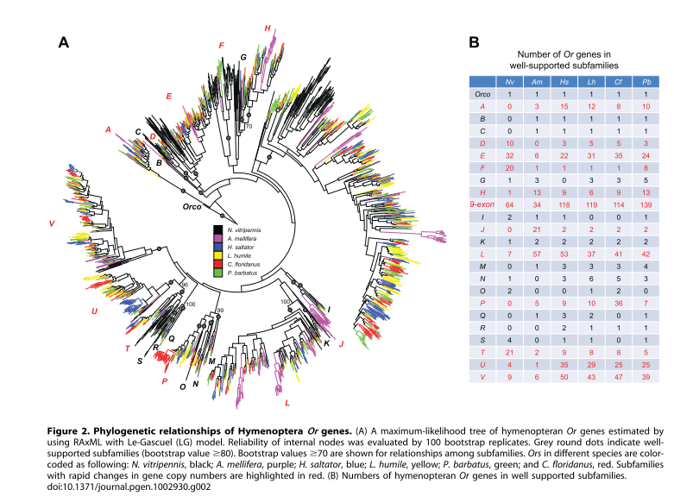

**Results:**

**TABLE OF TOTAL NUMBER OF OR GENES IDENTIFIED IN POLLINATOR AND NONPOLLINATORS**

**OR MAX LIKELIHOOD TREE HERE**

**BAYESIAN TREE HERE**

**LIKELIHOOD HERE**

**Discussion:**

Stay tuned.

**Sources:**

Drummond, A. J., Suchard, M. A., Xie, D., & Rambaut, A. (2012). Bayesian P hylogenetics with BEAUti and the BEAST 1 . 7 Research article, *29*(8), 1969–1973. https://doi.org/10.1093/molbev/mss075

Engsontia, P., Sangket, U., Chotigeat, W., & Satasook, C. (2014). Molecular evolution of the odorant and gustatory receptor genes in lepidopteran insects: Implications for their adaptation and speciation. *Journal of Molecular Evolution*, *79*(1–2), 21–39. https://doi.org/10.1007/s00239-014-9633-0

Kajitani, R., Toshimoto, K., Noguchi, H., Toyoda, A., Ogura, Y., Okuno, M., … Itoh, T. (2014). Efficient de novo assembly of highly heterozygous genomes from whole-genome shotgun short reads. *Genome Research*, *24*, 1384–1395. https://doi.org/10.1101/gr.170720.113.Freely

Katoh, K., Kuma, K., Toh, H., & Miyata, T. (2005). MAFFT version 5 : improvement in accuracy of multiple sequence alignment, *33*(2), 511–518. https://doi.org/10.1093/nar/gki198

Mcginnis, S., & Madden, T. L. (2004). BLAST : at the core of a powerful and diverse set of sequence analysis tools. *Nucleic Acids Research*, *32*, 20–25. https://doi.org/10.1093/nar/gkh435

Montagné, N., De Fouchier, A., Newcomb, R. D., & Jacquin-Joly, E. (2015). Advances in the identification and characterization of olfactory receptors in insects. *Progress in Molecular Biology and Translational Science*, *130*, 55–80. https://doi.org/10.1016/bs.pmbts.2014.11.003

Nakagawa, T., Pellegrino, M., Sato, K., Vosshall, L. B., & Touhara, K. (2012). Amino acid residues contributing to function of the heteromeric insect olfactory receptor complex. *PLoS ONE*, *7*(3). https://doi.org/10.1371/journal.pone.0032372

Robertson, H. M., Gadau, J., & Wanner, K. W. (2010). The insect chemoreceptor superfamily of the parasitoid jewel wasp Nasonia vitripennis. *Insect Molecular Biology*. https://doi.org/10.1111/j.1365-2583.2009.00979.x

Robertson, H. M., & Wanner, K. W. (2006). The chemoreceptor superfamily in the honey bee , Apis mellifera : Expansion of the odorant , but not gustatory , receptor family, 1395–1403. https://doi.org/10.1101/gr.5057506.

Sato, K., Pellegrino, M., Nakagawa, T., Nakagawa, T., Vosshall, L. B., & Touhara, K. (2008). Insect olfactory receptors are heteromeric ligand-gated ion channels. *Nature*, *452*(7190), 1002–1006. https://doi.org/10.1038/nature06850

Silbering, A. F., Rytz, R., Grosjean, Y., Abuin, L., Ramdya, P., Jefferis, G. S. X. E., & Benton, R. (2011). Complementary Function and Integrated Wiring of the Evolutionarily Distinct Drosophila Olfactory Subsystems. *Journal of Neuroscience*, *31*(38), 13357–13375. https://doi.org/10.1523/JNEUROSCI.2360-11.2011

Smith, C. D., Zimin, A., Holt, C., Abouheif, E., Benton, R., Cash, E., … Fernandes, V. (2011). Draft genome of the globally widespread and invasive Argentine ant ( Linepithema humile ), *108*(14), 5673–5678. https://doi.org/10.1073/pnas.1008617108

Smith, C. R., Smith, C. D., Robertson, H. M., Helmkampf, M., Zimin, A., Yandell, M., … Graur, D. (2011). Draft genome of the red harvester ant Pogonomyrmex barbatus, *108*(14), 5667–5672. https://doi.org/10.1073/pnas.1007901108

Stamatakis, A. (2014). RAxML version 8 : a tool for phylogenetic analysis and post-analysis of large phylogenies, *30*(9), 1312–1313. https://doi.org/10.1093/bioinformatics/btu033

Stanke, M., Keller, O., Gunduz, I., Hayes, A., & Waack, S. (2006). AUGUSTUS : ab initio prediction of alternative transcripts. *Nucleic Acids Research*, *34*(16), 435–439. https://doi.org/10.1093/nar/gkl200

Weiblen, G. D. (2002). How to be a fig wasp. *Annual Review of Entomology*, *47*, 299–330.

Xiao, J.-H., Yue, Z., Jia, L.-Y., Yang, X.-H., Niu, L.-H., Wang, Z., … Huang, D.-W. (2013). Obligate mutualism within a host drives the extreme specialization of a fig wasp genome. *Genome Biology*. https://doi.org/10.1186/gb-2013-14-12-r141

Zhou, X., Slone, J. D., Rokas, A., Berger, S. L., Liebig, J., Ray, A., … Zwiebel, L. J. (2012). Phylogenetic and Transcriptomic Analysis of Chemosensory Receptors in a Pair of Divergent Ant Species Reveals Sex-Specific Signatures of Odor Coding. *PLoS Genetics*. https://doi.org/10.1371/journal.pgen.1002930