**Experiment No. 5**

**Title:** Create a Filter with a single level and filter on multi-pages.

**Introduction**

In Power BI, filtering is an essential feature that allows users to refine and analyze data based on specific conditions. Filters help in narrowing down large datasets to focus on relevant information, improving insights and decision-making.

Power BI provides various filtering techniques, including:

1. **Visual-Level Filters** – Applied to specific visuals on a report page.
2. **Page-Level Filters** – Applied to all visuals on a single report page.
3. **Report-Level Filters** – Applied across multiple pages of a report.

In this experiment, we explore how to apply a **single-level filter** and **multi-page filtering** to categorize loan defaulters based on employment status.

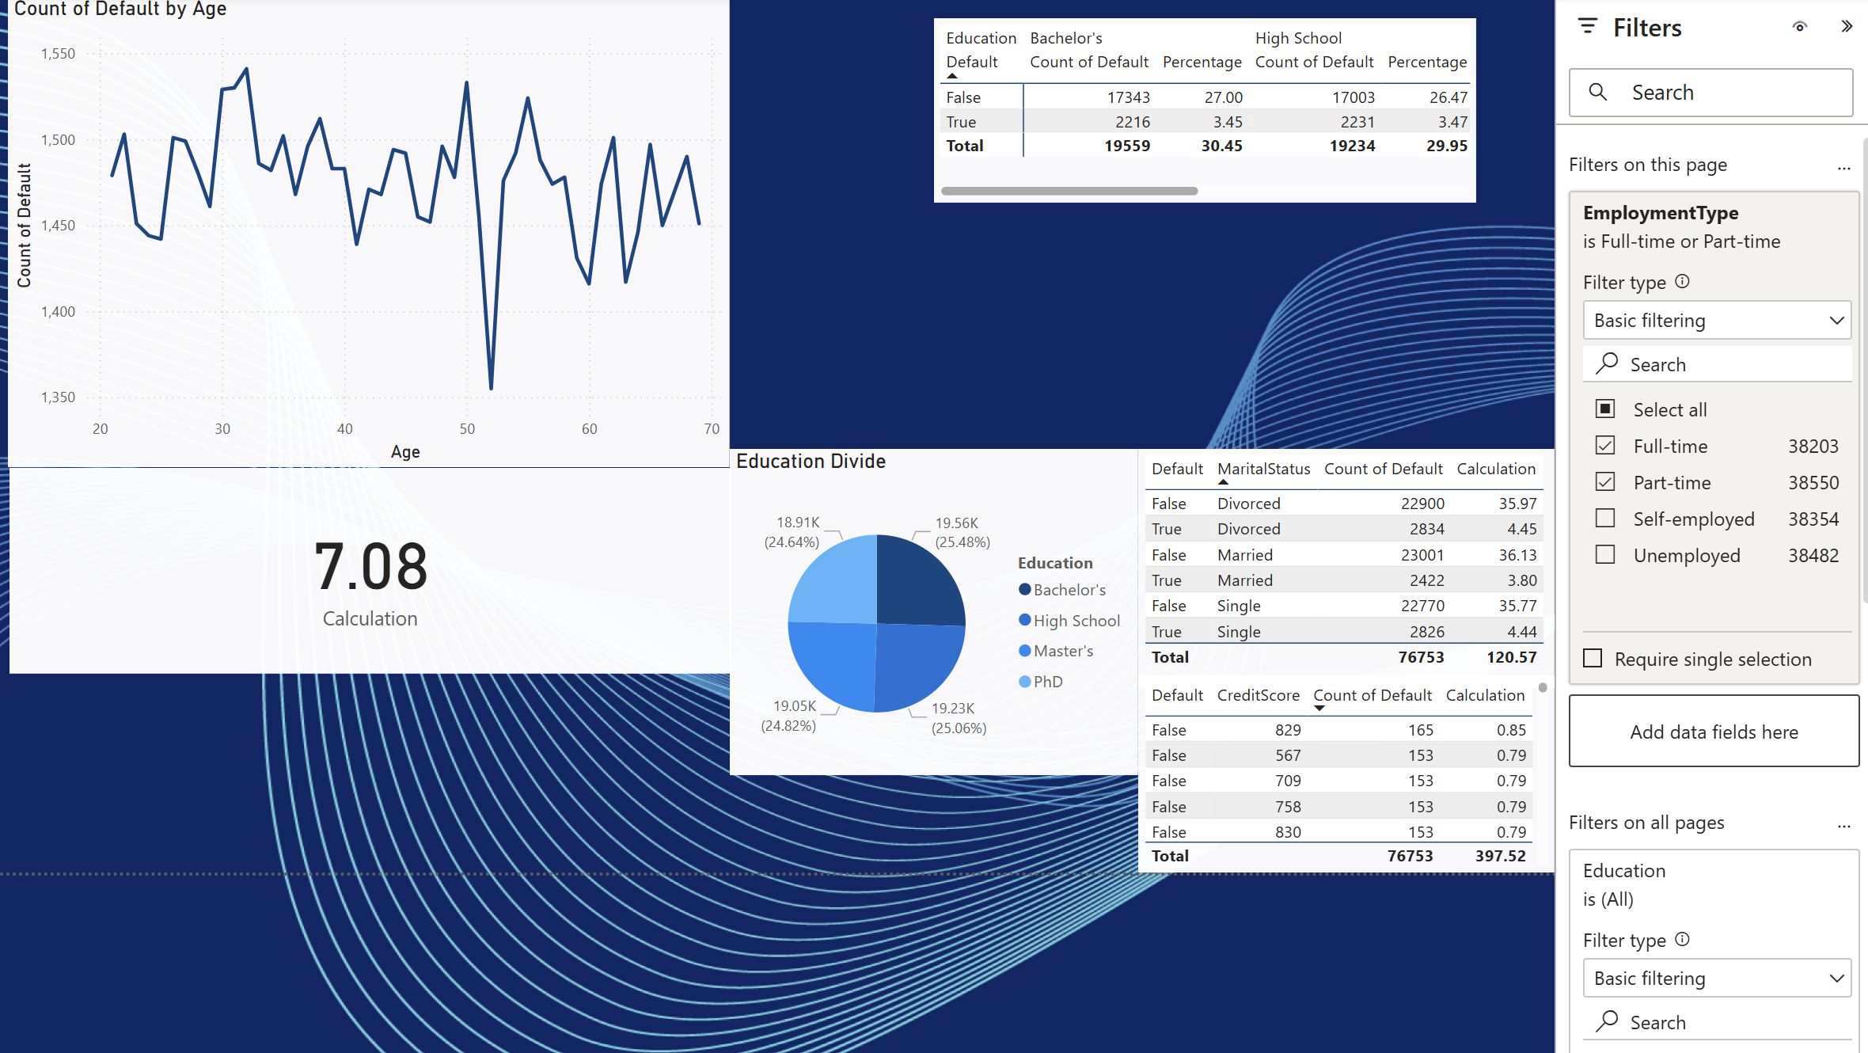

Page 1

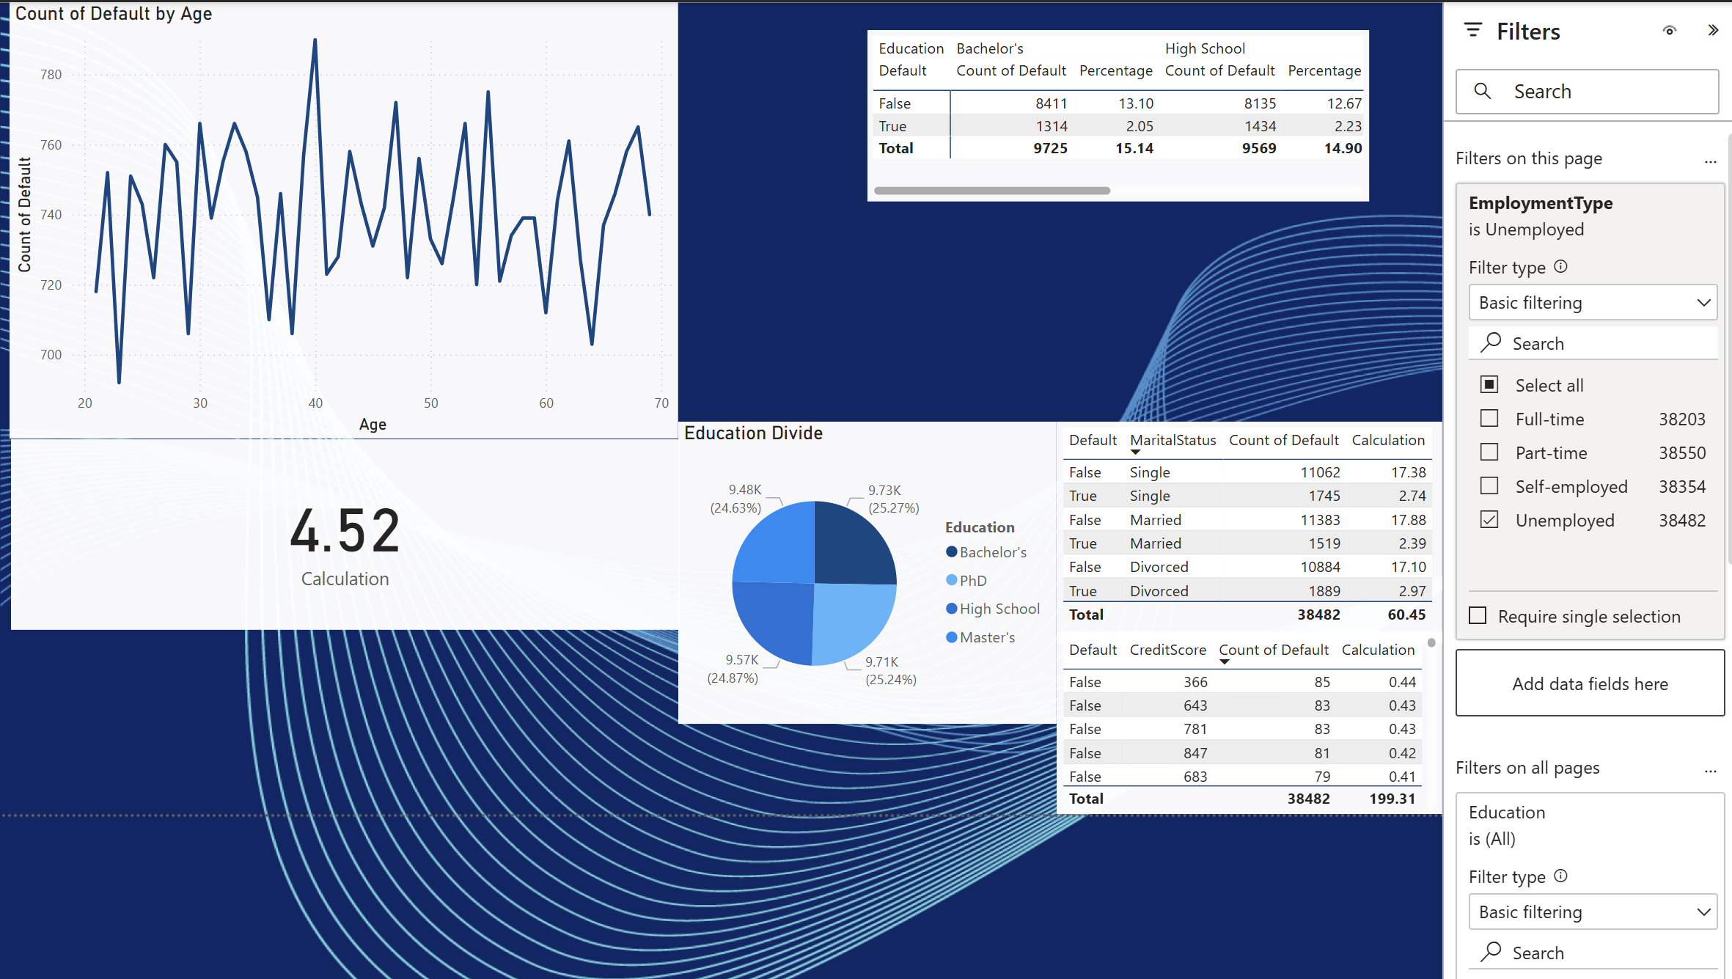

Page 2

1. **Page Filtering**
   1. 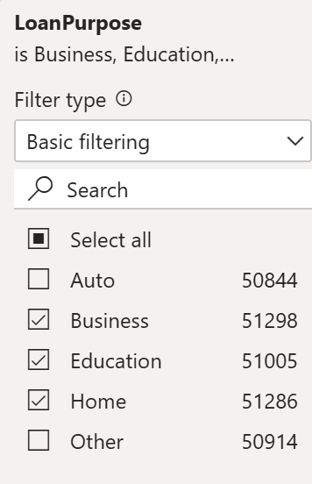
      1. **This filter is applied on all pages because this report was targeted at only meaningfull loan defaulters**
   2. 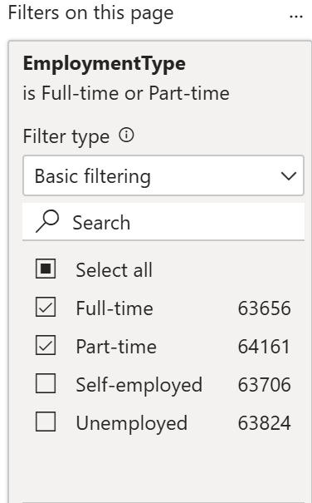
      1. **This Filter was for page 1 which had employed people loan defaulter report**
   3. 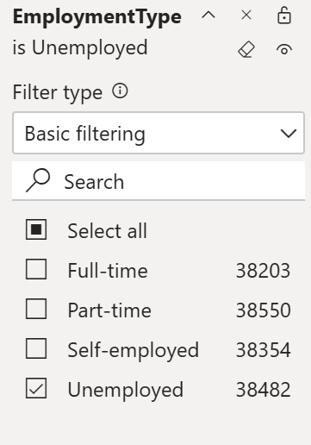
      1. 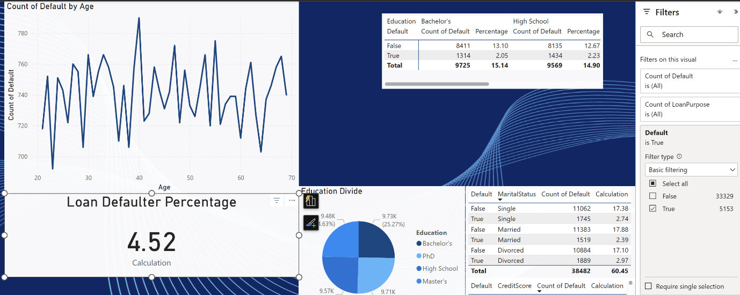**This Is the second page report filter for unemployed people**

**This is the Loan Percentage Calculator Filter**

**It is set to true because we want percentage of people who have defaulted their loans**

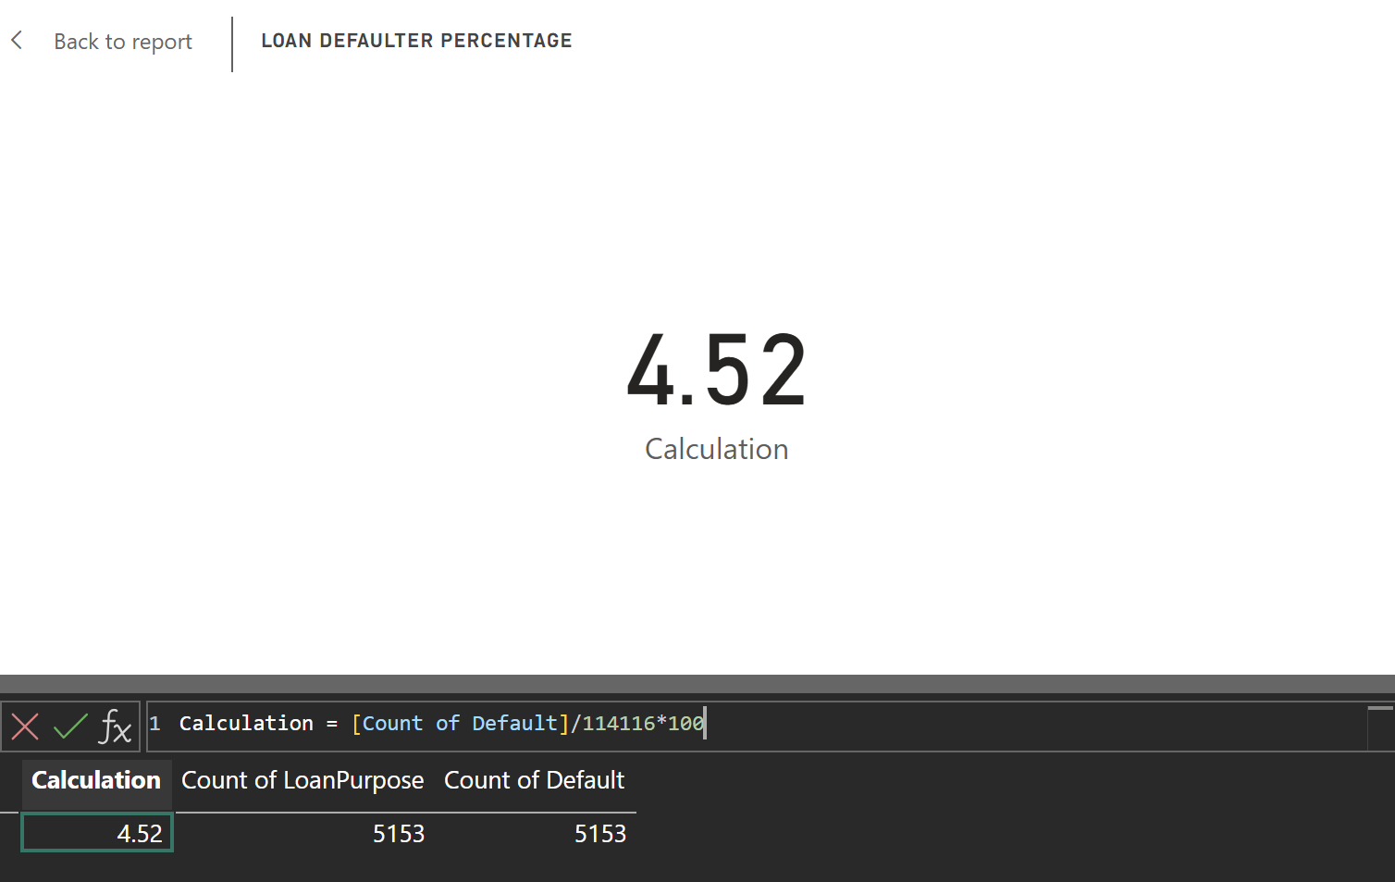

**This is the calculation for finding loan defaulters**

**Count of Default Represents no of people who have defaulted**

Conclusion

Filtering in Power BI is a powerful technique that enhances data analysis by refining large datasets based on specific criteria. In this experiment, we successfully applied both **global** and **page-specific filters** to categorize loan defaulters based on employment status.