**Experiment No. 6**

**Title:** Create a sample report and use the Calculate function with ALL, ALL Except.

**Introduction**

This report demonstrates how to leverage two powerful DAX functions—**ALL** and **ALLEXCEPT**—within the **CALCULATE** function to derive meaningful insights from loan default data. By applying these functions, we can selectively ignore filters or retain specific ones to perform context-sensitive calculations. The examples presented here illustrate how to calculate average income for different segments and how to analyze default distributions across employment, education, and home loan statuses.

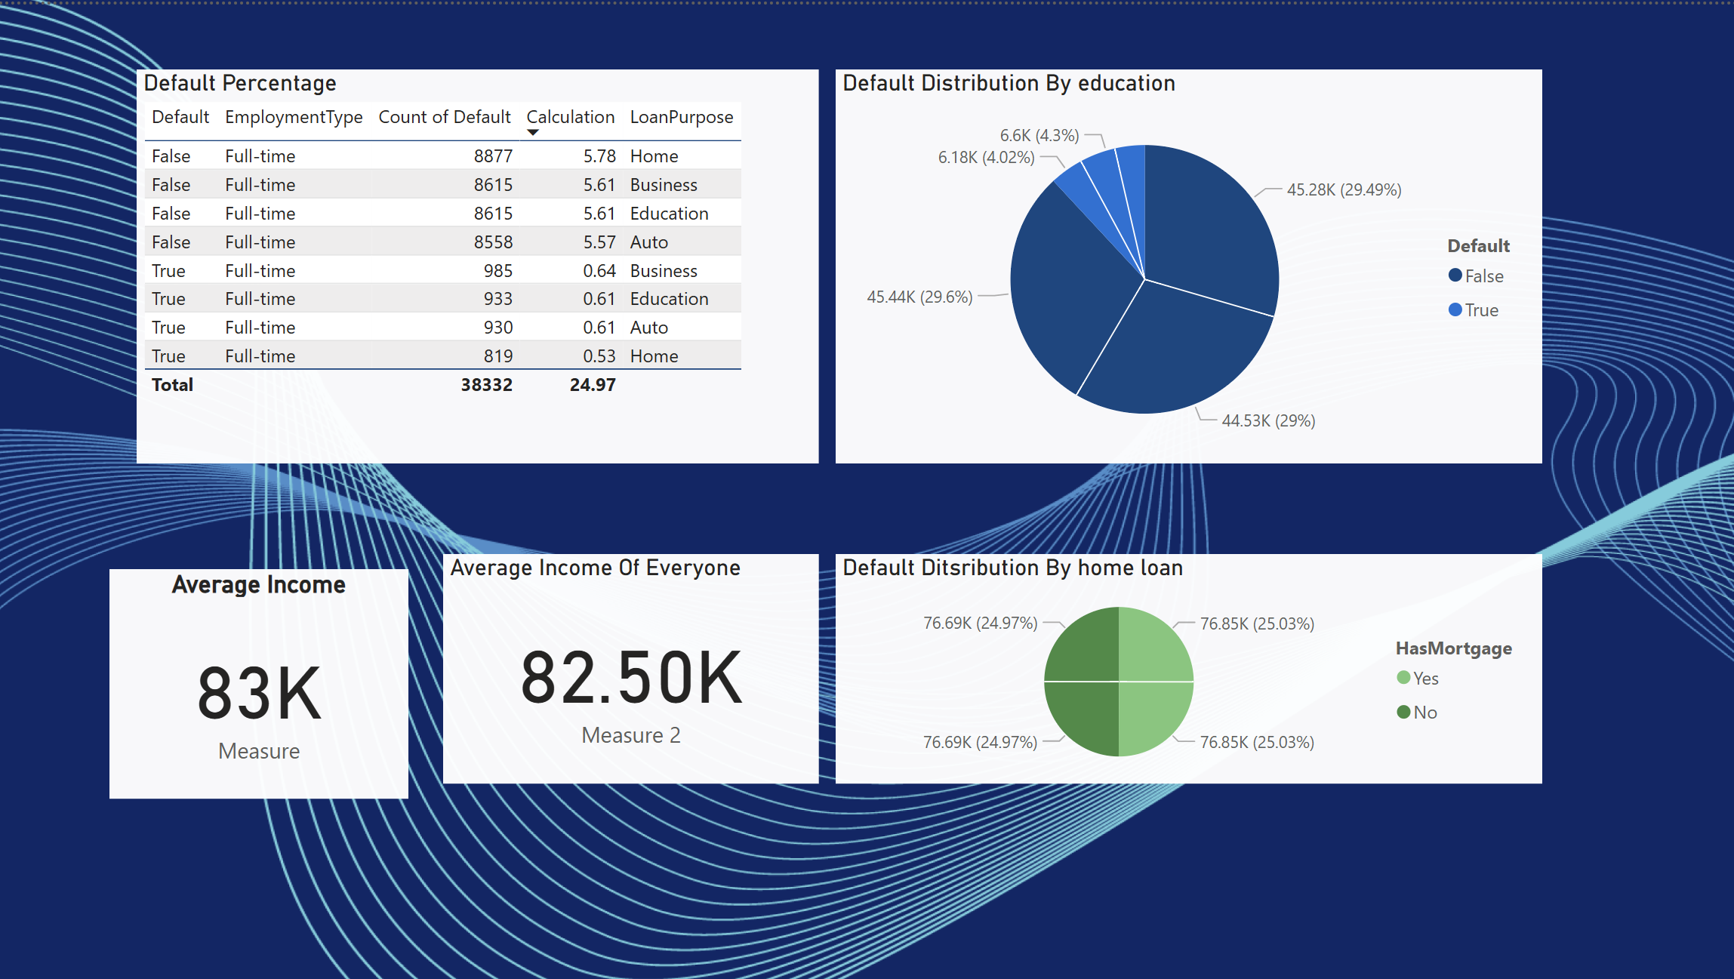

**Theoretical Background**

**The ALL Function**

* **Purpose:**  
  The **ALL** function removes all filters from the specified table or column. This is particularly useful when you need to compute an aggregate measure across the entire dataset, regardless of any slicers or context filters.
* **Example Use Case:**  
  Calculating the overall average income from the entire dataset, ensuring that no subset filtering (e.g., by education or employment) interferes with the aggregate result.
* **DAX Formula Example:**

DAX

Measure_All = CALCULATE(AVERAGE(Loan_default[Income]), ALL(Loan_default))

This measure computes the average income without any filters on the *Loan_default* table.

**The ALLEXCEPT Function**

* **Purpose:**  
  The **ALLEXCEPT** function works similarly to ALL by removing filters, but it allows you to retain filters on specified columns. This means you can ignore all filters except for those explicitly defined, making it useful for segmented analysis.
* **Example Use Case:**  
  Calculating the average income for each education group while ignoring other filters (such as those on employment or location) ensures that the analysis remains focused on education as the key differentiator.
* **DAX Formula Example:**

DAX

Measure_Educated = CALCULATE(AVERAGE(Loan_default[Income]), ALLEXCEPT(Loan_default, Loan_default[Education]))

This measure calculates the average income for each education category by removing all other filters except the one on *Education*.

**Insights and Visualizations**

**1. Average Income of Educated People**

* **Visual Type:**  
  Number

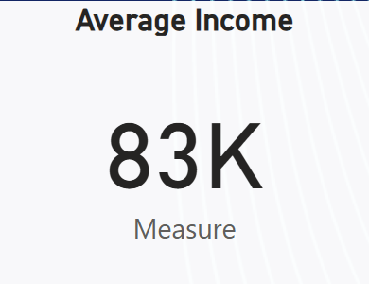

* **Measure:**

Measure_Educated = CALCULATE(AVERAGE(Loan_default[Income]), ALLEXCEPT(Loan_default, Loan_default[Education]))

* **Insight:**  
  This visual reveals how the average income varies across different education levels. By preserving the education filter and ignoring others, you can isolate the impact of education on income, which may help in targeting financial products or understanding default risks within different education groups.

**2. Average Income of Everyone**

* **Visual Type:**  
  A card displaying a single value.

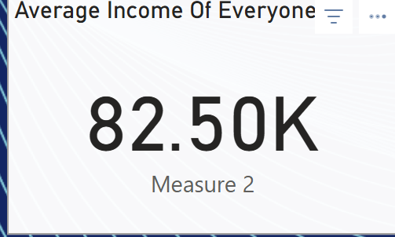

* **Measure:**

DAX

Measure_All = CALCULATE(AVERAGE(Loan_default[Income]), ALL(Loan_default))

* **Insight:**  
  This measure provides the overall average income of all individuals in the dataset, offering a baseline for comparisons. It is useful for benchmarking and understanding the general income landscape, free from segmentation biases.

**3. Default Distribution Among Employed People**

* **Visual Type:**  
  A table or clustered bar chart focusing on employment status.

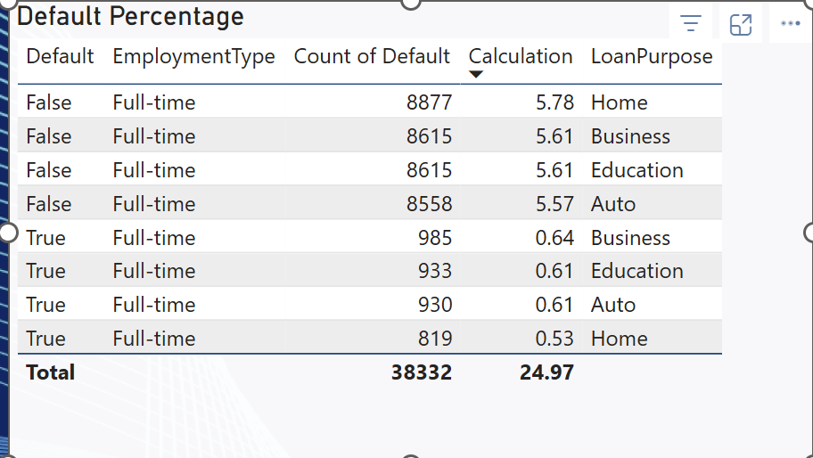

* **Insight:**  
  This visual breaks down the default rates among individuals who are employed. By filtering the dataset to include only employed people, the analysis can reveal if employment status correlates with lower or higher default probabilities.

**4. Default Distribution by Education**

* **Visual Type:**  
  A pie chart illustrating the proportion of defaults across different education levels.

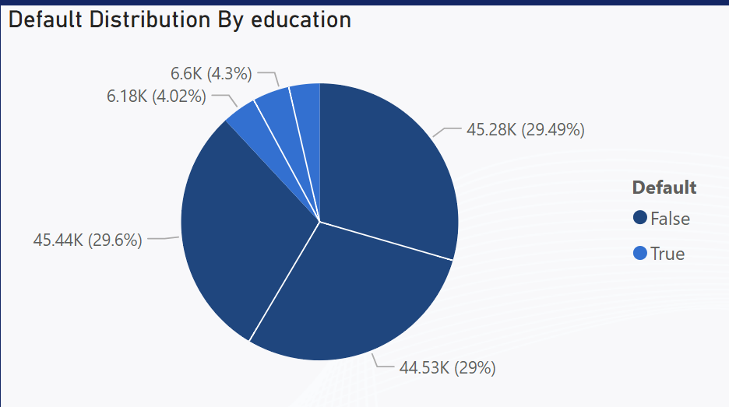

* **Insight:**  
  This chart helps to visualize how defaults are distributed among various education groups. It assists in identifying if certain education levels are more prone to defaults, which could drive targeted risk management strategies.

**5. Default Distribution by Home Loan Status**

* **Visual Type:**  
  A pie chart showing default counts for individuals with and without home loans.

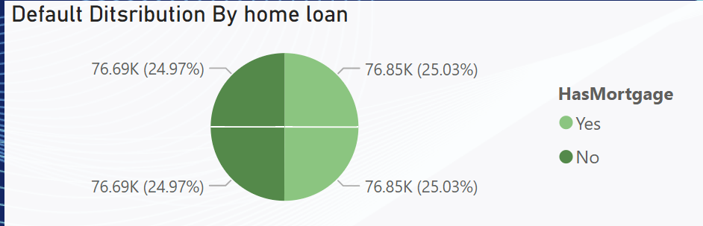

* **Insight:**  
  By comparing default rates based on home loan status, this visual provides insights into whether holding a home loan is associated with higher or lower default risks. Such information is crucial for financial institutions when designing loan products or managing risk portfolios.

**Conclusion**

By combining the **CALCULATE** function with **ALL** and **ALLEXCEPT**, this report demonstrates how to create dynamic measures that either remove filters entirely or retain them selectively. These techniques allow analysts to drill down into specific segments or view overall trends, thereby enhancing data-driven decision-making in financial risk assessments. Each visual is designed to answer targeted questions regarding income distribution and default risk, making the overall report a comprehensive tool for both exploratory analysis and strategic planning.

Feel free to adjust the visuals and measures based on additional filtering criteria or new business requirements.