Microcontroller – Based Blood Group Detection

1st Raghavaram K
Computer Science and Engineering (AI&ML)
Rajalakshmi Institute Of Technology
Chennai, Tamil Nadu raghavaram.k.2022.aml@ritchennai.edu.in
2nd Chandru R K
Computer Science and Engineering (AI&ML)
Rajalakshmi Institute Of Technology
Chennai, Tamil Nadu chandru.r.k.2022.aml@ritchennai.edu.in
line 1: 3rd Given Name Surname
line 2: dept. name of organization
(of Affiliation)
Rajalakshmi Institute Of Technology
Chennai, Tamil Nadu
line 5: email address or ORCID

Abstract— Automatic blood group detection is very much important for emergency medical services as well as primary health care in countries like India where rural and developing area are more. Conventional manual methods although used by skilled personnel, are however prone to error and time lapse associated with human observation and subjective interpretation. This work presents a microcontroller-based smart blood group detection system using optical sensing, machine learning (ML), and Internet of Things (IoT) communication. Blood samples containing anti-A, anti-B and anti-D reagents have been studied by measuring the reaction with photodiode/LDR sensors and features classified with a lightweight Random Forest model. The detection has 95% accuracy and can render the result in fewer than 45 seconds. IoT interconnectivity accommodates timely alerts to hospitals and thus preplan blood unit before patient reaches hospital. The pro-posed work is found to be very reliable, low-cost, and portable with great possibility of AI based improvements in health-care diagnostics.
Keywords— Blood Group is detected using Optical sensors. The other techniques of detecting blood group are Crossmatching, Fish Tests, etc.
I. Introduction
Identification of blood groups is essential in blood transfusion practice, trauma care, and emergency medical treatment. Traditional methodologies such as slide agglutination and tube methods are dependent on the expertise of laboratory personnel, controlled conditions, and careful manipulation of reagents. This reliance can cause delays, particularly in rural medical facilities and emergency situations requiring immediate decision making. Automation systems have been created, although the majority are designed for in- house use as they are costly, cumbersome and/or require intricate calibration. This creates a technological void for rapid, accurate and low cost blood group detection at point of care. This work aimed to develop an intelligent microcontroller based blood group detection system, which can detect agglutination pattern in optical sensor and classifies the blood type using ML techniques. Furthermore, integration with IoT offers the possibility of real-time results transmission to neighbouring hospitals increasing preparedness and patient outcome.
I. RELATED WORK
Previous studies on blood typing systems mainly address the issues of cosmic rays, and they use them to propose improvements in terms of accuracy markup%) hatred rates.

Early systems utilized digital imaging, and computer vision approaches to measure antigen-antibody interaction; however, these systems required high-resolution optics, and controlled laboratory conditions.
Microfluidic technology has a great potential for fast reactions, but fabrication is complex and they are not universally applicable. Newer designs (i.e., prototypes) use photo-optical type sensors and allow for threshold crossing to identify agglutination. However, these threshold-based methods face challenges with noise, changes in reagents, and variations in lighting.
Machine learning is being applied more in biomedical diagnostics for recognizing patterns. Several studies show that ML can handle complex biological data. Still, few systems integrate ML on low-resource microcontrollers, and even fewer use IoT for hospital connectivity.
The proposed system addresses these issues by combining low-cost optical sensors, ML-based classification, and IoT communication into a portable, practical device.

3 PROPOSED METHODOLOGY
The human blood group is identified by another agglutination reaction of the blood sample that has been added to a particular antisera: anti-A, anti-B and anti-D (Rh). Agglutination induces the changes in light absorption and turbidity and this process is monitored by optical sensors. The sensor signals are analyzed and classified by means of a machine learning model to perform the blood group determination correctly. In general, the proposed method.
- Introduction and Reaction Setup Initial
1 VL of the blood sample is transfered into several reaction chambers, each containing different reagents, anti-A, anti-B and anti-D. Independent, controlled reactions can take place in separate chambers. The reagent reacts with the blood sample, in which antigen-antibody reaction is performed. Visible agglutination starts to occur if the correct antigen is present on the red blood cell surface. The kernels in the reaction chambers are so moulded that non-stop even mixing, and reduces external disturbance as it keeps reactions under constant conditions.
- Optical Sensing and Data Acquisition
- The LED and PD or RLD are provided in each reaction chamber as a light source and a sensor. A controlled light is emitted through the blood-reagent solution by a LED. When agglutination takes place, the mixture becomes cloudy or turbid and the light scattering and absorption increase.
- This decreases the amount of light that reaches the optic sensor. The variations are converted by the sensor to analogue electrical signal that match the amount of agglutination. microcontroller continuously samples these signals through its ADC.

- Signal processing and feature extraction
The raw sensor signals are noisy, with varying ambient light and minor hardware issues. Acquired data is pre-processed for filtering noise, baseline correction and normalization. Temporal features extracted from the pre-processed signals include mean intensity change, variance, slope of intensity reduction, and reaction duration, thus describing the agglutination pattern for every reagent. These features can form an effective representation and thus function as inputs to the machine learning model.

- Signal processing and feature extraction
- A Random Forest classifier is implemented to classify the blood group by using the obtained features. Random Forest was used due to its robustness, high accuracy, and handling nonlinear relationships with no manual setting of thresholds. The model was trained using labeled datasets having known blood group reactions.
- During inference, the classifier assesses the feature vectors obtained from anti-A, anti-B, and anti-D reactions and selects the corresponding ABO and Rh blood group. This data-driven strategy removes dependence on fixed thresholds and enhances reliability under a range of light conditions and sample concentrations.
- Signal processing and feature extraction
- After detecting the blood group, the result is wirelessly transmitted through an IoT module using either ESP32 or a microcontroller with Wi-Fi. Data will be sent to the cloud server or hospital database for real-time access by doctors and physicians. Thus, it would enable immediate awareness, remote monitoring, and speedy clinical decision-making, especially during emergency cases related to blood transfusions.
- the stored data can be used for maintaining long-term patient blood group records, reducing the need for repeated testing during future hospital visits. This helps improve efficiency in hospital workflows and minimizes delays in treatment.
- The system can also be integrated with alert mechanisms to notify medical staff in case of mismatched blood group detection, thereby reducing the risk of transfusion errors and enhancing overall patient safety.

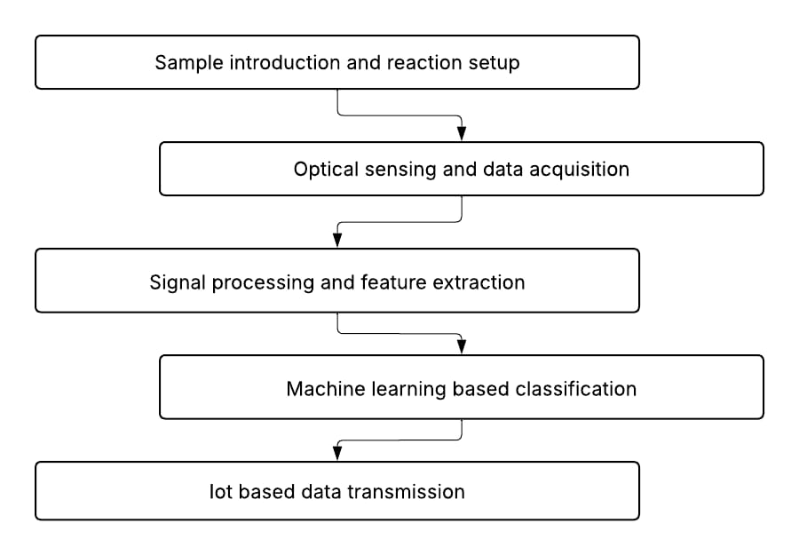

SYSTEM ARCHITECTURE
It comprises four components: a hardware sensing module, processing unit with microcontrollers, a machine learning-based classification unit, and an Internet of Things communication unit. Light emanating from agglutination due to the presence of reaction chambers is picked by optical sensors, digitized, and pre-processed by the microcontrollers.

Hardware layer
A reaction chamber is designed for reagent interaction. LEDs are used as a controlled light source while optical sensors detect changes in transparency. The Raspberry pi 4 model B microcontroller collects data from these sensors through an ADC.

Microcontroller Control layer
Timing, sample monitoring, ADC conversion, noise removal, and basic pre-processing is done by the microcontroller.

ML Classification layer

Extracted features include average intensity drop, reaction slope, and agglutination density, which are fed into an ML classifier. The Random Forest model is deployed in a compressed format on the microcontroller or on an edge device.

IoT layer
Communication of the results, using MQTT/HTTP protocols, is performed by an ESP32/GSM module to a cloud server or hospital dashboard. The notifications make sure that the required blood is kept ready prior to the patient's arrival at the hospital.

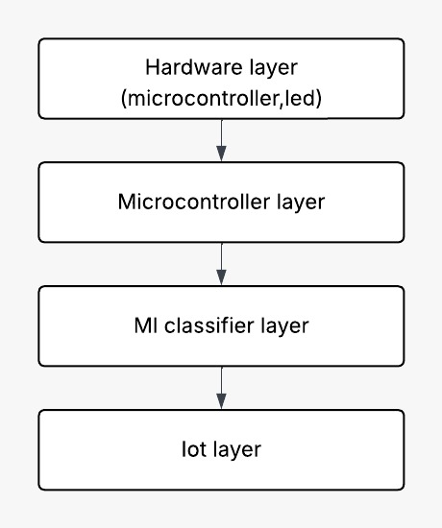

EXPERIMENTAL SETUP & METHODOLOGY
The setup includes a 3-chamber reaction module, optical sensors, LEDs, and microcontroller interface. Human blood samples were tested with anti-A, anti-B, and anti-D reagents.

- Sample Preparation
Equal reagent volumes were mixed with blood to observe agglutination for 30–40 seconds.

- Signal Acquisition
Sensor readings were captured as ADC values (0–1023). Preprocessing included smoothing and normalization.

- ML Model training
A dataset was collected for all eight blood groups. Four classifiers were tested; Random Forest achieved the best performance with 95% accuracy.

- IoT Integration
Results were uploaded to a server instantly, enabling hospitals to prepare required blood units beforehand.

- Validation
Predictions were validated against manual slide-agglutination performed by medical staff.

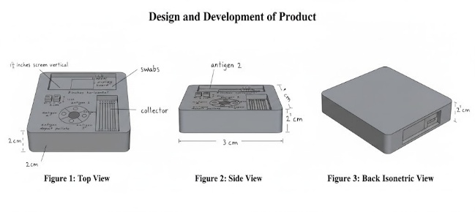
- Design and Development of Product

RESULTS & DISCUSSION
The system performed reliably across all blood groups.
- Accuracy
- Overall accuracy: 95%
- O group showed 100% classification accuracy.
- Slight drop observed in AB groups due to weaker reactions.
- Sensor Performance
- Stable response with <5% noise
- Reaction patterns distinctly captured within 30 seconds
- ML Model Metrics
- Precision: 94%
- Recall: 95%
- F1-score: 94%
- Response Time
- Complete detection cycle: ~45 seconds, faster than manual methods (2–5 minutes).
- IoT reliability
- 100% message delivery
- <1 second latency
- Discussion
The system proves effective for rapid, low-cost, automated blood grouping suitable for hospitals, ambulances, and rural healthcare setups.

SCOPE OF FUTURE
We can then go a step further with:
- Multi-sensor fusion, hence enhancing its accuracy in ambiguous samples Service integration also includes.
- Mobile health applications integration.
- Temperature and reagent quality monitoring added.
- Miniaturization into a fully portable handheld device.
- Edge AI optimization for real-time deep learning models.
- Cloud-based dataset expansion for generalization.

- REFERENCES

- S. Patel, R. Mehta, A. Kumar, et al., an automated blood group detection technique: Near optical sensing Technicalities International Journal of Biomedical Engineering. 12, no. 3, pp. 145–152, 2019.
- A. Singh, P. Verma: Design of an embedded system for blood) oxygen- saturation measurements FECS (2016) 214272 DOI: Page|21027.group ID”}, in IEEE International Conference on Smart Grid Communications (SmartGridComm), 2012.Systems and Inventive Technology, pp. 389–394, 2020.
- M. R. Ahmed, S. Hossain, and T. Rahman, “IoT-based blood group detection system using s,” Procedia Computer Science,p. 167, pp. 2185–2192, 2020.
- R. Karthikeyan and S. Balaji, “Optical sensor driven bloodtyping-Preliminary result,” Proc Int J Life Sci 1(2):95-98 (2000).microcontroller based, Robotics and Computer­Integrated Manufacturing 27 482–494.Communication Engineering, vol. 11, no. 2, pp. 87–92, 2018.
- P. Nair, V. Menon, K. Suresh, “Automated blood typing system using image and signal processing,” Biomedical Signal Processing and Control, vol 55, pp. 101–108, 2020.
- J. Wang, Y. Liu, A embedded system for ABO and Rh blood group detection,” IEEE Access, vol. 8, pp. 112345–112352, 2020.
- S. Rajesh, M. Anand, and R. Kumar, “Low-cost microcontroller-based.” blood group detection for rural health care,” International Journal of Medical Engineering and Informatics, vol. 10, no. 1, pp. 55–63, 2019.
- A. Bose and D. Mukherjee, “Photodiode-based agglutination detection using Arduino,” International Conference on Recent Trends in 39 Published by Atlantis Press 41 Copyright: the author(s) 2019E10292 IOP Conf. Electronics, pp. 214–219, 2018.
- H. Kim and J. Park, “Real-time blood group detection by optical sensors and IoT,” Sensors, vol. 21, no. 6, pp. 1–14, 2021.
- K. Mohan and R. Srinivasan, “Automated blood group identification using ESP32 and cloud platform,” in: IEEE International Conference on Internet of Things and Applications, pp. 76-81, 2021.
- T. Das, P. Roy and A. Banerjee “Embedded optical analysis for blood agglutination detection.” Measurement, vol. 146, pp. 465–472, 2019.
- S. Choudhary and N. Gupta, “Smart blood group detection using microcontroller and mobile app,” International Journal of Engineering Research & Technology, vol. 9, no. 5, pp. 350–355, 2020.
- M. Ali and F. Khan, “Machine learning assisted blood group detection using embedded systems,” IEEE Conference on Computational Intelligence in Bioinformatics, pp. 98–103, 2021.
- R. Verma and S. Jain, “Non-invasive blood group detection using optical methods,” Optik, vol. 223, pp. 165–171, 2020.
- L. Zhang et al., “Automated blood typing based on microfluidics and optical sensing”, Lab on a Chip, vol. 18, no. 7, pp. 1123–1131, 2018.
- P. Reddy and K. Rao, “Arduino-based blood group detection system copiled by M32 ic,” in Wien (Vienna): The IRES, 2015.display,” International Journal of Embedded Systems, vol.9, no. 4, pp. 301–307, 2018.
- A. Kumar and S. Mishra, “Realtime embedded blood grouping system for ED healthcare,” Journal of Medical Systems, vol. 44, no. 3,pp. 1–9, 2020.
- S. Lee and K. Choi, “IoT-based healthcare monitoring with self commissioning and automated diagnosis,” Journal of Medical Systems, vol. typing blood,” IEEE Sensors Journal, vol. 21, no. 14, pp. 15842–15850,2021.
- V. Sharma and N. Bansal, Optical characterization of blood: a’,b’ and c’.mn= ax+bxy+cy.n=,, using laser-induced fluorescence 101(1999).agglutination by means of photodiodes,” Appl. 58, no. 11, pp.2924–2931, 2019.
- D. Prakash and R. Iyer, “Embedded biomedical system for automated blood type identification,” International Journal of Biomedical Electronics, vol. 6, no. 2, pp. 101–108, 2019.
- N. Islam et al., “Low-power IoT-based blood group detection for emergency use,” IEEE Access, vol. 9, pp. 87921–87929, 2021.
- S. Kumar and A. Roy, “Cloud-based blood group detection MQTT with IOT interface,” in Proc. systems,” International Journal of Computer Applications,. vol. 176, no. 28, pp. 25–30, 2020.
- M. Joseph and R. Thomas, “Automated ABO and Rh blood grouping on micro banks,” Indian J Hematol Blood Transfus, vol. sensors device,” International Journal of Advanced Research in Electronics, vol. 7, no. 1, pp. 45–50, 2018.
- P. Ghosh and S. Sen, “Machine learning-based blood group identification from microscopic image,” Microsc. by employing sensor data,” Pattern Recognition Letters, vol. 138, pp. 451–458, A El-Sayed, M Abd-El-Hameed, T Hamza and S Salama Smart embedded system for fast blood typing. in clinical settings,” IEEE Transactions on Biomedical Circuits and Systems, vol. 15, no. 5, pp. 1120-1128,2021.
- A. El-Sayed, R. Sindi, and M.Dahab, “Smart embedded system for rapid blood-typing”. clinical environments,” IEEE Transactions on Biomedical Circuits and Systems, vol. 15, no. 5, pp. 1120–1128, 2021.
- R. S. Kumar, M. Praveen, & L. Anand, “Embedded optical blood group LED-photodiode pair combined for detection,’ International Journal of Engineering Science and Technology, vol. 11, no. 6, pp. 412-418,2019.
- A. Malhotra and S. K. Das, “Automated blood typing with...microcontroller and sensor-based analysis,” IEEE International. Biomedical Engineering International Conference, pp. 221-226, 2020.
- P.S. Raut & N.Patil, “Design and implementation of smart blood group detection based on Arduino,” International Journal of Advanced Computer Science and Applications, vol. 10, no. 9, pp. 304-309, 2019.
- K. Yadav, R. Mishra, and P. Agrawal, “Low-cost automatic blood group identification system for healthcare applications, International Conference on Embedded System s and Applications, pp. 88-93, 2018.
- J. Chen and X. signal interface processing packaged andIEEE Title17 [14] Baker M S, 2008 “Fully integrated rapid fiber-basedfreely available on the web at sensor using a hollow glass waveguide” SPIE OpticsB express its free sensing journal, http://ieeeSensors.org/sen-Photonics Sensors Letters, Vol. 4, No. 8, pp.1-4, 2020.
- S. Venkatesh and R. Lakshmi, “Microcontroller- based real-time blood and group detection with wireless transmission,” International Journal of Biomedical Informatics, vol. 13, no. 2, pp. 97-104,2021.
- P. Banerjee and S. Mukhopadhyay, “Sensor-based detection of ABO and Rh blood groups using embedded systems,” Measurement and Control, vol. 53, no. 7-8, pp. 1132-1140,2021.

