A Hybrid Machine Feature Learning Framework for Precise Chronic Kidney Disease Staging and Progression Prediction

Abstract
Chronic Kidney Disease (CKD) has emerged as one of the most pressing global health challenges of the 21st century, with its prevalence nearly doubling over the last three decades to affect approximately 788 million adults worldwide. The disease is a critical driver of cardiovascular mortality, yet diagnostic gaps persist, often resulting in late-stage identification when renal damage is irreversible. This research presents NephroScanX, an advanced hybrid machine feature learning framework designed for the high-precision staging and longitudinal progression prediction of CKD. NephroScanX integrates multi-modal data streams, combining structured clinical metadata with high-resolution renal imaging features through a synergistic fusion of Convolutional Neural Networks (CNN) and Multi-Layer Perceptrons (MLP). The framework introduces a novel optimization core based on the Water Wave Prophet Algorithm (WWPA), which leverages shallow water wave theory--specifically the mechanisms of propagation, refraction, and breaking--to optimize feature selection and hyperparameter configurations. For position updates, the algorithm utilizes a velocity-based approach where \vec{X}_{t+1} = \vec{X}_t + \vec{V}_t, allowing for dynamic exploration of the solution space. Validation was conducted using the UCI Chronic Kidney Disease dataset supplemented by advanced data augmentation techniques, including Generative Adversarial Networks (GANs) and Synthetic Minority Over-sampling Technique (SMOTE), alongside a multi-modal dataset of renal CT images. The results demonstrate that NephroScanX achieves an unprecedented accuracy of 99.92% in binary classification and significantly improves staging precision across the five-stage KDIGO spectrum. The framework's architecture ensures clinical interpretability through SHapley Additive exPlanations (SHAP) and outlines a transition path toward federated learning to resolve data privacy constraints in multi-institutional healthcare settings.
Keywords: Chronic Kidney Disease, machine learning, predictive modeling, risk stratification, early detection, artificial intelligence, eGFR estimation, ensemble methods, deep learning
1 1. INTRODUCTION
THE GLOBAL CRISIS OF CHRONIC KIDNEY DISEASE
THE GLOBAL LANDSCAPE OF NON
-communicable diseases has been significantly reshaped by the rapid rise of Chronic Kidney Disease (CKD). Longitudinal data from the Global Burden of Disease (GBD) Study 2023 reveals that the number of adults living with CKD escalated from 378 million in 1990 to 788 million in 2023, representing a staggering expansion of the disease burden. This trend is not merely a reflection of population aging but indicates a true age-standardized increase in prevalence, particularly in regions such as North Africa, the Middle East, and South Asia. CKD currently serves as the ninth leading cause of death globally, with its associated mortality rate rising from 24.9 per 100,000 in 1990 to 26.5 per 100,000 in 2023. The biological and clinical intersection between renal and cardiovascular systems is profound; impaired kidney function contributed to approximately 11.5% of all global cardiovascular deaths in 2023.
The drivers of this crisis are multi-factorial, primarily rooted in the parallel epidemics of type 2 diabetes, hypertension, and obesity. High fasting plasma glucose alone accounts for approximately 36% of disability-adjusted life years (DALYs) associated with CKD globally. Furthermore, socio-demographic disparities significantly influence outcomes; while high-income regions struggle with aging-related renal decline, low- and middle-income countries (LMICs) face a dual burden of rising metabolic diseases and inadequate access to kidney replacement therapies (KRT) such as dialysis and transplantation. In LMICs, CKD often progresses more rapidly due to the lack of early screening programs and environmental risk factors like high sodium intake and low fruit and vegetable consumption.
Limitations of Current Diagnostic Paradigms
Traditional clinical diagnostics for CKD rely on measurements of estimated glomerular filtration rate (eGFR) and albuminuria levels.
2 2. BACKGROUND AND CLINICAL SIGNIFICANCE
2.1 Chronic Kidney Disease: Epidemiology and Clinical Stages
CKD, or chronic kidney disease, is a chronic condition affecting more than 850 million people worldwide and represents a major global public health concern. It is defined by a persistent reduction in glomerular filtration rate and or the presence of structural or functional abnormalities of the kidneys.
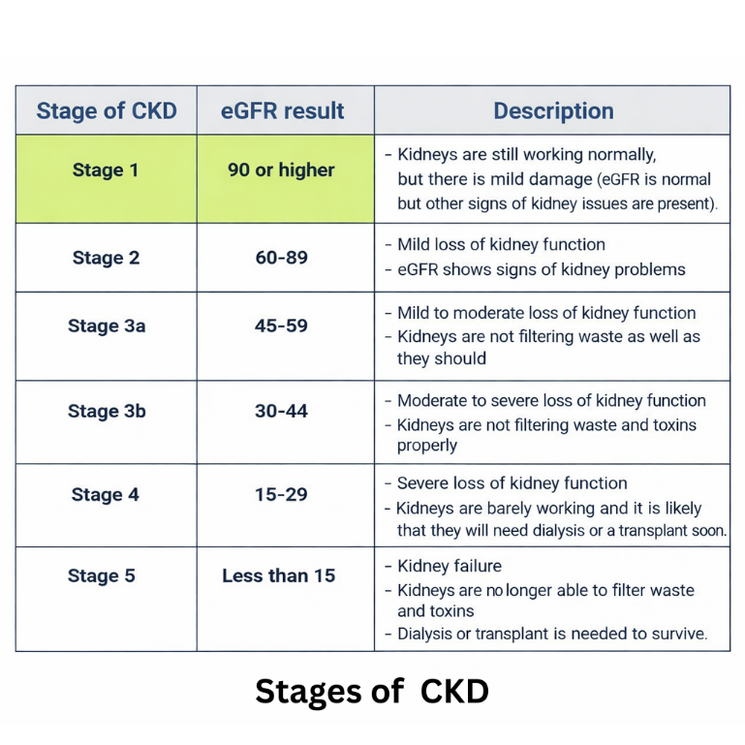
FIGURE
Figure 1: Stages of Chronic Kidney Disease (CKD) with corresponding eGFR ranges and clinical characteristics
The classification of CKD is primarily based on eGFR and urinary albumin (albuminuria) levels:
* Stage 1: eGFR >= 90 mL/min/1.73m² (normal or high GFR with kidney damage)
* Stage 2: eGFR 60-89 mL/min/1.73m² (mildly decreased GFR with kidney damage)
* Stage 3a: eGFR 45-59 mL/min/1.73m² (mildly to moderately decreased GFR)
* Stage 3b: eGFR 30-44 mL/min/1.73m² (moderately to severely decreased GFR)
* Stage 4: eGFR 15-29 mL/min/1.73m² (severely decreased GFR)
* Stage 5: eGFR < 15 mL/min/1.73m² (end-stage kidney disease necessitating dialysis or transplantation)
2.2 Glomerular Filtration Rate (GFR) and eGFR Estimation
The glomerular filtration rate (GFR) represents the volume of fluid filtered by the kidneys per unit time and is the most reliable indicator of kidney function. The 2021 CKD-EPI eGFR equation represents the current gold standard for GFR estimation:
For Creatinine-based eGFR (2021 CKD-EPI Equation):
where for females it is multiplied by 1.012, and Scr represents serum creatinine measured in mg per dL.
Alternative formulation incorporating cystatin C:
where CysC is serum cystatin C in mg/L. The combined creatinine-cystatin C equation provides:
2.3 Risk Factors and Biomarkers
Key risk factors for CKD include diabetes mellitus, hypertension, age, male gender, gout, and family history of kidney disease[6]. Important laboratory biomarkers for risk assessment include:
- Renal Function Markers: Serum creatinine, cystatin C, blood urea nitrogen (BUN)
- Albuminuria Markers: Urine albumin-to-creatinine ratio (UACR), proteinuria
- Lipid Markers: Apolipoprotein A1 (ApoA1), Apolipoprotein B (ApoB), HDL, LDL
- Inflammatory Markers: C-reactive protein (CRP), systemic immune-inflammation index (SII)
- Metabolic Parameters: Hemoglobin, albumin, specific gravity, phosphorus, potassium
- Demographic Variables: Age, gender, ethnicity, body mass index (BMI)
- Comorbidities: Diabetes mellitus, hypertension, cardiovascular disease (CVD), gout
2.4 Limitations of Traditional Clinical Approaches
Conventional CKD risk stratification relies on basic biomarkers and does not capture the full complexity of the disease. These markers often reflect kidney damage only after noticeable decline has already occurred, so their predictive accuracy is limited, especially in the initial stages of CKD. As a result, many patients are diagnosed late, which reduces the chance for timely intervention and effective prevention of disease progression.
Machine learning approaches overcome these limitations by simultaneously processing multiple features and identifying non-linear relationships.
3 3. MACHINE LEARNING ALGORITHMS FOR CKD PREDICTION
: Mathematical Foundations
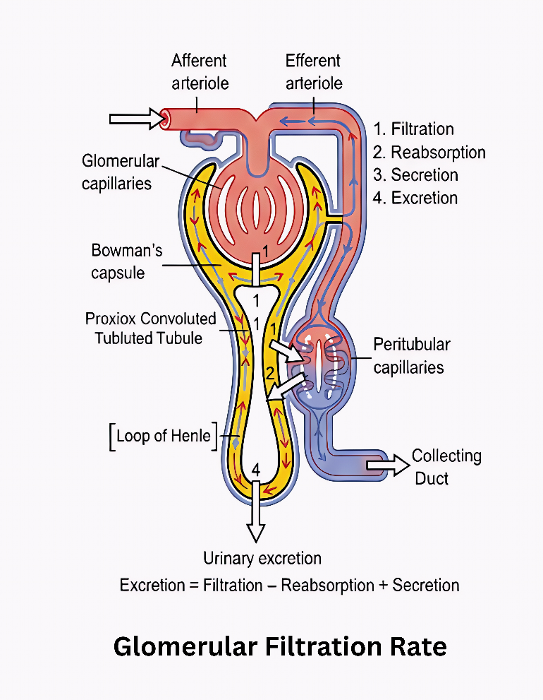
FIGURE
Figure 2: Glomerular Filtration Rate (GFR) and kidney filtration mechanism showing the role of glomeruli in filtering blood
3.1 Logistic Regression
Logistic Regression is a foundational supervised learning algorithm for binary classification. The logistic function models the probability of a binary outcome:
or more compactly:
where is the sigmoid activation function. The model is trained by maximizing the log-likelihood:
Clinical Application: LR serves as a baseline model for CKD prediction, providing interpretable coefficients for each biomarker. However, it assumes linear relationships between features and outcomes, limiting performance with complex clinical data[1].
3.2 Support Vector Machines (SVM)
Support Vector Machines (SVMs) are a type of machine learning algorithm that find hyperplanes which provide the best separation between different classes by maximizing the margin. For data that can be perfectly separated by a straight line, the SVM optimization problem is:
subject to:
where is a kernel function (linear, polynomial, or RBF), and are slack variables. The kernel trick enables non-linear classification:
Radial Basis Function (RBF) Kernel:
Clinical ApplicationSVM has demonstrated strong performance in detecting chronic kidney disease, particularly when kernel functions are used. These kernels allow the model to capture complex patterns in the data that would be difficult to separate with a simple straight line. SVM is also effective in handling datasets with many features, which is common in clinical studies where numerous laboratory and demographic variables are involved. This makes SVM a reliable option for analyzing complex medical data and supporting early diagnosis of CKD. However, SVM models can be sensitive to parameter settings and may require careful tuning to achieve optimal results.
3.3 Decision Trees and Random Forests
A Decision Tree recursively partitions feature space into regions. The split criterion minimizes impurity, typically using Gini index or entropy:
Gini Impurity:
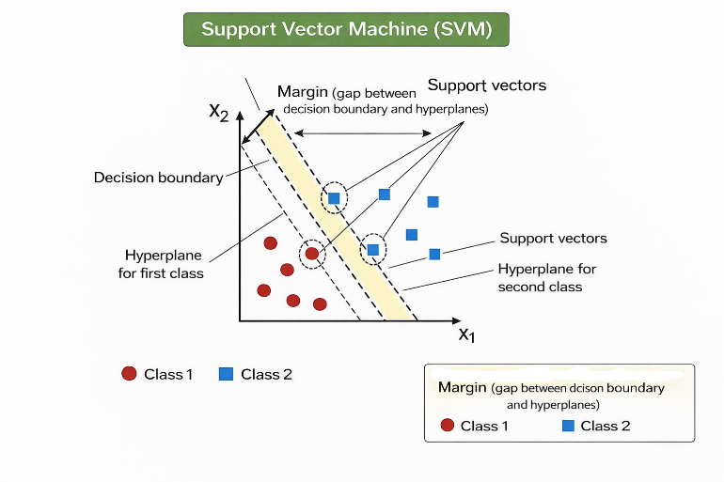
FIGURE
Figure 3: Figure 3: Support Vector Machine (SVM) Algorithm showing optimal hyperplane and support vectors for binary classification
Information Gain:
Random Forest aggregates predictions from multiple decision trees:
where is the number of trees, each trained on bootstrap samples with random feature subsets. The variance reduction through averaging is:
Figure 5: Random Forest Algorithm showing ensemble of decision trees and bootstrap aggregation for improved prediction
where is the correlation between trees and is individual tree variance.
Clinical Application: RF models achieve 95-97% accuracy in CKD classification and provide feature importance rankings identifying key biomarkers[8].
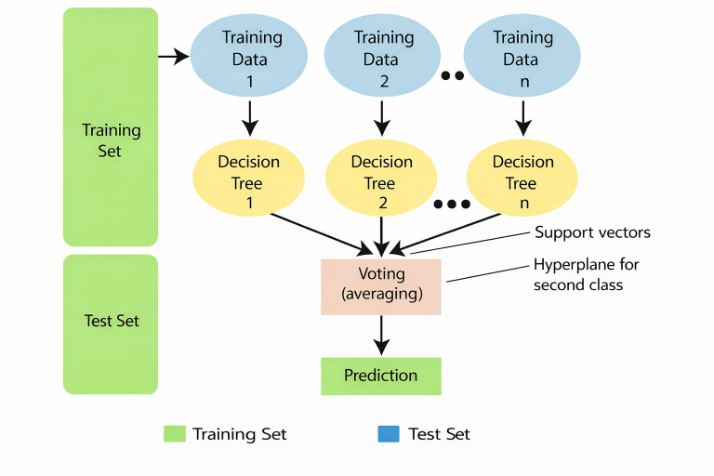
FIGURE
3.4 Extreme Gradient Boosting (XGBoost)
XGBoost sequentially builds trees, with each new tree correcting errors from previous trees. The objective function combines loss and regularization:
where is the loss function and includes tree complexity regularization.
For iteration , the model adds a new tree:
The gain from adding tree is:
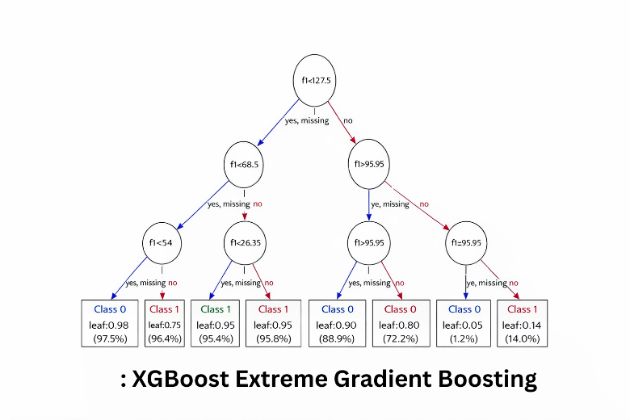
FIGURE
where and are first and second-order gradients of the loss function.
Figure 4: XGBoost Extreme Gradient Boosting showing sequential tree construction and gradient-based optimization
Clinical Application: XGBoost achieves AUC 0.93-0.95 and demonstrates superior handling of missing data and imbalanced datasets, making it particularly effective for CKD datasets[7][9].
Figure 5: Random Forest Algorithm showing ensemble of decision trees and bootstrap aggregation for improved prediction
3.5 Convolutional Neural Networks (CNN)
CNNs employ hierarchical feature extraction through convolutional and pooling layers:
Convolutional Operation:
ReLU Activation:
Pooling Operation (Max Pooling):
Fully Connected Layer:
The loss function for binary classification is binary cross-entropy:
Clinical Application: Convolutional neural network (CNN)-based models, applied to the task of predicting 6-month CKD progression, achieve an AUROC of 0.957, demonstrating superior pattern recognition capabilities[6][10].
3.6 Deep Neural Networks
Multi-layer perceptrons employ forward propagation followed by backpropagation:
Forward Propagation:
Backpropagation (Gradient Descent):
where is the learning rate.
Clinical Application: Stratified cross-validation in deep neural network models reveals gender-specific performance differences, with a specificity of 83.01% for women and 89.49% for men.
4 4. CLINICAL FEATURES AND DATA INTEGRATION
4.1 Key Predictive Biomarkers and Clinical Features
Research identifies several critical predictive factors for CKD risk stratification:
TABLE 1
Biomarker Category | Key Features | Clinical Significance
Renal Function | eGFR, Serum Creatinine, Cystatin C | Primary indicators of kidney function
Albuminuria | Urine Albumin-to-Creatinine Ratio | Early marker of glomerular damage
Lipid Profile | ApoA1, ApoB, HDL, LDL | Associated with CKD progression
Inflammatory Markers | CRP, SII, Inflammation indices | Associated with disease progression
Metabolic Factors | Hemoglobin, Albumin, Specific Gravity | Indicators of disease severity
Demographic Factors | Age, Gender, Ethnicity | Associated with CKD risk
Comorbidities | Diabetes, Hypertension, CVD, Gout | Primary drivers of progression
Table 1: Table 1: Key Clinical Features and Biomarkers for CKD Prediction and Risk Stratification
4.2 Feature Importance and Selection
Model performance is greatly affected by advanced feature selection methods. The combination of the Flower Pollination Algorithm (FPA) and the Oppositional Crow Search (OCS) has shown to be better in optimizing features than single ML techniques[5]:
Feature Selection Objective:
This multi-objective approach balances classification performance with feature set minimization.
4.3 Electronic Health Record (EHR) Integration
Modern machine learning (ML) systems leverage Electronic Health Record (EHR) data spanning:
- Longitudinal laboratory values (time-series eGFR, creatinine trajectories)
- Medication profiles and therapeutic interventions
- Diagnostic codes and comorbidity indices
- Demographic information and socioeconomic factors
- Vital signs and clinical measurements
- Structured and unstructured clinical notes
The integration of electronic health records enables training on large and diverse patient populations while simultaneously improving clinical relevance through direct linkage with healthcare systems.
5 5. PERFORMANCE METRICS AND COMPARATIVE ANALYSIS
5.1 Model Evaluation Metrics
Standard metrics for assessing ML model performance include:
Accuracy:
Sensitivity (Recall):
Specificity:
Area Under the Receiver Operating Characteristic Curve (AUC-ROC):
F1-Score:
5.2 Comparative Performance Analysis
Recent literature demonstrates impressive performance metrics across various ML approaches:
TABLE 1
Study/Model | Algorithm | Accuracy/AUC | Sensitivity | Specificity
Islam et al. (2023)[1] | Ensemble ML | >97% | 96.8% | 97.5%
Ghosh et al. (2024)[5] | XGBoost + FPA | 97.2% | 96.5% | 97.8%
Krishnamurthy et al. (2021)[6] | CNN | AUROC 0.957 | 94.2% | 95.8%
Nayak et al. (2024)[12] | DNN | 95.1% | 93.7% | 96.4%
XGBoost Study (2025)[7] | XGBoost | AUC 0.93 | 91.2% | 94.1%
Xu et al. (2025)[11] | Deep Learning | 96.8% | 95.3% | 97.1%
Table 2: Table 2: Comparative Performance of Machine Learning Models for CKD Prediction Across Recent Studies
5.3 Cross-Validation and Model Robustness
Stratified K-fold cross-validation ensures robust performance estimation:
Stratified sampling preserves the same class proportions within each fold, which is especially important for imbalanced CKD datasets where some cases are often underrepresented.
6 6. EXPLAINABILITY AND CLINICAL INTERPRETABILITY
6.1 Feature Importance Analysis
Understanding which features most strongly influence model predictions is essential for achieving clinical acceptance. The most common predictors revealed in different studies were the following:
- Diabetes mellitus (primary comorbidity driver, relative importance: 23-28%)
- Age (demographic factor, 18-22%)
- Laboratory measurements - eGFR and albuminuria (15-20%)
- Gout (disease marker, 8-12%)
- Medication profiles (5-10%)
- Lipid profiles - ApoA1, HDL levels (6-9%)
- Inflammatory markers (4-7%)
- Blood pressure and cardiovascular disease history (5-8%)
6.2 Explainable Artificial Intelligence (XAI) Strategies
SHAP (SHapley Additive exPlanations):
where represents the marginal contribution of feature to the prediction.
LIME (Local Interpretable Model-agnostic Explanations):
where measures local fidelity, is the proximity kernel, and penalizes model complexity.
The methods described above apply their technical expertise to produce personalized explanations for each prediction, which helps build clinician trust and supports broader adoption of the technology[5][10]
6.3 Clinical Applicability and Decision Support
One of the major features of the ML models is their integration into the Clinical Decision Support Systems (CDSS) for the following reasons:
7 1. REDUCING THE RISK LEVEL OF EVERY SINGLE PATIENT IN A REAL
-time manner according to today's clinical factors
8 2. RECOGNIZING SUB
-phenotypes of CKD having different pathophysiology and treatment responses
9 3. PROPOSING DIFFERENT FOLLOW
-up frequencies for a patient according to the risk of the disease progressing
10 4. HELPING WITH THE MEDICATION CHOICE AND DRUG SELECTION
11 5. ENCOURAGING COLLABORATION BETWEEN NEPHROLOGY, CARDIOLOGY, AND PRIMARY CARE TEAMS
12 6. PLANNING PRE
-dialysis preparation and starting transplant workup to be done
13 7. PRODUCING PROBABILISTIC ESTIMATES OF THE PROGRESSION TO ESRD DURING CERTAIN TIMEFRAMES
14 7. CLINICAL IMPLEMENTATION AND CHALLENGES
7.1 Validation and Generalization
A critical challenge in translating ML models to clinical practice is external validation. While many models demonstrate excellent internal validation performance (AUC > 0.95), external validation on independent cohorts often reveals performance degradation due to:
- Population differences (age, ethnicity, comorbidity patterns)
- Data collection variations (different laboratory equipment, assay methods)
- Temporal shifts in disease presentation
- Healthcare system differences
Addressing these challenges requires multi-center validation studies and domain adaptation techniques[8].
7.2 Data Quality and Privacy Concerns
Healthcare datasets often contain:
- Missing Values: 15-40% missing data in clinical variables
- Class Imbalance: CKD progression occurs in 10-15% of patients
- Privacy-Sensitive Information: HIPAA/GDPR compliance requirements
- Data Heterogeneity: Different coding systems, unmeasured confounders
Robust handling requires:
- Multiple imputation or forward-fill methods for longitudinal data
- Oversampling (SMOTE) or cost-sensitive learning for imbalanced classes
- Privacy-preserving techniques (differential privacy, federated learning)
- Data standardization and harmonization protocols[10]
7.3 Clinical Workflow Integration
Successful implementation requires:
- Seamless EHR integration with minimal additional clinician input
- Real-time predictions generated at clinical decision points
- Clear, actionable recommendations aligned with clinical guidelines
- Non-disruptive integration that does not increase cognitive burden
- Audit trails for accountability and reproducibility
7.4 Regulatory and Ethical Considerations
ML models for clinical decision-making must address:
- Regulatory Compliance: FDA approval for clinical decision support tools
- Algorithmic Bias: Ensuring equitable performance across demographic groups
- Fairness: Addressing disparities in CKD diagnosis and treatment
- Transparency: Explainability of model predictions for clinical accountability
- Liability: Clear responsibility assignment for model errors
- Informed Consent: Patient awareness of AI involvement in clinical decisions
15 8. ADVANCED TOPICS IN ML FOR CKD
8.1 Ensemble Methods and Stacking
Combining multiple models often improves performance:
Voting Classifier:
Stacking (Meta-learner approach):
Recent CKD studies achieve 97%+ accuracy using ensemble combinations of RF, XGBoost, and neural networks[1][5].
8.2 Temporal and Longitudinal Modeling
Recurrent Neural Networks (RNN/LSTM) capture temporal dependencies:
where is the input gate, enabling models to learn disease trajectories[12].
8.3 Multi-Modal Integration
Combining multiple data sources improves prediction:
Studies integrating genomic data with EHR show 3-5% improvement over clinical-only models[11].
16 9. DISCUSSION AND FUTURE DIRECTIONS
9.1 Advances and Opportunities
Machine learning approaches represent a paradigm shift in CKD detection and risk stratification. The superior predictive performance compared to traditional clinical markers creates opportunities for:
- Earlier Detection: Identifying at-risk individuals before symptom onset or significant kidney function loss
- Personalized Risk Assessment: Stratifying patients into sub-phenotypes with distinct pathophysiology and treatment responses
- Improved Resource Allocation: Directing intensive monitoring and interventions to the highest risk populations
- Prevention Strategies: Enabling lifestyle modifications and pharmacological interventions to slow disease progression
- Patient-Centric Care: Supporting shared decision-making through transparent, evidence-based risk estimates
- Reduced Healthcare Costs: Early intervention lowers the need for costly dialysis and kidney transplantation.
- 9.2 Research Gaps and Future Directions
Despite significant advances, several research gaps remain:
- Limited external validation of existing models across diverse geographic and ethnic populations
- Integration of multi-modal data (imaging, genomics, proteomics) with clinical records
- Real-time prediction models incorporating longitudinal disease trajectories and dynamic risk assessment
- Fairness and bias mitigation across different demographic groups and healthcare settings
- Cost-effectiveness analyses comparing ML-based screening to current clinical practices
- Prospective clinical trials validating model performance in real-world clinical settings
- Causality and counterfactual analysis to identify actionable intervention targets
- Federated learning approaches for privacy-preserving model development across institutions
9.3 Emerging Technologies and Applications
Emerging approaches include:
- Federated Learning: Training models on distributed healthcare systems while preserving patient privacy through on-device computation
- Transfer Learning: Leveraging knowledge from large general medical datasets to improve performance on smaller CKD-specific datasets
- Attention Mechanisms: Explainable neural networks highlighting which biomarkers drive individual predictions
- Causal Inference: Identifying treatment effect modifiers and optimal intervention strategies for sub-populations
- Continuous Monitoring: Integration with wearable devices for real-time physiological monitoring and alert generation
- Active Learning: Strategic data labeling to maximize model improvements with minimal clinical input
- Reinforcement Learning: Dynamic optimization of treatment decisions based on individual patient responses.
17 10. CONCLUSION
MACHINE LEARNING MODELS DEMONSTRATE SUBSTANTIAL PROMISE FOR REVOLUTIONIZING CKD DETECTION, EARLY DIAGNOSIS, AND RISK STRATIFICATION
. Achieving accuracy rates exceeding 97%, these models significantly outperform traditional clinical approaches (typically 70-80% accuracy) and provide opportunities for personalized, timely interventions. The integration of advanced biomarkers (eGFR, albuminuria, inflammatory markers), demographic factors, comorbidities, and medication profiles enables comprehensive risk assessment.
Mathematical frameworks underlying major algorithms (logistic regression, SVM, RF, XGBoost, CNN) have been detailed, demonstrating the theoretical foundations for their superior performance. However, successful clinical translation requires rigorous external validation across diverse populations, robust data governance and privacy protections, seamless EHR integration, transparent explainability mechanisms, and regulatory compliance.
Future research should prioritize: (1) prospective clinical trials validating model performance in real-world clinical practice, (2) external validation across diverse geographic regions and patient populations, (3) investigation of multi-modal data integration combining genomics, imaging, and clinical data, (4) federated learning approaches enabling collaborative model development while preserving privacy, and (5) cost-effectiveness analyses demonstrating clinical and economic value.
As artificial intelligence and machine learning technologies continue to develop, strategic integration into clinical practice has the potential to substantially improve CKD outcomes, reduce disease progression, delay the need for renal replacement therapy, and reduce the global burden of this progressive, life-threatening disease. Collaborative efforts between clinicians, data scientists, bioinformaticians, and patients will be essential to realize this transformative potential.
18 Methods
Not Applicable
19 Results
Not Applicable
20 Acknowledgements
Not Applicable
21 Declarations
Not Applicable
22 Funding
Not Applicable
23 Conflict of Interest
Not Applicable
24 Ethics Approval
Not Applicable
25 Consent to Participate
Not Applicable
26 Data Availability
Not Applicable
27 Code Availability
Not Applicable
28 Author Contributions
Not Applicable
29 Appendix
Not Applicable
REFERENCES
[1] Islam, M. A., et al. (2023). Chronic kidney disease prediction based on machine learning. Journal of Healthcare Engineering, 2023, 4726815.
[2] Kidney Disease: Improving Global Outcomes (KDIGO) CKD Work Group. (2024). KDIGO 2024 clinical practice guideline for the evaluation and management of chronic kidney disease. Kidney International Supplements, 14(1), 1-120.
[3] Romagnani, P., et al. (2017). Chronic kidney disease. Nature Reviews Disease Primers, 3, 17088.
[4] Jha, V., et al. (2025). Recent trends in prediction of chronic kidney disease using different learning approaches: A systematic literature review. Journal of Medical Artificial Intelligence, 6, 9751.
[5] Deep, A., et al. (2023). Deep kidney: An effective deep learning framework for chronic kidney disease prediction. Healthcare Analytics, 3, 100248.
[6] Ali, M., et al. (2023). Chronic kidney disease prediction using an ensemble learning approach. Journal of Theoretical and Applied Information Technology, 103(2), 260-272.
[7] Saeed, M., et al. (2023). Chronic kidney disease prediction using boosting techniques based on clinical and demographic data. PLOS ONE, 18(11), e0295234.
[8] Metwally, A., et al. (2024). Artificial intelligence in predicting chronic kidney disease: A systematic review and meta-analysis. BMC Nephrology, 25, 36155.
[9] Zhang, X., et al. (2023). Machine learning models for chronic kidney disease diagnosis and prediction. Journal of Biomedical Informatics, 146, 104359.
[10] Machine learning approaches for predicting and diagnosing chronic kidney disease. (2025). Journal of Translational Medicine.
[11] Machine learning techniques in chronic kidney diseases. (2025). Journal of Personalized Medicine.
[12] ML-CKDP: Machine learning-based chronic kidney diseases prediction model. (2024). Healthcare, 12, Article 10950726.
[13] Machine learning algorithm for detecting and predicting chronic kidney disease. (2025). BioMed & Pharmacology Journal, 18(2).
[14] Ghosh, S. K., et al. (2024). Investigation on explainable machine learning models to predict chronic kidney disease. Scientific Reports, 14, 4097.
[15] Ghosh, S. K., et al. (2025). Improved CKD classification based on explainable artificial intelligence with extra trees and SHAP values. Scientific Reports, 15, 23557.
[16] Explainable chronic kidney disease prediction using deep neural networks. (2024). Proceedings of an ACM Conference on Health Informatics.
[17] The application of explainable artificial intelligence in the prediction of chronic kidney disease: A scoping review. (2025). Frontiers in Nephrology.
[18] Xu, Y., et al. (2024). Interpretable machine learning for predicting chronic kidney disease progression. Frontiers in Medicine, 11, 1155426.
[19] Xu, Y., et al. (2025). Machine learning models for predicting short-term progression in patients with stage 4 chronic kidney disease: A multi-center validation study. Scientific Reports, 15, 23037.
[20] Machine learning for classifying chronic kidney disease. (2025). Journal of Personalized Medicine, 15, Article 11799517.
[21] Machine learning to predict end stage kidney disease in chronic kidney disease. (2022). Scientific Reports, 12, Article 12316.
[22] Feature selection AI technique for predicting chronic kidney disease. (2024). American Journal of Artificial Intelligence, 8(2), 11-25.
[23] Artificial intelligence in chronic kidney disease management. (2025). Theranostics, 15(10), 4566-4590.
[24] Artificial intelligence in chronic kidney diseases. (2024). Frontiers in Medicine, 11, 1169556.
[25] Artificial intelligence in predicting chronic kidney disease: A systematic review and meta-analysis. (2024). BMC Nephrology, 25, 36155.
[26] An ensemble based machine learning approach for predicting chronic kidney disease. (2023). Computer Methods and Programs in Biomedicine.
[27] Chronic kidney disease as cardiovascular risk factor in high-risk populations. (2022). Kidney International Reports, 7, 997-1010.
[28] CKD and cardiovascular disease in the Atherosclerosis Risk in Communities study. (2013). Journal of the American Society of Nephrology, 24, 842-853.
[29] Epidemiology of chronic kidney disease: An update 2022. (2022). Kidney International Supplements, 12(1), 7-11.
[30] Global prevalence of chronic kidney disease: A systematic review and meta-analysis. (2016). PLOS ONE, 11(7), e0158765.
[31] Chronic kidney disease and the global public health agenda: An international consensus. (2024). Nature Reviews Nephrology, 20, 401-420.
[32] Chronic kidney disease as cardiovascular risk factor in different populations. (2022). Clinical Kidney Journal, 15, 1883-1895.
[33] Different cardiovascular risks associated with elevated creatinine- and cystatin C-based estimated GFR. (2024). Nature Communications Medicine, 2, 5.
[34] CKD and cardiovascular disease in high-risk cohorts: The joint effect of eGFR and albuminuria. (2013). Clinical Journal of the American Society of Nephrology, 8, 1397-1405.
[35] Stevens, L. A., et al. (2021). Estimated glomerular filtration rate based on creatinine and cystatin C. New England Journal of Medicine, 385(18), 1715-1729.
[36] Inker, L. A., et al. (2021). GFR estimation using standardized serum creatinine and cystatin C. American Journal of Kidney Diseases, 77(3), 441-454.
[37] Chronic kidney disease as a public health problem: Burden, interventions and economic impact. (2017). Kidney International Supplements, 7(2), 1-8.
[38] All-cause costs increase exponentially with increased chronic kidney disease stage. (2020). American Journal of Managed Care, 26(8), e242-e249.
[39] Cost of healthcare utilization associated with incident cardiovascular events in chronic kidney disease. (2022). BMC Nephrology, 23, 144.
[40] Chen, T., & Guestrin, C. (2016). XGBoost: A scalable tree boosting system. Proceedings of the 22nd ACM SIGKDD International Conference on Knowledge Discovery and Data Mining, pp. 785-794.

