SmartLife Guardian: An AI-Driven Multimodal Health Monitoring System for Elderly Care

Hemaa shri G  Department of Artificial Intelligence  and Data Science  Rajalakshmi Institute of Technology Chennai, Tamil Nadu, India  hemaashri.g.2022.ads@ritchennai.edu.in | Fouzia Banu A R  Department of Artificial Intelligence  and Data Science  Rajalakshmi Institute of Technology Chennai, Tamil Nadu, India  fouziabanu.a.r.2022.ads@ritchennai.edu.in | Ganesh Raja L  Department of Artificial Intelligence  and Data Science  Rajalakshmi Institute of Technology Chennai, Tamil Nadu, India  ganeshraja.l.2022.ads@ritchennai.edu.in
Divya Muralitharan
Assistant Professor
Department of Artificial Intelligence
and Data Science
Rajalakshmi Institute of Technology
Chennai, Tamil Nadu, India
divyamuralitharan@gmail.com
ABSTRACT:

There are many elderly people who require constant monitoring of their vitals. Everyday going to hospitals for checkups or being admitted in the hospital for monitoring their vitals is tiring; therefore, there is a high demand for smart health monitoring systems. To support elderly healthcare, this paper introduces the SmartLife Guardian, which is a glove-based wearable system that helps to monitor the vitals of the human body. This glove is combined with different sensors, Edge AI, and cloud-assisted monitoring. Heart rate, SpO₂, body temperature, respiration, and activity patterns are the vital parameters that are monitored using this wearable system. Tiny ML models are integrated with the hardware that helps in spotting odd patterns of the vital signs and customized health assessment. Tiny ML guarantees in low latency, improves privacy and decreases network dependency. the overview of the health insights and alerts are sent to the cloud so that the caregiver and family members can access and visualize the patient records. The system uses a voice assistant to remind users to take their medication, drink water, or rest when their vital signs show early signs of instability. Experimented results shows that this smart health monitoring system has improved alert accuracy, less false alarms and energy efficient operation making it suitable for long term consistent health monitoring system for elder people.
KEYWORDS: Edge AI, TinyML, IoT-based elderly monitoring, Wearable health-care systems, Embedded sensors, Medical Reminder System, Real-time health prediction, Intelligent alerting.

INTRODUCTION
There is an increase in elder people population in recent years. Therefore, it requires continuous health monitoring system.[7] This system detects abnormal conditions of elder people within a shorter duration frequently [3]. Elder people are at risk to get chronic conditions, mobility issues, respiratory complications, and sudden health emergencies, particularly when living independently [7]. Regular healthcare approaches depend on occasional clinical visits and manual observations, which fails to capture the abnormalities [18]. Recent Improvements in wearable sensors, IoT and AI have enabled Real-time health monitoring [1][2][15]. Many Health monitoring systems which are in existence are depend on cloud processing and fixed threshold-based alerts, which leads to delay in data transfer, high power consumption and low privacy [6][7][15]. To overcome the limitations, this work introduces Edge AI enabled wearable glove that performs on-device analysis using TinyML models [8][12][16]. By learning personalized physiological baselines and detecting deviations locally this enables a predictive and preventive monitoring. The system provides timely voice-based reminders for medication intake, hydration and rest whenever slight instability is detected in the user’s vital signs [3]. ESP32 is a low power microcontroller with built in Wi-Fi and Bluetooth that enables real time data collection and wireless transmission from wearable sensors [8][17]. TinyML allows tiny devices to understand data act smartly without always needing cloud support [12][16][17]. Edge AI analyses data on the device itself, which helps the system react quickly and keeps data private.[15][16]

LITERATURE REVIEW
Wearable health monitoring systems are in demand for elder adults because it helps doctors and caretakers to check the patient's health regularly from anywhere. Pantelopoulos and Bourbakis [18] were among the first to study wearable health sensors. They made a survey on the devices that track heart rate, oxygen level, ECG and body temperature and described that these devices need to use low power, be comfortable to wear, should be reliable in work and keep the user's data safe. Study [3] explains why smart and automatic health alerts are important. Signs of stress and unusual health changes in elder people are found using machine learning by collecting data from different wearable sensors.
Many systems using IoT have designed to monitor the health of elderly people. These systems help make healthcare easier to access and allow quick decisions based on real time health data. MAX30102 and temperature sensors are used in IoT system that measures heart rate and oxygen level which is shown in Study [10]. The data is sent to the cloud, where doctors or caregivers can easily check it from anywhere. In [4] a more advanced remote monitoring system was introduced. It uses small connected services to analyse real time health data and predict the risk of infectious in elderly people. This system helps us to understand that IoT is useful in checking the patient's health from distance and keeps us informed about their health in real time.
Research on detecting falls is also very important because older adults have a high chance of falling and getting injured. LIDAR based fall detection [5] developed a system which uses depth sensing to correctly identify when a person falls. Lakhdari et al. [11] looked at fall detection systems that work using IoT. They focused on sharing the processing work across devices, protecting the user’s privacy and sending instant alerts when a fall happens. Khojasteh et al [13] showed that using machine learning makes wearable fall detection much more accurate. Instead of using just basic threshold values, they used accelerometer data and smart algorithms to correctly identify falls more reliably.
New technology now allows wearable devices to have built in smart features using TinyML and edge computing. This helps the device work faster, use less battery and not depend too much on cloud servers for processing. Abdullah et al. [17] introduced a wearable device using ESP32 with TINYML to detect unusual heart rate, oxygen level and temperature changes. This device shows that small neural networks can run effectively on low power microcontrollers. Patel et al [16] demonstrated that running the processing inside the device will be useful. It makes the system faster, keeps the user’s data more private and saves battery. They found that using edge processing reduced alert delays by more than 60% compared to cloud-based systems. All these studies depict and support a smart, low power and real time wearable health devices that helps us to monitor elder people continuously and effectively.

SYSTEM ARCHITECTURE
The system design shows how the whole model works. It starts from the wearable sensors that continuously collect the elderly person's health data to the smart processing that makes decisions and finally to the user being able to see the results. The system uses both edge and cloud together [15][16]. The wearable device does the important health analysis on the spot, while the cloud is used to store the data, show dashboards and allow remote access. The smart glove uses multiple sensors to continuously collect health data, including heart rate, SpO2, body temperature, respiration and fall related movements [3][7][10]. The data is first cleaned using Arduino to remove noise and incorrect values [12]. ESP32 uses Edge AI to analyse health data and identify abnormal conditions [8][12][17]. TinyML learns patterns from each user's vital signs to calculate health risk score [12][16][17]. Edge AI lets the system handle data locally, so actions can be taken quickly without sending all data online. The system stores the processed data securely in the Firebase and uses it to send alerts and notifications whenever necessary [3]. The mobile application is user-friendly that helps to displays real time health monitoring, send alerts, and voice reminders for their medication, that allows caregivers and family members stay updated and take quick action during emergencies.
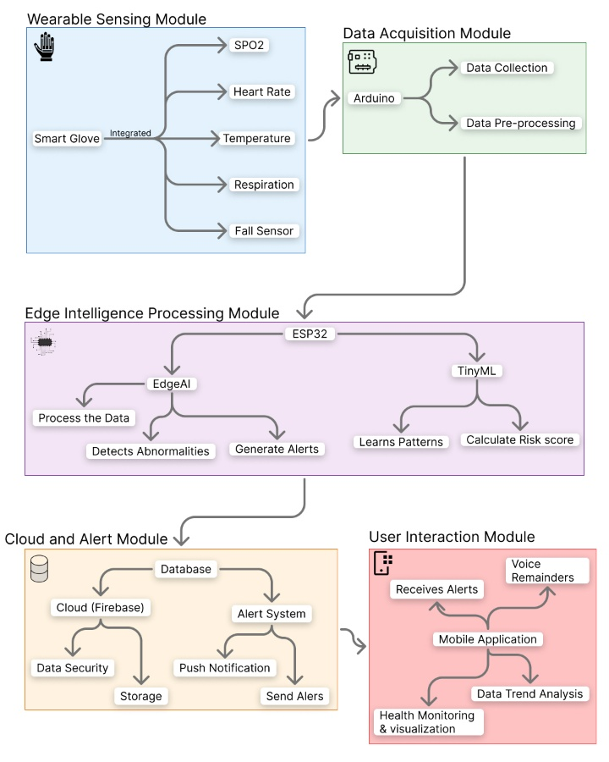
Figure 1 System Architecture

Hardware Design

Smart Glove Design
The smart glove is the main wearable device in this elderly support system. It is made to be comfortable to wear for a long time, keep the sensors steady in one place, and be easy for older people to use. The glove is designed using lightweight, breathable, and stretchable fabric to ensure comfort and long-term wearability for elderly users. Sensors are embedded within the glove lining to maintain stable skin contact, while the processing and power units are housed in a compact, detachable wrist enclosure for ease of maintenance.

Sensors and Embedded Processing
This hardware model includes different sensors that monitors the body vitals and movements. This helps to track the patient's health constantly. To measure the patient's oxygen level in the blood and their heart rate a PPG sensor is placed near the fingertip [3][7][10]. This helps to monitor the vitals more precisely because fingertip has a good blood flow and this helps the sensor to get a clear signal. The smart glove also integrates, a temperature sensor for monitoring body temperature, an IMU for motion and activity tracking, and a respiration sensor for breathing analysis [5][6][13]. An Arduino microcontroller handles sensor acquisition and preprocessing, while an ESP32 performs feature extraction, Edge AI inference, and wireless communication [8][12][17].

Microcontroller and Local Processing
This system uses Arduino and ESP32 microcontrollers where each one handles specified tasks that helps the system to run smoothly. Arduino plays a major role in reading the data from all the health sensors which is connected to the system. It continuously collects the clean data by removing noise, filtering the signals and arranging the information for further process [12][13]. ESP32 plays a key role as central processing and communication unit. ESP32 takes the clean data from Arduino and selects the important information and process this information on the TinyML to make smart predictions directly on the device [8][12][17]. ESP32 uses its built-in WI-FI to send the processed data safely to the cloud. Since the ESP32 has two cores it uses very little power and supports built-in machine learning and it can handle its tasks efficiently and reliably [8][17].

Data Transmission using Firebase
Firebase is used as a cloud platform that send and store all the health data which is collected from the smart glove. The ESP32 sends the cleaned health readings like heart rate, oxygen level, breathing, temperature and risk score to Firebase instantly using a secure connection. As soon as the data reaches Firebase, it automatically updates on the user dashboard so the doctors, caregivers and family members can see the live health information without needing to refresh anything [3][10]. Firebase send alerts automatically to caregivers and family members, if the health monitoring system finds any abnormal changes in the vital signs of the patient [3]. It provides continuous monitoring of the vital signs, make immediate actions in emergency situations and maintains the patient’s health record safely.

Power Management
Good power management is very important to keep the wearable device running smoothly without interruptions. The smart glove runs on a rechargeable lithium-ion or lithium-polymer battery which is safely placed in the wrist area of the glove [1]. Voltage regulators make sure the sensors and microcontrollers get a steady power supply, which protects the components from sudden changes in voltage. To make the battery last longer the system uses power saving methods like turning sensors on only when needed, putting the microcontrollers into low- power sleep mode and sending data only when an important event happens [12][17].

Software Implementation
The software design structure functions as a Cloud-Edge AI Platform. Lightweight Tiny ML models running on the ESP32 perform real-time personalized baselines, anomaly detection, and health risk assessment and scoring [12][16][17]. Firebase is used as the cloud backend for safe storage, syncing, and display of data [3][10]. Also, firebase is used to send alerts and push notification. On the mobile app, there are live vital signs, historical trends of those vital signs, health scores, visualization and receives emergency alerts [3]. The software provides voice based medical reminders.Fig.2 shows the workflow of the software. The system starts by collecting all the vital signs using the integrated sensors in the smart glove. The collected vital signs are sent to Arduino for preprocessing the data like removing noise and smoothing the signals and making the data efficient. Then the data is transmitted to ESP32 where Edge AI process the data and TinyML learns the patterns of the patient’s health vitals and based on these patterns it makes a personalised baseline for each patient. There are two possible outcomes from this system.
- When the system detects any abnormal changes TinyML calculates the risk score and generates the alert and this alert is immediately sent as a notification to the caregiver and the family members and required actions are taken.
- If the vitals are normal then the health vitals are stored in cloud and provides safe access of patient’s vitals on dashboard. These data can be accessed by caregivers and family members from anywhere at any time.
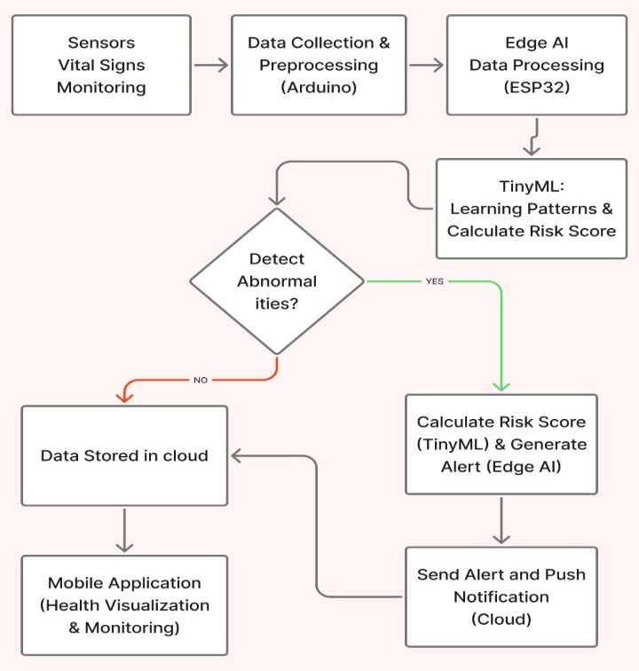
Figure 2 Workflow of the System
This mobile app will continuously display the live vitals of the patient which makes it easy for the caregivers and family members to monitor the patient regularly and remotely.

RESULTS AND ANALYSIS
These findings demonstrate a successful and robust capability to monitor essential signals of humans when performing typical daily tasks. Patient-specific risk assessments have fewer false alarms than existing threshold-based alerting systems [7][13]. With Edge-AI involvement on a local basis, the system was able to respond immediately enabling emergency response [15][16]. The power analysis provided demonstrates that the maximum energy is saved and suitable for extended wearable use [17].

Vital parameter | Traditional Method (Fixed  Threshold) | Proposed System (Personalized) | Accuracy (Traditional Method) | Accuracy (Proposed System)
Heart Rate | 60-100 | Baseline ± 10 bpm (e.g. 68-88) | 75-80 | 92-96
SpO2 | >=95 | Baseline ± 2% (e.g. 94-98) | 78-82 | 93-97
Temperature | 36.1-37.2 | Baseline± 0.5ºC (e.g.68-88) | 80-85 | 94-97
Respiration | 12-20 | Baseline ± 3 (e.g. 14-20) | 70-75 | 90-94
Fall Detection | >2.5g | Baseline deviation + risk score > 60 | 72-78 | 93-96
Table 1 Comparison of vital signs and monitoring accuracy between traditional health system and SmartLife Guardian

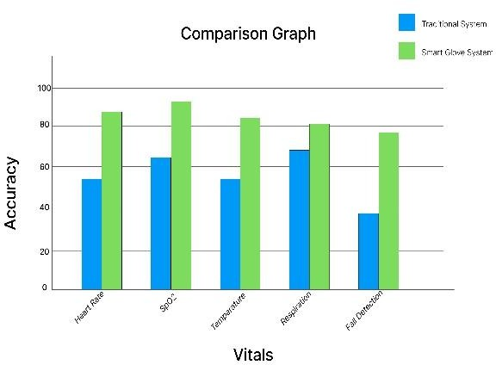
This proposed SmartLife Guardian shows better efficiency and accuracy when compared to traditional health monitoring systems. The proposed system combines multiple sensors into single wearable device and it can measure heart rate, SpO2, temperature and respiration more reliably.
Figure 3 Traditional health system vs SmartLife Guardian

The personalised baseline for each user created using TinyML is helpful in understanding the patient’s normal health patterns and monitors the change in patient’s vital accordingly. 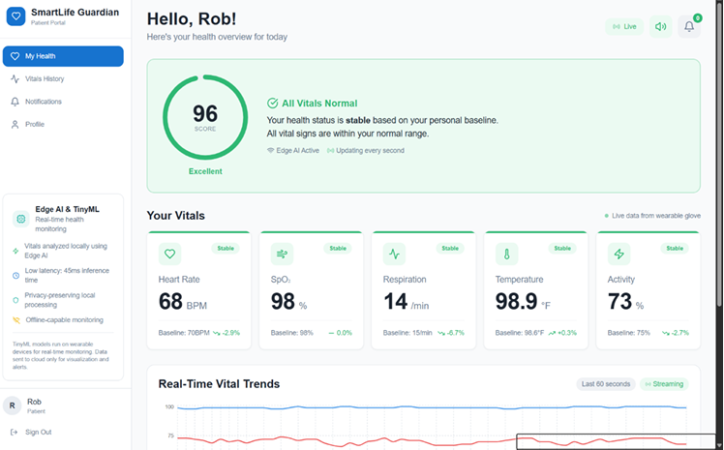
Figure 4 Patient dashboard displaying live vitals
Table 1 shows how the vital signs are monitored in both traditional and proposed system. The results show that SmartLife Guardian has achieved higher accuracy, faster detection and provides less false alarm than traditional monitoring system.
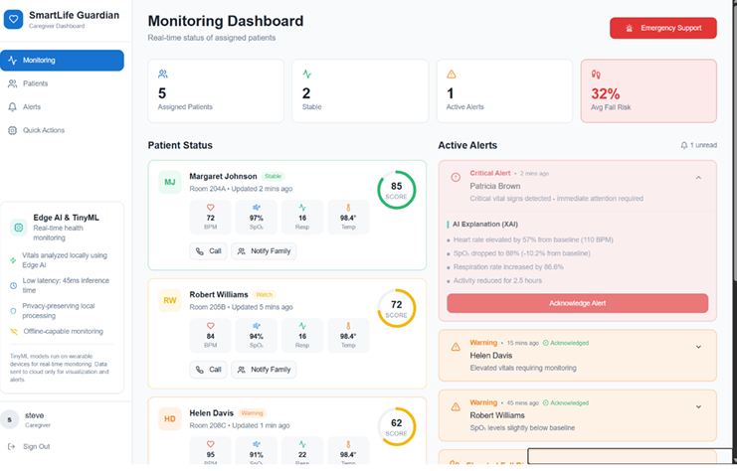
Figure 5 Caregiver dashboard displaying vitals and alerts.

FUTURE SCOPE
Future developments may include integrating advanced TinyML models such as autoencoders and LSTM networks to improve personalised health risk prediction [8][12][16]. The system can be developed to perform fall risk prediction by analysing gait patterns, hand tremors, fatigue indicators to calculate the probability of a fall before it happens [6] [13]. The system can also be improved by making the system to predict the expected vital signs of the patient in next 24-48 hours and help the caregivers to take preventive actions. Gesture bases SOS can be added that allows elder people to trigger emergency alerts using simple hand movements without requiring phone or button.

CONCLUSION
This paper presents a wearable-enabled system that utilizes multimodal sensing using Edge-AI and TinyML for real-time and personalized health monitoring of the elderly through a smart glove. Through the transfer of processing to the edge, the system has improved latency and privacy while providing predictive healthcare monitoring capabilities. Therefore, this method provides a realistic, scalable and user-centric way to enhance both safety and quality of life in elderly care.
REFERENCES
- H. M. Kaidi, M. A. M. Izhar, R. A. Dziyauddin, N. E. Shaiful, and R. Ahmad, “A comprehensive review on wireless healthcare monitoring: System components,” IEEE Access, vol. 12, pp. 35008–35032, 2024, doi:10.1109/ACCESS.2024.3349547.
- S. I. Lopes, F. Silva, P. Pinho, P. Marques, C. Abreu, J. Milheiro, B. Braga, G. Queirós, R. Almeida, and N. B. Carvalho, “CoViS: A contactless health monitoring system for the nursing home-Lessons learned from practice,” IEEE Access, vol. 12, pp. 20802–20828, 2024, doi: 10.1109/ACCESS.2024.3355060.

- F. Delmastro, F. Di Martino, and C. Dolciotti, “Cognitive training and stress detection in MCI frail older people through wearable sensors and machine learning,” IEEE Access, vol. 8, pp. 6557365590,2020,doi:10.1109/ACCESS.2020.2985301.
- H. Calderón-Gómez, L. Mendoza-Pittí, M. Vargas-Lombardo, J. M. Gómez- Pulido, J. L. Castillo-Sequera, J. Sanz- Moreno, and G. Sención, “Telemonitoring system for infectious disease prediction in elderly people based on a novel microservice architecture,” IEEE Access, vol. 8, pp. 118340–118360, 2020, doi: 10.1109/ACCESS.2020.3005638.
- M. Piñeiro, D. Araya, D. Ruete, and C. Taramasco, “Low-cost LIDAR-based monitoring system for fall detection,” IEEE Access, vol. 12, pp. 72051–72061, 2024, doi: 10.1109/ACCESS.2024.3401651.
- S. K. Sona and S. Swapna Kumar, “IoT- based system for real-time fall risk assessment and health monitoring,” Journal of Electronics and Electrical Engineering, vol. 3, no. 2, pp. 514–521, 2024, doi: 10.37256/jeee.3220245472.
- S. Abdulmalek, A. Nasir, W. A. Jabbar, M. A. M. Almuhaya, A. K. Bairagi, M. A.- M. Khan, and S.-H. Kee, “IoT-based healthcare-monitoring system towards improving quality of life: A review,” Healthcare, vol. 10, no. 10, Art. no. 1993, 2022, doi: 10.3390/healthcare10101993.

- R. Prajwal, K. V. Pallavi, N. Sumanth, N. N. Panicker, and S. R. Bharadwaj, “Edge-deployable LSTM- based fall detection on ESP32 with accelerometer–gyroscope fusion for elderly safety,” International Research Journal on Advanced Engineering Hub (IRJAEH), vol. 3, no. 9, pp. 3730–3737, Sep. 2025 doi:10.47392/IRJAEH.2025.0542.
- J. Wang, Z. Zhang, B. Li, S. Lee, and S. Sherratt, “An enhanced fall detection system for elderly person monitoring using consumer home networks,” IEEE Transactions on Consumer Electronics, vol. 60, no. 1, pp. 23–29, Feb. 2014, doi: 10.1109/TCE.2014.6780921.

- R. Dzaky and C. Dewi, “Elderly health monitoring system based on IoT,” Journal of Industrial Automation and Electrical Engineering, vol. 2, no. 2, pp. 22–28, Dec.2025.
- Lakhdari, J. Li, A. Abusafia, and A. Bouguettaya, “Privacy-aware IoT fall detection services for aging in place,” arXiv preprint, arXiv:2506.22462, Jun. 2025.

- Abdou, Q. Mascret, D. Gurve, K. Mai, B. Gosselin, and S. Krishnan, “Embedded TinyML approach for fall detection in geriatric care,” TechRxiv, Jun. 2025. doi:10.36227/techrxiv.174918043.39615584/v1.

- S. B. Khojasteh, J. R. Villar, C. Chira, V. M. González, and E. de la Cal, “Improving fall detection using an on-wrist wearable accelerometer,” Sensors, vol. 18, no. 5, Art. no. 1350, Apr. 2018, doi: 10.3390/s18051350.

- N. Thombare, S. S. Kuber, V. Dhaigude, and P. Wale, “IoT based fall detection and alert system for elderly people,” International Journal of Scientific Research in Computer Science, Engineering and Information Technology, vol. 11, no. 5, pp. 47–53, Sep.–Oct. 2025, doi: 10.32628/CSEIT24113373.

- L. Xi, C. Li, M. S. Anari, and K. Rezaee, “Integrating wearable health devices with AI and edge computing for personalized healthcare,” Journal of Cloud Computing, vol. 14, Art. no. 64, pp. 1–17, 2025, doi: 10.1186/s13677-025-00795-0.
- Patel, P., Davis, R., and Andrew, J., “Edge Computing for Real-Time Patient Monitoring and Data Processing,” unpublished manuscript, Mar. 2025.
- Abdullah, Z., Prarthana, H. D., Vhanne, S. R., Sanjay, M., and Sharath, C., “A TinyML-Based IoT Wearable Device for Real-Time Health Monitoring and Anomaly Detection,” Journal of Emerging Technologies and Innovative Research (JETIR), vol. 12, no. 11, pp. 1–6, Nov. 2025.
- Pantelopoulos and N. Bourbakis, “A Survey on Wearable Biosensor Systems for Health Monitoring,” in Proc. 30th Annual International IEEE EMBS Conference, Vancouver, BC, Canada, Aug. 20–24, 2008

