**Simulated Annealing** : used to floorplan the **slicing structure** which is represented by the **normalized polish expression**

Perturbation:M1 M2 M3

Random number generator : M1~M3

是否Rotate 90? (減少area)

**Slicing method:**

高度遞減(寬度遞增) i = 1,

寬度遞增 i = m, m--

Use stack to implement

Wheel 2V 2H

**SA: (*P*, ε, *r*, *k*)**

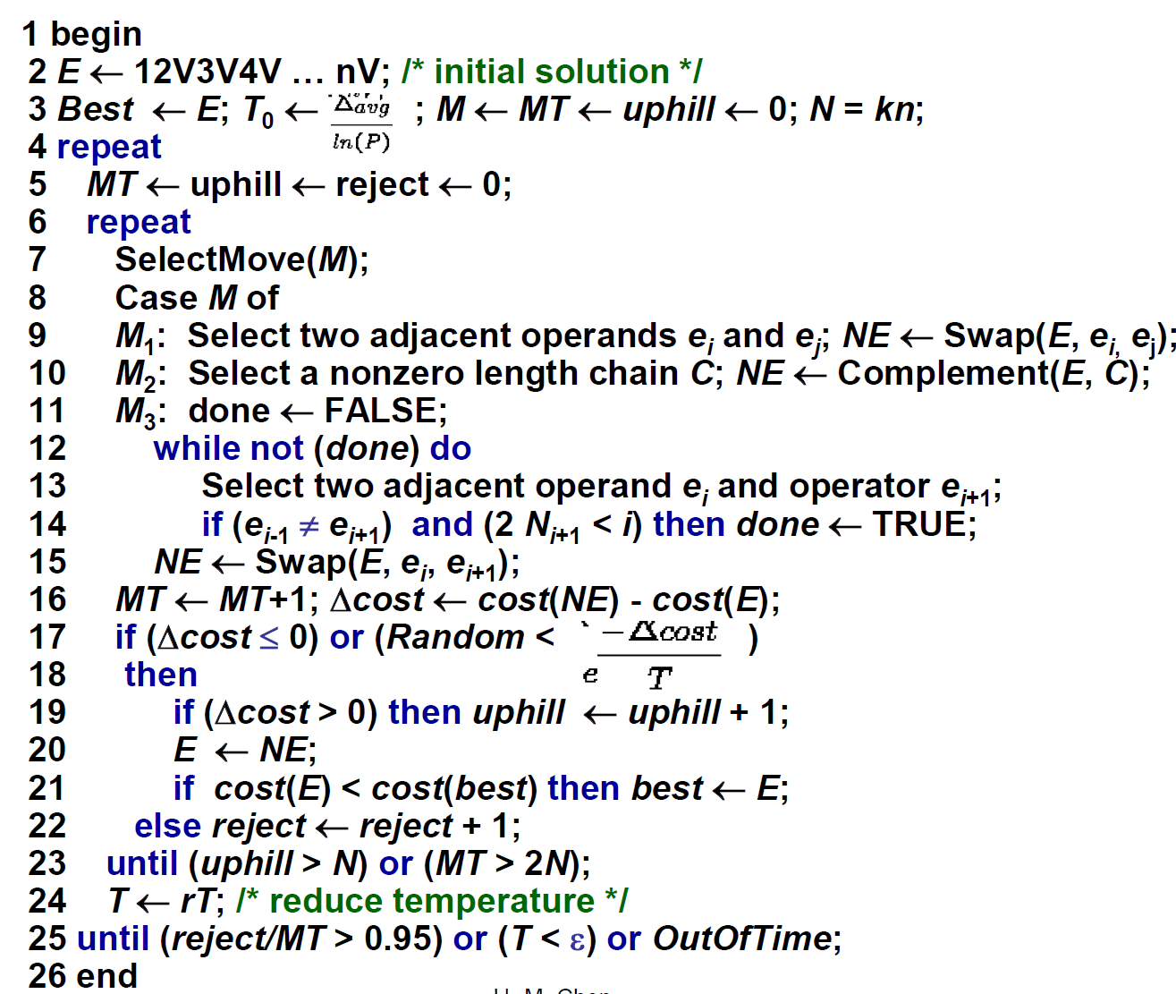

**Fast-SA:**

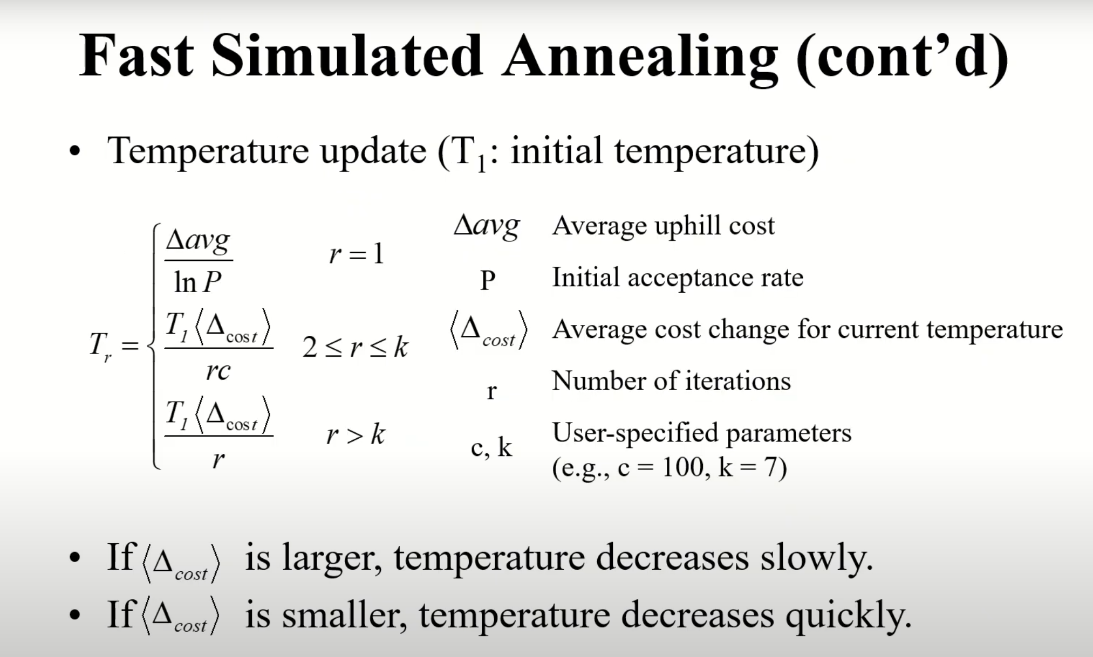

**B*:**

Op1: Rotate a module

Op2: Move a module to another place

Op3: Swap two modules

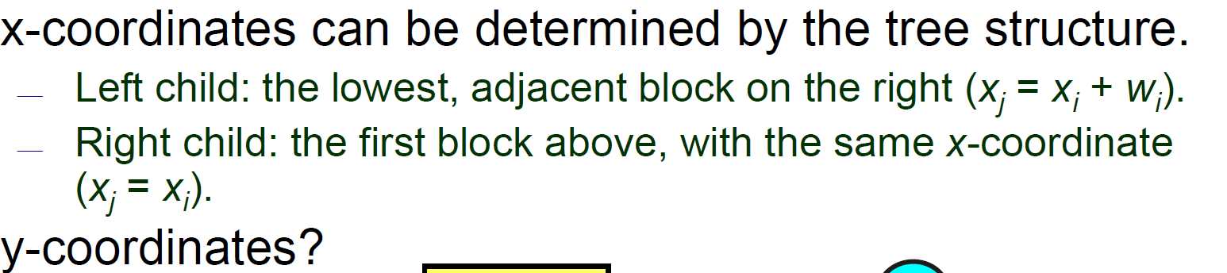

y 盡可能低

**SA using B*:**

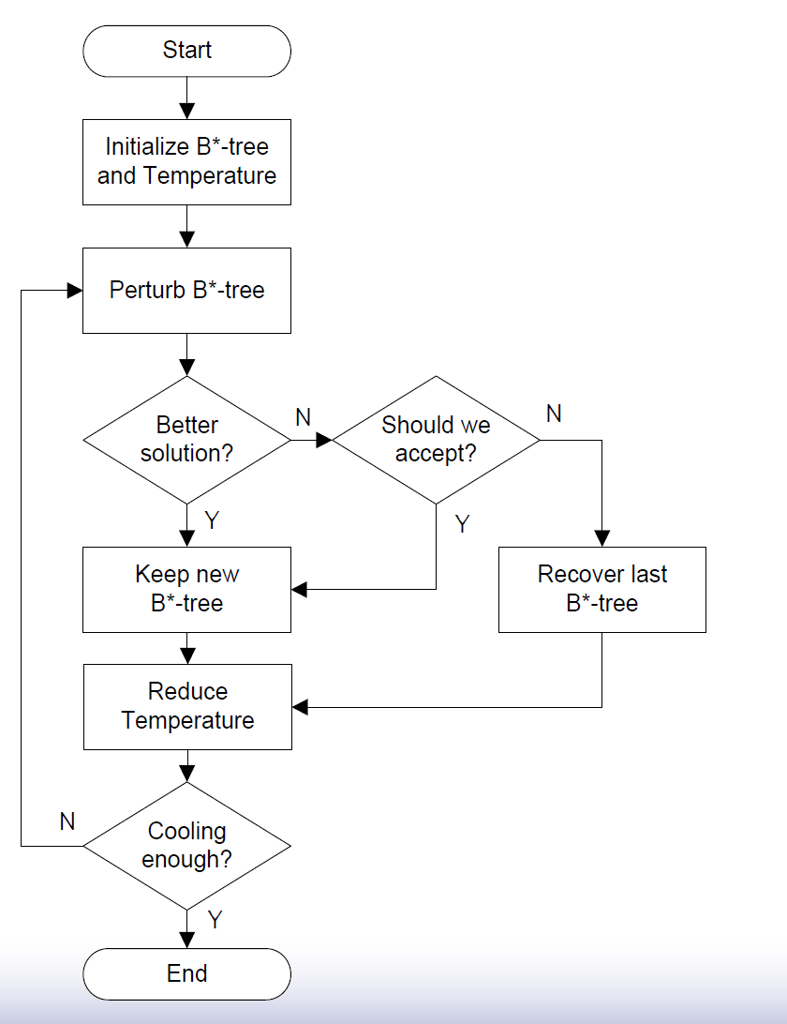

**Fixed Outline Floorplanning:**

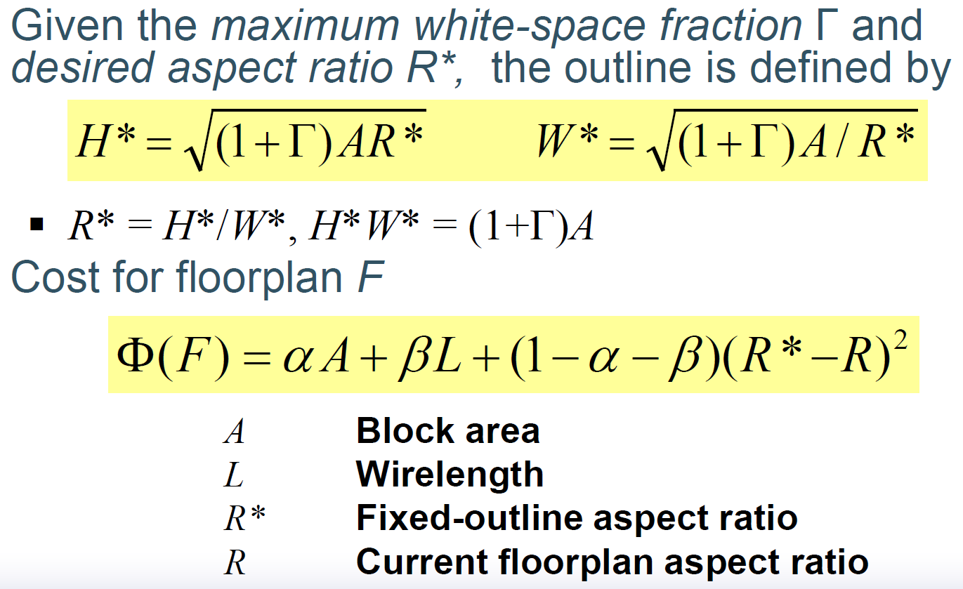

DeltaAvg 數字太小

多線程?