Cost Function:

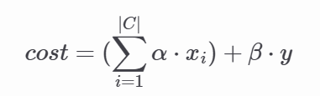

|C| = # merged FFs

Xi = # cell move of each FF inserted

y = Total dist. from init. solution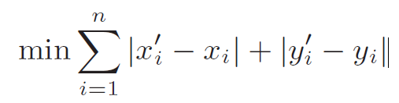

Constraints:

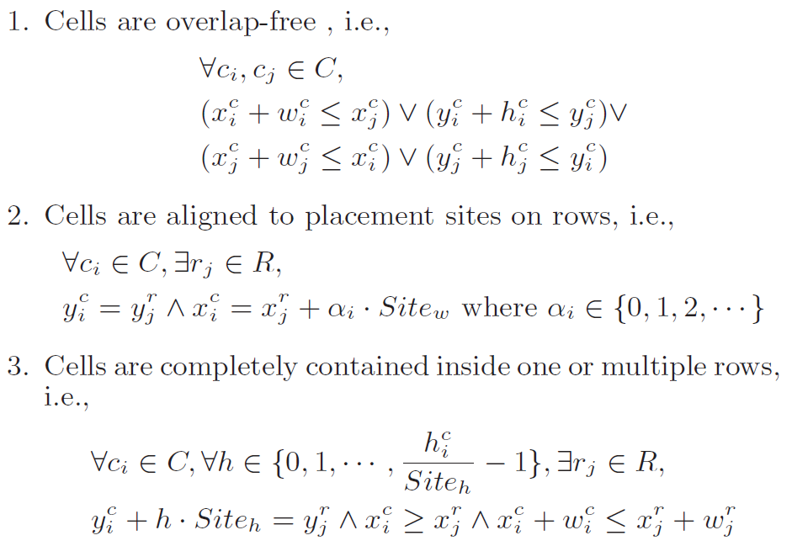

Main algorithm

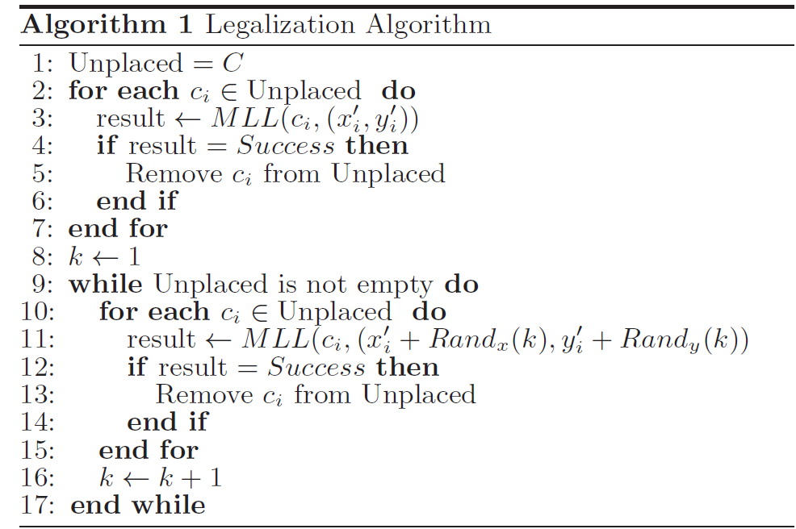

// variables

Placement Site

Unplaced cells

Local Region W 





Rx, Ry are user-defined (30, 5)

 = 

*local segment / non-local segment :

W中each row挑一個最靠近W center的segment as local segment

*local cell / non-local cell

不在W內 => non-local cell

在W內 && local segment內 => local cell 否則為 non-local cell

MLL

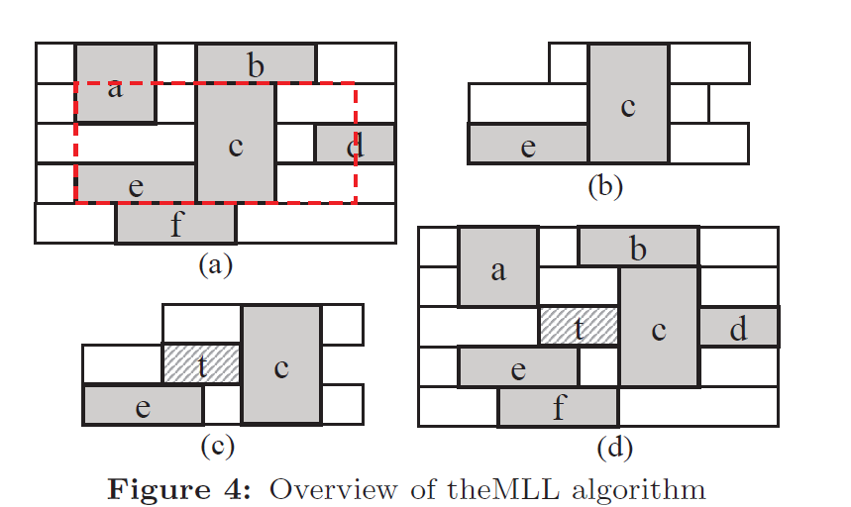

extracted local region()

gaps(r, i, j) :

rth segment, the cell on its left (or L), the cell on its right (or R)

**1.Insertion Point Enumeration**

**\*insertion interval** :

xi/xj is the leftmost/rightmost possible x-coordinate for the target cell in

the gap on segment r.

*length of interval = xj - xi

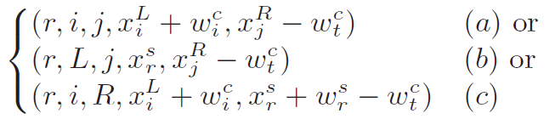

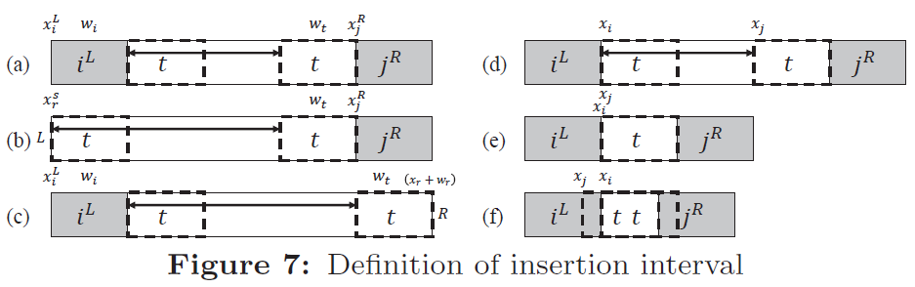

**\*find valid insertion point**

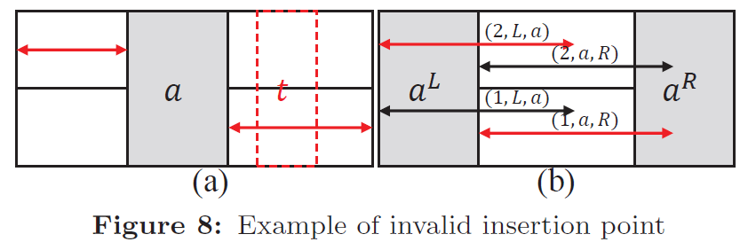

**\*** **enumerate all valid insertion points**

Sort the endpoint (xi,xj) of insertion intervals in decreasing order, then according to this sorted list, enqueue $I_{i,j}^{r}$ to $Q_{s}^{r}$

$Q_{s}^{r}$: storing intervals , (1) 1 ≤ r ≠ s ≤ hW (2) |r − s| ≤ ht – 1

enumerate all the insertion intervals  inside the local region W

|| ≤ (|Cw| + 1) * hw , |Cw| is number of local cells in region W

**2.Insertion Point Enumeration**

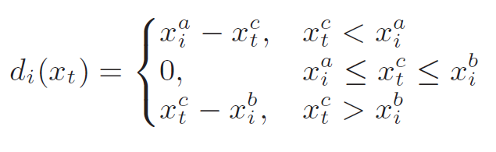

Optimal solution of target is is the median of the set of critical positions .

Total displacement is sum of di(xt) and will be used as cost of the intersection point.

Critical position of left neighbors of target cells is 

Critical position of right neighbors target cell is 

3. **Legal Placement Realization**

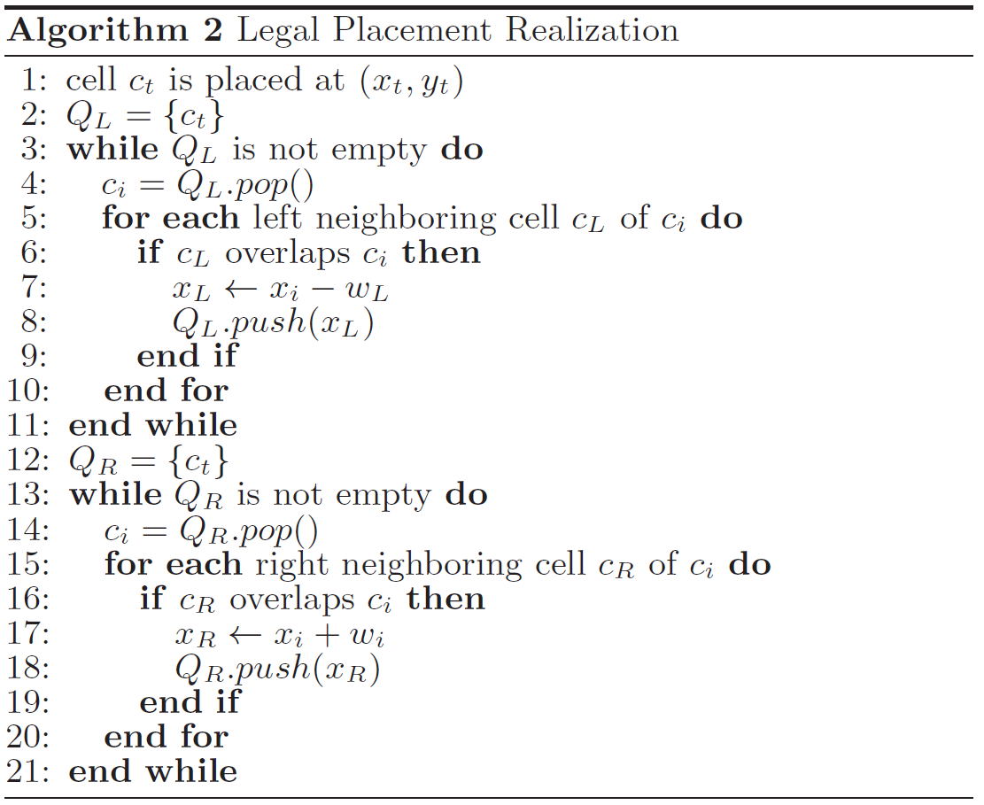

對ct 左右邊的neighbors 做legalization

Thinks:

unordered_map<string, vector<Cell *>> unplaced_FFs;

unordered_map<string, Cell *> unplaced_mFFs;

blockage

1.:每一步都要完成才下一步

2.cells放在rows或segments或both?

3.不移動placed cells 找空位就好

bool MLL(mFF, , )

{

If no overlap直接放並 return true

else

{

為每個local cells找到legal placement

}

}

blockage (fixed cells) , segment

local region W , extracted local region W’

local cell / non-local cell

local segment

1. 找到cost最小的valid insertion point

1. 找出所有possible insertion intervals

2. 找出所有valid insertion point

3. 找到cost最小的valid insertion point

(2) Given any valid insertion point,

determine the exact target cell position that can minimize the total displacement

(3) Given any valid insertion point and the exact target cell position,

we can produce a legal placement with minimal displacement