Cost Function:

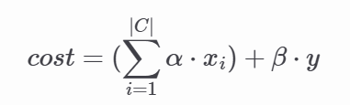

|C| = # merged FFs

Xi = # cell move of each FF inserted

y = Total dist. from init. solution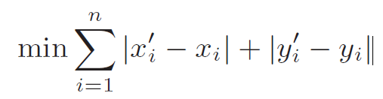

Constraints:

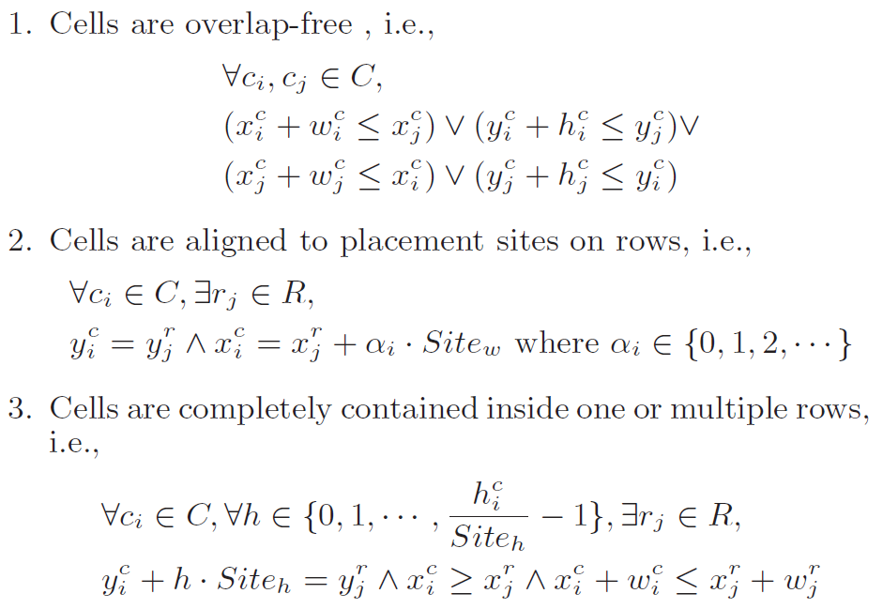

3-1不一定

Main algorithm

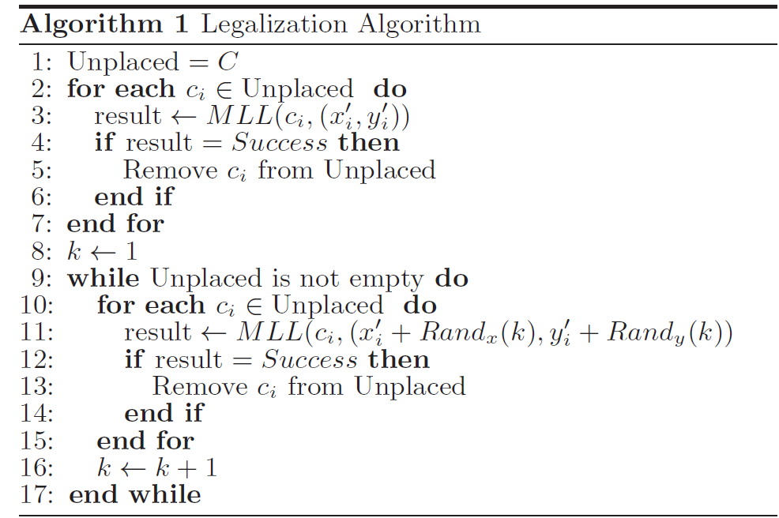

// variables

Unplaced cells

Local Region W  



Rx, Ry are user-defined (30, 5)

 = 

*local segment / non-local segment

*local cell / non-local cell

MLL

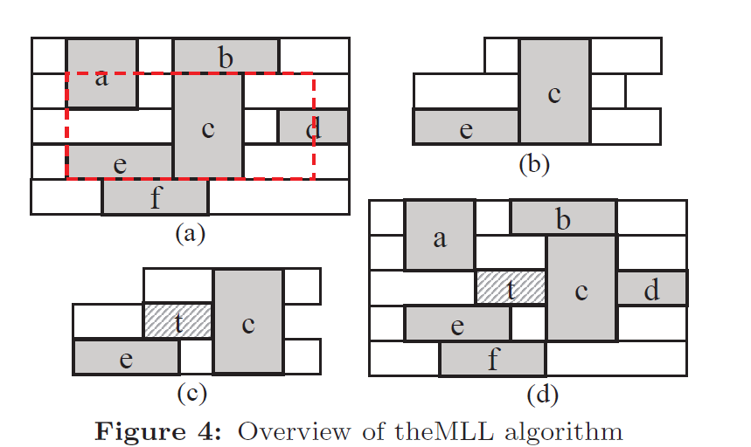

extracted local region

gaps(r, i, j) :

rth segment, the cell on its left (or L), the cell on its right (or R)

**1.Insertion Point Enumeration**

**\*insertion interval** :

xi/xj is the leftmost/rightmost possible x-coordinate for the target cell in

the gap on segment r.

*length of interval = xj - xi

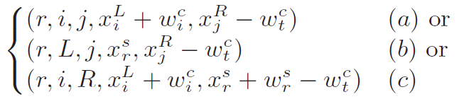

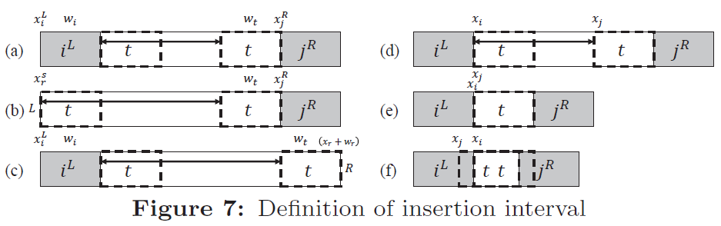

**\*find valid insertion point**

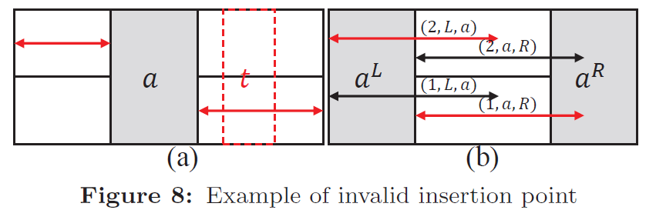

**\*** **enumerate all valid insertion points**

Sort the endpoint (xi,xj) of insertion intervals in decreasing order, then according to this sorted list, enqueue $I_{i,j}^{r}$ to $Q_{s}^{r}$

$Q_{s}^{r}$: storing intervals , (1) 1 ≤ r ≠ s ≤ hW (2) |r − s| ≤ ht – 1

enumerate all the insertion intervals  inside the local region W

|| ≤ (|Cw| + 1) * hw , |Cw| is number of local cells in region W

**2.Insertion Point Enumeration**

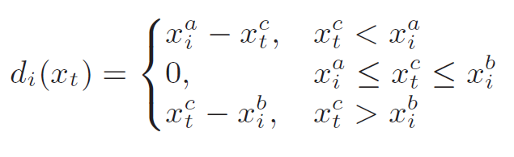

Optimal solution of target is is the median of the set of critical positions .

Total displacement is sum of di(xt) and will be used as cost of the intersection point.

Critical position of left neighbors of target cells is 

Critical position of right neighbors target cell is 

3. **Legal Placement Realization**

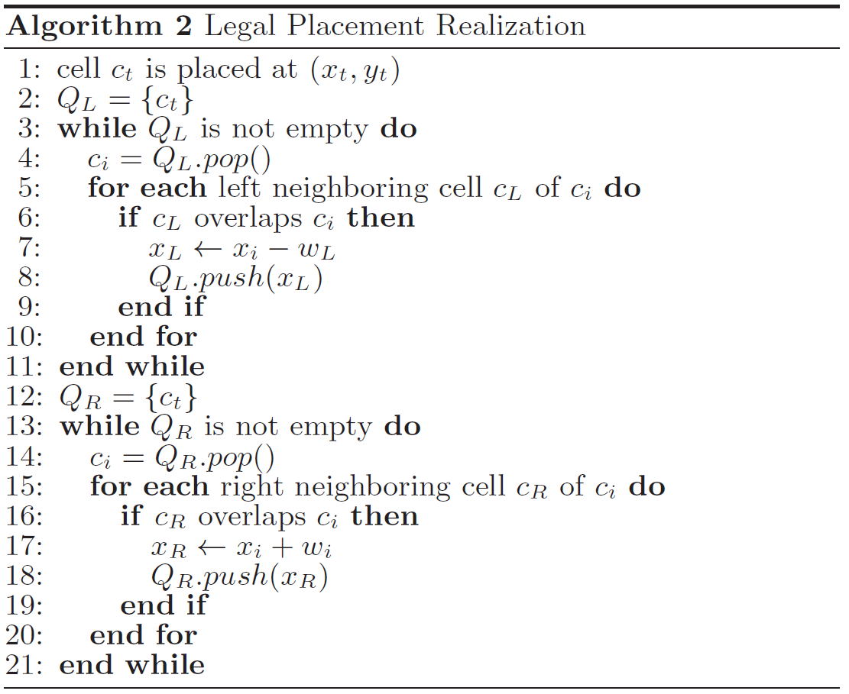

對ct 左右邊的neighbors 做legalization