This is a sample of the report, but applicable for all homework.

[113062575] [徐義鈞] This is for double verification.

Don't copy the problem statement, just write the answer.

Please write down the question number in unit of sub-question.

Please write down the sub-question number even if you don't know how to solve it.

**Part1**

(1.3.1)

=================================================================================

Layer (type:depth-idx) Output Shape Param #

=================================================================================

Net [1, 10] --

├─Sequential: 1-1 [1, 6, 28, 28] --

│ └─Conv2d: 2-1 [1, 6, 28, 28] 150

│ └─ReLU: 2-2 [1, 6, 28, 28] --

├─Sequential: 1-2 [1, 6, 14, 14] --

│ └─MaxPool2d: 2-3 [1, 6, 14, 14] --

├─Sequential: 1-3 [1, 16, 10, 10] --

│ └─Conv2d: 2-4 [1, 16, 10, 10] 2,400

│ └─ReLU: 2-5 [1, 16, 10, 10] --

├─Sequential: 1-4 [1, 16, 5, 5] --

│ └─MaxPool2d: 2-6 [1, 16, 5, 5] --

├─Sequential: 1-5 [1, 120, 1, 1] --

│ └─Conv2d: 2-7 [1, 120, 1, 1] 48,000

│ └─ReLU: 2-8 [1, 120, 1, 1] --

├─Sequential: 1-6 [1, 84] --

│ └─Linear: 2-9 [1, 84] 10,080

│ └─ReLU: 2-10 [1, 84] --

├─Sequential: 1-7 [1, 10] --

│ └─Linear: 2-11 [1, 10] 840

=================================================================================

Total params: 61,470

Trainable params: 61,470

Non-trainable params: 0

Total mult-adds (Units.MEGABYTES): 0.42

=================================================================================

Input size (MB): 0.00

Forward/backward pass size (MB): 0.05

Params size (MB): 0.25

Estimated Total Size (MB): 0.30

=================================================================================

(1.3.2)

|  |  |  |  |  |
| --- | --- | --- | --- | --- |
|  | **type** | **input activation size** | **output activation size** | **activation function** |
| conv1 | convolution | 1*32*32 | 6*28*28 | ReLU |
| maxpool2 | pooling | 6*28*28 | 6*14*14 |  |
| conv3 | convolution | 6*14*14 | 16*10*10 | ReLU |
| maxpool4 | pooling | 16*10*10 | 16*5*5 |  |
| conv5 | convolution | 16*5*5 | 120*1*1 | ReLU |
| fc6 | fully-connected | 120 | 84 | ReLU |
| output | fully-connected | 84 | 10 |  |

(1.3.3)

可以，藉由修改input / ouput activation size 即可正常運作。但是會使參數量顯著提升，影響模型效能，對於影像識別的表現可能會下降。

(2.1.1)

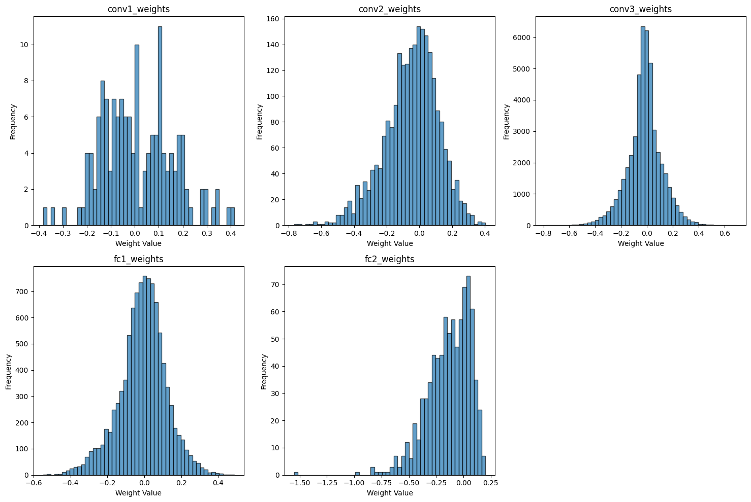

(2.2.1)

我使用symmetric quantization

根據最大最小值的絕對值大小，來決定範圍是[-max, max] 或 [min, min]

其中 sW: scaling factor值為 max(abs(max), abs(min)) / 127

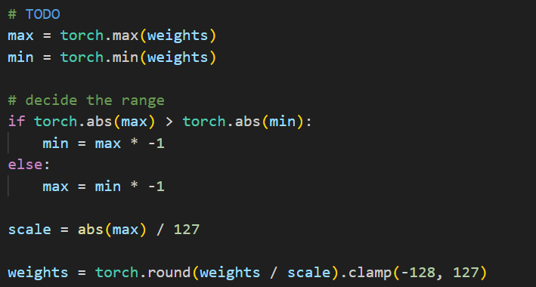

(2.2.2)





根據accuracy degradation定義應為 -0.01 %

(2.3.1)

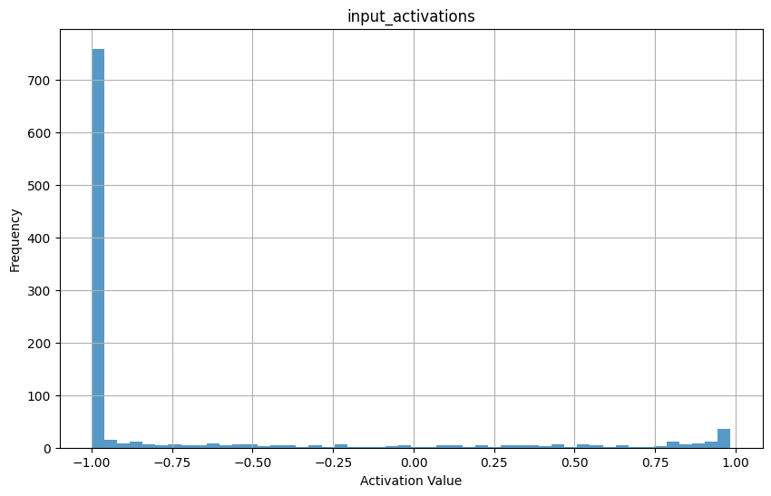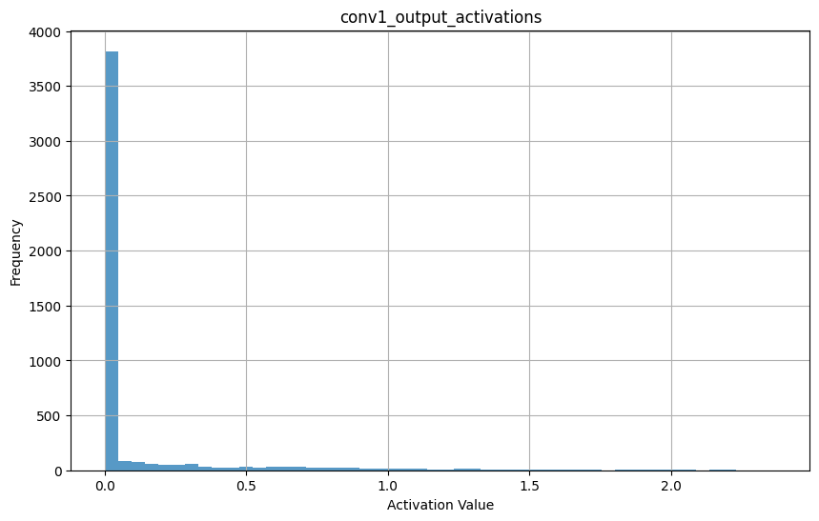

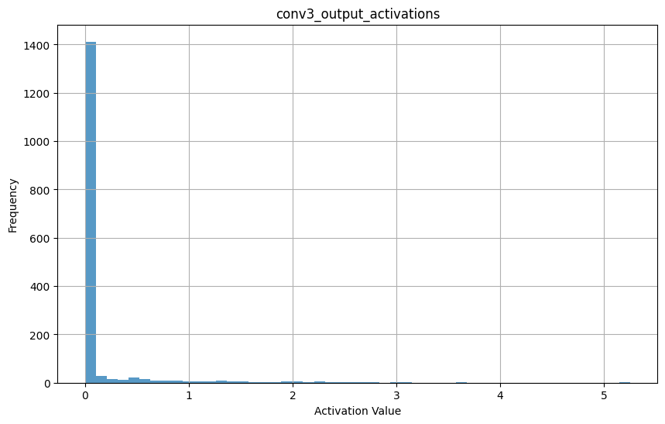

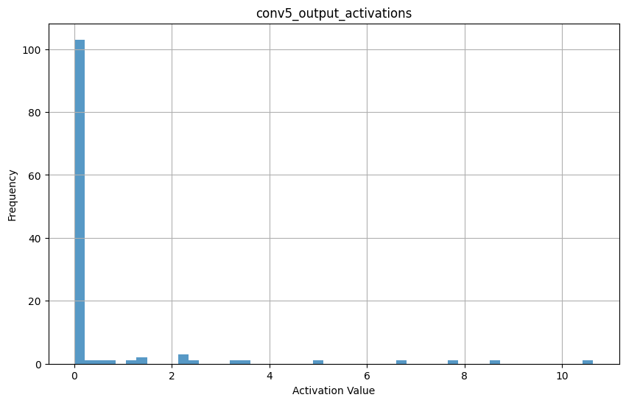

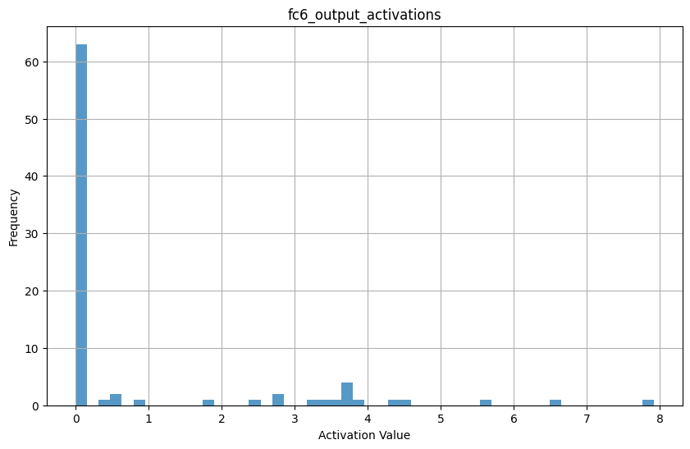

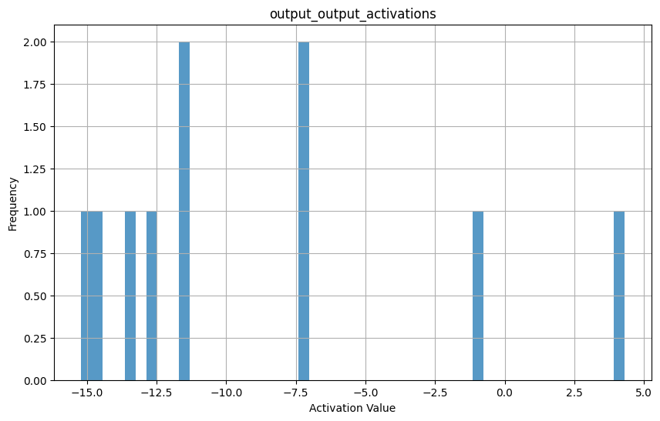

(2.4.1)

(2.4.2)

(2.4.3)

(2.4.4)

(2.4.6)

(2.4.7)

(2.5.1)

(3.1.1)

(3.1.2)

**Part2**

(2.1.1)

(2.1.2)

(2.2.1)

(2.2.2)

(3.1.1)

(3.1.2)