Here are some questions about the ICCAD 2025 contests, Problem B:

1. Can the pins of the flipflop be flipped as shown in the examples below?

Case 1: flip a single bit FF (the top one)

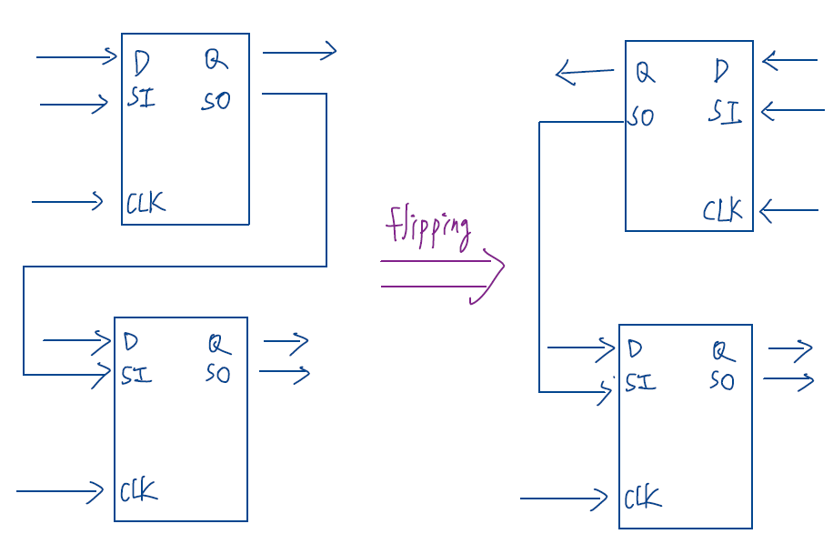

Case 2: flip all the pins of a MBFF

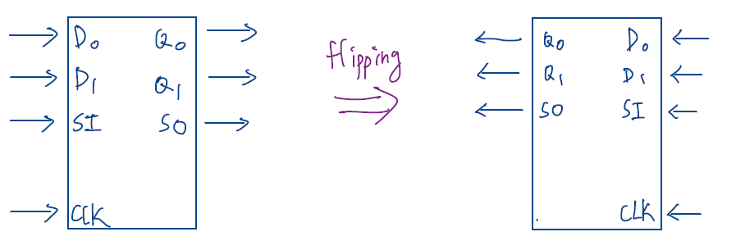

Case 3: flip the partial pins of a MBFF

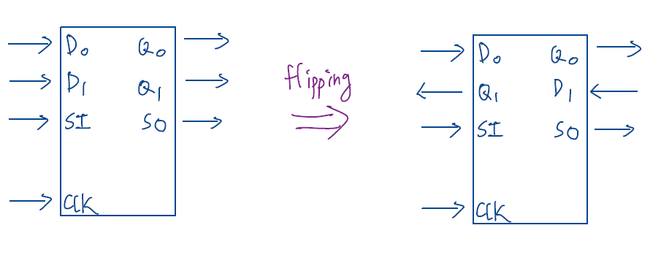

1. If the scan chain order of the single-bit flip-flops is FF1 → FF2 → FF3 → FF4, does it mean that the mapping must follow the order (i.e. the D pins of FF1,FF2,FF3,FF4 must be mapped to D0,D1,D2,D3 of the MBFF respectively) after banking? Or can the D pins of FF1, FF2, FF3, and FF4 be mapped to D3, D1, D0, and D2, for example?
2. How should the pins of single-bit FFs be mapped to a MBFF after banking in the case shown below (where the scan chain orders are FF1 → FF2 and FF3 → FF4)? If I map the SI of FF1 to the SI of the MBFF, does that imply the SO of FF4 should be mapped to the SO of the MBFF? Do I understand correctly?

