|  |  |  |
| --- | --- | --- |
|  | Public | Private |
| Mode1 | 0.78066 | 0.78800 |
| Model2 | 0.71333 | 0.70933 |
| Model3 | 0.80933 | 0.80466 |
| Model4 | 0.83333 | 0.83000 |
| Ensemble1 | 0.81533 | 0.80800 |
| Ensemble2 | 0.83400 | 0.84200 |
| Ensemble3 | 0.84400 | 0.83933 |
| Ensemble4 | 0.84733 | 0.84600 |
| Ensemble5 | 0.85466 | 0.85666 |

|  |  |  |
| --- | --- | --- |
|  | Public | Private |
| Fold_1_res18 | 0.75266 | 0.74533 |
| Fold_2_res18 | 0.78600 | 0.80066 |
| Fold_3_res18 | 0.79333 | 0.79800 |
| Fold_4_res18 | 0.76866 | 0.74600 |
| Fold_1_cnn | 0.82333 | 0.82000 |
| Fold_2_cnn | 0.77333 | 0.77933 |
| Fold_3_cnn | 0.77400 | 0.75533 |
| Fold_4_cnn | 0.81466 | 0.80666 |

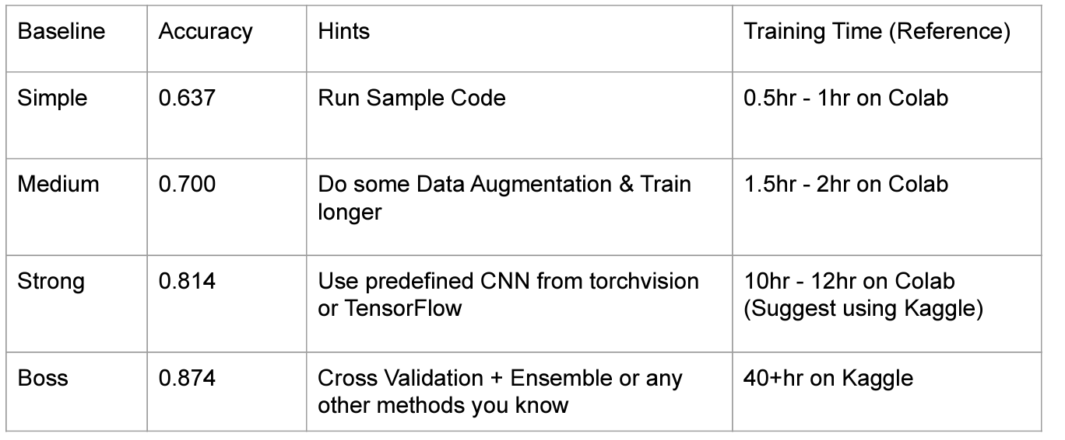

model1: CNN

model2: ResNet18 (建議用50，但要train很久)

mode3: ResNet18 + Cross-Validation (fold = 4)

model4: CNN + Cross-Validation (fold = 4)

Ensemble1.csv：將mode1, mode2, mode3作ensemble by voting

Ensemble2.csv：將mode1, mode3, mode4作ensemble by voting

Ensemble3.csv：將mode1, mode4中的fold_1_cnn, fold_4_cnn(表現最好的兩個)作ensemble by fusion (averaged output from all models)

Ensemble4.csv：將model4, Ensemble2, Ensemble3作ensemble by voting

(用Ensembel1不如預期所以用model4替代得到)

Ensemble5.csv：將mode1~4, Ensemble1~4, fold_1~4_res18, fold_1~4_cnn 作 ensemble by voting

調整更好的learning rate, weight decay, scheduler週期或是增加k-fold值應該可以過boss line，一次train要好幾十小時，懶得測試了