**For the submission of your work:**

- Create a folder named **RollNo_Name_DBI202_PaperNo**, e.g. se01245_LongNT_DBI202_02. **Do not** create any subfolder in this folder. All file created will be located in the above folder.

- For each question, you are required to write a database script. Create a file with the name corresponding to the index of the question. For example, **for question 1**, we will create a file named **Q1.sql** and create a file **Q2.sql for question 2**. So, if you do 10 questions, your folder must contain **only** 10 files Q1.sql, Q2.sql, Q3.sql, Q4.sql, Q5.sql, Q6.sql, Q7.sql, Q8.sql, Q9.sql and Q10.sql.

- Do not use any commands having the database name such as create database, alter database, use [database name], *etc*.

- Your response must contain only necessary commands for answering the question. Do not include any other command. For example, if you are required to create a trigger/procedure, then your response should contain only commands for creating the corresponding trigger/procedure; all commands for testing the created trigger/procedure are forbidden.

- On completion, import your work by browsing to the above folder.

**- Note that:**

**+ You could use only SQL Server, SQL Server Management Studio, and paper or offline document in your computer.**

**+ If any of the previous requirements is not respected, your mark will be 0.**

**From the 2nd question**, you should use the database provided in the .sql file which has the following database diagram. Please, run the provided script to create tables and insert data into your database.

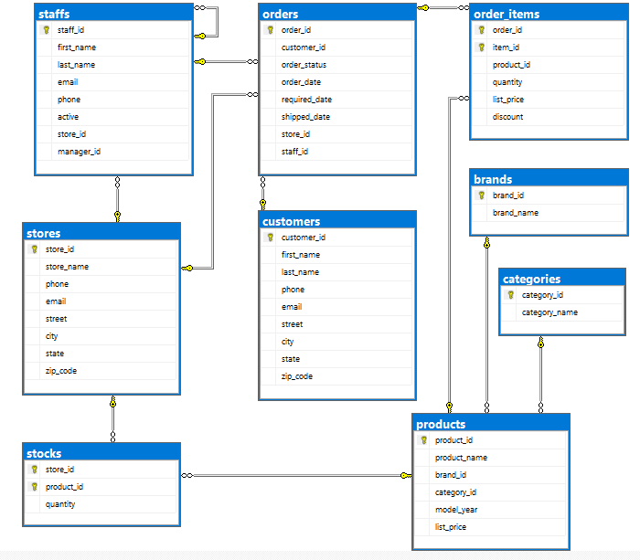

**Question 1:**

Create one database and then write SQL statements to create, in this database, all tables derived from the ERD given in the following picture with appropriate attributes, primary keys and foreign keys.

NOTE that when creating the SQL commands as request, you MUST keep the name of tables, relationship, attributes and data type of attributes as SAME as given in the given ERD.

Attributes with underline belong to the Primary Key of each entity.

Attributes which reference to the primary key of another table must have the same name as the attributes in the primary key of the referencing table.

When submitting the responses for this question, submit only SQL statements for creating tables with corresponding keys and foreign keys. Do not use “create database”, “Alter database”, “use database_name” or any statements using database’s name in your submission.

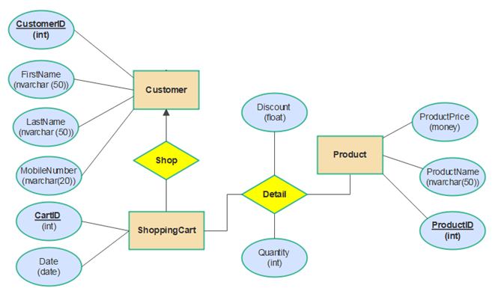

Picture 1.1

**Question 2:**

Write a query to find product_id, product_name, list_price of all products whose list_prices are 199.99.



Picture 2.1

**Question 3:**

Find customer_id, first_name, last_name, email, order_date of all customers who ordered after 2018-08-08.

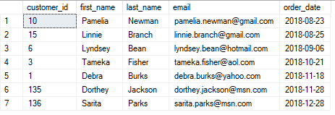

Picture 3.1

**Question 4:**

Write a query that finds brand_id, brand_name and the number of products of each brand. The result only shows the brands with number of products at least 10 and order by number of products.

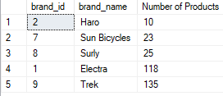

Picture 4.1

**Question 5:**

Write a query to find customer_id, first_name, last_name, street, city of all customers who ordered the products with the lowest price. The result is ordered by customer_id.

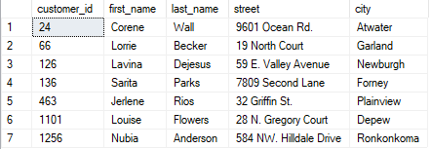

Picture 5.1

**Question 6:**

Find product_id, product_name, list_price, category_name of all products in category Mountain Bikes with brand Haro or Ritchey.

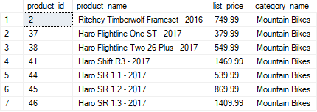

Picture 6.1

**Question 7:**

Write a query to find customer_id, first_name, last_name, product_name, order_date of all customers who ordered products with product_name containing Queen and order_date in 4.2018.



Picture 7.1

**Question 8:**

Create a function named **funcate** to count the number of products in a category.

For example, when the statement below (to find the number of products in a category 6) is executed, the result should be as in the Picture 8.1:

declare @cateid int = 6;

declare @number int = (select dbo.funcate (@cateid))

select @cateid as CategoryID, @number as NumberOfProducts;



Picture 8.1

**Question 9:**

Delete all staffs who are not managers and do not make any orders.

**Question 10:**

Create a trigger named **trigins_2** for the insert statement on the staffs table so that when we insert a new record the system will lowercase the email attribute.

For example, when the following statement is executed, the result will be as shown in the Picture 10.1:

INSERT INTO staffs(first_name, last_name, email, phone, active, store_id, manager_id)

VALUES('Anna','Nguyen','ANna.NGUYen@hotmail.com',NULL,1,3,1);

SELECT first_name, last_name, email, phone, active, store_id, manager_id

FROM staffs

WHERE staff_id = (SELECT max(staff_id) FROM staffs)



Picture 10.1