**For the submission of your work:**

- Create a folder named **RollNo_Name_DBI202_PaperNo**, e.g. CE12345_LongNT_DBI202_01. **Do not** create any subfolder in this folder. All file created will be located in the above folder.

- For each question, you are required to write a database script. Create a file with the name corresponding to the index of the question. For example, **for question 1**, we will create a file named **Q1.sql** and create a file **Q2.sql for question 2**. So, if you do 10 questions, your folder must contain **only** 10 files Q1.sql, Q2.sql, Q3.sql, Q4.sql, Q5.sql, Q6.sql, Q7.sql, Q8.sql, Q9.sql and Q10.sql.

- Do not use any commands having the database name such as create database, alter database, use [database name], *etc*.

- Your response must contain only necessary commands for answering the question. Do not include any other command. For example, if you are required to create a trigger/procedure, then your response should contain only commands for creating the corresponding trigger/procedure; all commands for testing the created trigger/procedure are forbidden.

- On completion, import your work by browsing to the above folder.

**- Note that:**

**+ You could use only SQL Server, SQL Server Management Studio, and paper or offline document in your computer.**

**+ If any of the previous requirements is not respected, your mark will be 0.**

**From the 2nd question**, you should use the database provided in the .sql file which has the following database diagram. Please, run the provided script to create tables and insert data into your database.



**Question 1:**

Create one database and then write SQL statements to create, in this database, all tables derived from the ERD given in the following picture with appropriate attributes, primary keys and foreign keys.

NOTE that when creating the SQL commands as request, you MUST keep the name of tables, relationship, attributes and data type of attributes as SAME as given in the given ERD.

Attributes with underline belong to the Primary Key of each entity.

Attributes which reference to the primary key of another table must have the same name as the attributes in the primary key of the referencing table.

When submitting the responses for this question, submit only SQL statements for creating tables with corresponding keys and foreign keys. Do not use “create database”, “Alter database”, “use database_name” or any statements using database’s name in your submission.

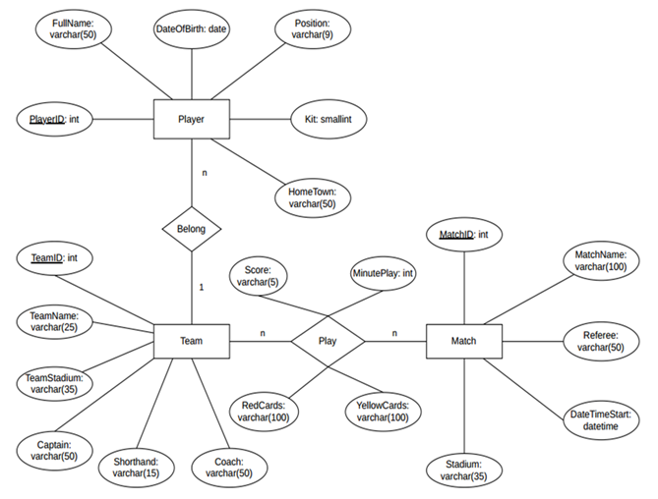

Picture 1.1

**Question 2:**

Write a query to show ProductID, Name, Price, SellStartDate of all products whose Name is Chainring.



Picture 2.1

**Question 3:**

Write a query to find SubcategoryID, Category, Name of all ProductSubcategory corresponding to the SubcategoryID between 15 and 20. Display the results in descending order of SubcategoryID as follows:

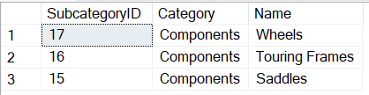

Picture 3.1

**Question 4:**

Write a query to display ProductID, Name, Cost, Quantity of all products having the Cost is 98.77 and Quantity smaller than 300:

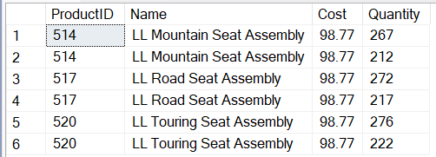

Picture 4.1

**Question 5:**

Write a query to find all ProductID, ProductName, Price, and SellStartDate of all products corresponding to having a Price smaller than 5 and a SellStartDate of 2003. Display the results in ascending order of Price as follows:

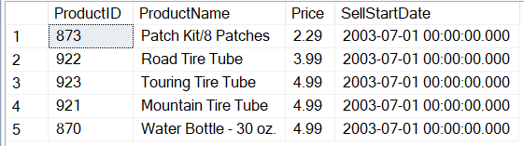

Picture 5.1

**Question 6:**

Write a query to find the ProductID, ProductName, and Price_of_Product of all products with the highest Price_of_Product. The result is ordered by ProductID.

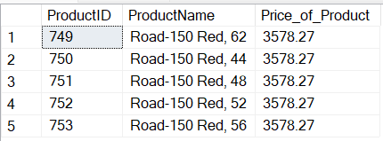

Picture 6.1

**Question 7:**

Write a query to find the ProductID, ModelID, ProductName, and Sum_Quantity of all products with Sum_Quantity greater than 920 and ModelID is not NULL. Display the results in ascending order by Sum_Quantity as follows:

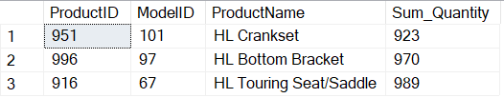

Picture 7.1

**Question 8:**

Create a procedure named **CountPro** to count the number of products in a color.

For example, when the statement below (to find the number of products in a color “Red”) is executed, the result should be as in the Picture 8.1:

DECLARE @x NVARCHAR(15) = 'Red';

DECLARE @number INT;

EXEC CountPro @x, @number OUTPUT;

SELECT @x AS Color, @number AS NumberOfProduct;



Picture 8.1

**Question 9:**

Create a trigger named **TriggerIns** that ensures the Price of a product is at most 100000.00. When a new product is inserted to the Product table with the Price greater than 100000.00, then its Price is set to 100000.00.

For example, when the following statement is executed, the result will be as shown in the Picture 9.1:

INSERT INTO Product(ProductID, Name, Color, Cost, Price, SubcategoryID, ModelID, SellStartDate, SellEndDate)

VALUES(1002, 'Captain-2024', 'Red', 95000.00, 105000.00, Null, Null, '2024-6-19', Null);

SELECT ProductID, Name, Price

FROM Product

WHERE ProductID = (SELECT MAX(ProductID) FROM Product)



Picture 9.1

**Question 10:**

Delete all Product of ProductCostHistory whose first character of the product name is ‘B’ (does not distinguish between uppercase and lowercase letters).