**For the submission of your work:**

- Create a folder named **RollNo_Name_DBI202_PaperNo**, e.g. CE12345_LongNT_DBI202_02. **Do not** create any subfolder in this folder. All file created will be located in the above folder.

- For each question, you are required to write a database script. Create a file with the name corresponding to the index of the question. For example, **for question 1**, we will create a file named **Q1.sql** and create a file **Q2.sql for question 2**. So, if you do 10 questions, your folder must contain **only** 10 files Q1.sql, Q2.sql, Q3.sql, Q4.sql, Q5.sql, Q6.sql, Q7.sql, Q8.sql, Q9.sql and Q10.sql.

- Do not use any commands having the database name such as create database, alter database, use [database name], *etc*.

- Your response must contain only necessary commands for answering the question. Do not include any other command. For example, if you are required to create a trigger/procedure, then your response should contain only commands for creating the corresponding trigger/procedure; all commands for testing the created trigger/procedure are forbidden.

- On completion, import your work by browsing to the above folder.

**- Note that:**

**+ You could use only SQL Server, SQL Server Management Studio, and paper or offline document in your computer.**

**+ If any of the previous requirements is not respected, your mark will be 0.**

**From the 2nd question**, you should use the database provided in the .sql file which has the following database diagram. Please, run the provided script to create tables and insert data into your database.



**Question 1:**

Create one database and then write SQL statements to create, in this database, all tables derived from the ERD given in the following picture with appropriate attributes, primary keys and foreign keys.

NOTE that when creating the SQL commands as request, you MUST keep the name of tables, relationship, attributes and data type of attributes as SAME as given in the given ERD.

Attributes with underline belong to the Primary Key of each entity.

Attributes which reference to the primary key of another table must have the same name as the attributes in the primary key of the referencing table.

When submitting the responses for this question, submit only SQL statements for creating tables with corresponding keys and foreign keys. Do not use “create database”, “Alter database”, “use database_name” or any statements using database’s name in your submission.

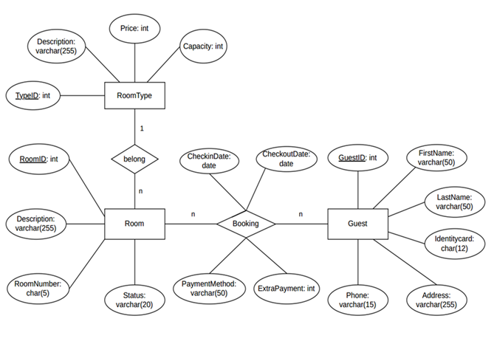

Picture 1.1

**Question 2:**

Write a query to show ProductID, Name, Price, SellStartDate of all products whose Price is 1431.50.

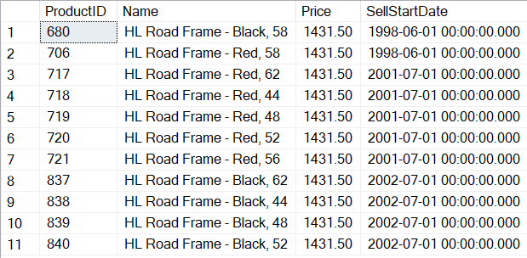

Picture 2.1

**Question 3:**

Write a query to find the first 3 SubcategoryID in the table ProductSubcategory

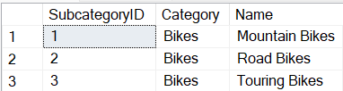

Picture 3.1

**Question 4:**

Write a query to display ProductID, Name, Price, Color, Quantity of all products having the Color is Silver and Quantity between 330 and 350 as follows:

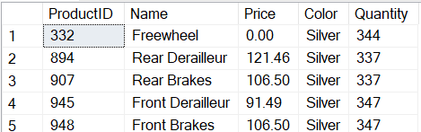

Picture 4.1

**Question 5:**

Write a query to find all ProductID, ProductName, Cost, and SellEndDate of all products corresponding to Cost smaller than 15 and a SellEndDate of 2003. Display the results in ascending order of Cost as follows:

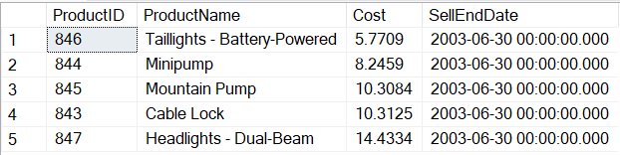

Picture 5.1

**Question 6:**

Write a query to find the ProductID, ProductName, and Cost_of_Product of all products with the highest Cost_of_Product. The result is ordered by ProductID.

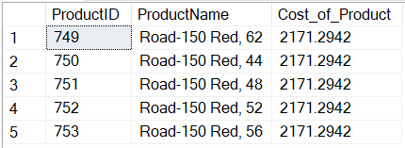

Picture 6.1

**Question 7:**

Write a query to find the first 4 ProductID, ProductName, CategoryName, and Sum_Quantity of all products with Sum_Quantity smaller than 350.

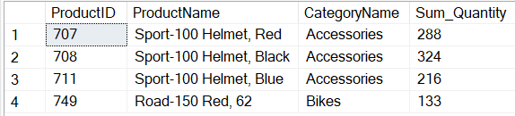

Picture 7.1

**Question 8:**

Create a procedure named **ProCount** to count the number of inventory products in a LocationID.

For example, when the statement below (to find the number of inventory products in a LocationID is 1) is executed, the result should be as in the Picture 8.1:

DECLARE @x SMALLINT = 1;

DECLARE @number INT;

EXEC ProCount @x, @number OUTPUT;

SELECT @x AS LocationID, @number AS NumberOfInventoryProduct;



Picture 8.1

**Question 9:**

Create a trigger named **InsTrigger** that ensures the Cost of a product is at least 10000.00, when a new product is inserted to the Product table with the Cost less than 10000.00, then its Cost is set to 10000.00.

For example, when the following statement is executed, the result will be as shown in the Picture 9.1:

INSERT INTO Product(ProductID, Name, Color, Cost, Price, SubcategoryID, ModelID, SellStartDate, SellEndDate)

VALUES(1001, 'Marvel-2024', 'Blue', 9000.00, 9500.00, Null, Null, '2024-6-19', Null);

SELECT ProductID, Name, Cost

FROM Product

WHERE ProductID = (SELECT MAX(ProductID) FROM Product)



Picture 9.1

**Question 10:**

Delete all Product of ProductPriceHistory whose second character of the product name is ‘a’ (does not distinguish between uppercase and lowercase letters).