**PLAB 10 – Build Small Network**

**Topology**

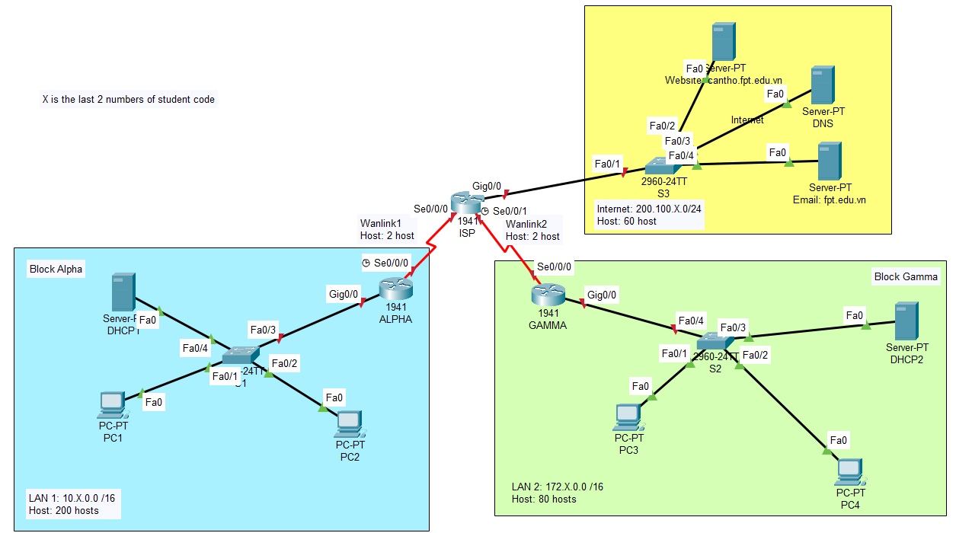

**Network information:**

Intranet:

* Block Alpha uses IP belonging to network **10.1.0.0/16**
* LAN1: 200 hosts
* Block Gamma uses IP belonging to network **172.1.0.0/16**
* LAN2: 80 hosts

Internet: **200.100.1.0/24**

* Server: 60 hosts
* Wanlink1: 2 hosts
* Wanlink2: 2 hosts

**X** is the last 2 numbers of Group 01

1. **IP Subnetting**
   1. **VLSM**

|  |  |  |  |  |  |  |
| --- | --- | --- | --- | --- | --- | --- |
| **Network name** | **Network address** | **Broadcast address** | **Subnetmask** | **The First IP Address** | **The Last IP address** | **Number of usable IP** |
| LAN1 | 10.1.0.0/24 | 10.1.0.255 | 255.255.255.0 | 10.1.0.1 | 10.1.0.254 | 254 |
| LAN2 | 172.1.0.0 | 172.1.0.127 | 255.255.255.128 | 172.1.0.1 | 172.1.0.126 | 80 |
| Server | 200.100.1.0 | 200.100.1.63 | 255.255.255.192 | 200.100.1.1 | 200.100.1.62 | 60 |
| Wanlink1 | 200.100.1.64 | 200.100.1.67 | 255.255.255.252 | 200.100.1.65 | 200.100.1.66 | 2 |
| Wanlink2 | 200.100.1.68 | 200.100.1.71 | 255.255.255.252 | 200.100.1.69 | 200.100.1.70 | 2 |
|  |  |  |  |  |  |  |
|  |  |  |  |  |  |  |
|  |  |  |  |  |  |  |

* 1. **IP Address Planning**

|  |  |  |  |
| --- | --- | --- | --- |
| **Device** | **IP Address** | **Subnetmask** | **Prefix** |
| PC1 | DHCP | 255.255.255.0 | /24 |
| PC2 | DHCP | 255.255.255.0 | /24 |
| DCHP1 | 10.1.0.2 | 255.255.255.0 | /24 |
| S1-Vlan1 | 10.1.0.3 | 255.255.255.0 | /24 |
| ALPHA-G0/0 | 10.1.0.1 | 255.255.255.0 | /24 |
| ALPHA-S0/0/0 | 200.100.1.65 | 255.255.255.252 | /30 |
| PC3 | DHCP | 255.255.255.128 | /25 |
| PC4 | DHCP | 255.255.255.128 | /25 |
| DHCP2 | 172.1.0.2 | 255.255.255.128 | /25 |
| S2-Vlan1 | 172.1.0.1 | 255.255.255.128 | /25 |
| GAMMA-G0/0 | 172.1.0.1 | 255.255.255.128 | /25 |
| GAMMA-S0/0/0 | 200.100.1.69 | 255.255.255.252 | /30 |
| S3-Vlan1 | 200.100.1.2 | 255.255.255.192 | /26 |
| ISP-G0/0 | 200.100.1.1 | 255.255.255.192 | /26 |
| ISP-S0/0/0 | 200.100.1.65 | 255.255.255.252 | /30 |
| ISP-S0/0/1 | 200.100.1.70 | 255.255.255.252 | /30 |
| Website Server | 200.100.1.2 | 255.255.255.192 | /26 |
| Mail Server | 200.100.1.4 | 255.255.255.192 | /26 |
| DNS Server | 200.100.1.3 | 255.255.255.192 | /26 |
|  |  |  |  |
|  |  |  |  |
|  |  |  |  |
|  |  |  |  |
|  |  |  |  |
|  |  |  |  |
|  |  |  |  |

1. **Device configuration:**

* Configure addresses for devices according to IP Planning
* Configure basic parameters for Router and Switch:
  + Name in Topology
  + Banner: #**NameDevice + *configure by* + YourName**#
  + Console pass: fptcon
  + Telnet pass: fptvti
  + Enable secret: fptsecret
  + Enable level 7 password encryption
* Routing Configure. Command for 3 router:

ALPHA(config)#ip route 0.0.0.0 0.0.0.0 s0/0/0

GAMMA(config)#ip route 0.0.0.0 0.0.0.0 s0/0/0

ISP(config)#ip route 10.0.0.0 255.0.0.0 s0/0/0

ISP(config)#ip route 172.0.0.0 255.0.0.0 s0/0/1

* Configure services on corresponding Servers: DHCP, DNS, Web, Email.
* All PC with Dynamic IPv4.
* Email:
  + PC1: Configure user email ***nva@fpt.edu.vn***
  + PC3: Configure user email ***tvb@fpt.edu.vn***
  + Check sending emails to each other.
* Save configuration of Router and Switch devices.

1. **Verify**

* Check connections with the Ping command
* Tested DHCP, DNS, Web, Email services successfully.