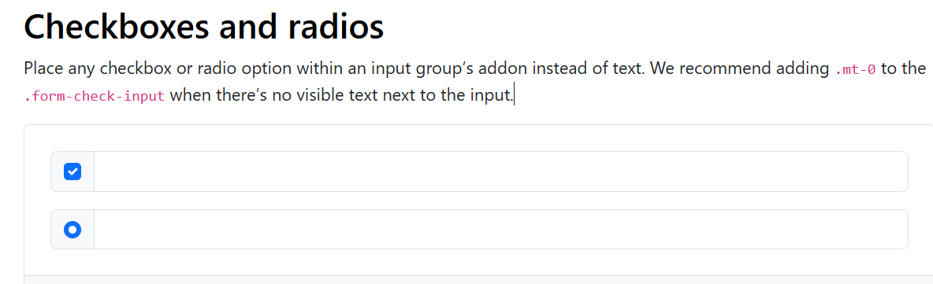

<div class="input-group mb-3">

<div class="input-group-text">

<input class="form-check-input mt-0" type="checkbox" value="" aria-label="Checkbox for following text input">

</div>

<input type="text" class="form-control" aria-label="Text input with checkbox">

</div>

<div class="input-group">

<div class="input-group-text">

<input class="form-check-input mt-0" type="radio" value="" aria-label="Radio button for following text input">

</div>

<input type="text" class="form-control" aria-label="Text input with radio button">

</div>

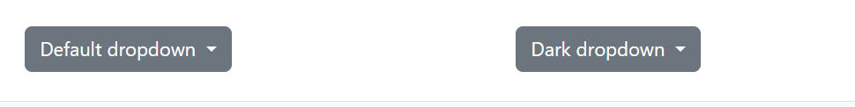

<div class="dropdown" data-bs-theme="light">

<button class="btn btn-secondary dropdown-toggle" type="button" id="dropdownMenuButtonLight" data-bs-toggle="dropdown" aria-expanded="false">

Default dropdown

</button>

<ul class="dropdown-menu" aria-labelledby="dropdownMenuButtonLight">

<li><a class="dropdown-item active" href="#">Action</a></li>

<li><a class="dropdown-item" href="#">Action</a></li>

<li><a class="dropdown-item" href="#">Another action</a></li>

<li><a class="dropdown-item" href="#">Something else here</a></li>

<li><hr class="dropdown-divider"></li>

<li><a class="dropdown-item" href="#">Separated link</a></li>

</ul>

</div>

<div class="dropdown" data-bs-theme="dark">

<button class="btn btn-secondary dropdown-toggle" type="button" id="dropdownMenuButtonDark" data-bs-toggle="dropdown" aria-expanded="false">

Dark dropdown

</button>

<ul class="dropdown-menu" aria-labelledby="dropdownMenuButtonDark">

<li><a class="dropdown-item active" href="#">Action</a></li>

<li><a class="dropdown-item" href="#">Action</a></li>

<li><a class="dropdown-item" href="#">Another action</a></li>

<li><a class="dropdown-item" href="#">Something else here</a></li>

<li><hr class="dropdown-divider"></li>

<li><a class="dropdown-item" href="#">Separated link</a></li>

</ul>

</div>

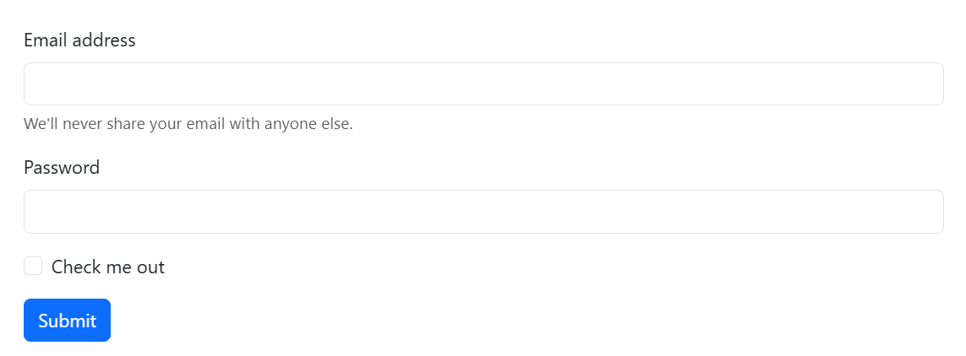

<form>

<div class="mb-3">

<label for="exampleInputEmail1" class="form-label">Email address</label>

<input type="email" class="form-control" id="exampleInputEmail1" aria-describedby="emailHelp">

<div id="emailHelp" class="form-text">We'll never share your email with anyone else.</div>

</div>

<div class="mb-3">

<label for="exampleInputPassword1" class="form-label">Password</label>

<input type="password" class="form-control" id="exampleInputPassword1">

</div>

<div class="mb-3 form-check">

<input type="checkbox" class="form-check-input" id="exampleCheck1">

<label class="form-check-label" for="exampleCheck1">Check me out</label>

</div>

<button type="submit" class="btn btn-primary">Submit</button>

</form>

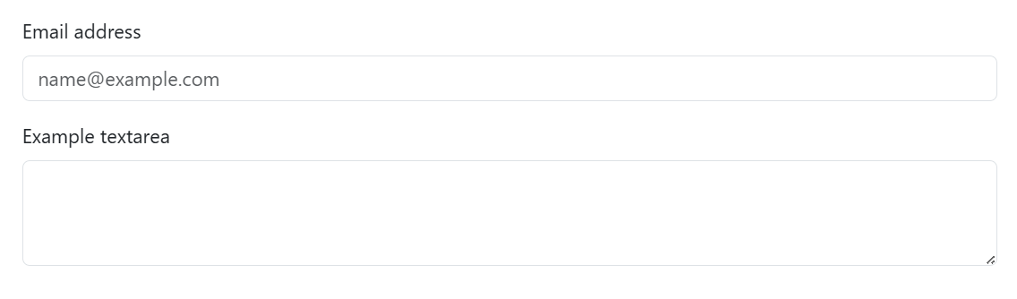

<div class="mb-3">

<label for="exampleFormControlInput1" class="form-label">Email address</label>

<input type="email" class="form-control" id="exampleFormControlInput1" placeholder="name@example.com">

</div>

<div class="mb-3">

<label for="exampleFormControlTextarea1" class="form-label">Example textarea</label>

<textarea class="form-control" id="exampleFormControlTextarea1" rows="3"></textarea>

</div>

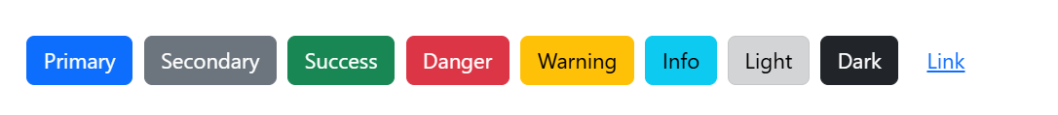

<button type="button" class="btn btn-primary">Primary</button>

<button type="button" class="btn btn-secondary">Secondary</button>

<button type="button" class="btn btn-success">Success</button>

<button type="button" class="btn btn-danger">Danger</button>

<button type="button" class="btn btn-warning">Warning</button>

<button type="button" class="btn btn-info">Info</button>

<button type="button" class="btn btn-light">Light</button>

<button type="button" class="btn btn-dark">Dark</button>

<button type="button" class="btn btn-link">Link</button>

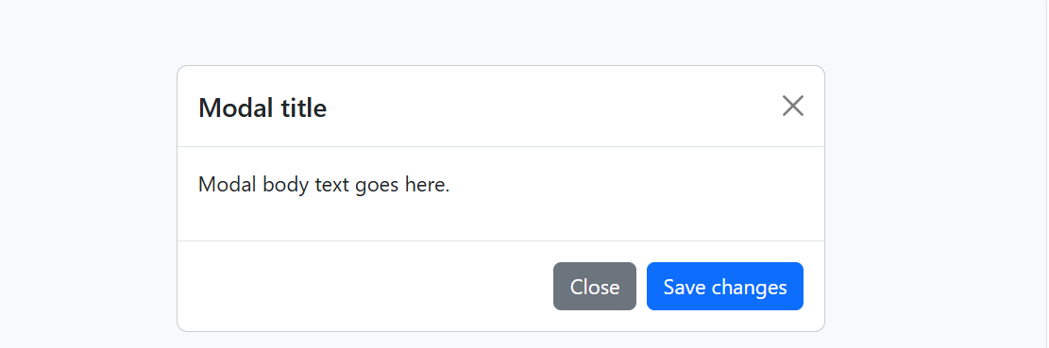

<!-- Button trigger modal -->

<button type="button" class="btn btn-primary" data-bs-toggle="modal" data-bs-target="#exampleModal">

Launch demo modal

</button>

<!-- Modal -->

<div class="modal fade" id="exampleModal" tabindex="-1" aria-labelledby="exampleModalLabel" aria-hidden="true">

<div class="modal-dialog">

<div class="modal-content">

<div class="modal-header">

<h1 class="modal-title fs-5" id="exampleModalLabel">Modal title</h1>

<button type="button" class="btn-close" data-bs-dismiss="modal" aria-label="Close"></button>

</div>

<div class="modal-body">

...

</div>

<div class="modal-footer">

<button type="button" class="btn btn-secondary" data-bs-dismiss="modal">Close</button>

<button type="button" class="btn btn-primary">Save changes</button>

</div>

</div>

</div>

</div>

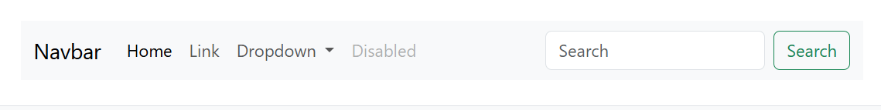

<nav class="navbar navbar-expand-lg bg-body-tertiary">

<div class="container-fluid">

<a class="navbar-brand" href="#">Navbar</a>

<button class="navbar-toggler" type="button" data-bs-toggle="collapse" data-bs-target="#navbarSupportedContent" aria-controls="navbarSupportedContent" aria-expanded="false" aria-label="Toggle navigation">

<span class="navbar-toggler-icon"></span>

</button>

<div class="collapse navbar-collapse" id="navbarSupportedContent">

<ul class="navbar-nav me-auto mb-2 mb-lg-0">

<li class="nav-item">

<a class="nav-link active" aria-current="page" href="#">Home</a>

</li>

<li class="nav-item">

<a class="nav-link" href="#">Link</a>

</li>

<li class="nav-item dropdown">

<a class="nav-link dropdown-toggle" href="#" role="button" data-bs-toggle="dropdown" aria-expanded="false">

Dropdown

</a>

<ul class="dropdown-menu">

<li><a class="dropdown-item" href="#">Action</a></li>

<li><a class="dropdown-item" href="#">Another action</a></li>

<li><hr class="dropdown-divider"></li>

<li><a class="dropdown-item" href="#">Something else here</a></li>

</ul>

</li>

<li class="nav-item">

<a class="nav-link disabled" aria-disabled="true">Disabled</a>

</li>

</ul>

<form class="d-flex" role="search">

<input class="form-control me-2" type="search" placeholder="Search" aria-label="Search">

<button class="btn btn-outline-success" type="submit">Search</button>

</form>

</div>

</div>

</nav>

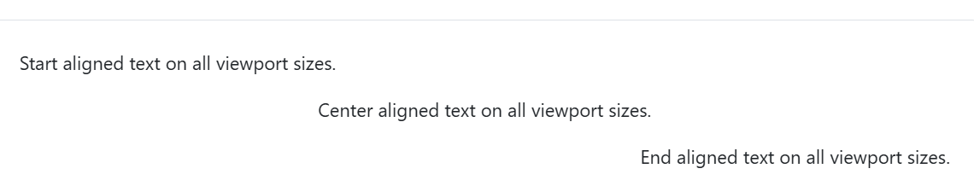

<p class="text-start">Start aligned text on all viewport sizes.</p>

<p class="text-center">Center aligned text on all viewport sizes.</p>

<p class="text-end">End aligned text on all viewport sizes.</p>