Experience

CHLOE JEESUN PARK

PORTFOLIO: https://cjsp2dm.wixsite.com/mysite

2D Visual artist-Freelance
Synergy Design Development -Walnut Creek CA synergydesdev.com
Sep 2019 - Present
* Architectural drawing and rendering for residential house project
* closet design for residential and commercial building
* The key elements of existing models with the practical understanding of the Product Management and Problem-solving, and the tools and mechanisms to be used at each phases
*Schematic Design, Design Development, Construction Documents, Bidding, and Construction Administration, according to the American Institute of Architects (AIA).

Researcher
Apr 2009 to June 2019
Ramona Interior company www.RamonaTan.com
- Research materials and objects for residential and commercial interior

Automotive Designer
Andus Group - CX Tech R&D in Ontario, CA Aug 2007 - Apr 2009 · 1 yr 9 mos
- Created exterior and interior design for confidential projects: Van, Sedan, SUV
- Designed company logo graphics
- Used Alias for 3D modeling working with Clay.
- Created clay models (1/4 scale, full scale)

3D Alias Modeler
Nissan Design America (Contracted by the company Underground) in San diego, CA Jun 2007 - Aug 2007 · 3 mos
- Created 3D Alias Modeling for concept project : US Van interior

Automotive Graphic Designer
Center BMW of Center automotive group in Greater Los Angeles Area CA Apr 2004 - Jul 2006 · 2 yrs 4 mos
- Created automotive graphics, interior design for TJ concept model
- Designed branding for automotive graphics division: Mongographics
- Designed icons, decals, interior and exterior graphics
- Projects: BMW X3, Chrysler TJ, new JK concept model

Industrial Design Instructor
ANDLAB in Los Angeles, CA
Aug 2004 - Jan 2010 · 5 yrs 6 mos
- Taught transportation design, product design

Art Teacher
Song's institute in Los Angeles CA May 2002 - Oct 2003 · 1 yr 6 mos
- Taught drawing, painting, designing for kids age group 3-10yrs old

Freelancing works
Substitute Teacher for Randall Smack's Transportation Design class in ACCD 2003-2008 Product Design for Brook stone: a digital clock(concept design, Alias modeling, Photoshop, VRED, Illustrator,
Final mock up) 2003
Car design drawing for GM Commercial back ground 2003 Golf luggage design for a golf product start-up company 2004
Architectural drawing for residential house back yard project 2018 Interior design assistant 2018

Skills
Microsoft
Adobe
2D and 3D


Word


Excel


Power Point
Illustrator



Photoshop

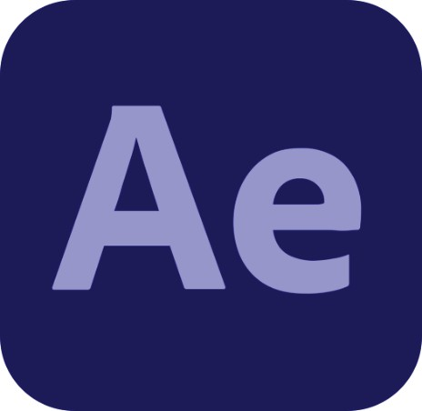
After Effect
Autodesk 3D Alias



Clay Modeling

Design process

Reserch
Conceptualization Sketching Rendering

Education

Language

English
BS, Transportation design
in Art Center College of Design in Pasadena CA (1999-2002)

Korean

