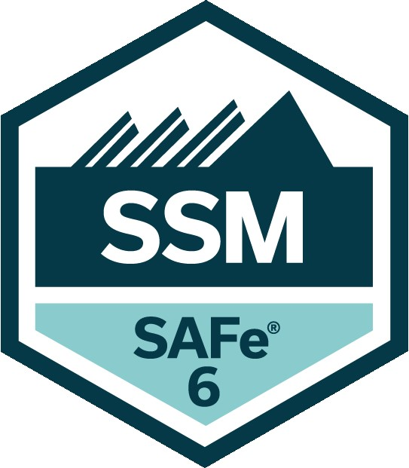
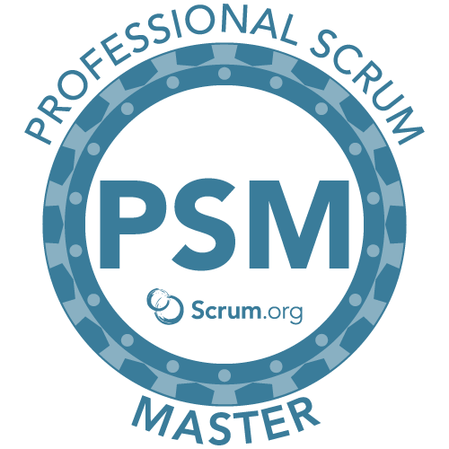
Sudhakar Selka
SAFe 6 | PSM | CSTE | 6σ(GB)
516-710-1325
sudhakarselka@yahoo.com
___________________________________________________________________________________________

Certified SAFe Scrum Master, Project Manager and Agile Coach with 20 years of experience in delivering strategic projects with diverse set of skill sets and experience in Agile Coaching & Transformation, Continuous Process Improvement, Six Sigma, SAFe, Innovation, Design Thinking, Machine Learning and Quality Assurance.

- Skilled in coaching and mentoring project teams and assisting them in Agile transformation.
- Adoption to enterprise-wide Scaled Agile (SAFe) framework and work actively with Release train in coordinating PI Planning and ART sync sessions.
- Adept knowledge of SDLC process and implementation of Agile methodology across project teams.
- Proficient in facilitating Scrum ceremonies including Release planning, Sprint planning, Daily scrum, Backlog grooming, Sprint review and Sprint retrospective.
- Administrative experience in Jira and Confluence with configuring workflow as per project requirements.
- Ensure that team adheres to Definition of Done and Definition of Ready by removing all impediments.
- Ensure that user stories follow INVEST principles and maximize the value of Product backlog.
- Proficient in scheduling project tasks, allocating resources, identifying gaps and risk factors, performing risk analysis, and embedding risk driven testing in the test process.
- Experienced with lean Six Sigma five-step framework to create a common problem-solving approach.
- Extensive experience in establishing test process, test planning, test case development and execution.
- Expertise in manual and automation testing with involvement in all test phases.
- Efficient in adopting industry best-practices like Continuous Integration utilizing DevOps model, TDD, BDD, ATDD, XP and Pair Programming.
- Excellent communication and interpersonal skills and the ability to quickly adapt across various domains.
- Delivered high traffic web-based projects with a responsive design for regular web, mobile and tablet platforms across Pharma, Healthcare, Retail, Finance and Manufacturing industries.

Education and Certifications

Education: Bachelor’s degree in Computer Science and Engineering, Bangalore University, India - 2000

- Certified SAFe6 Scrum Master (PSM) from Scaled Agile, Inc.
- Certified SAFe Agilist from Scaled Agile, Inc.
- Certified Scrum Master (PSM) from Scrum.org
- Six Sigma Green Belt Certification from Delphi Automotive Systems Inc.
- CSTE (Certified Software Tester) certification from Quality Assurance Institute (QAI)
- Data Governance, Machine Learning certifications from LinkedIn

Technology Skills

Project Management | Jira, Confluence, Rally, Product Board, Windows, MS Office
Database Tools | SQL Server, Oracle, Amazon - Dynamo DB, S3, RedShift, Toad
Development Tools | Java, .NET, Amazon AWS (Lambda, REACT.js, Node.js), VB Script, Pager Duty
Testing Tools | HP UFT (QTP), HP QC/ALM, X-Ray, Microsoft TFS

Professional Experience

Genmab Pharma (Remote) Jan 2023 – Current
Healthcare Senior Scrum Master

RDAP Data Lake: RDAP is a new Data Lake being built in-house to store clinical data from multiple source systems. It is a part of research and data analytics platform. The Data Lake is built on Amazon AWS platform.

- Administered JIRA/Confluence and ensured business and IT teams adhered to the JIRA standards.
- Coached teams on SAFe Agile Principles and assisted the teams in adopting SAFe across their projects.
- Configured JIRA as per project requirements and aided teams on workflow usage.
- Reported consistently on Agile metrics such as Sprint Velocity, Burn-down and Burn-up charts.
- Participated in Scrum of Scrums meeting and synced up weekly with the Release Train Engineer (RTE).
- Followed Kanban framework and reduced cycle time by 20% by breaking down user stories and following best industry practices, test automation and effective resource utilization.

Merck & Co., Inc. (Remote) Jan 2021 – Dec 2023
Senior Scrum Master

MRL Data Hub (PRIMA): PRIMA is a Data Lake that collates and harmonizes clinical regulatory data from heterogenous IT systems and serves downstream consumers like REDS, VRIM, MANTIS and others for regulatory submissions, reporting, and analytics. The solution is implemented on Amazon AWS and developed in-house.

- Established JIRA and Confluence standards, and ensured that they were implemented across the team.
- Provided coaching and mentoring to the DHI Program Data Hub and Data Governance teams.
- Established team capacity, managed JIRA board, provided tool support and reported metrics along with Impediments faced with resource downtimes to the senior management.
- Facilitated scrum ceremonies – Sprint planning, Daily Scrum, Sprint review, and Sprint retrospective ensured that they were kept within the timebox.
- Worked with Product Owner/Product Manager on Product Roadmap and timelines, prioritized product backlog and ensured Backlog and User stories aligned with DEEP and INVEST criteria.
- Assisted the team in Identifying and highlighting Risks, Impediments and ensured Risk mitigation and Impediment resolution that interfered in fulfillment of the Sprint Goal.
- Interacted with wide range of stakeholders including Business technology partners, Consumers and Data Governance teams to deliver Minimum Viable Product (MVP) across releases.
- Initiated effective Risk and Issue management across sprints and releases
- Received award from Program Manager for successful project execution and release in 2021.

Johnson & Johnson (Remote/ Raritan, NJ) Aug 2016 – Dec 2020
Healthcare Scrum Master and Agile Coach

Worked on multiple clinical GxP and Non GxP projects and ensured SDLC Agile process adherence from the project initiation to completion.

Discovery Data Sciences: Worked with the data scientists in the Amazon AWS environment and assisted them in effectively utilizing Kanban framework to build, train and deploy machine learning data models.

JJAR (Johnson and Johnson Activity Repository): JJAR application captures data on clinical studies, market research and patient support programs for the pharma and the consumer sectors. It also replaces legacy systems being used in the pharma and the consumer sector. This is a data migration project.

IoT EMS (Environmental Management System): EMS collects real time temperature and humidity data via Raspberry Pi (Sensor) and pushes it to the backend - Azure IoT Hub (Cloud platform) via a gateway server. The cloud stores the data and generates reports via a Web UI.

- Worked on the Continuous Release model which reduced release time from 6+ months to 4-5 weeks.
- Increased Team Velocity by 20% within a span of 6 months by reducing technical debt, changing design, and implementing test automation.
- Managed JIRA board, provided technical tool support and reported on JIRA metrics along with Impediments and resource downtimes to the senior management.
- Facilitated all scrum events and worked with Product Owner and Business analyst to groom the user stories, prioritize them, and ensure that the user story format aligned with J&J SDLC format.
- Utilized Data Sampling Plan during Data migration and guided the QA team on testing data samples.
- Hosted SoS (Scrum of Scrums) meeting to ensure that cross team collaboration on planning, dependencies, addressing points of integration and identifying conflicts.
- Ensured traceability matrix and stage gate completion in all development phases.
- Received appreciation for implementing Lean Agile and Zero CAPA from SQA for JJAR Audit.

Tiffany & Co. (Retail), Parsippany, NJ Jan 2015 – Jul 2016
Scrum Master and Business Analyst

Tiffany Vendor Exchange (TVE): TVE is a .NET web-based application that hosts supplier data. It feeds downstream systems - JD Edwards, MIPS (Mainframe), Warehouse management system (Manhattan WMS) and Enterprise data warehouse. The three workflows are – Vendor Onboarding, Maintenance, and discontinuation.

- Facilitated scrum ceremonies and ensured that all stakeholders adopted Agile mindset.
- Improved Lead time and burn down chart by breaking down user stories and completing on time.
- Ensured that the Definition of Ready and Done were met across all sprints.
- Assisted the Product owner in backlog refinement and ensured the backlog adhered to the DEEP criteria.
- Managed Risk logs and ensured risks were highlighted and mitigated across releases and sprints.
- Resolved conflicts between development and design team by adopting GxP documentation practices.
- The sprint velocity increased within a span of 6 months by following best industry practices like next gen tools, test automation, reducing team meetings and following best documentation practices.

Aetna Insurance, New York, NY Jun 2011 – Dec 2014
Healthcare Scrum Master and Project Manager

Active Care Team: Active Care Team is a care management solution customized for Banner Health and Hunterdon. It is used primarily by Physicians and Providers for disease management and clinical analysis.

- Coached the teams on Agile methodology and ensured efficient migration from Waterfall to Agile.
- Collaborated with Product Owners to identify, evaluate, and manage changes to project scope.
- Enforced Kanban principles as a scrum master with WIP limits that resulted in reduction of Cycle time.
- Enabled improvement in team delivery commitments and capacity planning for sprints by identifying & tracking hidden tasks that increased customer satisfaction.
- Worked with project stakeholders to define and manage objectives, assumptions, schedule, scope, requirements, risks, issues, changes, metrics, change control, and successful deployment.
- Managed onsite resources, monitored test execution, and provided status updates to the management.

Morgan Stanley, New York, NY Aug 2010 - Jun 2011
Scrum Master and Test Manager

MS-360 64-bit Upgrade (Wealth Management): This is a .NET based web application used by financial advisors to access Morgan Stanley tools. It provides real time data on positions, balances, gains, and losses.

- Coordinated with Application and portfolio managers to integration testing activities for their teams.
- Assigned project tasks, managed test resources, and provided weekly updates to the management.
- Used SQL Queries to perform data validation between Oracle and Business Objects.
- Proposed run book creation to the business team to assist new team members in master requirements.

UBS Financial Services, Weehawken, NJ Jan 2007 – Feb 2010
Technical Test Lead and Scrum Master

Ultra-High net worth reporting (Wealth Management): This is a web-based reporting application that provides client reports and performance functionality with multi-currency reporting for the clients.

- Responsible for supporting Onsite and offshore project team and hosted Scrum Ceremonies.
- Worked with Product owners and utilized Moscow prioritization for user stories.
- Involved in data migration testing by comparing the source data to the converted data.
- Received PRIMA Award from Infosys for Excellence in Project Execution

Manhattan Associates (Retail), Bangalore, India Oct 2005 - Dec 2006
Senior QA Analyst

Manhattan WMS (Retail): Inventory Management is a part of WMS that helps to maintain Inbound and Outbound of goods in the warehouse. The Inbound side mainly consists of Pre-receiving, Receiving and Inventory Management. The Outbound side mainly consists of Allocation, Wave, Pick& Pack and Shipping.

- Involved in Test planning, Test Case Design, Execution, Defect Tracking, Metrics and Status reporting.
- Automation was achieved by Win Runner and Data Driven Framework was used to develop scripts.
- Handled defect management and change management using Star Team tool from Borland.

Delphi Automotive Systems, Bangalore, India May 2001- Aug 2005
Automation Tester

Global FTQ (First Time Quality): This is a web-based application that reduces customer complaints and scrap/rework costs across all Delphi manufacturing plants. It analyzes the first-time quality and minimizes the complaints/line rejects that escape the inspection process.

- Worked as a Configuration Management tool administrator for CM Synergy tool.
- Created test plan, test cases and performed manual and automated testing using Rational Robot.
- Attained Six Sigma Green Belt Certification for successful completion of Six Sigma project

Philanthropic Involvement:
1. Received appreciation from Memorial Sloan Kettering Cancer Center for my monetary contributions.
2. Active Donor to St. Jude Childrens research hospital and Lupus foundation of America.

