VENKATA RAMA SATYA PHANENDRA VARMA RUDRARAJU
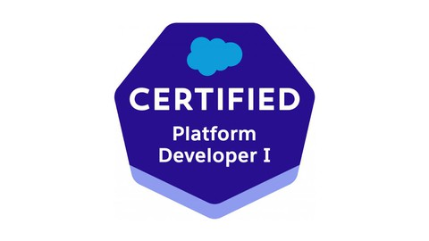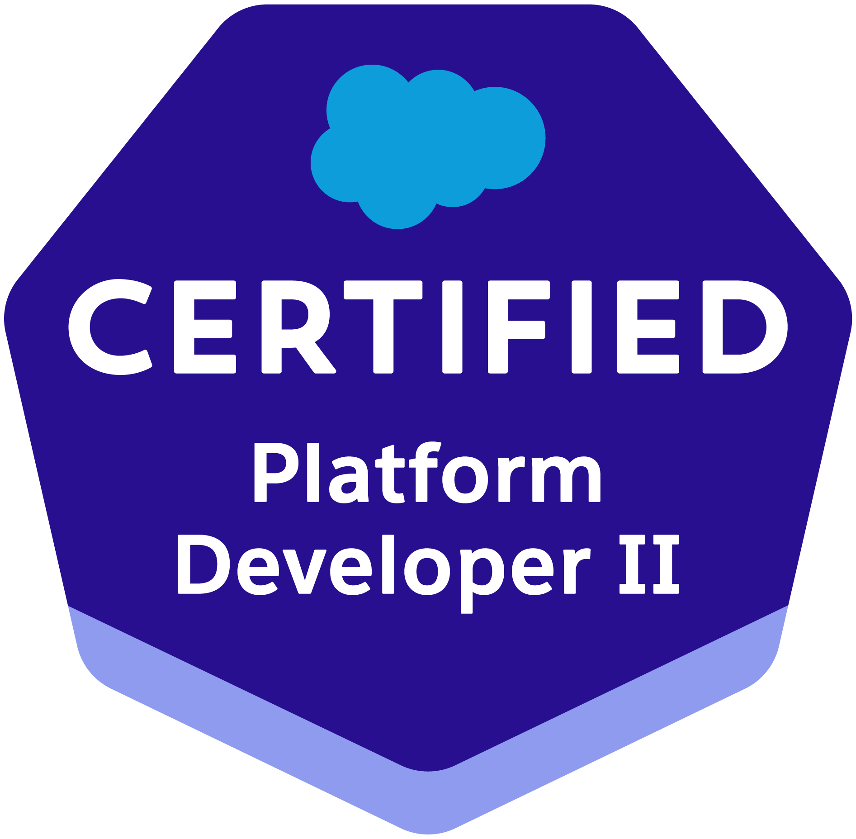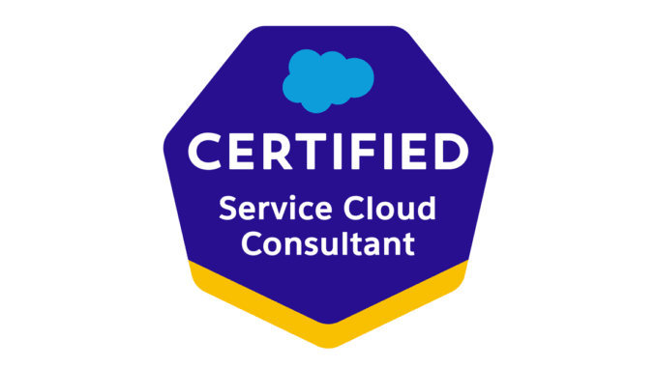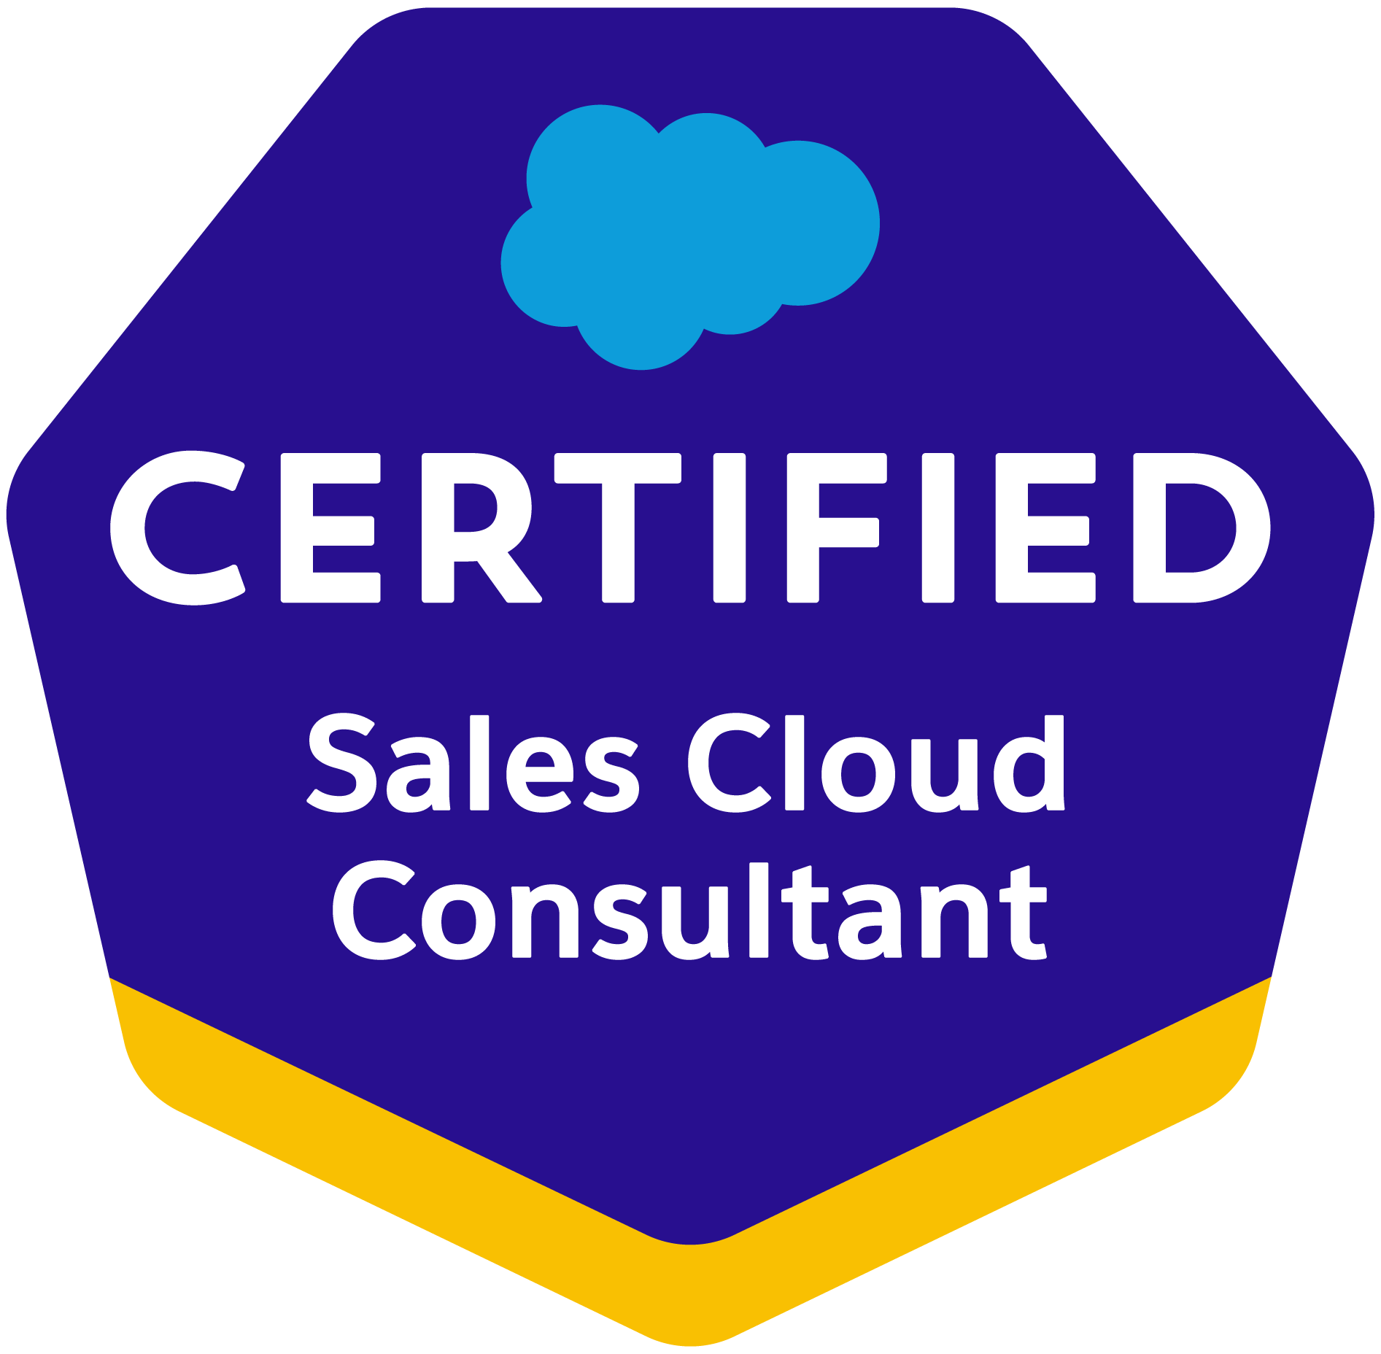
Salesforce Lightning Developer
Phone: 2146999583
Email: vrudraraju3333@gmail.com
www.linkedin.com/in/varma-rudraraju-77ab04173
SUMMARY:
- Over my 10-year tenure in the IT sector, I have honed my skills across two core areas. Initially, I immersed myself in the world of Java/J2EE, developing custom applications. This foundation paved the way for a deeper engagement with Salesforce technologies, where I have spent 6 plus year of my career analysing, designing, developing, and supporting advanced Salesforce cloud solutions.
- Experience in administration, configuration, customization, and Integration (Soap API, Rest API, and Metadata API as Call in and call-out services), and Support of Salesforce CRM and Salesforce applications.
- Proficient in designing and implementing Lightning Web Components (LWC) to enhance user interfaces and deliver dynamic, responsive functionality, contributing to an improved and modernized Salesforce user experience.
- Experience in modifying Visualforce pages to support the Lightning Experience and a good understanding of lightning mode and its features.
- Implemented web Lightning framework with applications, components, controllers, and stylesheets.
- Worked on Visual Flows and Process Builder to automate workflow actions based on functional requirements.
- Designed various webpages in Visual Force for functional needs and created Custom Controllers and Standard Controllers in Visual Force.
- Determine the specific tasks or interactions you want the chatbot to handle. These could include customer support inquiries, lead qualification, appointment scheduling
- Implemented Apex Triggers and Wrapper Classes as per the custom business requirement.
- Worked on Visualforce pages and have experience with CSS and JavaScript
- Experience working across various SFDC implementations that are covering Sales Cloud, Service Cloud, Experience (Community) Cloud and Apttus CPQ.
- Experience in using source control Git, Copado and used Visual studio code, and Eclipse IDE.
- Experience in XML, JavaScript, HTML, Eclipse, and SVN.
- Extensive experience with Salesforce reporting, including the creation of custom report types and implementation of complex filter and cross-filter criteria to extract valuable insights
- Having experience on support projects providing solutions to Level-1, Level-2, and Level-3 tickets
- Worked on Soap API and Rest API to design and support web services platform.
- Created the Validation Rules, Approval Process, and workflows for automated lead routing, lead escalation, and Email Alerts.
- Proficient in Salesforce NPSP platform, adept at building custom fields, objects, permission sets, and flows to tailor the system to organizational needs.

- Spearheaded the successful implementation and customization of Litify, a comprehensive legal practice management solution built on the Salesforce platform, optimizing case management, client communication, and document automation processes for legal teams.
- Acted as a subject matter expert in Litify, providing strategic guidance and technical support to stakeholders, including attorneys, paralegals, and administrative staff, resulting in increased user proficiency, streamlined workflows, and improved overall efficiency within the legal practice.
- Expert in developing User Interface (UI) applications and professional web applications using JavaScript, JSP, HTML5 /DHTML, XHTML, jQuery, CSS3, and Ajax.
- Worked on Web services using REST API exclusively on obtaining the needed information using the URL approach.
- Having experience with REST methods such as Put (), Get (), Post (), and Delete ().
- Having experience with partner WSDL, Enterprise WSDL, and Metadata API.
- Experience in MuleSoft any point API platform on designing and implementing mule APIs.
- Having experience in live support activities providing solutions to end users in a Production environment.
- Worked on Sales cloud such as Web-to-lead to support online lead capture, with auto-response rules.
- Proficient in Configuration, Customization, and Programming with Apex API (Controllers & Triggers), Visual force Pages, and Visual force Components using up-to-date technology & implementing new instances of Salesforce.
- Defined assignment rules to route case requests to appropriate case support work platforms.
- Implemented security and sharing rules at object, field, and record levels for users at different levels of organization created various profiles, and configured the permissions based on the organizational hierarchy.
- Experience in customizing existing Visualforce to align with Salesforce’s new Lightning UI experience.
- Experience working with Data Loader, import wizard, salesforce.com, and Sandbox environments.
- Expertise in using Salesforce Lightning Design System (SLDS) for developing Lightning Components, Actions, Events, and Server - Side Controller
- Proven ability to integrate Marketing Cloud with Salesforce CRM platforms (Sales Cloud, Service Cloud) and external systems, ensuring seamless data flow and synchronization. Experienced in utilizing Marketing Cloud Connect for comprehensive customer journey management across platforms, enhancing cross-functional team collaboration and campaign effectiveness.
- Experience in working on Field Service Lightning (FSL) in the service cloud and sales cloud.
- Deployed code using Copado to the next environments also used back promotion feature
- Worked on the designing of custom objects, custom fields, role-based page layouts, custom Tabs, custom reports, report extractions to various formats, and design of Visual Force Pages, Dashboards, and various other components as per the client and application requirements.
- Experienced in Conga Mail Merge, Conga Composer, and Conga Conductor and in creating Conga Template and Quick Merge Links.
- Experienced in Conga documents and generation process followed by DocuSign integration.
- Experience with all aspects of Salesforce.com customizations, data loading, integration using Jitterbit data loader and Apex Data Loader, and Web Services (Soap and Rest).
- Experienced in all phases of Software development life cycle (SDLC), quality management systems, and project life cycle processes.
- Conducted comprehensive training sessions for legal teams on utilizing Litify's Salesforce platform
- Designed and implemented Salesforce Platform Events to facilitate real-time communication and data synchronization across various system components. Utilized the event-driven architecture to enable seamless integration and event-driven processes within the Salesforce platform.

Salesforce Technologies | SalesForce.com, Force.com, Sales Cloud, Service Cloud, LWC, Lighting components, CPQ, Apttus CPQ, Apex Classes/Controllers, Apex Triggers, SOQL, SOSL, Visual Force Pages/ Component, Apex Web Services, Partner WSDL & Enterprise WSDL, Dashboard, Analytic Snapshots.
Salesforce Tools | Force.com IDE (Eclipse), AJAX Tool Kit, Force.com API tools (Data Loader), Force.com Explorer, Force.com Platform
Languages | Apex, C/C++, Java, J2EE, HTML, XML, CSS.
Database | SQL Server 2008, Oracle, MySQL.
Web | HTML, XML, CSS, JSP, JavaScript, WSDL, SOAP.
Tools | MS Office, Adobe Photoshop, MS Excel, Silverlight, Eclipse IDE.
Web Servers | IBM WebSphere 4.x/5.x, Apache Web Server, Tomcat 6.x
Platforms | UNIX and Windows (NT/2000/XP/Vista/7)
TECHNICAL SKILLS:

EDUCATION:
- Masters in computer and information science; university of Massachusetts, Dartmouth, MA
- Bachelors of technology; SRKR engineering college, IN
CERTIFICATIONS:
- Certified by Salesforce Admin
- Certified by Salesforce Platform Developer-I
- Certified by Salesforce platform Developer-II
- Certified by Salesforce Sales Cloud
- Certified by Salesforce Service Cloud

WORK EXPERIENCE:

Client: LexisNexis, Alpharetta, Atlanta Feb 2022 – Till Date
Role: Salesforce lightning developer
Responsibilities:
- Gathered business requirements and configured/customized Salesforce Lightning accordingly.
- Participated in estimating and analysing migration from Salesforce Classic to Lightning. Created custom objects and fields in the Lightning experience.
- Developed custom components for handling unsupported buttons in Lightning.
- Created Email Templates and Mail Merge Templates for different objects in Lightning. Translated Email templates and components using Custom labels and the translation workbench.
- Developed Lightning applications using Lightning Web Components, Controllers, and Events. Built reusable UI/UX components with the Lightning Web Component framework.
- Implemented and configured Field Service Lightning (FSL) in Service Cloud. Customized Field Service Lightning for enhanced field service operations.
- Wrote Apex Triggers on Account, Contact, and Opportunity for automation. Developed Apex Classes, Batch Classes, and Schedule classes. Worked with SOQL and SOSL queries with Governor Limitations.
- Developed batch processes for loading data from external systems to Salesforce.
- Implemented REST callouts in Salesforce Flows for seamless integration with external APIs, boosting data precision and streamlining processes like address validation and shipping calculations. Leveraged Apex and Flow Builder for efficient communication between Salesforce and third-party services.
- Implemented and configured Customer Community Cloud in two different portals. Created API services for data integration using MuleSoft ESB.
- Leveraged JIRA to streamline project management and issue tracking for Salesforce implementation projects, enhancing team collaboration and ensuring timely resolution of development and configuration challenges.
- Design and implement OmniStudio solutions to enhance customer engagement across Salesforce Clouds. Expert in utilizing OmniScript for complex guided experiences, integrating seamlessly with Salesforce ecosystems (Sales, Service, Experience, and Marketing Clouds). Skilled in crafting user-centric interfaces with OmniStudio (FlexCards, DataRaptors), leveraging Salesforce's customizations, Apex, LWC, and APIs for scalable, efficient business solutions.
- Demonstrated expertise in deploying targeted email campaigns, automating marketing workflows using Journey Builder, segmenting audiences for personalized engagement, and optimizing marketing strategies to enhance customer experiences and ROI.
- By integrating with LexisNexis Financial Services Cloud, financial institutions can access a wide array of comprehensive financial data, including market trends, regulatory updates, and customer profiles, enabling informed decision-making and risk assessment.
- Implemented Einstein Chatbots within Salesforce Lightning UI, streamlining customer interactions and boosting operational efficiency. Leveraged AI capabilities for personalized user experiences, resulting in a 25% reduction in average response time and a 15% increase in customer satisfaction ratings.
- Streamlined user interfaces by customizing Lightning Record and App Pages, leveraging Lightning Web Components and App Builder for enhanced user experience.
- Drive digital process automation with OmniStudio, enhancing operational efficiency and customer satisfaction. Specialize in developing OmniScripts for business process automation, integrating Salesforce platforms with external systems for streamlined operations. Ensure high security and data integrity using Salesforce Shield and OmniStudio, while deploying interactive applications on Experience Cloud with web technologies (HTML, XML, JavaScript, CSS).
- Utilized Copado for deploying code from sandbox to production. Enabled CI/CD for faster, error-free releases.
- Configured applications from the App Exchange like Conga builder, EchoSign. Integrated DocuSign for e-signature in Conga documents.
- LexisNexis Financial Services Cloud offers robust compliance and due diligence solutions, providing financial institutions with access to up-to-date regulatory information and tools for monitoring compliance with industry standards and regulations, thereby reducing risk and ensuring regulatory compliance.
- Developed Lightning Aura Components to enhance user interface and functionality, addressing specific business requirements. Customized Salesforce Lightning by creating and configuring components, handling unsupported buttons, and optimizing for improved performance.
- Integrated Einstein Chatbots seamlessly into Salesforce Lightning components, enhancing user engagement and automating routine tasks. Collaborated with cross-functional teams to design and deploy chatbots, leading to a improvement in lead qualification accuracy and a reduction in manual data entry efforts.
- Integrated Salesforce.com with back-office systems using Jitterbit Data Loader.
- Actively participated in daily stand-up meetings and Scrum processes.
- Worked on different Salesforce environments like Sales Cloud, and Service Cloud.
Environment: Apex, Visual force, Apex Classes, SOQL, Lightning Components, Lightning Web components, Field Service Lightning (FSL), Apex triggers, Visual force, MuleSoft, Pages, Batch Apex, Copado, Schedule Apex, SOAP, REST, Jitterbit, Conga, DocuSign Workflows, and Approvals

Client: UPS, sandy spring, Atlanta June 2020 – Jan 2022
Role: Salesforce CPQ developer
Responsibilities:
- Engaged proactively with users to grasp intricate business requirements, meticulously documenting them for clarity.
- Designed, developed, and executed data modelling for applications, ensuring strict adherence to Salesforce governor limits.
- Demonstrated extensive proficiency in Salesforce CPQ, adeptly managing pricing through various methods like list, cost/markup, percent total, block, price rules, and calculator plugins. Skilfully handled system and user discounts, along with filter rules.
- Implemented seamless integration between Salesforce CPQ and third-party systems, facilitating real-time data exchange and automating order processing workflows
- Proficient Salesforce CPQ developer skilled in leveraging comprehensive product knowledge, intricate pricing configurations, and robust automation functionalities to seamlessly transition into a CPQ testing role, ensuring rigorous testing protocols, meticulous quality assurance, and optimal system performance
- Demonstrated proficiency in leveraging MuleSoft Anypoint Platform to architect and implement robust integrations between Salesforce CPQ and various external systems, ensuring efficient data synchronization and streamlined sales processes.
- Skilled in designing, developing, and deploying secure and scalable APIs using MuleSoft, facilitating seamless connectivity between Salesforce CPQ, ERP, and CRM systems, thus enhancing operational efficiency and improving data accuracy across platforms.
- Proficient in integrating Salesforce CPQ with Salesforce Financial Services Cloud, enabling streamlined quote-to-cash processes within financial services environments. This integration facilitates more accurate quoting, faster deal closure, and a unified view of financial products and customer data, enhancing the overall customer experience in the financial sector
- Produced comprehensive documents to augment the team's understanding of the Salesforce.com CRM system.
- Generated quotation word documents from Salesforce.com, leveraging CPQ features.
- Conducted data migration and updates through tools provided by Salesforce.com and Copado.
- Actively participated in end-to-end testing and configured enhancements for CPQ and CLM functionalities.
- Collaborated closely with Salesforce.com consultants to implement business solutions for client requirements, effectively utilizing APPTUS CPQ within a custom framework.
- Skilled in customizing and configuring Salesforce Financial Services Cloud to meet specific business requirements, leveraging Salesforce CPQ to offer complex financial products and services. Expertise includes tailoring pricing models, automating approval workflows, and ensuring compliance with financial regulations, driving efficiency, and innovation in financial services operations.
- Collaborated with stakeholders to conceptualize and implement chatbot solutions within Salesforce CPQ, facilitating real-time guidance and support for sales representatives during complex quoting scenarios. Orchestrated the seamless interaction between chatbots and CPQ workflows
- Integrated APPTUS for efficient management of quotes, invoicing, and discounting by sales reps alongside CRM data.
- Configured product and pricing setups using CPQ/Product consoles, encompassing price ramps, Price Matrix, Price Rule sets, price list items, tiered pricing, and asset pricing.
- Leveraged Salesforce CPQ's native functionalities and customizations to integrate CLM workflows seamlessly, ensuring accurate pricing, discounting, and contract terms alignment with customer requirements, thereby optimizing sales processes and driving revenue growth.
- Formulated CPQ processes using Apttus CPQ and CL AppExchange tools in Quotes.
- Implemented Sales Cloud, incorporating Web-to-Lead for online lead capture with auto-response rules.
- Developed integrations to connect data from Salesforce.com using SFDC APIs.
- Customized APTTUS CPQ for specific business requirements. Involved in CPQ design and mapping to Salesforce custom objects.
- Experienced in creating custom MuleSoft connectors and flows to extend Salesforce CPQ capabilities, enabling automated quote-to-cash processes and personalized pricing models that align with business requirements and objectives.
- Spearheaded the integration and customization of S-Docs document generation tool. revolutionizing document management processes. Designed and implemented dynamic document templates, enabling users to generate professional-grade documents directly within Salesforce Lightning Experience, boosting efficiency and ensuring regulatory compliance.
- Leveraged Copado for automated testing, continuous integration, and continuous deployment.
- Crafted Page Layouts to systematically organize fields, custom links, related lists, and other components on record pages.
- Implemented picklists, dependent picklists, lookup, master-detail relationships, validation, and formula fields for custom objects.
- Executed Case Assignment Rules to streamline the direction of cases to appropriate groups, such as Stories and PCS Central Support.
- Spearheaded the integration of chatbot functionalities into Salesforce CPQ processes, enabling automated quoting and product configuration assistance for sales teams. Leveraged Salesforce Einstein Bots to enhance user experience and streamline communication channels
- Utilized Salesforce Lightning components and Apex to optimize user interfaces and automate business operations. Worked closely with stakeholders to design intuitive interfaces, boosting productivity. Integrated Salesforce Flows to automate tasks, enhancing system performance for both organizations.
- Proficient in developing strategic integration solutions with MuleSoft to optimize Salesforce CPQ performance, including error handling, logging, and monitoring, ensuring high availability and reliability of sales quoting and configuration processes.
- Implemented communities using both standard out-of-the-box templates and fully customized solutions with lightning components. Leveraged Community Cloud (Experience Cloud) builder to configure or moderate partner communities.
- Orchestrated the creation and scheduling of data synchronization tasks using Jitterbit to seamlessly synchronize data between Salesforce orgs and other applications and databases.
Environment: Apex, Visual force, Apex Classes, Apex triggers, Visual force, Pages, Batch Apex, Schedule Apex, Workflows, and Approvals, Data Warehousing, Case Management, Copado, Automation, Sandbox testing, Jitterbit, SalesForce.com Platform

Client: Discover, Houston, TX, USA Nov 2018 – May 2020
Role: Salesforce developer
Responsibilities:
- Focused on the development, implementation, and updating of Sales Cloud and Service Cloud within Salesforce.com.
- Worked on Salesforce.com Standard Objects, including Accounts, Contacts, Opportunities, Campaigns, Cases, and solutions.
- Created various Profiles, Roles, Page Layouts, and Record Types, configuring Permissions based on organizational hierarchy requirements.
- Developed and customized AI-driven chatbot solutions within the Salesforce platform to automate customer service inquiries and sales processes, significantly enhancing efficiency and user engagement. Utilized Salesforce Einstein Bots and Apex programming to tailor chatbot behaviour in customer satisfaction scores.
- Utilizing Salesforce Financial Services Cloud, Discover can leverage predictive analytics to customize financial products and services, directly aligning with customers' evolving needs and enhancing personalization.
- Collaborated with Business Analysts to offer recommendations and design optimal solutions for implementing new business ideas.
- Committed to professional development, holding certifications in MuleSoft development and integration, underscoring a deep understanding of integration strategies and technologies.
- Developed Page Layouts to organize fields, custom links, related lists, and other components on record pages.
- Implemented advanced fields like Picklist Fields, Master-Detail Fields, and Custom Formula Fields, defining Field Dependencies for custom picklist fields.
- Utilized Jitterbit, Copado tools, and Heroku connects for data and metadata migration between organizations.
- Customized case management, establishing Assignment rules, Auto response, and escalation rules for directing cases to appropriate groups.
- Salesforce Financial Services Cloud equips Discover with advanced tools for real-time fraud detection, improving security and trust by swiftly identifying and addressing suspicious activities.
- Implemented an Apex Trigger on Contact for cross-object field updates for reporting purposes.
- Enhanced Apex Class and Visual Force Page to create a custom Related List, displaying activities for selected contacts or clients.
- Developed and deployed a comprehensive financial management system on Salesforce, incorporating features such as budget tracking, revenue forecasting, and expense management, resulting in improved financial transparency and streamlined reporting processes.
- Experienced in conducting end-user training sessions and developing comprehensive business process documentation to facilitate smooth adoption and usage of Salesforce NPSP platform.
- Created and maintained Reports and Dashboards to provide quick access to key business metrics.
- Provided live support, addressing end-user queries in a Production environment.
- Managed Case Management by Configuring Email-to-Case for end users to submit cases through Outlook.
- Created and configured Email templates for PCS Central users, used in approval processes and other field updates.
- Implemented Copado to enhance Salesforce release management and version control efficiency.
- Customized Salesforce.com User Profiles, setting layouts, apps, Field-level Security, and Permission Sets for client services and marketing.
- Configured Chatter objects and tabs to monitor progress and discussions on business processes.
- Developed and configured various Custom Reports and Report Folders tailored to different user profiles.
- Configured Chatter to track emails from Outlook to Salesforce by following a user.
- Implemented AppExchange Dup Catcher to filter and prevent duplicate records.
- Developed and deployed a comprehensive financial management system on Salesforce, incorporating features such as budget tracking, revenue forecasting, and expense management, resulting in improved financial transparency and streamlined reporting processes.
- Responsible for weekly and monthly data export, updates, and backup for the organization.
- Used Apex Data Loader to Insert, Update, and Import data from Microsoft Excel into Salesforce.com.
- Integrated applications using web services by consuming WSDL files to extract data from external systems.

Environment: SFDC, Apex Triggers, Apex Classes, Data Loader, Force.com, z, Import Wizard, Eclipse IDE, Controllers, Visual Force Pages, WSDL, Chatter, XML, API.

Client: JC Penney, Plano, TX, USA Apr 2017 – Oct 2018
Role: Salesforce Administrator
Responsibilities:
- Designed and developed custom objects, fields, workflows, and validation rules tailored to the Financial Industry.
- Extensively customized various SFDC standard objects, including Accounts, Contacts, Opportunities, Cases, Entitlements,
Service Contracts, Reports, and Dashboards.
- Salesforce to seamlessly integrate JCPenney's e-commerce platform with other systems, such as inventory management, customer relationship management (CRM), and marketing automation. This integration ensures smooth data flow and provides a unified view of customer interactions across various touchpoints.
- Developed custom Salesforce tools to track supplier performance metrics, improving collaboration and accountability, and contributing to the optimization of supplier relationships and timely deliveries.
- By integrating Salesforce Financial Services Cloud with J.C. Penney's systems, the company gains deep insights into customer financial behaviours and preferences. This allows for targeted marketing efforts, personalized promotions, and tailored product recommendations based on individual financial profiles, ultimately driving higher customer engagement and satisfaction.
- Implemented Salesforce solutions to enhance supply chain transparency, resulting in a increase in inventory accuracy and a reduction in fulfilment times, thereby optimizing overall efficiency.
- Knowledgeable about nonprofit processes, demonstrating an understanding of the unique requirements and challenges faced by nonprofit organizations.
- Skilled in gathering detailed requests for system improvements or changes, ensuring alignment with organizational objectives and user requirements.
- Customized JIRA workflows and dashboards for Salesforce administration tasks, enabling precise tracking of enhancement requests, bug reports, and user feedback, which significantly improved response times and user satisfaction.
- Created and maintained reports and dashboards, offering key business insights to stakeholders, including executives and
department heads.
- Collaborated with cross-functional teams to establish contract management best practices, including version control, approval workflows, and compliance tracking, ensuring adherence to regulatory requirements and minimizing risks associated with contract management.
- Established Custom Objects and defined Lookup and Master-Detail Relationships on Salesforce objects.
- Utilized JavaScript and jQuery for client-side programming.
- Personalized Customer Experiences: Leverage Salesforce's capabilities to implement personalized marketing campaigns, product recommendations, and targeted promotions based on customer behavior and preferences. By analyzing e-commerce data within Salesforce, you can tailor the shopping experience to individual customers, increasing engagement and driving sales.
- Collaborated with cross-functional teams to streamline supply chain processes, leveraging Salesforce reporting for data-driven decision-making, and ensuring real-time insights into inventory levels and logistics performance.
- Implemented Email-to-Case, Web-to-Case entry, and manual case entry for customer cases in the Cases Tab.
- Evaluated Cast Iron for data migration within Salesforce.com.
- Extensive experience in creating Roles, Profiles, Email Services, and Page Layouts.
- Developed various Approval processes in Salesforce.com for the smooth operation of the Sales process within the organization.
- Conducted a comprehensive analysis of business and technical requirements, devising the solution by customizing standard objects within Salesforce.com (SFDC) and leveraging platform-based technologies such as Visualforce, force.com API, and web services.
- Salesforce Financial Services Cloud enables J.C. Penney to efficiently manage its range of financial products, such as credit cards and loyalty programs. With centralized data management and automated workflows, the company can streamline processes like application processing, account management, and rewards distribution, leading to improved operational efficiency and cost savings.
- Implemented and managed chatbots within Salesforce to provide instant support and automate routine administrative tasks.
- Integrated Salesforce with the Order Management System (OMS), leading to a increase in order processing efficiency and a improvement in customer satisfaction scores through automation and improved communication channels.
- Streamline order management processes by configuring Salesforce to handle order processing, inventory tracking, and fulfilment operations efficiently. Utilize Salesforce's automation tools to automate tasks like order routing, shipping notifications, and returns processing, ensuring a seamless end-to-end e-commerce experience for customers.
- Designed and developed Sales Force Automation (SFA) applications on the force.com platform, utilizing Apex programming language at the backend and Visualforce pages as the user interface.
- Created Scheduled and Batch Apex jobs based on business requirements.
- Implemented Salesforce tools to enhance order accuracy and delivery times, resulting in increased customer satisfaction and improved transparency throughout the order fulfillment process.
- Developed Apex Triggers to meet various functional needs in the application and improved existing Apex code.
- Conducted regular data hygiene and clean-up activities to maintain financial data integrity in Salesforce.
- Implemented requirements on the Salesforce.com platform and Force.com IDE Plug-in using Eclipse.
- Utilized SOQL & SOSL for data manipulation within the application using platform database objects.
- Proficient in troubleshooting and debugging Salesforce applications using Salesforce DX.
- Proficient in writing k classes and performing unit testing on Salesforce applications using Salesforce DX.
- Integrated with external sources by making callouts using SOAP/REST.
- Used Force.com web services API to create, update, retrieve, and delete records from SOAP-based web services using Java.
- Worked in GIT version control systems for maintaining file history and actively participated in the Code Review board to uphold the standard of Apex code.
- collaboration efforts to align order management processes, conducting training sessions for over 100 users to ensure successful adoption of Salesforce tools and fostering collaboration between sales, customer service, and logistics teams for efficient order management.
- Expertise in writing custom Apex classes, triggers, Visualforce pages, and other Deployments using Salesforce DX.
- Responsible for deployment using change sets and Eclipse, ensuring the backup of the production environment before deployment.
- Conducted Unit, Integration, Regression, and User Acceptance Testing.

Environment: Saleforce.com platform, Fields & Relationships, Workflow & Approvals, Apex Language, Visualforce (Pages, Component & Controllers), Data Loader, HTML, Salesforce DX, Reports, Dashboards.

Client: Bain Capital, Boston, MA Sep 2015 – Mar 2017
Role: Java Developer
Responsibilities:
- Analysed business requirements and implemented the application using Java and Mozilla XUL.
- Engaged in development using Spring, Hibernate, and JSF Framework, leveraging ANT scripts for project deployment.
- Created use case, sequence diagrams, and design-class grams to facilitate User Interface design.
- Contributed to Data Modelling for both logical and physical models.
- Conducted requirements gathering, prototyping, walkthroughs with business groups, and performed gap analysis.
- Demonstrated expertise in database modelling, administration, and development using SQL and PL/SQL in Oracle and SQL
Server environments.
- Translated business aspects of the application into comprehensive requirements documents.
- Developed Proof of Concepts (POC) for initial patterns and vendor Lightnings.
- Conducted code reviews with developers and delivery teams.
- Coordinated and managed Global Delivery teams at offshore locations.
- Scheduled and organized weekly or daily stand-up meetings with the entire development teams, both onshore and offshore.
- Developed Functional Requirements Specifications (FRS).
- Conducted business process reviews and modelling.

Environment: Java, JSP, Servlets, HTML, JDBC, JDK, Waterfall Model, Tomcat, Windows XP.

Client: HCSC, Chicago, USA Oct 2013 – Aug 2015
Role: Java developer
Responsibilities:
- Developed applications following the n-tier architecture in accordance with the Struts-based MVC design, utilizing Servlets,
- Struts Action classes, Action Forms, JSP, and Session Beans. Crafted User Interfaces using JSP, HTML, and CSS.
- Created business modules employing J2EE design patterns and extensively utilized the Java Collections API.
- Scripted test cases based on received specifications and conducted testing at various levels, including integration and system testing, employing diverse methodologies.
- Implemented Maven and utilized Jenkins as a build tool to generate jar and war files, subsequently deploying war files to
- target servers. Managed builds using Maven.
- Coded using JSP, Java Servlets, Spring MVC, and XML.
- Proactively monitored performance, diagnosed problems, and tuned queries and databases.
- Utilized the Maven Build Tool for application building and deployed the application on Apache Tomcat Server.
- Worked with the dynamic, object-oriented programming language RUBY.
- Possessed experience working with Version Control Tools such as Git and Apex ClassesHub.

Environment: SQL, PL/SQL, DB2, Apache Tomcat, XML, CSS, Windows XP, Linux, Java1.7, Struts, EJB 2.0, Java/J2EE coding, J2EE patterns, Bootstrap, Angular JS, Web service, JDBC, Spring, WSDL, jQuery, Hibernate.

